PRACTICAL CHAPTER • SECOND EDITION 2027

Hands-On SPARTA
Reproducing the Mohammadzadeh
Lid-Driven Cavity
  - A reproducible Linux, MPI, validation, and Codex workflow for students
Evidence status
The serial smoke workflow and the classroom-resolution case have been executed with official SPARTA source. The publication-resolution, repeated-seed validation remains explicitly pending.

Ehsan Roohi
Companion repository • Ehsan-Roohi/DSMC_Python
Draft prepared 3 August 2026

How to use this chapter
Editorial placement
Place this as a standalone practical chapter immediately after the book's theoretical cavity chapter. Do not bury it at the end of the data-driven chapter: the reader should first learn the physics and then reproduce it in SPARTA before moving to AI-assisted analysis.

Learning outcomes
- Translate a literature DSMC benchmark into a traceable SPARTA input deck.
- Build official SPARTA source locally on Linux in serial and MPI modes.
- Distinguish a syntax smoke test, a classroom run, and a publication validation.
- Extract lid-adjacent velocity slip and temperature and compare them with digitized reference data.
- Use Codex to inspect, run, and explain the workflow without silently changing the benchmark.

Contents
Part | Purpose
1–2 | Benchmark physics and the SPARTA mapping
3–5 | Linux installation, case anatomy, and execution
6–8 | Post-processing, validation, and collision-model studies
9–11 | Codex workflow, exercises, troubleshooting, and references

Evidence vocabulary used throughout
Label | What it proves | What it does not prove
Smoke | Deck parses; particles, collisions, walls, averaging, dump, and parser work. | Agreement with the paper.
Student | A usable learning profile and a first quantitative diagnostic. | Grid/time/PPC independence.
Production | A candidate high-resolution result. | Validation until repeats and uncertainty are reported.

1. Benchmark definition
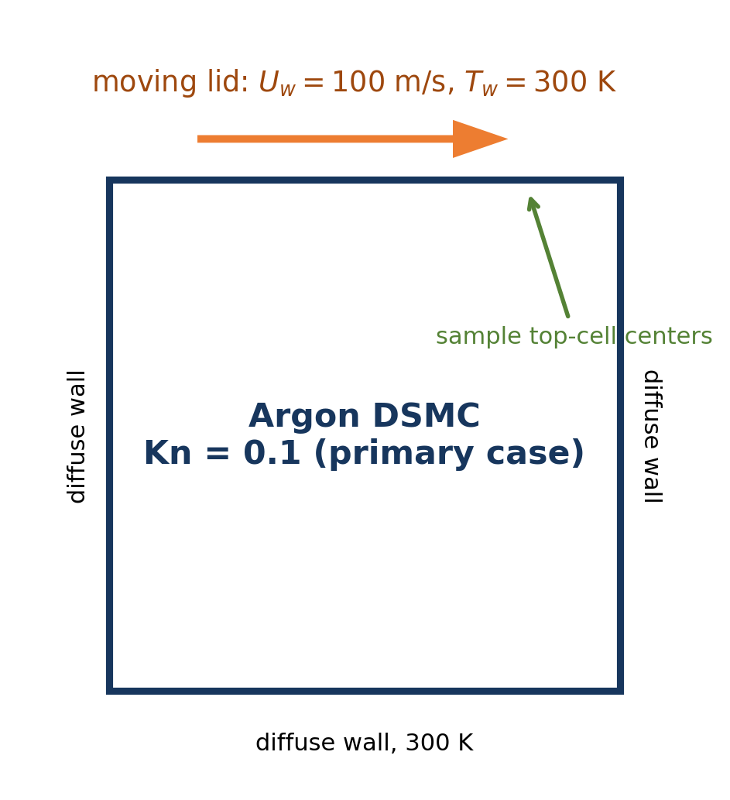
Figure 1. Dimensional realization of the square lid-driven cavity used in this chapter.
Mohammadzadeh et al. studied monatomic argon in a square micro- or nanocavity using DSMC. All walls are isothermal at 300 K; the top wall translates at 100 m/s. Molecular reflection is fully diffuse with full thermal accommodation. The paper reports Kn = 0.005, 0.05, and 0.1. This implementation starts with Kn = 0.1 because the rarefaction signal is large and the production grid is comfortably finer than the mean free path.
Parameter | Value | Traceability
Gas / molecular mass | Ar / 6.63 × 10⁻²⁶ kg | PRE paper
Reference diameter | 4.17 × 10⁻¹⁰ m | PRE paper
Wall temperature | 300 K | PRE paper
Lid speed | 100 m/s | PRE paper
Wall scattering | Diffuse; accommodation = 1 | PRE paper
Collision model | VHS, ω = 0.81, α = 1 | Paper + repository model file
Primary resolution | 200 × 200; 32 particles/cell | Paper-selected grid and population

1.1 Similarity-preserving dimensionalization
The paper specifies the flow through Kn = λ/L but does not state one mandatory absolute cavity length. We choose L = 1 μm. This is a dimensional realization, not a new physical claim. Once Kn, wall speed, wall temperature, gas model, and geometry are preserved, L determines λ and the required number density.
lambda = Kn L
n = 1 / (sqrt(2) pi d_ref^2 lambda)
fnum = n L^2 / N_sim # SPARTA 2-D unit-depth convention
Important benchmark nuance
The paper states Δx ≈ 0.1λ and also selects a 200 × 200 grid. Across three Kn values those two statements cannot both hold with one fixed grid. This package records Δx/λ in every metadata file. For Kn = 0.1, the 200 × 200 production deck gives Δx/λ = 0.05.

2. From DSMC physics to SPARTA commands
SPARTA advances simulator particles through free flight, boundary interaction, and stochastic collisions. The mapping below makes each literature assumption auditable in the input deck.
Physical choice | SPARTA realization | Audit question
Two-dimensional square | dimension 2; boundary s s p | Are x/y walls surfaces and z periodic?
Uniform collision cells | create_grid Nx Nx 1 | Is Δx/λ reported?
Argon at 300 K | species + mixture + global nrho/temp | Do mass, density, and fnum agree?
Fully diffuse fixed walls | surf_collide fixed diffuse 300 1 | Is accommodation exactly one?
Moving diffuse lid | surf_collide lid … translate 100 0 0 | Is only yhi assigned to lid?
VHS/NTC collisions | collide vss gas argon.vss; α = 1 | Does the data file represent VHS?
Macroscopic sampling | compute grid + fix ave/grid | Is warm-up excluded from averaging?

2.1 Time-step rule
The generator uses a conservative cell-crossing scale and records both Δt and Δt/τ. For the production preset, Δt = 8.26 × 10⁻¹³ s. Never treat one time step as universal: repeat the result at a smaller Δt before publication.
c_mp = sqrt(2 k_B T / m)
dt = 0.25 (L/Nx) / (4 c_mp + U_lid)
tau = lambda / c_mp

2.2 Particle weight in a 2-D calculation
SPARTA's 2-D calculation is interpreted with unit out-of-plane depth. Therefore fnum scales with nL² rather than nL³. The generator targets an initial particles-per-cell value; stochastic rounding may produce one fewer or one more particle globally.

3. Obtain and build the case on Linux

3.1 Clone the teaching branch
git clone --branch agent/validated-dsmc-cavity --single-branch \
https://github.com/Ehsan-Roohi/DSMC_Python.git
cd DSMC_Python/sparta_cavity_mohammadzadeh

3.2 Install prerequisites
sudo apt update
sudo apt install -y git build-essential openmpi-bin libopenmpi-dev \
python3 python3-venv
On a managed cluster, use the site compiler and MPI modules instead of sudo. The package installer itself never requests administrative privileges.

3.3 Build pinned official SPARTA source
bash scripts/install_sparta_linux.sh serial
# Optional MPI executable
bash scripts/install_sparta_linux.sh mpi
The installer clones the official sparta/sparta repository, checks out commit 912c9e163c38ea5c3562d039e65215f6e2a4f3f8, and invokes SPARTA's make target. Pinning separates a reproducible book case from future upstream changes.
One-command bootstrap
From an empty directory, the documented bootstrap clones this branch, builds serial SPARTA, runs the unit test, and executes the smoke case. It refuses to overwrite an existing directory.

bash <(curl -fsSL https://raw.githubusercontent.com/Ehsan-Roohi/DSMC_Python/agent/validated-dsmc-cavity/sparta_cavity_mohammadzadeh/scripts/bootstrap_linux.sh)

3.4 Repository map
sparta_cavity_mohammadzadeh/
├── cases/ # committed generated decks
├── data/ # argon species and collision data
├── reference/ # digitized PRE profiles
├── scripts/ # generate, run, install, post-process
├── hpc/ # Unity CPU/MPI template
├── tests/ # regression checks
├── AGENTS.md # constraints for Codex
└── VALIDATION_STATUS.md # current scientific evidence

4. Read the SPARTA input deck
The deck is generated from metadata; do not hand-edit derived values. The first block defines units, stochastic seed, geometry, computational grid, and global gas state.
units si
seed 20260803
dimension 2
boundary s s p
create_box 0.0 1.0e-6 0.0 1.0e-6 -0.5 0.5
create_grid 200 200 1
global nrho 1.2943836530e25 fnum 1.011237229e7 temp 300
species argon.species Ar
mixture gas Ar nrho 1.2943836530e25 temp 300 vstream 0 0 0

4.1 Why boundary s s p?
For a 2-D problem, x and y are physical surface boundaries (s) while z is periodic (p). The z extent in create_box is bookkeeping for the 2-D unit-depth formulation.

4.2 Wall and lid models
surf_collide fixed diffuse 300 1.0
surf_collide lid diffuse 300 1.0 translate 100 0 0
bound_modify xlo xhi ylo collide fixed
bound_modify yhi collide lid
The translate keyword supplies the moving wall velocity to the diffuse reflection model. Assignment is explicit: three stationary faces use fixed, and only the top face (yhi) uses lid.
Common error
A moving incoming gas stream is not the same as a moving wall. Keep the initial mixture stream at zero and translate the lid surface model.

5. Collisions, sampling, and output

5.1 VHS collisions
collide vss gas argon.vss
create_particles gas n 0
timestep 8.2567881869e-13
SPARTA's vss collision style reads one line per species. Setting the scattering parameter α = 1 gives the VHS angular law. The n 0 option lets the specified number density and fnum determine the initial simulator population.

5.2 Separate warm-up from sampling
run 14000
reset_timestep 0
compute flow grid all gas nrho u v w temp
fix flowavg ave/grid all 10 1 10 c_flow[*] ave running
dump fields grid all 26000 grid.final.* id xc yc f_flowavg[*]
dump_modify fields pad 8
run 26000
No production sample is accumulated during warm-up. fix ave/grid forms a running mean during the sampling phase, and the final dump carries cell centers plus averaged density, velocity components, and temperature.

5.3 Presets
Preset | Grid | Particles/cell | Warm-up + sample | Δx/λ | Claim allowed
smoke | 12² | 4 | 20 + 30 | 0.833 | Syntax/data path
student | 50² | 12 | 4,000 + 8,000 | 0.200 | Learning profile
production | 200² | 32 | 14,000 + 26,000 | 0.050 | Validation candidate

5.4 Run commands
python3 -m unittest discover -s tests -v
bash scripts/run_case.sh smoke serial
bash scripts/run_case.sh student serial
# MPI examples
MPI_RANKS=8 bash scripts/run_case.sh student mpi
MPI_RANKS=16 bash scripts/run_case.sh production mpi

6. Read the outputs and compare with the paper
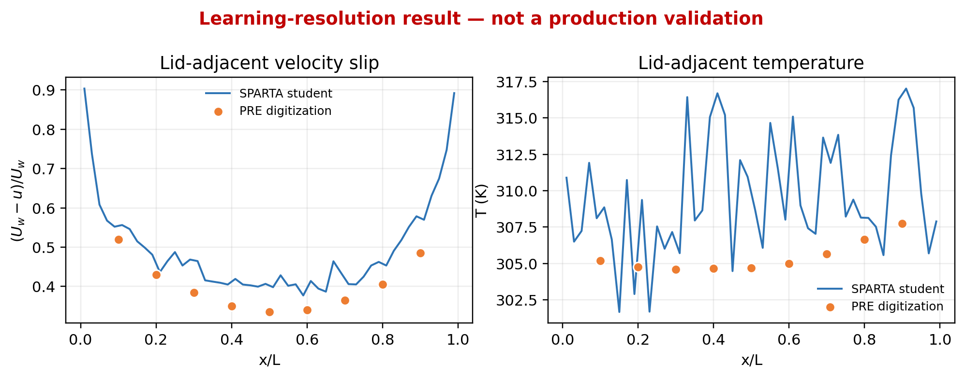
Figure 2. Executed student-resolution pilot at Kn = 0.1 compared with digitized PRE lid profiles. The red heading is intentional: this is not a production validation.
The executed 50 × 50, 12-particles-per-cell pilot produced slip RMSE = 0.0613 and temperature RMSE = 6.17 K. The slip regression gate passed; the temperature gate did not. This is useful diagnostic evidence: the case is wired correctly, but the learning resolution and sample window are insufficient for a publication claim.

6.1 Output contract
File | Meaning | Reader check
case_metadata.json | Inputs plus derived λ, n, fnum, Δt, Δx/λ, and evidence label | Can the case be regenerated exactly?
log.cavity | SPARTA performance and event counts | Are collisions and wall hits nonzero?
grid.final.* | Final running-average grid fields | Are expected columns present?
lid_profile.csv | Top-cell-center slip and temperature | Is x/L monotonic and complete?
validation_metrics.json | RMSE gates and pass/fail status | Is a learning run being overclaimed?

6.2 Macro sampling versus direct wall sampling
This package compares macroscopic values in the centers of the cells adjacent to the lid. The PRE paper discusses meaningful differences between direct wall sampling and macroscopic cell sampling near nonequilibrium corners. Do not mix those two observables in one validation curve. A future extension should add direct incident/reflected molecular sampling as a separate dataset.

7. Publication-validation protocol
A visually plausible curve is not validation. Use the following protocol and retain every metadata/metrics file.
- Baseline: run the 200 × 200, 32-particles-per-cell deck at Kn = 0.1.
- Repeat at least three statistically independent seeds; report means and 95% confidence intervals.
- Grid study: compare at least 100², 200², and 400² while controlling particles per cell and sample quality.
- Particle study: increase particles/cell at fixed grid and time step.
- Time-step study: reduce Δt; quantify changes rather than quoting a rule only.
- Sampling study: increase warm-up and averaging windows; demonstrate stationary means.
- Compare raw top-cell-center profiles with the digitized paper data.
- Apply the paper's five-neighbor filter only as a second, labelled curve; never discard the raw data.
- Cross-check with the repository's independent Python NTC-PreScan solver.

7.1 Metrics
RMSE_q = sqrt[(1/N) sum_i (q_SPARTA(x_i) - q_PRE(x_i))^2]
Current regression targets:
velocity-slip RMSE <= 0.08
temperature RMSE <= 2 K
Reference coordinates are generally different from grid-cell centers; the post-processor interpolates the SPARTA profile to reference x/L values. Digitization uncertainty is recorded in the reference CSV and should be propagated in the final book results.
Decision rule
Passing the two RMSE gates is necessary for the automated regression, but not sufficient for scientific validation. Convergence and uncertainty evidence remain mandatory.

7.2 Unity cluster
cd DSMC_Python/sparta_cavity_mohammadzadeh
mkdir -p logs
sbatch hpc/unity_sparta_production.slurm
Unity template: 16 CPU/MPI tasks; verify local modules. GPU SPARTA needs a separate Kokkos/CUDA build.

8. Collision-model experiments
The published benchmark baseline is VHS. SPARTA names the general command collide vss; the species-pair data determine whether the angular law behaves as VHS or VSS.
Experiment | argon.vss α | Purpose | Validation status
VHS baseline | 1.0 | Reproduce the paper model | Eligible after convergence study
VSS sensitivity | 1.4 | Test angular-scattering sensitivity | Not the paper baseline
Collisionless | collide none | Free-molecular code check only | Not a cavity benchmark substitute

8.1 Make a model comparison reproducible
- Copy the baseline case into a new named run directory; never overwrite baseline output.
- Change only one collision-model parameter at a time.
- Record the model identifier and source data in metadata.
- Use the same seed set, grid, time step, population, warm-up, and sample window.
- Compare profiles with uncertainty bands, not only one-seed lines.
# Baseline argon.vss
# species diameter(m) omega Tref(K) alpha
Ar 4.17e-10 0.81 273.0 1.0
# Sensitivity-only VSS variant
Ar 4.17e-10 0.81 273.0 1.4
Do not move the goalposts
If the VSS sensitivity happens to fit one observable better, it must still be labelled a different physical model. It does not retroactively become the Mohammadzadeh VHS validation.

9. Running SPARTA with Codex
Codex is most useful here as a guarded laboratory assistant: it can read the repository contract, run tests, inspect logs, and explain failures. It should not silently install privileged packages, alter the benchmark, or declare a learning run validated.

9.1 Install and start the CLI
curl -fsSL https://chatgpt.com/codex/install.sh | sh
cd DSMC_Python/sparta_cavity_mohammadzadeh
codex
In the interactive session, ask Codex to read AGENTS.md and VALIDATION_STATUS.md first. Then request the smoke workflow and review each command before extending it.

9.2 Guarded non-interactive run
# Build SPARTA once
bash scripts/install_sparta_linux.sh serial
# Let Codex run the bounded verification prompt
bash scripts/run_with_codex.sh
# Read the saved summary
less runs/codex_smoke_report.md
The wrapper invokes codex exec --sandbox workspace-write. The bundled prompt runs unit tests and smoke only, stops if SPARTA is absent, forbids sudo, and saves a concise PASS/FAIL report.

9.3 A good interactive prompt
Read AGENTS.md, README.md, and VALIDATION_STATUS.md. Run the unit tests and
the serial smoke case. Inspect the SPARTA log, generated metadata, and validation
metrics. Do not change constants, use sudo, or start production. Explain why this
run is or is not technically healthy, and give exactly one next command.

9.4 What Codex may change
Allowed after review | Requires explicit scientific decision
Fix path handling, parser errors, tests, documentation, and Slurm syntax. | Gas constants, wall model, Kn definition, reference data, filters, validation gates.
Add a new, separately named resolution or seed matrix. | Replace or relabel the paper baseline.

10. Student exercises
1. Audit the deck
For the student preset, recompute λ, n, fnum, Δx/λ, and Δt/τ from case_metadata.json. Explain every discrepancy from hand rounding.
2. Resolution ladder
Run smoke and student. Plot both against the PRE data and explain why faster is not equivalent to more credible.
3. Repeat seeds
Add three student seeds without overwriting outputs. Compute mean and 95% confidence intervals at the PRE x/L coordinates.
4. Time-step sensitivity
Repeat with Δt/2 at fixed grid and population. Compare slip and temperature RMSE.
5. VHS versus VSS
Create a sensitivity-only α = 1.4 data file. Hold numerical settings fixed and discuss physical—not just visual—differences.
6. Knudsen sweep
Generate Kn = 0.05 and 0.005 cases. Choose grids based on Δx/λ rather than copying Nx blindly.

7. Raw versus filtered
Implement the paper's five-neighbor filter as a new output column. Preserve and plot raw data beside it.
8. Parallel efficiency
Run one identical student problem on 1, 2, 4, and 8 MPI tasks. Report speedup, efficiency, and particle imbalance.
9. Independent solver
Compare SPARTA with the repository Python NTC-PreScan implementation using the same gas and wall assumptions.
10. Codex audit
Ask Codex to identify every statement that would be needed before writing 'validated'. Manually verify its evidence references.
Deliverable standard
Every exercise submission must include its exact command, metadata JSON, relevant log excerpt, plot, numerical metric, and one paragraph separating numerical evidence from physical interpretation.

11. Troubleshooting
Symptom | Likely cause | Action
SPARTA binary not found | Local build was not run or mode differs | Run install script for serial or mpi; check SPARTA_BIN.
mpirun missing | MPI packages/modules absent | Install OpenMPI locally or load the site MPI module.
Zero/near-zero collisions | Density, fnum, species, or collision model wrong | Audit metadata and argon.vss; inspect log counts.
No lid motion | Moving wall assigned to wrong face | Confirm bound_modify yhi collide lid.
Post-processor reports missing column | Dump command changed | Restore id xc yc f_flowavg[*] or update parser and tests together.
Temperature is noisy | Too few particles/samples; transient contamination | Increase population/warm-up/window; repeat seeds.
Slurm rejects GPU request | CPU partition with GPU GRES or CPU-only binary | Use supplied CPU/MPI template; build Kokkos/CUDA separately.
Codex asks for sudo | System prerequisite is absent | Stop automation; install through approved system/cluster process.

11.1 Minimal health checklist
- Unit test is green and generated metadata carries the correct evidence label.
- SPARTA log reports nonzero boundary collisions and gas collisions.
- The final grid dump contains the expected averaged fields.
- The profile has one row per top grid cell and spans the domain monotonically.
- A failed learning-resolution metric is reported, not suppressed.

References and reproducibility resources
[1] Mohammadzadeh, A., Roohi, E., Niazmand, H., Stefanov, S., & Myong, R. S. (2012). Thermal and second-law analysis of a micro- or nanocavity using direct-simulation Monte Carlo. Physical Review E, 85, 056310. DOI: 10.1103/PhysRevE.85.056310. https://doi.org/10.1103/PhysRevE.85.056310
[2] SPARTA official documentation: Getting Started / build and run commands. https://sparta.github.io/doc/Section_start.html
[3] SPARTA boundary and bound_modify documentation. https://sparta.github.io/doc/boundary.html
[4] SPARTA diffuse and translating surf_collide documentation. https://sparta.github.io/doc/surf_collide.html
[5] SPARTA gas-collision documentation. https://sparta.github.io/doc/collide.html
[6] SPARTA official source repository. https://github.com/sparta/sparta
[7] OpenAI Codex CLI documentation. https://developers.openai.com/codex/cli/
[8] OpenAI Codex CLI command reference. https://developers.openai.com/codex/cli/reference/
[9] Companion book repository and executable case. https://github.com/Ehsan-Roohi/DSMC_Python/tree/agent/validated-dsmc-cavity/sparta_cavity_mohammadzadeh

Reproducibility record for this draft
Item | Recorded value
SPARTA upstream commit | 912c9e163c38ea5c3562d039e65215f6e2a4f3f8
SPARTA executable banner | 24 Sep 2025
Executed teaching preset | student, 50 × 50, 12 particles/cell, seed 20260803
Pilot metrics | slip RMSE 0.0613; temperature RMSE 6.17 K
Scientific status | Workflow verified; production validation pending
Recommended next manuscript step
After the Unity production matrix finishes, replace Figure 2 with repeated-seed production means and confidence intervals. Keep the present pilot as an instructor note or online exercise so readers can see why evidence labels matter.

