RUNNING A RAREFIED
LID-DRIVEN CAVITY WITH SPARTA
A reproducible DSMC tutorial with serial, MPI, and Unity workflows
Teaching report | 11 August 2026 | Kn = 0.1
Open the complete code and data on GitHub
Outcome: generate a dimensional SPARTA input, run a fully diffuse VHS-argon cavity, post-process raw and display-smoothed fields, and combine independent random seeds.

1. Purpose and learning objectives
This chapter presents a complete SPARTA workflow for a two-dimensional rarefied lid-driven cavity. The emphasis is reproducibility: every dimensional input is generated by a script, the executable is built from a pinned SPARTA commit, and the post-processor reports the solver output directly.
- Identify the SPARTA commands that define the domain, molecular model, moving wall, and sampling operation.
- Run smoke, classroom, and production presets without editing dimensional numbers by hand.
- Read SPARTA timing, particle, and collision diagnostics from log.cavity.
- Combine three independent seeds and distinguish raw DSMC output from labelled display smoothing.

2. Physical and numerical setup
The domain is a square cavity of side L = 1.0 × 10⁻⁶ m. The stationary walls and translating lid are fully diffuse at 300 K, and the lid moves at 100 m/s in the positive x direction. The gas is monatomic argon.
Quantity | Production value | Interpretation
Knudsen number | 0.1 | Mean free path λ = 1.0 × 10⁻⁷ m
Grid | 200 × 200 | Δx/λ = 0.05
Simulator population | 32 particles/cell | 1,280,000 nominal particles
Argon mass | 6.63 × 10⁻²⁶ kg | Monatomic species
VHS parameters | dref = 4.17 × 10⁻¹⁰ m | ω = 0.81; Tref = 273 K; α = 1
Time step | 8.2568 × 10⁻¹³ s | Δt/τc ≈ 0.00292
Averaging | 14,000 + 26,000 steps | Stride = 10 steps

SPARTA exposes the VHS limit through its vss collision style. The collision-data file sets α = 1.0; this produces isotropic hard-sphere angular scattering while retaining the variable collision diameter controlled by ω.

3. The generated SPARTA input

3.1 Domain and grid
dimension 2
boundary s s p
create_box 0.0 1.0e-6 0.0 1.0e-6 -0.5 0.5
create_grid 200 200 1

3.2 Gas, walls, and molecular collisions
species argon.species Ar
mixture gas Ar nrho 1.294383653e25 temp 300
surf_collide fixed diffuse 300 1.0
surf_collide lid diffuse 300 1.0 translate 100 0.0 0.0
bound_modify xlo xhi ylo collide fixed
bound_modify yhi collide lid
collide vss gas argon.vss

3.3 Warm-up and sampling
run 14000
reset_timestep 0
compute flow grid all gas nrho u v w temp
fix flowavg ave/grid all 10 1 10 c_flow[*] ave running
dump fields grid all 26000 grid.final.* id xc yc f_flowavg[*]
run 26000
The first block develops the flow before statistics are accumulated. The second block samples number density, velocity components, and translational temperature. The final dump therefore contains running time averages rather than an instantaneous particle snapshot.

4. Build, test, and run

4.1 Download and build
git clone --branch agent/sparta-lid-driven-cavity-tutorial --single-branch \
https://github.com/Ehsan-Roohi/DSMC_Python.git
cd DSMC_Python/sparta_lid_driven_cavity_tutorial
bash scripts/install_sparta_linux.sh serial

4.2 Unit tests and smoke run
python3 -m unittest discover -s tests -v
bash scripts/run_case.sh smoke serial
bash scripts/run_case.sh tutorial serial

4.3 MPI production run
SEED=20260803 MPI_RANKS=16 bash scripts/run_case.sh production mpi
The runner refuses to overwrite an existing run directory. Each run keeps its generated input, model data, metadata, log, grid dump, profiles, figures, and JSON summary together.

5. Unity/Slurm workflow
The Unity helper submits a short build job followed by a three-task production array. Each array task uses one seed and 16 MPI CPU ranks.
bash hpc/submit_unity.sh
source LAST_SPARTA_TUTORIAL_JOBS.env
squeue -j "${BUILD_JOB_ID},${ARRAY_JOB_ID}"
sacct -X -j "${BUILD_JOB_ID},${ARRAY_JOB_ID}" \
--format=JobID%24,JobName%22,State,ExitCode,Elapsed,MaxRSS,NodeList%20
The array script performs an MPI preflight, feeds the input deck on standard input to avoid launcher-option ambiguity, checks for grid.final.00026000, and then runs the standalone post-processor.

6. Post-processing and ensemble statistics
python3 scripts/ensemble_postprocess.py \
runs/production_kn01_seed_20260803 \
runs/production_kn01_seed_20260819 \
runs/production_kn01_seed_20260831 \
--output runs/production_kn01_ensemble
The ensemble script calculates cellwise means and two-sided 95% Student-t intervals across independent seeds. Raw lid values remain in CSV form. An 11-cell moving average is plotted as a labelled readability aid; field panels use a sigma-one-cell Gaussian display filter.

7. Completed SPARTA results
Slurm array 62778322 completed all three production seeds on 16 MPI CPU ranks. Every seed produced the expected final dump at sampling step 26,000, and no particle became stuck.
Seed | Warm-up (s) | Sampling (s) | Steps/s | Collisions | Stuck
20260803 | 138.664 | 326.124 | 79.724 | 53,397,088 | 0
20260819 | 69.750 | 132.906 | 195.627 | 53,404,533 | 0
20260831 | 69.593 | 149.983 | 173.353 | 53,407,045 | 0

Reported quantity | Three-seed result
Maximum ensemble-mean speed | 67.337 m/s
Ensemble-mean domain temperature | 294.570–314.102 K
Mean lid-adjacent temperature | 311.036 K
11-cell lid temperature range | 304.378–312.991 K
Mean lid cellwise seed standard deviation | 1.199 K

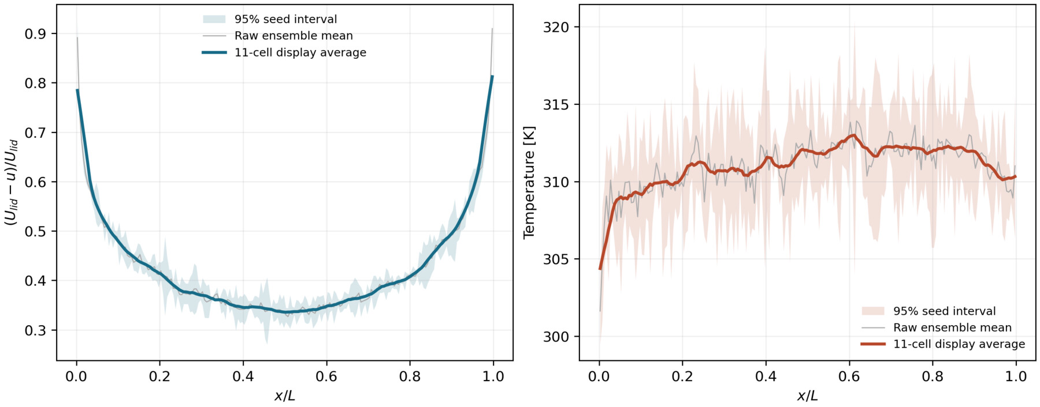
Figure 1. Three-seed lid profiles. Thin gray: raw ensemble mean; shaded region: 95% seed interval; heavy curve: labelled 11-cell display average.
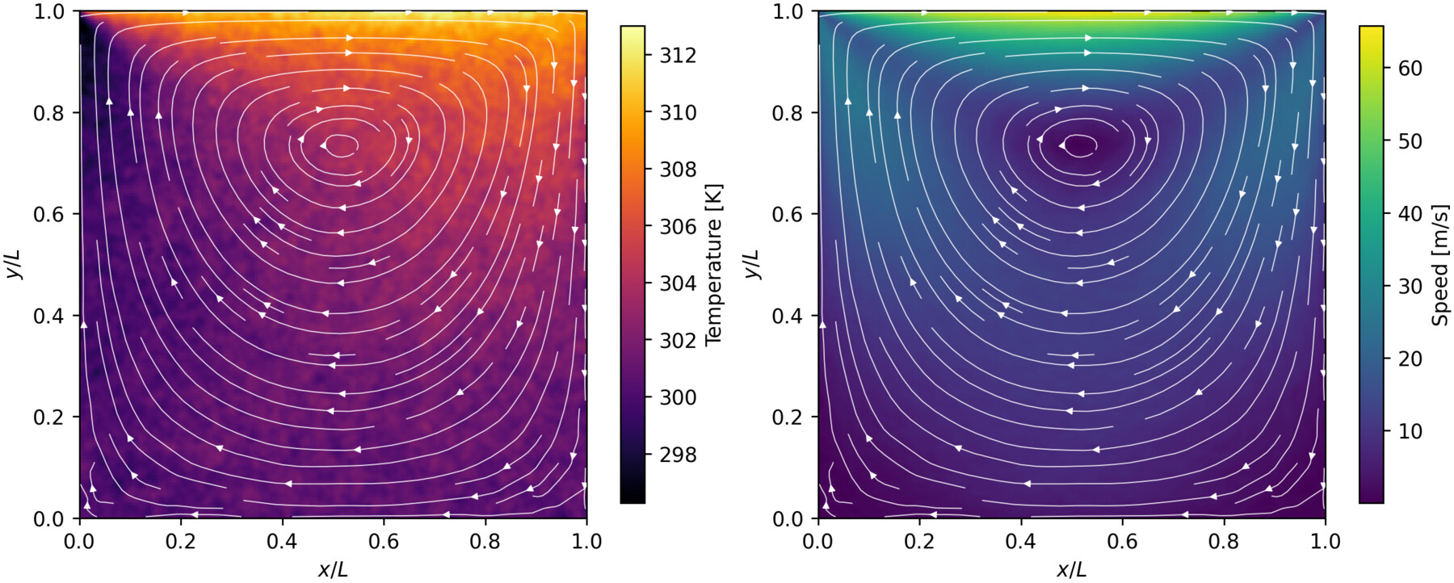
Figure 2. Ensemble-mean temperature (left) and speed (right), both with continuous streamlines. A sigma-one-cell filter is used only for display.
The translating lid creates one dominant clockwise recirculating vortex. The maximum cell-centered speed is below the imposed lid speed because the sampled gas lies inside the cavity. Despite isothermal walls, the gas temperature is nonuniform: shear work, molecular energy transport, local expansion, and nonequilibrium effects redistribute translational energy.
The variation in measured wall-clock performance among seeds reflects different allocated nodes and runtime conditions. The collision counts and macroscopic patterns are reproducible, so timing variability should be interpreted as a computing-performance observation rather than a change in the physical case.

8. Reading the output files
File | Use
case_metadata.json | Complete dimensional and numerical setup
log.cavity | Particle count, collisions, loop time, and performance
grid.final.00026000 | Time-averaged cell fields at the end of sampling
lid_profile_raw.csv | Unsmoothed top-cell-center profile
lid_profile_11cell.csv | Labelled display average
run_summary.json | Seed-specific solver and field statistics
ensemble_lid_profile.csv | Three-seed mean and 95% interval

9. Suggested classroom exercise
- Run the unit tests and smoke case, then identify which errors each stage can catch.
- Inspect argon.vss and explain why alpha = 1.0 makes the collision law VHS.
- Compare metadata from the smoke, tutorial, and production presets.
- Read log.cavity and locate particle count, attempted collisions, completed collisions, loop time, and MPI performance.
- Plot the raw lid profile before adding the labelled display curve.
- Repeat with a new random seed and quantify stochastic variability with the ensemble script.

10. Reproducibility link
The complete input generator, molecular data, local and Unity runners, tests, post-processing scripts, compact results, and this report are maintained together at:
https://github.com/Ehsan-Roohi/DSMC_Python/tree/agent/sparta-lid-driven-cavity-tutorial/sparta_lid_driven_cavity_tutorial

