- A particle moving with constant speed creates two spherical disturbances as shown in the figure If the radius of the first sphere is 8 meters and the radius of the second sphere is 3 meters, find the Mach number of the particle.
Hint: Use the similarity of triangles.
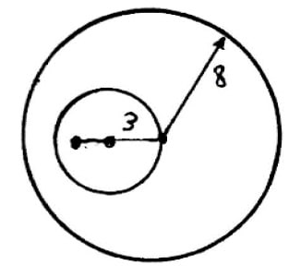
- The dimensionless Knudsen number (Kn = A/L) is a parameter that determines the fluid flow regime. If this number is less than 0.001, the flow is in the continuum regime; between 0.001 and 0.1, the flow is in the slip flow regime; between 0.1 and 10, it is the transitional flow regime and if it is greater than 10, the flow exhibits free molecular behavior. It can be said that:
$$kn=\sqrt{\frac{γπ}{2}}\frac{M_{∞}}{Re}$$
For a rocket with a length of 10 meters flying at a speed of 1000 m/s within an altitude range of 30,000 to 80,000 meters, the air properties are given in Table (where R=287 J/kg.K and γ=1.4). Determine the flight regime of the rocket.

Altitude (m) | Pressure (Pa) | Temperature(K) | Dynamic viscosity (N.s/m²)
30000 | 1171.87 | 226.51 | 1.475×10⁻⁵
80000 | 1.10 | 198.64 | 1.321×10⁻⁵

- The equation of state for a gas under conditions of low temperature and high pressure is given by the Van der Waals equation:
$$(p+\frac{a}{υ^{2}})\left(ν-b\right)=RT$$
In this equation, $ν$ is the specific volume. For nitrogen gas, the coefficients a and b are constants, with values a=0.1790 N.m⁴/kg² and b=0.001397 m³/kg.(a) Calculate the speed of sound in nitrogen at a temperature of -40 $C$ and a pressure of 1.8 MPa using the Van der Waals equation, and compare it to the result obtained from the ideal gas equation.
(b) The specific internal energy is given by the relation e=cT−a/$ν$. What is the value of C_{p}−C_{v}?

