Aerodynamics HW#1
Due: 09/06/2024
1- The flow passes over an airfoil with a speed of $U_{∞}$. The dashed line indicates the control volume around the airfoil. The upper and lower boundaries align with the streamlines, while the other two boundaries are positioned vertically. The velocity at boundaries 1 and 3 is only in the x-direction. The pressure and density at all boundaries of the control volume are constant and equal to $P_{∞}$ and $ρ_{∞}$, respectively. The velocity at inlet 1 is uniform and equal to $U_{∞}$, and the velocity profile on boundary 3 is shown in the figure below. $U_{e}$ represents the maximum velocity. The ratio of $h/g$is equal to 2.292.
- Find the maximum speed, $U_{e}$, at the exit surface as a function of $U_{∞}$.
- Calculate the drag force D as a function of $ρ_{∞}$, $U_{∞}$, and $g$
- Calculate the lift force L.

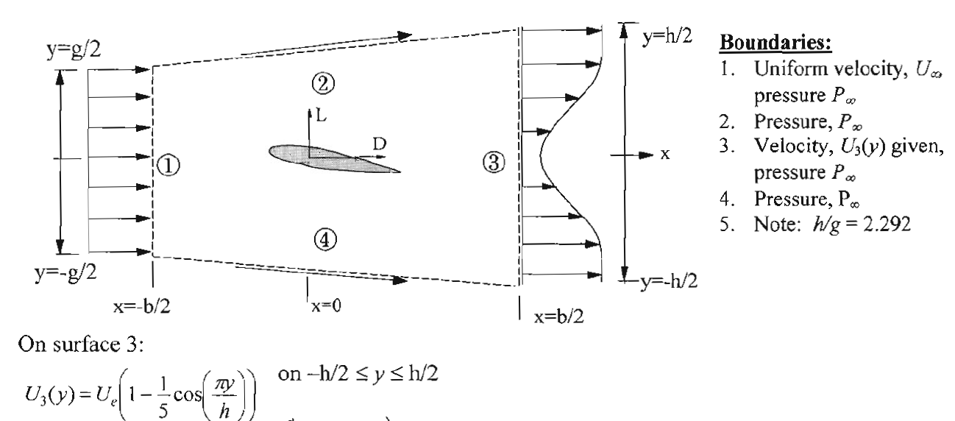

2- The velocity profile of the flow going over the surface of an airfoil in region 3 is measured as follows: ($Δ=0.04m$).
$$u_{x}=U_{∞}{\left(\frac{y}{Δ}\right)}^{\frac{1}{7}} for y<Δ$$
$$u_{x}=U_{∞} for y>Δ$$

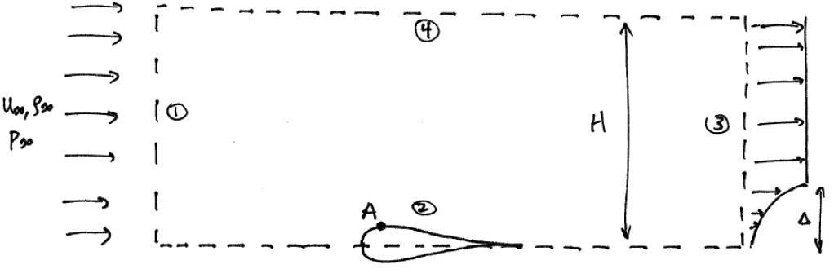

- Calculate the mass flow rate passing through surface 4 using the continuity equation.
- Calculate the drag force on the airfoil using the momentum and continuity equations. (Note that surface 2 (the lower boundary of the control volume) is a line of symmetry)

