AE 319 Aerodynamics Fall 2024
Homework 10

1-The distribution of the pressure coefficient at M=0.3 at zero angle of attack over NACA 0012 is shown in figure below. Find the critical Mach number. Use Laiton relation. Write a MATLAB code to solve this problem, i..e, use fsolve function, you can use AI.

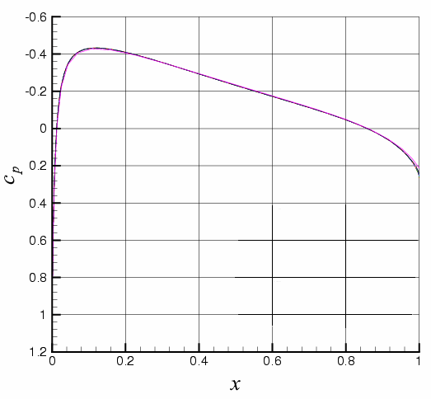

$$C_{p_{cr}}=\frac{2}{γM_{cr}^{2}}\left[{\left(\frac{1+\frac{γ-1}{2}M_{cr}^{2}}{1+\frac{γ-1}{2}}\right)}^{\frac{γ}{γ-1}}-1\right]$$
$$C_{p}=\frac{C_{p_{0}}}{\sqrt{1-M_{∞}^{2}}+\frac{M_{∞}^{2}}{\sqrt{1-M_{∞}^{2}}}\frac{C_{p_{0}}}{2}\left(1+\frac{γ-1}{2}M_{∞}^{2}\right)}$$

2- The following symmetrical airfoil is at M=1.8, P=58.6 KPa and angle of attack of 3 degree. Use the shock/expansion method and linearized theory to find C_{l} and C_{d}.

3- Consider a half-diamond airfoil with a freestream Mach number of M = 3.7, a wedge angle of ε = 3.0, and an angle of attack of a = 4.0. Compute the pressure ratio for each surface, the lift coefficient, and the drag coefficient use the shock/expansion method and linearized theory.

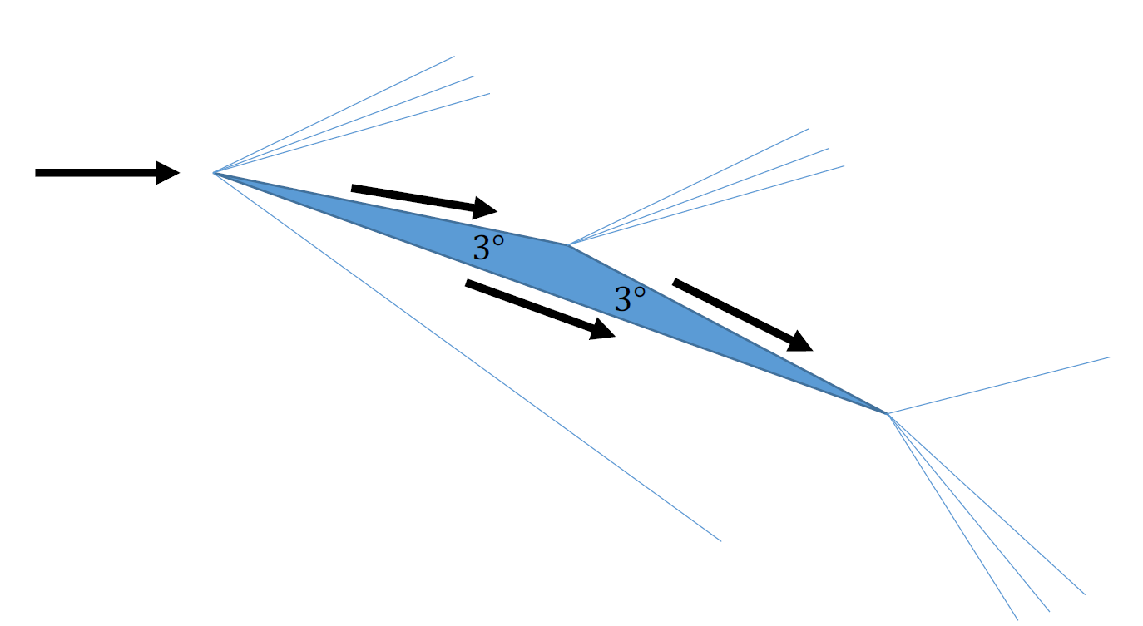
4- Consider the trapezoidal airfoil shown in the diagram above. The maximum thickness is 𝑡, the length from tip to tip is 𝑐, and angles at the leading and trailing edges are both 𝜖. Regions of uniform flow over the airfoil are numbered 1 through 5. The angle of attack 𝛼 is measured relative to the flat, bottom side of the airfoil.
(a) Classify the waves at the boundaries of each region (Wave 1-2, Wave 2-3, Wave 3-4, and Wave 1-5) as an expansion or a shock according to the angle of attack 𝛼. Make a table like this, replacing the “?” marks with the appropriate angle:
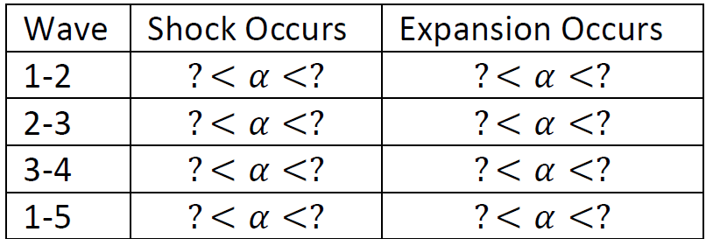
“Never” and “always” are acceptable entries in the table.
(b) Using shock-expansion theory, compute the lift and drag coefficients for 𝑀 = 3.0, 𝛼 = 3.5∘, 𝜖 = 2∘, and 𝑡/𝑐 = 0.03.
