- The pressure coefficient distribution on a cylinder is shown from three different distributions in the figure below.
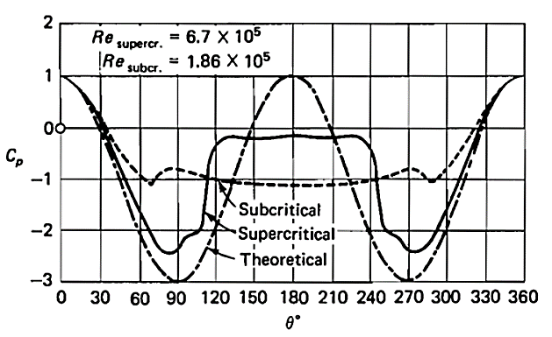

a) Determine the potential, laminar, and turbulent flows on the graphs shown in the figure.
b) Explain the reason for constant pressure regions in the two distributions shown. Why is the location of the constant pressure region different in these two distributions?
c) At a 30-degree angle, calculate the pressure coefficient of the potential flow using its relation and explain what does this value implies.
d) Before the separation point, the potential, laminar, and turbulent solutions do not necessarily coincide. Explain the reason for this phenomenon.
e) Based on the figure, compare the pressure in the laminar and turbulent separation regions (Hint: Consider the diameter of the cylinder, viscosity, pressure, and air density to be the same in both regimes, and use the given Reynolds number to calculate the velocity).
2- A two-dimensional incompressible flow is described by the stream function $ψ=x^{2}-y^{2}$. Find the value of $\frac{∇P}{ρ}$at the point (1,2).

- Consider the following velocity distribution:
$$\vec{v}=\left(x^{2}+y^{2}\right) \hat{x}+2xy^{2} \hat{y}$$
- Is the flow rotational or irrotational?
- Using the line integral, calculate the circulation around the following triangle in a counterclockwise direction.

(2,0)
(0,0)
(2,2)

- Calculate the circulation for the three-dimensional velocity field $V=\left(16x^{2}+y\right)i+10j+yz^{2}k$ over a rectangle with corners at (0,0), (10,0), (10,5), and (0,5).

- Consider the semi-cylinder shown below. The pressure on the left side is obtained from the potential theory solution for a non-spinning cylinder, and the pressure on the right side is assumed to be the pressure at the corner, i.e., p at 90 degrees. Computer the drag and lift coefficient of this geometry.

