AE 319 Aerodynamics Fall 2024

Homework 8

1. (3 points) Consider the flow over a cone of 20º half cone angle, at 0º angle of attack.
a. For a free stream Mach number of M∞ = 3 (assume standard see level conditions), evaluate the shock wave angle, p, T, ρ, and M immediately behind the shock wave and on the cone surface.
b. Evaluate the minimum free stream Mach number for the flow to remain attached.
c. Evaluate the drag coefficient for the Mach number range of 1.5 < M∞ < 5.5. The drag coefficient is defined as C_{D}=D/q∞A_{b}, where A_{b} is the area of the base of the cone. Assume p_{b} is equal to the free stream pressure.

2. The two figures below show the intakes of a supersonic airplane. The pressure and temperature of the ambient flows are 243 psia and 392 degrees R. M₀=2.5
a- Find T, P, M and change in entropy just after the normal shock in the first figure.
b- If the wedge with 15 degree is replaced with two wedges with 7 and 8 degrees, as figure below, find T, P, M and change in entropy in region 4.

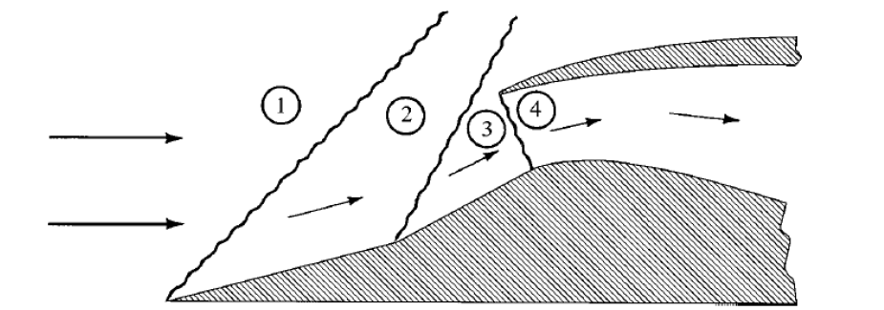

c- Report drop in P₀ for both cases a and b and make a conclusion.

3. Flow with M=3.3 approaches the below configuration. Find: T₃/T₁, p₃/p₁, M₃ and β.

4. Two oblique shocks with θ=30 interact with each other’s. Find:
a- P, T and M in region 2.
b- P, T and M in region 3.
c- Angle of the reflected shocks.
Hint: The reflected shocks make the flow again horizontal.

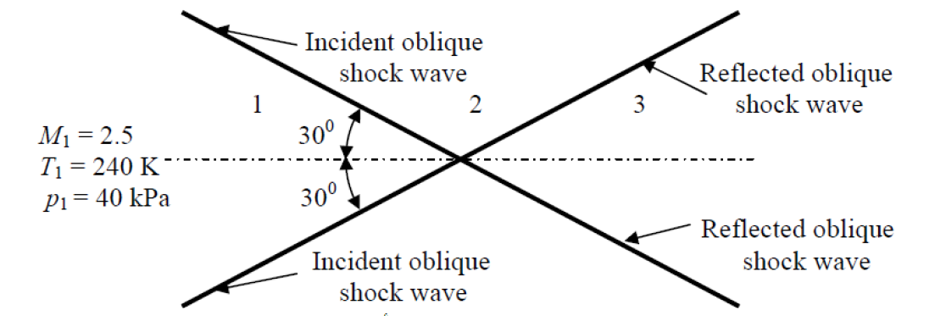

5- For the below geometry, find C_{p} and C_{d}.

