lift acting on an incremental spanwise element of the wing:
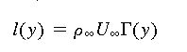
Total lift
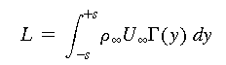
The total vortex drag
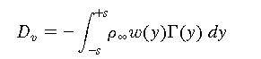
Induced velocity at any point y₁
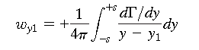
Downwash angle
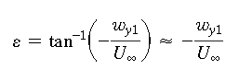
Effective angle of attack of the airfoil
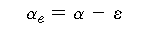
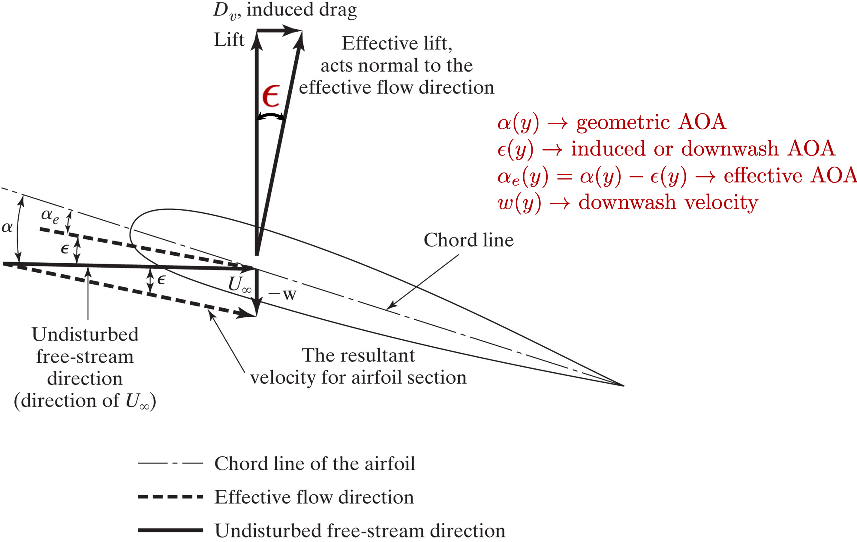

Case of Elliptic Spanwise Circulation Distribution

Elliptic circulation distribution
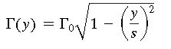
Induced downwash velocity

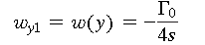
Total lift for the wing
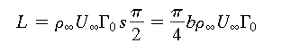
Lift coefficient
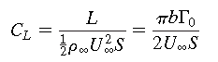
Downwash angle
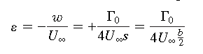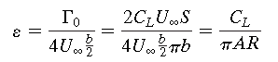
Total vortex (or induced) drag for the wing.
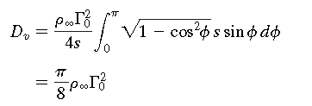

Drag coefficient
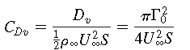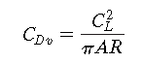

Geometric angle of attack for an elliptic lift distribution
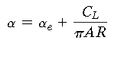
Lift-curve slope
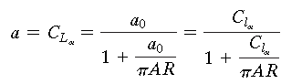
a₀: Airfoil lift slope
General Spanwise Circulation Distribution
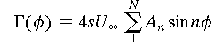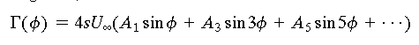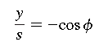

The section lift force
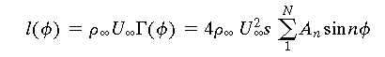

Section lift coefficient
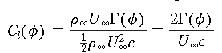
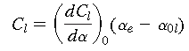

Downwash angle

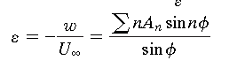
General Prandtl Equation

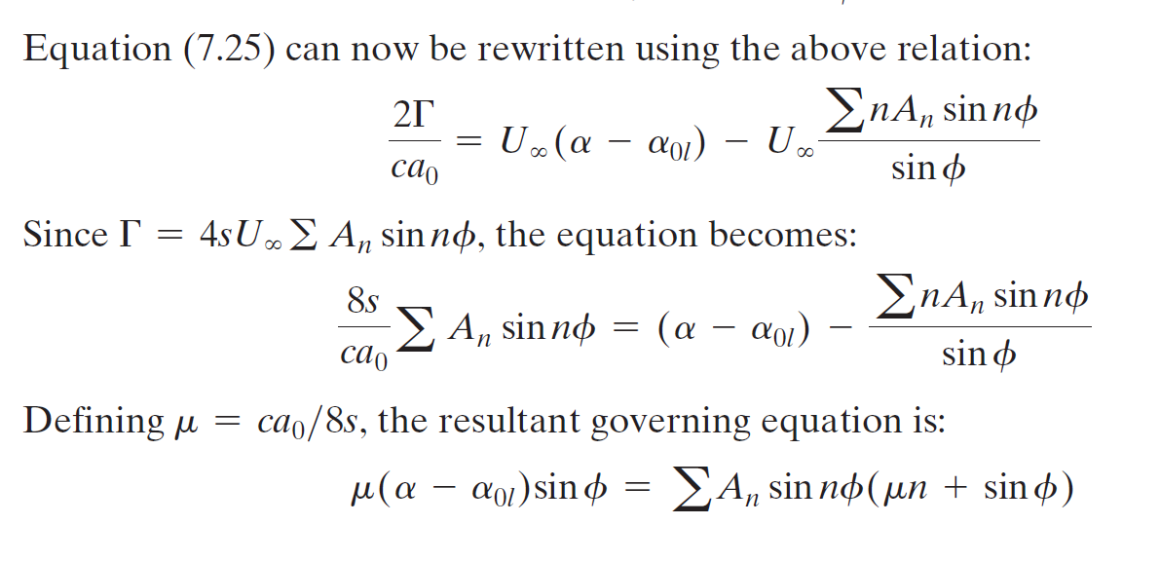
Solve this equation for n-sections of the wing to get A₁, …, A_{n}

Lift on the Wing
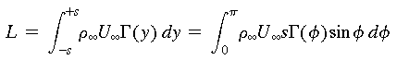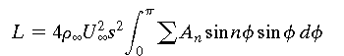
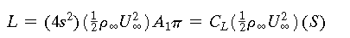

Wing lift coefficient
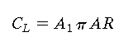

Vortex-Induced Drag
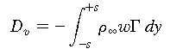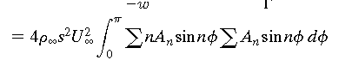

Coefficient for the vortex-induced drag
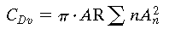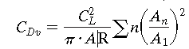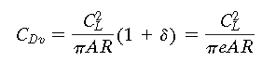

Span efficiency factor
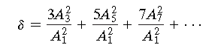
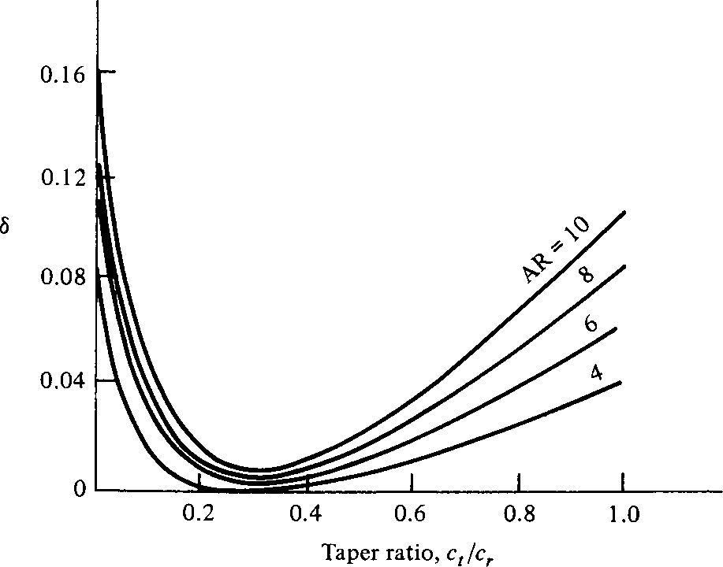

You can read δ from this chart.
Lift curve slop for a general wing usually assumes δ=τ
