MIE 402 Lab 2
Single Pendulum | Fall 2026 | Prof. Ehsan Roohi
Your group will record a single pendulum with a high-speed camera, use Pendulum Motion Analyzer to track the bob, convert tracked position to angle, and compare the measured response with a theoretical model. The three trials test the limit of the small-angle approximation.

Learning objectives
- Identify the physical meaning of pivot, bob, length, angle, and angular velocity.
- Use high-speed video and image tracking for dynamic measurement.
- Convert bob coordinates into angular displacement about a fixed pivot.
- Compare measured period and frequency with theory.
- Explain why finite initial angle changes pendulum period.

Equipment and required trials
- Single-pendulum assembly, black background, protractor, calibration marks, and scale or balance.
- High-speed camera, tripod, lens, ring light, power supply, and SD card.
- Computer with MATLAB and Pendulum Motion Analyzer.
- Trial A: less than 10 degrees; Trial B: 10 to 90 degrees; Trial C: 90 to 180 degrees.
- Every trial begins from rest. Record initial angle, pivot-to-bob distance l, bob mass M, bar mass m, frame rate, calibration distance, and file name.
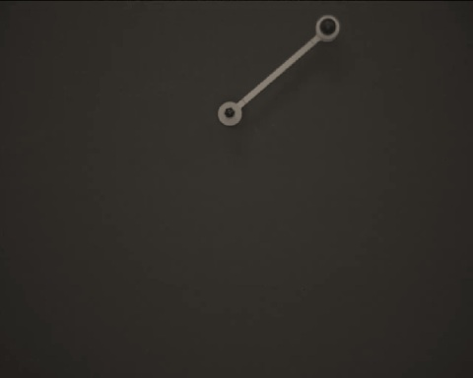
Figure 1. Single-pendulum apparatus. Track the center of the bob and use the pivot rotation center as reference.

Model of the actual apparatus
The common point-mass formula assumes a massless bar. The laboratory bar has measurable mass, so use a compound-pendulum model. Let M be the bob and attached hardware mass, m the uniform bar mass, and l the distance from pivot to bob center. The bar center of mass lies at l/2 and its pivot inertia is ml^2/3.
For small angles, use radians and replace sin(theta) with theta:
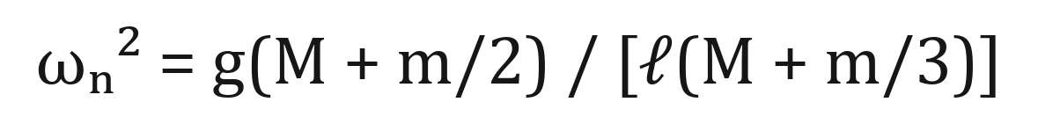
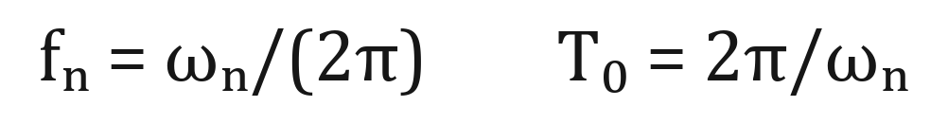
The ideal point-mass result follows only when bar mass is negligible. Use the compound model for the theoretical frequency of the real apparatus. For large initial angles, solve the nonlinear equation numerically because sin(theta) cannot be replaced by theta.

Camera setup and safety
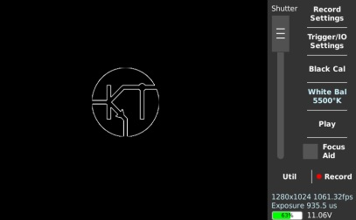
Figure 2. Camera main screen. Record, playback, shutter, and Record Settings are available here.
- Mount camera and lens securely; mount ring light as shown by the GTA.
- Set pendulum against black background. Confirm pivot and bob have high contrast.
- Insert SD card gently, connect power, and confirm tripod stability.
- Frame the full motion and perform a low-amplitude test swing.
- Adjust focus and brightness until the bob edge is sharp without reflection at its center.
Walk carefully around camera, tripod, and cables. Do not move the tripod while recording.

Camera settings before each trial
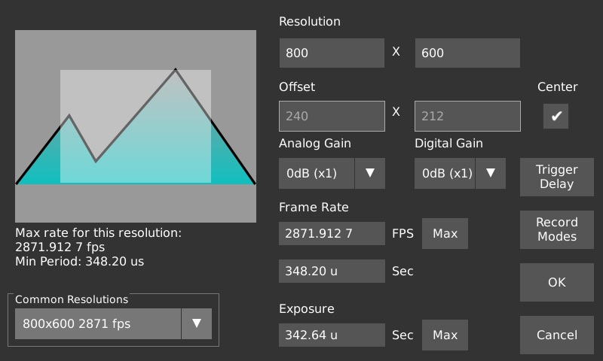
Figure 3. Record Settings. Use the GTA-assigned resolution and frame rate. The normal target is 1280 x 1024 at 1000 frames/s when available.
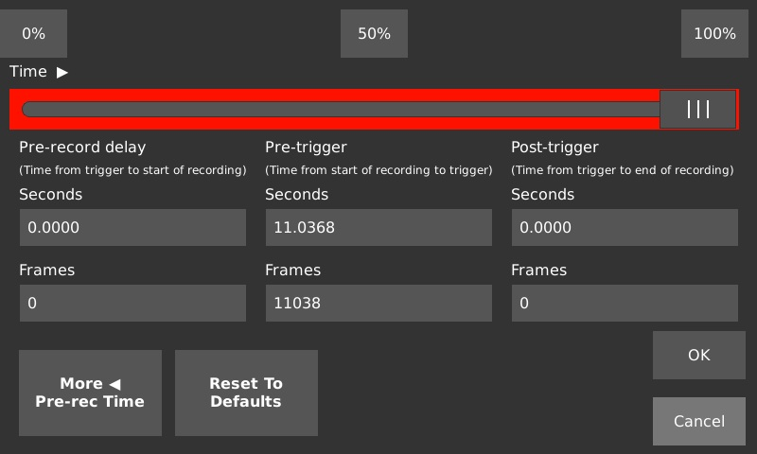
Figure 4. Trigger delay. Choose the GTA-specified setting so release and several full cycles appear in the saved video.
- Record actual resolution and frame rate in notes.
- Use trigger delay that captures release and several cycles.
- Use test video to check focus, contrast, and full motion range.
- Name every record with angle and trial, for example single_35deg_trial01.

Record and save
- Press Record.
- Hold pendulum at measured initial angle, keep it stationary, and release without pushing.
- After about 15 seconds, press Stop.
- Use Playback to confirm release and early cycles are visible.
- Mark useful segment. Select H.264, turn Text Overlay off, save to SD card, and wait for completion.
- Safely remove SD card and copy videos to group storage.
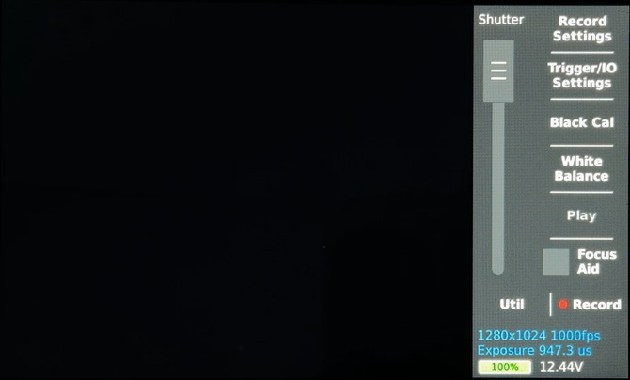
Figure 5. Save settings. Confirm filename, H.264 format, Text Overlay off, and SD-card location.

Track in Pendulum Motion Analyzer
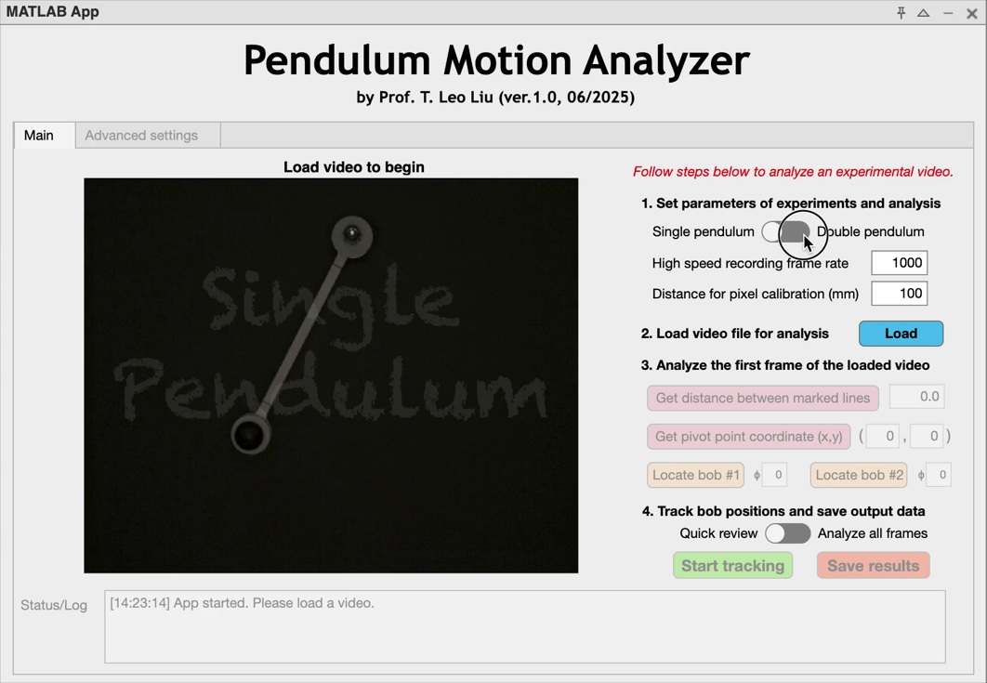
Figure 6. Select Single pendulum and enter the actual camera frame rate.
- Enter camera frame rate and 100 mm calibration distance between black arm marks unless the GTA says otherwise.
- Load video, draw calibration line in first usable frame, then locate pivot and bob center.
- Run Quick Review. If the marker misses more than about 10 percent of frames, improve focus or repeat point selection.
- Run Analyze All Frames after review succeeds. Save Results as MAT file.
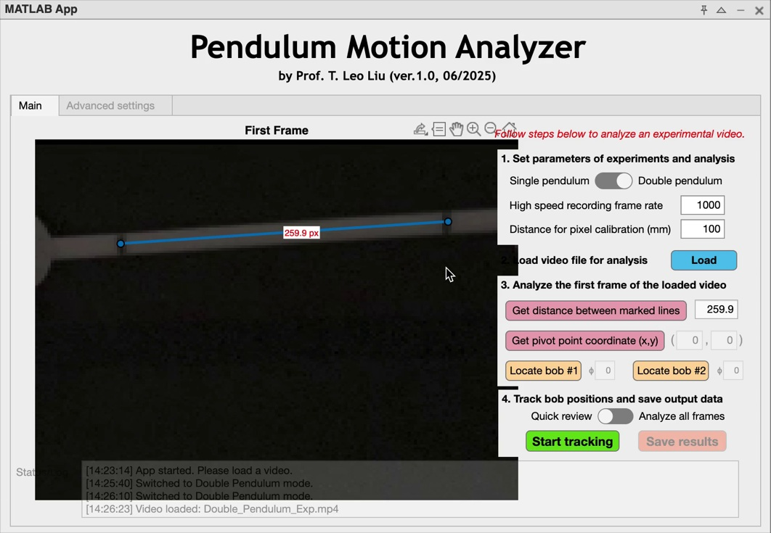
Figure 7. The known distance between black marks converts pixels to millimeters.
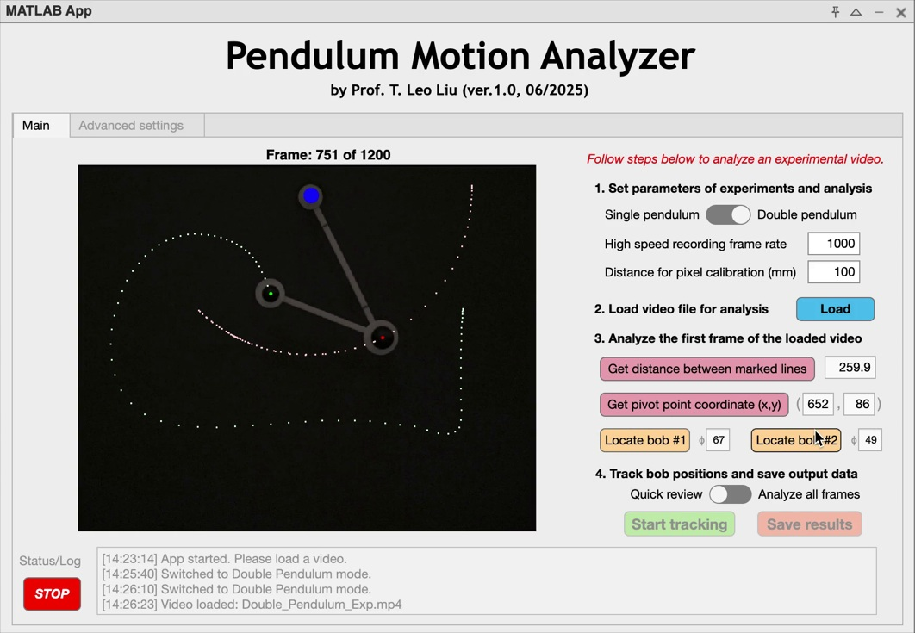
Figure 8. The overlay marker should follow the bob center through the usable record.

MAT output and analysis
The app saves ExpData. Column 1 is time in seconds, columns 2 and 3 are bob 1 x and y in millimeters, and columns 4 and 5 are bob 2 x and y when a second bob is used. Lab 2 uses columns 1 to 3. Record the pivot coordinates selected in the app. In standard image coordinates, y increases downward, so calculate angle as follows:
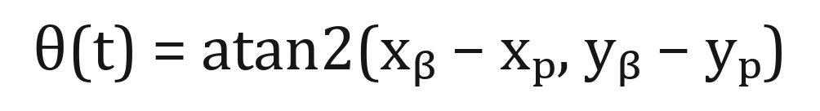
This definition gives theta = 0 when the bob hangs below the pivot. Verify the sign with a known frame before processing all trials. Use radians in equations and label degree plots clearly.
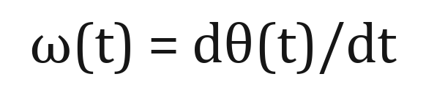
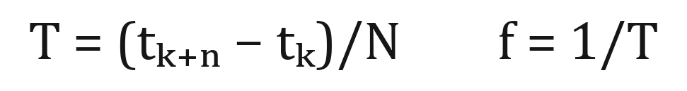
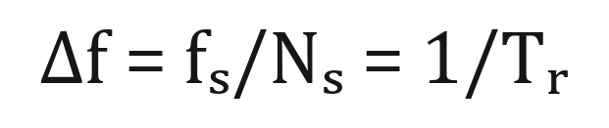
- For each trial plot theta(t) and angular velocity. State the numerical derivative and any smoothing method. Do not smooth until tracking errors have been checked.
- Estimate period from several same-direction peaks in theta(t), not from one cycle. Report the interval and number of cycles used.
- Plot spectra for theta and angular velocity after removing the mean. Report dominant frequency, record duration, and FFT-bin spacing Delta f = 1/T_record.
- Calculate the compound-pendulum small-angle frequency. Compare the low-angle trial with this value and compare all three trials with the nonlinear numerical model from Pre-Lab 2.
- Create a table of l, M, m, initial angle, compound-model frequency, time-domain frequency, spectral frequency, and percent difference.
- Discuss model assumptions separately from measurement errors: finite angle and damping affect the physics; calibration, tracking, timing, and release error affect the measurement.

Required evidence for the combined Labs 2 and 3 report
- A labeled apparatus schematic defining pivot, l, M, m, theta, and the positive direction.
- A measurement table with units, camera settings, calibration distance, and every source file name.
- For each Lab 2 angle: theta(t), angular velocity, and spectra with readable axes and captions.
- A comparison table containing analytical small-angle, nonlinear simulation, time-domain, and FFT estimates.
- A discussion that explains why period grows with initial angle and why the bar mass changes the small-angle prediction.

Before leaving
- One saved video and verified MAT file exist for each angle range.
- Notes include frame rate, calibration distance, length, masses, initial angle, and file names.
- Group checks one theta(t) plot and one spectrum with GTA.
- Back up raw videos, MAT files, notes, and exported figures.

