Visualization

# [link to original page](https://fivethirtyeight.com/features/which-state-has-the-worst-drivers/?fbclid=IwAR2_xY0IwlqkFRTP3tKVHXz9PqclX4P_usqhtbcAq2MBerxOBhdDVq9nVDA)

# From first four graphs, I recreated one.  
   
# My code:  
setwd("~/Study /MADA_2021/Ehsan_Suez-MADA-portfolio")  
library(tidyverse)  
library(ggplot2)  
library(knitr)  
library(readr)

hw5<-read_csv("hw5.csv")

## Rows: 51 Columns: 8

## ── Column specification ────────────────────────────────────────────────────────  
## Delimiter: ","  
## chr (1): State  
## dbl (7): Number of drivers involved in fatal collisiion per billion miles, P...

##   
## ℹ Use `spec()` to retrieve the full column specification for this data.  
## ℹ Specify the column types or set `show_col_types = FALSE` to quiet this message.

colnames(hw5)

## [1] "State"   
## [2] "Number of drivers involved in fatal collisiion per billion miles"   
## [3] "Percentage of drivers involved in fatal collosion who were speeding"   
## [4] "Percentage of drivers involved in fatal collosion who were alchohol-impaired"   
## [5] "Percentage of drivers involved in fatal collosion who were not-distracted"   
## [6] "Percentage of drivers involved in fatal collosion who had not been involved in any previous accident"  
## [7] "Car insurance premium ($)"   
## [8] "Losses incurred by insurance companies for collisions per insured driver ($)"

hw5.1 <- hw5 %>% pivot_longer(names_to = "Categories", values_to = "Percentage", cols = c("Percentage of drivers involved in fatal collosion who were speeding", "Percentage of drivers involved in fatal collosion who were alchohol-impaired", "Percentage of drivers involved in fatal collosion who were not-distracted", "Percentage of drivers involved in fatal collosion who had not been involved in any previous accident"))  
  
hw5.2 <- hw5.1 %>%   
 mutate(Number.collisiion.Each.Category = `Number of drivers involved in fatal collisiion per billion miles` * Percentage * 0.01)  
  
hw5.3 <- hw5.2 %>% pivot_longer(names_to = "Category.Number", values_to = "Number.Collisiion", cols = c("Number of drivers involved in fatal collisiion per billion miles", "Number.collisiion.Each.Category"))  
  
# subset different percentage category for different cause of fatal accident  
  
  
# use speeding to recreate the third graph  
  
hw5.3.speed <- hw5.3 %>% subset(Categories == "Percentage of drivers involved in fatal collosion who were speeding")  
  
ggplot(hw5.3.speed, aes( x=State, y= Number.Collisiion,alpha=Category.Number))+  
 labs(title="Driver Who involved in fatal collisions while speeding")+  
 geom_bar(stat= 'identity',position = "stack", fill="maroon" ) +  
 theme(axis.text.x = element_text(angle=90), legend.position = "none")+  
 coord_flip()

## Warning: Using alpha for a discrete variable is not advised.

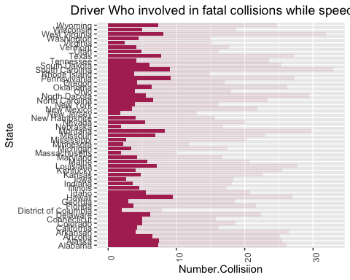

# Now recreating the last two graphs:

hw5<-read_csv("hw5.csv")

## Rows: 51 Columns: 8

## ── Column specification ────────────────────────────────────────────────────────  
## Delimiter: ","  
## chr (1): State  
## dbl (7): Number of drivers involved in fatal collisiion per billion miles, P...

##   
## ℹ Use `spec()` to retrieve the full column specification for this data.  
## ℹ Specify the column types or set `show_col_types = FALSE` to quiet this message.

hw5$Insurance<-round(hw5$`Car insurance premium ($)`,0)  
hw5 <- select(hw5, State, Insurance)  
  
 ggplot(hw5,aes(y=State, x= Insurance))+  
 labs(title="Average Combined Insurance Premium")+   
 labs(subtitle = '2011')+  
 geom_bar(stat= 'identity', fill="purple", width = 0.8)+  
 scale_y_discrete(limits=rev)+  
 geom_text(aes(label=Insurance), size=3,color = 'white', hjust = 1.5, fontface = 'bold')+  
 theme(axis.title.x=element_blank(), axis.title.y=element_blank(),  
 axis.ticks.x=element_blank(), axis.ticks.y=element_blank(),  
 axis.text.x=element_blank(), plot.title = element_text(face = 'bold', hjust = -0.36),   
 plot.subtitle = element_text(hjust = -.18))

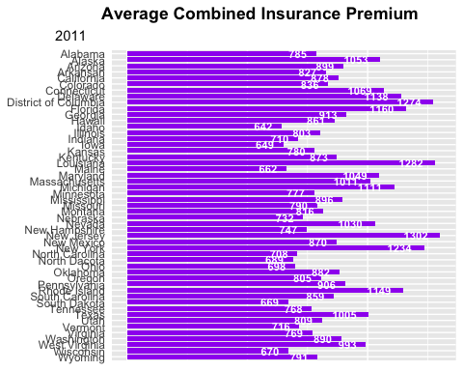

hw5<-read_csv("hw5.csv")

## Rows: 51 Columns: 8

## ── Column specification ────────────────────────────────────────────────────────  
## Delimiter: ","  
## chr (1): State  
## dbl (7): Number of drivers involved in fatal collisiion per billion miles, P...

##   
## ℹ Use `spec()` to retrieve the full column specification for this data.  
## ℹ Specify the column types or set `show_col_types = FALSE` to quiet this message.

hw5$Loss<-hw5$`Losses incurred by insurance companies for collisions per insured driver ($)`  
hw5 <- select(hw5, State, Loss)  
ggplot(hw5,aes(y=State, x= Loss))+  
 labs(title="Losses Incurred by Insurance Companies")+   
 labs(subtitle = 'Collisions per insured drivers, 2010')+  
 geom_bar(stat= 'identity', fill="pink", width = 0.8)+  
 scale_y_discrete(limits=rev)+  
 geom_text(aes(label=Loss), size=3,color = 'white', hjust = 1.5, fontface = 'bold')+  
 theme(axis.title.x=element_blank(), axis.title.y=element_blank(),  
 axis.ticks.x=element_blank(), axis.ticks.y=element_blank(),  
 axis.text.x=element_blank(), plot.title = element_text(face = 'bold', hjust = 1.2),   
 plot.subtitle = element_text(hjust = -4.6))

