Flea-Scope Parts, Assembly, and Test

Contents

Parts 2

Circuit Board 2

Assembly 2

Programming 2

Testing and Calibrating 7

Troubleshooting 12

Packaging 12

Test Checklist 13

# Parts

**U1** PIC32MK0512GPK064-I/MR has allowed substitutions (check availability and price for cheapest at [Microchip Direct](https://www.microchipdirect.com/product/PIC32MK0512GPK064-I/MR?productLoaded=true)):

* [PIC32MK0512GPK064-I/MR](https://www.microchipdirect.com/product/PIC32MK0512GPK064-I/MR?productLoaded=true) is first choice and usually cheapest at $7.20 in quantities of 1000’s
* [PIC32MK1024GPK064-I/MR](https://www.microchipdirect.com/product/PIC32MK1024GPK064-I/MR?productLoaded=true) is second choice at $7.40
* [PIC32MK0512MCM064-I/MR](https://www.microchipdirect.com/product/PIC32MK0512MCM064-I/MR?productLoaded=true) at $7.51
* [PIC32MK1024MCM064-I/MR](https://www.microchipdirect.com/product/PIC32MK1024MCM064-I/MR?productLoaded=true) at $7.70
* “-E/MR” suffix (extended temperature) adds $0.33 approximately and is also allowed
* (“/PT” suffix is for QFP instead of QFN and is **not** allowed!)

Do not substitute for Texas Instruments op amp **U3** OPA863SIDBVR.

Do not substitute for Wurth Elektronik LEDs **E1**, **E2**, and **E3**, even if other parts have identical forward voltage -- brightness has been calibrated to make all three LEDs equal; LEDs are non-linear, and it is actually possible to get a LED with a similar or even lower forward voltage that is less bright at the current I am driving it at (significantly below 20mA).

Resistors **R8**, **R9**, **R10**, and **R11** must be 1% tolerance, as in BoM.

Capacitors **C9** and **C10** must be 1% tolerance, as in BoM.

# Circuit Board

The latest circuit board layout has been optimized for ENIG surface finish. The pin strip through holes (not populated during assembly) are staggered slightly to grab the pin strips, to allow end users to conveniently insert pin strips without necessarily even needing to solder them. The staggering assumes the thinner ENIG surface finish. (So please do not use the thicker HASL surface finish, as the pin strip through holes will then be staggered too much.)

Panel boards as needed but please depanel prior to soldering the **single through-hole component** (the BNC connector) and programming and test.

# Assembly

See the assembly PDF and pickplace CSV files for SMT details.

Please also solder the **single through-hole component** (the BNC connector).

# Programming

After assembly and depaneling, the first step is to connect **both** the USB connector (for power) on the Flea-Scope board **and** the USB connector for the programmer (for programming) to the host computer (I use Windows 11 below). **Then** connect the programmer ICSP pins to the 6 board ICSP pins as shown below using a standard 0.1” (2.54 mm) header pin strip -- the holes in the flea-scope board are slightly “zigzag offset”, so they should hold the header pin strip snugly without need of bending or soldering.

Make sure pin #1 of the programmer is aligned with pin #1 (square pad) of the ICSP connector on the Flea-Scope board.

You can use any of these programmers:

* Snap (cheapest) -- <https://www.microchip.com/en-us/development-tool/PG164100>
* Pickit 3 -- available on ebay
* Pickit 4 -- <https://www.microchipdirect.com/dev-tools/PG164140?allDevTools=true>

I am using the “Snap” programmer in the pictures below, but the others are similar.

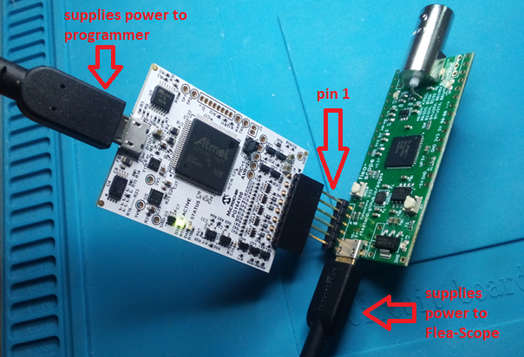

**0. Once USB is connected to the Flea-Scope, you can also verify the Flea-Scope board has power by measuring these pins (5V and -5V are unregulated, so they are approximate -- anything within 0.25V is good enough):**

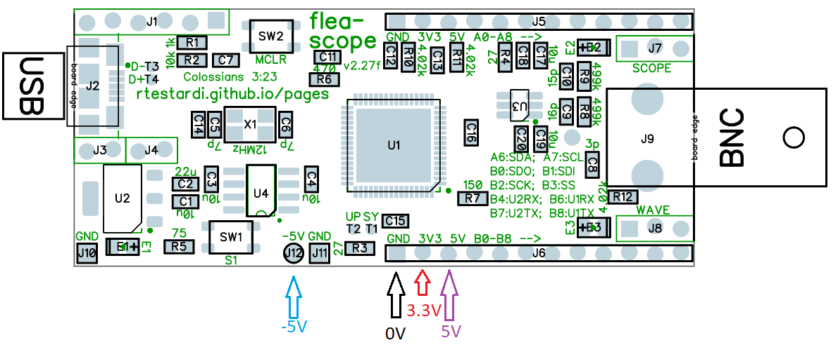

To program, I use MPLAB X v6.05 which is available here: [MPLAB® Ecosystem Downloads Archive | Microchip Technology](https://www.microchip.com/en-us/tools-resources/archives/mplab-ecosystem)

Search for “6.05” and download -- unfortunately the newest version of MPLAB X (v6.15) has bugs and hangs often.

The next step is to start MPLAB X v6.05 and import the firmware hex (prebuilt) file:

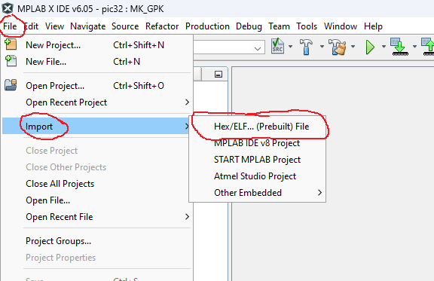

And then select your device and MCU and programmer as well:

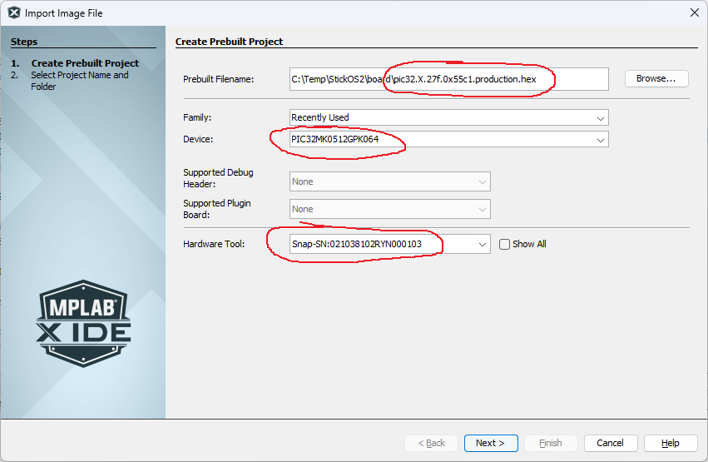

*Note that if you are substituting a different MCU than the PIC32MK0512GPK064, select your MCU above. Likewise if you are using a different programmer.*

And then click “Finish” to save the project:

At this point you can use the “Run Main Project” button as shown below to program the MCU (you will only have one project -- with “prebuilt” in the name -- I show two below):

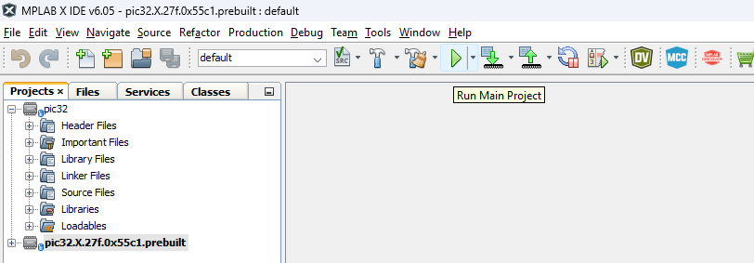

Program the MCU and you should see something like this at the bottom of the screen (without the warning that I have the wrong device ID -- I program various MCUs from the same project):

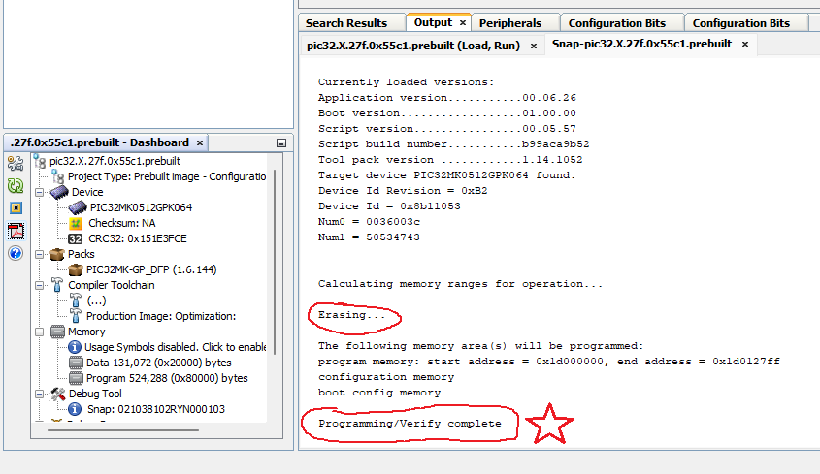

Programming the MCU successfully tests the USB power and main regulator, as well as portions of the MCU and portions of the reset circuitry.

**1. At this point, your Flea-Scope should have both green and red LEDs lit up, and the blue LED should be blinking steady at 1 Hz:**

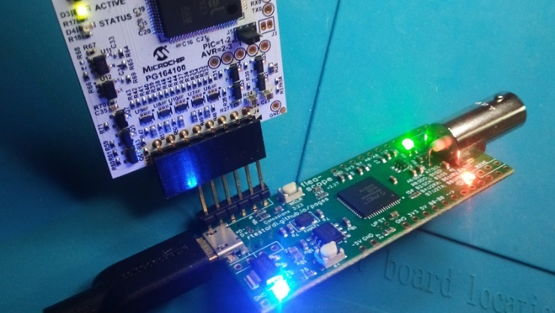

If the LEDs light up and flash, this tests large portions of the MCU, including flash self-programming (an error code flashed out the blue LED would be bad).

Finally, disconnect the programmer from the Flea-Scope (but leave its USB connector attached to the host computer).

# Testing and Calibrating

**2. Next, press the reset button (labeled MCLR) and make sure the LEDs go out while the button is held** -- this tests the rest of the reset circuitry, including the button.

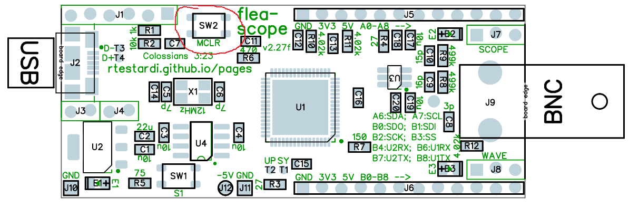

**3. Then release the reset button and the blue LED on the board should be blinking steady again at 1Hz, and red and green LEDs should be solid on.**

Once the Flea-Scope is programmed and basically alive, it is time to test it more thoroughly as well as calibrate it.

First connect a 1x oscilloscope probe to the BNC connector of the Flea-Scope -- be sure the oscilloscope probe range switch (if present) is in the “1x” position:

Then open the Flea-Scope User Interface web-page on the host computer:

<https://rtestardi.github.io/usbte/flea-scope.html>

And click the “Connect” button:

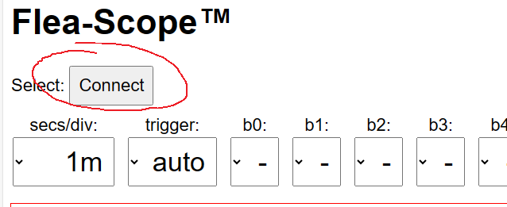

In the dialog box that pops up, select the Flea-Scope (you will likely have a different COM number than I show below) and then click “Connect” again:

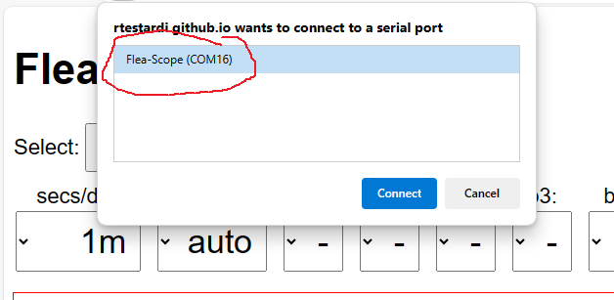

**4. At this point you should be live accessing the Flea-Scope from the Web-page User Interface, and you should see it updating periodically!**

5. Make sure the Flea-Scope firmware is the proper version “2.27g (checksum 0x7c8e)” at the bottom of the screen (note pictures below may show older versions):

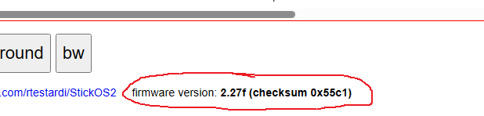

**6. The GUI should begin tracing, and all three LEDs should be blinking -- this tests USB data.**

The next step is to perform a probe calibration.

First we calibrate ground/zero by touching the oscilloscope probe tip to the ground/zero volt pin as shown below:

Then press the “cal_zero” button on the Flea-Scope User Interface:

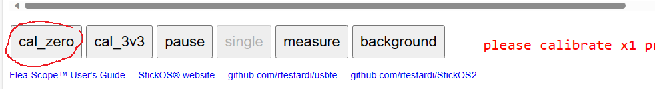

**7. The cal_zero_x1 value should be displayed within the range of 7 to 23.**

Then we calibrate 3.3 volts by touching the oscilloscope probe tip to the 3.3 volt pin as shown below:

Then press the “cal_3v3” button on the Flea-Scope User Interface:

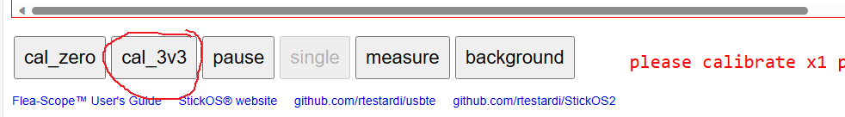

**8. The cal_3v3_x1 value should be displayed within the range of 245 to 275.**

The presence of proper calibration values tests the negative supply rail as well as the passive pullup/down circuitry, as well as the op amp. To force calibration even if the values are out of range, press the “measure” button first.

Finally, connect the oscilloscope probe to the wave output pin, and make sure you see a 1 kHz sine wave that approaches but does not actually touch the top and bottom of the display area:

**9. The waveform on the Flea-Scope User Interface should look like this -- be sure it is nearly full height full and unclipped:**

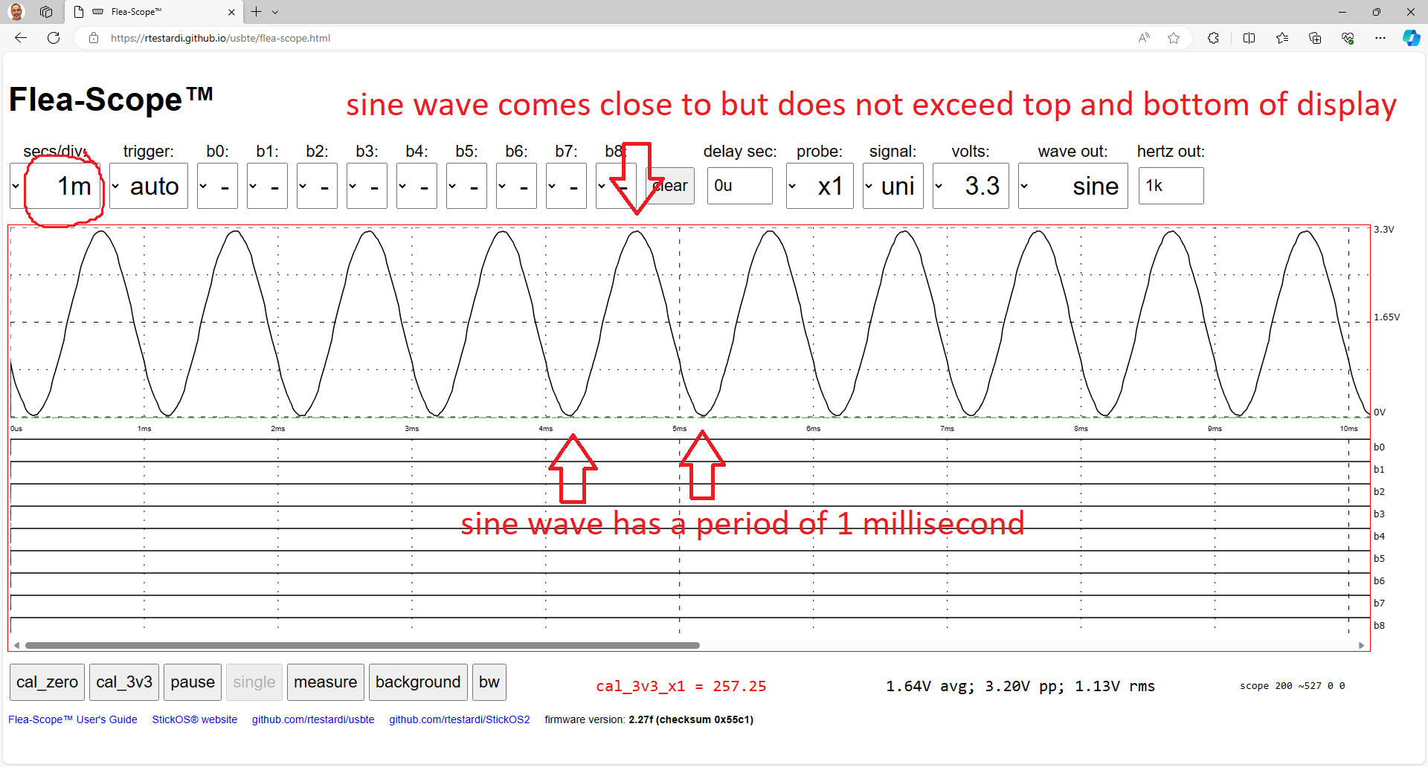

Note that if your oscilloscope probe range switch is incorrectly in the “10x” position, you will see a greatly attenuated waveform. If this happens, switch it to the “1x” position and perform all of the calibration steps again.

A proper waveform confirms the negative supply rail as well as the passive pullup/down circuitry, as well as the op amp as well as wave circuitry continuity.

For the final test, you need a small test harness that connects the “A” and “B” pins of the Flea-Scope together using spring/pogo pins like below (it is fine to also connect the first three power pins as well, like I did, but that is not needed):

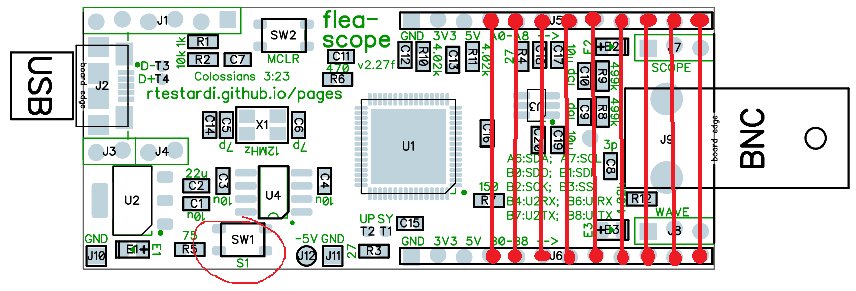

**10. Put the board on the test bed (which simply connects all "A" pins to the corresponding "B" pins, switch the GUI to 5 us/division, and press the "test" button (labeled S1) -- you should see all nine digital signal lines (b0 thru b8) pulse in sequence without any overlap (!) as below** -- this tests the remaining MCU pins for shorts/opens and the S1 button.

(Notice there is a bit of noise induced on the floating analog input during this test, especially by "b8", but this is not a problem as the scope is careful to keep these signals drivel low during actual operation, forming a quasi-ground plane on the back-side of the board.)

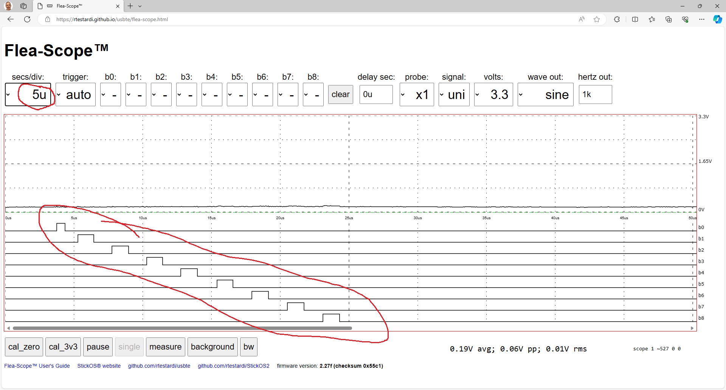

# Troubleshooting

If your Flea-Scope is not working, the first things to check are the power supplies and clocks. Instructions for checking the power supplies are above.

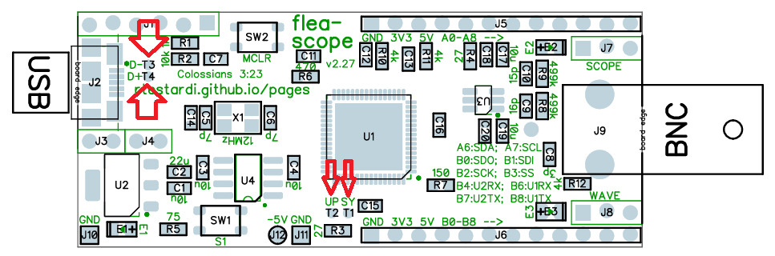

To check the clocks, attach a working oscilloscope probe to the “UP and “SY” test points below and check the frequency:

* SY testpoint (system clock divided by 1024) should be 117.2 kHz
* UP testpoint (USB PLL divided by 1024) should be 46.9 kHz

Then check the USB testpoints (these are controlled by firmware to allow the host computer to detect the Flea-Scope):

* D- testpoint should be ~0V,
* D+ testpoint should be ~3V

# Packaging

Please individually static bag each tested board, and then bulk pack them securely for shipping. Thank you!

# Test Checklist

|  |  |  |  |  |  |  |  |  |  |  |
| --- | --- | --- | --- | --- | --- | --- | --- | --- | --- | --- |
|  | indicate check mark for successful test | | | | | | | | | |
| board number | 1 | 2 | 3 | 4 | 5 | 6 | 7 | 8 | 9 | 10 |
| 0. 3.3 volt, 5 volt, and -5 volt power supplies are good |  |  |  |  |  |  |  |  |  |  |
| 1. programming successful, blue LED is flashing, red/green LEDs are on |  |  |  |  |  |  |  |  |  |  |
| 2.pressing reset (MCLR) button clears all LEDs |  |  |  |  |  |  |  |  |  |  |
| 3. LEDs light again when reset button (MCLR) is released |  |  |  |  |  |  |  |  |  |  |
| 4. Web-page user interface connects successfully to Flea-Scope! |  |  |  |  |  |  |  |  |  |  |
| 5. red, green, and blue LEDs are all flashing as user interface traces |  |  |  |  |  |  |  |  |  |  |
| 6. confirm firmware version is “2.27g (checksum 0x7c8e)” |  |  |  |  |  |  |  |  |  |  |
| 7. x1 zero/ground calibration succeeds with value in range 7 to 23 * |  |  |  |  |  |  |  |  |  |  |
| 8. x1 3.3 volt calibration succeeds with value in range 245 to 275 * |  |  |  |  |  |  |  |  |  |  |
| 9. the 1 kHz test waveform in web-page user interface looks good and  is nearly full height and unclipped! |  |  |  |  |  |  |  |  |  |  |
| 10. the testbed pulses when pressing S1 button at 5us/div are shown  in sequence without any overlap! |  |  |  |  |  |  |  |  |  |  |

* If any boards fail calibration, please mark them for special attention by me -- they may still be fine, but I may need to adjust the calibration limits in the web-page software.

|  |  |  |  |  |  |  |  |  |  |  |
| --- | --- | --- | --- | --- | --- | --- | --- | --- | --- | --- |
|  | indicate check mark for successful test | | | | | | | | | |
| board number | 1 | 2 | 3 | 4 | 5 | 6 | 7 | 8 | 9 | 10 |
| 0. 3.3 volt, 5 volt, and -5 volt power supplies are good |  |  |  |  |  |  |  |  |  |  |
| 1. programming successful, blue LED is flashing, red/green LEDs are on |  |  |  |  |  |  |  |  |  |  |
| 2.pressing reset (MCLR) button clears all LEDs |  |  |  |  |  |  |  |  |  |  |
| 3. LEDs light again when reset button (MCLR) is released |  |  |  |  |  |  |  |  |  |  |
| 4. Web-page user interface connects successfully to Flea-Scope! |  |  |  |  |  |  |  |  |  |  |
| 5. red, green, and blue LEDs are all flashing as user interface traces |  |  |  |  |  |  |  |  |  |  |
| 6. confirm firmware version is “2.27g (checksum 0x7c8e)” |  |  |  |  |  |  |  |  |  |  |
| 7. x1 zero/ground calibration succeeds with value in range 7 to 23 * |  |  |  |  |  |  |  |  |  |  |
| 8. x1 3.3 volt calibration succeeds with value in range 245 to 275 * |  |  |  |  |  |  |  |  |  |  |
| 9. the 1 kHz test waveform in web-page user interface looks good and  is nearly full height and unclipped! |  |  |  |  |  |  |  |  |  |  |
| 10. the testbed pulses when pressing S1 button at 5us/div are shown  in sequence without any overlap! |  |  |  |  |  |  |  |  |  |  |

|  |  |  |  |  |  |  |  |  |  |  |
| --- | --- | --- | --- | --- | --- | --- | --- | --- | --- | --- |
|  | indicate check mark for successful test | | | | | | | | | |
| board number | 1 | 2 | 3 | 4 | 5 | 6 | 7 | 8 | 9 | 10 |
| 0. 3.3 volt, 5 volt, and -5 volt power supplies are good |  |  |  |  |  |  |  |  |  |  |
| 1. programming successful, blue LED is flashing, red/green LEDs are on |  |  |  |  |  |  |  |  |  |  |
| 2.pressing reset (MCLR) button clears all LEDs |  |  |  |  |  |  |  |  |  |  |
| 3. LEDs light again when reset button (MCLR) is released |  |  |  |  |  |  |  |  |  |  |
| 4. Web-page user interface connects successfully to Flea-Scope! |  |  |  |  |  |  |  |  |  |  |
| 5. red, green, and blue LEDs are all flashing as user interface traces |  |  |  |  |  |  |  |  |  |  |
| 6. confirm firmware version is “2.27g (checksum 0x7c8e)” |  |  |  |  |  |  |  |  |  |  |
| 7. x1 zero/ground calibration succeeds with value in range 7 to 23 * |  |  |  |  |  |  |  |  |  |  |
| 8. x1 3.3 volt calibration succeeds with value in range 245 to 275 * |  |  |  |  |  |  |  |  |  |  |
| 9. the 1 kHz test waveform in web-page user interface looks good and  is nearly full height and unclipped! |  |  |  |  |  |  |  |  |  |  |
| 10. the testbed pulses when pressing S1 button at 5us/div are shown  in sequence without any overlap! |  |  |  |  |  |  |  |  |  |  |