PCBA for Dummies

For as long as I can remember I had been terrified of making the transition from bare printed circuit board (PCB) manufacture to printed circuit board assembly (PCBA), especially online!

I was very comfortable with creating gerber packages and uploading them to pcbway.com and receiving a small number of bare boards for an incredibly low price (about $3 for each bare board, including shipping) in the mail a couple of weeks later (or less!).

But I could not understand how a bill of materials (BoM) and pickplace location file could possibly be enough information to have someone else reproduce what I could do in my toaster oven! With a lot of practice, I was able to build and test about 8 boards per day -- all (!) of which would require some manual debug and rework after reflow! So I was spending roughly an hour of my time per board. I actually detailed the [build instructions on instructables.com](https://www.instructables.com/Flea-Scope-18-Msps-13-BoM-WebUSB/) so others might be able to duplicate it!

To me, the risk of having someone else build boards as costs went up (from $3 for each bare board to about $30 for each assembled board, including PCB, components, and assembly) simply scared me away.

More than anything, it was component specification and procurement which I assumed could not possibly go well. I was ordering most of my components from mouser.com, from a dozen different manufacturers, but the expensive microcontrollers themselves I was ordering directly from Microchip Direct. In the past, I had kitted components for a local assembly house, and even that was hard, but I could not imagine doing so for an assembly house on the other side of the planet (mailing microcontrollers, for example, worrying about import/export laws, tariffs, etc.) -- so I would have to trust the assembly house to procure parts and do a turnkey build. Could that really work?

But then, after reading my detailed build and debug instructions on instructables.com, someone from pcbway.com actually reached out to me, offering assistance and help as needed!

This was enough to get me to consider PCBA again. It was amazing how different it was to have a human being willing to communicate and help as needed, as compared to just a web upload form!

To share the punch line up front (spoiler alert!), the net result of all this was that I ordered 50 assembled boards from pcbway.com, and just over a month later had them at my door -- ***and every single one of them worked!***  But much better than that was that I was not holding my breath for a month to learn that. Rather, every week or so, pcbway.com was reaching out sharing information and pictures, getting confirmation from me on anything questionable, and pretty much showing proof of progress at every step of the way.

Was I nervous when the boards finally arrived at my door? A little bit. But would I be nervous next time? Not at all!!!

# Step 0 -- verify BoM parts “design risk”

Use the mouser.com BoM tool to verify no parts are going out of production or have other design risk -- they should all have green check marks under the “Design Risk” column!

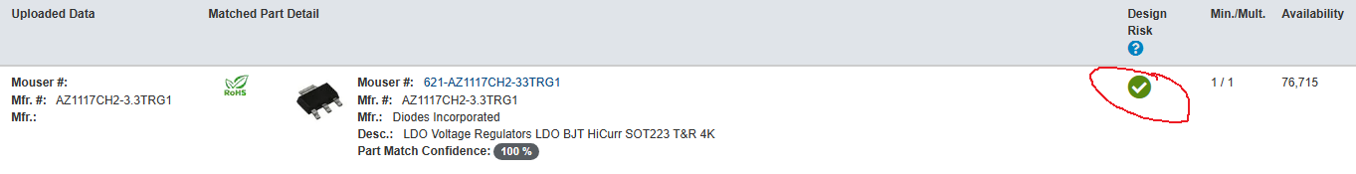

# Step 1 -- verify layouts at 0 degree have pin 1 in upper left corner

This will help reduce interactions at placement time, though pcbway.com still reached out to me with pictures for confirmation of all part layouts and rotations (which was much appreciated). Your pickplace file (mine was csv) will identify component centers and rotation left of 0 degrees

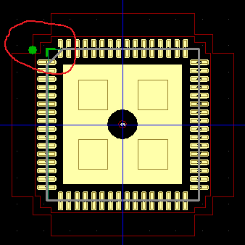

# Step 2 -- verify silkscreens

This will also help reduce interactions. Make sure pin 1’s are clearly marked. Diodes should have polarity markings on the silkscreens as well as any assembly diagrams. Diode pin 1 is typically cathode. Silkscreen and component values should match exactly (I had 4.02k resistors labeled as 4k on the silkscreen, and pcbway.com caught this discrepancy and verified it with me!).

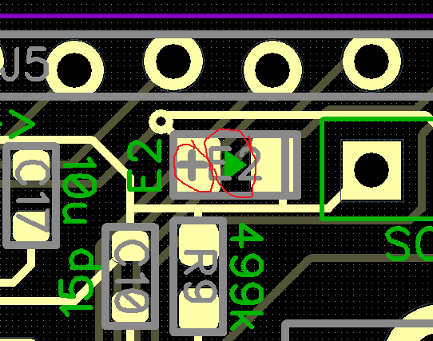

# Step 3 -- export gerbers with nc drill, pickplace, bill of materials

I accepted default solder mask swell and paste mask shrink of 0.00197in (0.05mm).

# Step 4 -- place the order

To start the process rolling with pcbway.com, you simply upload your gerbers, pickplace file, and bill of materials into the “Get Assembly Quote” form -- I selected Turnkey (they supply parts) and Panelized PCBs (since mine were so small):

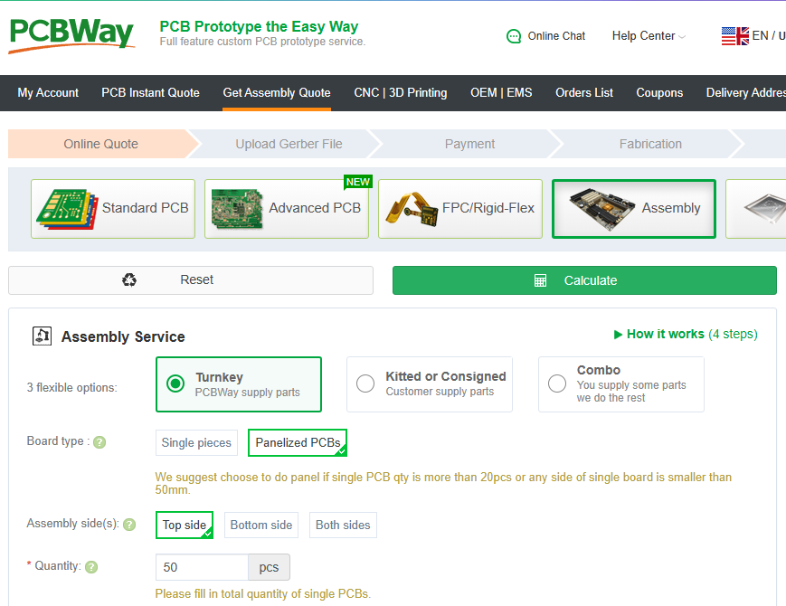

I submitted the gerbers, bill of materials (in csv form, just how my PCB program generated them), and pickplace file (also in csv form).

The best thing of all is before the order is even accepted -- i.e., before you can pay -- they return to you a “quoted bill of materials” which shows the components they are going to order, along with prices and timing -- it means they took everything from my free-form bill of materials, read it, checked it, and processed it!

They found one part that was not shipping (the MCU was still ramping up production) and suggested an alternative!

For example, I provided to them:

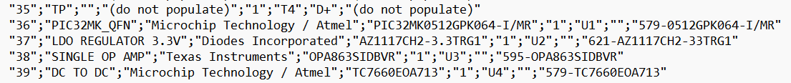

And they gave me back:

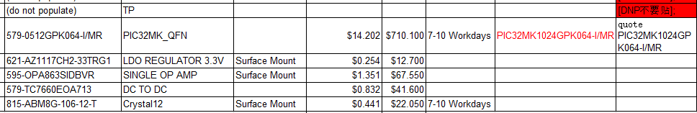

So far, so good!

At this point I was able to pay and start the production clock!

# Step 5 -- be available

I had a number of interactions with pcbway.com during the PCBA process, including:

* BoM verification (before payment!)
* component value clarification (4k vs. 4.02k)
* components placement verification (pictures)

# Step 6 -- don’t worry, be happy!

