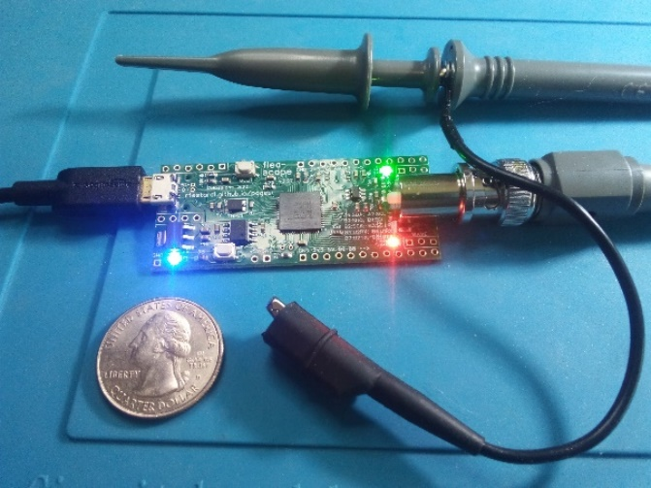[Flea-Scope™ for Education](https://rtestardi.github.io/usbte/schools.pdf)

Flea-Scope™ is a very low-cost ([$18 retail available here](https://www.elecrow.com/flea-scopetm-usb-o-scope.html)) and easy-to-use 18 million sample-per-second (Msps) USB oscilloscope and mixed-signal logic analyzer with a built-in waveform generator, and so much more! Flea-Scope can be controlled by any Chromium-based web browser that supports WebUSB API or Web Serial API running on a computer, tablet, or phone, with no need for further software install – just plug it in and open a web-page and you are up and running!

The goals of the Flea-Scope™ project are many:

1. first of all, to encourage students to become producers of technology, rather than just consumers of it!
2. then, to allow students to visualize signals changing over time as they build and debug electrical circuits,
3. to expose students to the concepts and uses of oscilloscopes, logic analyzers, and waveform generators
   * ("trigger out" pin allows multiple Flea-Scopes to work together simultaneously for more channels!),
4. to excite students about the capabilities of microcontrollers (MCUs) and embedded systems, and
5. to provide students with an embedded system core which they can leverage into their own projects!

Flea-Scope™ can be used on many levels, from beginner to advanced, including:

1. (beginner, $18) as an oscilloscope, logic analyzer, and function generator using only a web-page
2. (intermediate, $18) as a [simple BASIC embedded system core](https://rtestardi.github.io/StickOS/examples.htm) with debugger using only a web-page,
   * (18 programmable I/O pins, compatible with 0.1” (2.54mm) solderless breadboards!),
3. (advanced, $18 + $40) as a C embedded system core with debugger using [Snap ICE](https://www.microchip.com/en-us/development-tool/PG164100) and MPLAB X IDE
   * 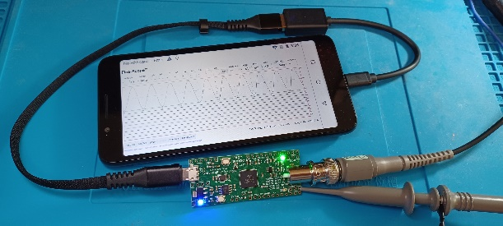(18 programmable I/O pins, compatible with 0.1” (2.54mm) solderless breadboards!).

Most of all, Flea-Scope™ is designed to be flexible and easy-to-use, with cross-platform support (Windows, Linux, macOS, and Android) and software-less install -- just open a web-page and you are up and running!

Flea-Scope™ is fully open-source, including:

* web-page GUI and deep-dive (BASIC) UI written in JavaScript,
* MCU firmware written in C using [Microchip MPLAB X](https://www.microchip.com/en-us/tools-resources/develop/mplab-x-ide),
* printed circuit board schematic and layout using [Novarm DipTrace](https://diptrace.com/), and
* 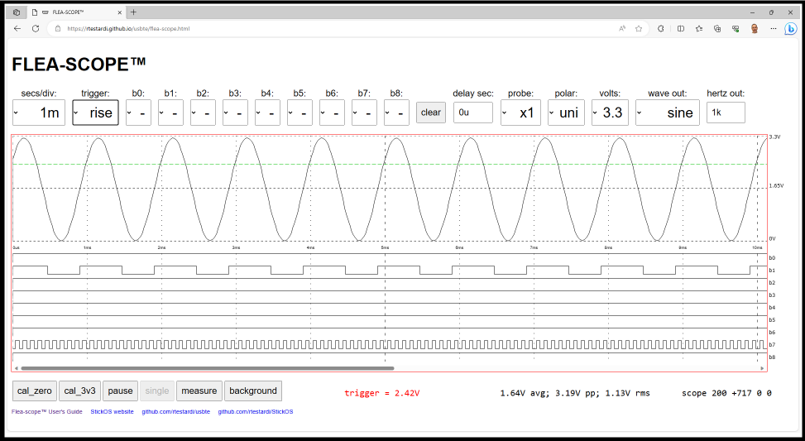extensive documentation.

See the github repositories ([web-page GUI and deep-dive UI user interfaces](https://github.com/rtestardi/usbte) and [MCU firmware/board/documentation](https://github.com/rtestardi/StickOS2/tree/main/board)).

See the [Flea-Scope™ User’s Guide](https://rtestardi.github.io/usbte/flea-scope.pdf) for detailed specifications and usage.

For more information, contact me at: Richard Testardi <rtestardi@live.com>