Build a Simple Toaster Oven Temperature Profile Controller  
(Or Anything Else You Want!)

# Introduction

Using a Flea-Scope™ board running StickOS® BASIC, it is possible to quickly build a toaster oven temperature profile controller for performing surface mount (SMT) printed circuit board reflow soldering at home. It is also possible to build a wide variety of other general-purpose embedded system projects with minimal software effort, *using only a web-page terminal emulator and high-level BASIC algorithmic statements to manipulate the microcontroller (MCU) pins and peripherals!*

A Flea-Scope can be controlled by *any Chromium-based web browser* that supports WebUSB API or Web Serial API running on a computer, tablet, or phone (!!!), with no need for further software install – just plug it in and open a web-page and you are up and running!

(I hope to have Flea-Scopes produced in quantity for under $20 in the near future, to get them into high-schools, but in the meantime, you can build one yourself with full instructions on the hackaday.io website, below. Oh, and Flea-Scope is also an 18 million-sample-per-second USB oscilloscope and mixed signal logic analyzer as a bonus!)

StickOS BASIC running within the Flea-Scope is an *entirely MCU-resident interactive programming environment*, which includes an easy-to-use editor, transparent line-by-line compiler, interactive debugger, performance profiler, and flash filesystem, all controlled thru an interactive command-line user interface (see Figure 1). In StickOS, external MCU pins may be mapped to BASIC “pin variables” for manipulation or examination, and internal MCU peripherals may be managed by BASIC control statements and interrupt handlers.

**web-page terminal emulator  
> _**

**MCU**

w/ StickOS BASIC

* editor
* compiler
* debugger
* profiler
* flash filesystem

Figure 1

embedded system

host computer, tablet, or phone!

usb

StickOS runs on a wide variety of MCUs, and seamlessly manages the MCU pins and peripherals, including BASIC program support for:

* digital input/output
* analog to digital converters
* pulse width modulators (for analog output or servo motor control)
* output compare timers (i.e., frequency generators)
* UARTs and I2C/SPI master serial interfaces
* periodic timers
* flash memory (i.e., self-programming)

By its very nature, StickOS supports "in-circuit emulation" -- all you need is a USB or UART transport connecting the MCU to a host computer, tablet, or phone, and you have full interactive control over the target embedded system, just as if you were using an in-circuit emulator.

With StickOS, it is no longer necessary to install a software development environment on the host computer, tablet, or phone; likewise, it is no longer necessary to connect any kind of flash programmer or debug hardware to the MCU. More importantly, though, with StickOS it is no longer necessary to study a 500+ page MCU Reference Manual in order to use the MCU external pins and internal peripherals -- StickOS manages them all for you!

*The bottom line is that using only a web-page terminal emulator (such as* [*https://rtestardi.github.io/usbte/stickos-basic.html*](https://rtestardi.github.io/usbte/stickos-basic.html)*) on your host computer, tablet, or phone connected to a Flea-Scope*, the user can easily edit a BASIC program and interactively debug it using breakpoints, assertions, watchpoints, single-stepping, execution tracing, live variable and pin examination and manipulation, edit-and-continue, etc. The user can then save the BASIC program to the internal flash filesystem, and finally set the BASIC program to autorun autonomously when the MCU powers-up.

## Hello World!

So what does the “Hello world!” program look like in StickOS BASIC? Well, if the baseline goal for an embedded system is to configure an I/O pin and get an LED to blink, such as the green LED on pin “e2” of the Flea-Scope™ board, then the “Hello world!” program looks like this (entered text is in **bold**):

> **10 dim led as pin e2 for digital output**

> **20 while 1 do**

> **30 let led = !led**

> **40 sleep 500 ms**

> **50 endwhile**

> **run**

**<Ctrl-C>**

STOP at line 40!

> _

Line 10 declares a “pin variable” named “led”, then configures the general purpose I/O pin “e2” for digital output, and finally binds the pin variable to the corresponding pin (in traditional BASIC, the “dim” statement is used to “dimension” the shape of a variable prior to use). From then on, any modification of the pin variable is immediately reflected at the I/O pin. Line 20 starts an infinite loop. Line 30 inverts the state of the “e2" digital output pin to blink the LED. Line 40 delays the program for 500 ms. And finally line 50 ends the infinite loop. Type “run” to start the program; press <Ctrl-C> to stop the program.

Of course, if you really *just* wanted to print “Hello world!” to the terminal, you could just do:

> **10 print "Hello world!"**

> **run**

Hello world!

> **_**

## Hello User!

If you want to use a switch, such as the user switch “S1” of the Flea-Scope™, to condition the blinking of the LED, so that you can push the switch to stop the blinking, in StickOS BASIC it’s nearly as easy:

> **10 dim led as pin e2 for digital output**

> **20 dim switch as pin s1 for digital input debounced inverted**

> **30 while 1 do**

> **40 if !switch then**

> **50 let led = !led**

> **60 endif**

> **70 sleep 500 ms**

> **80 endwhile**

> **run**

**<Ctrl-C>**

STOP at line 70!

> **_**

The bulk of the program is like before, with just a few changes. Line 20 declares a “pin variable” named “switch”, then configures I/O pin “s1” for inverted (i.e., active-low) and debounced (i.e., with a low-pass filter) digital input, and finally binds the pin variable to the corresponding pin. From then on, examination of the pin variables results in the current switch state being read. Lines 40 and 60 simply condition the LED blink at line 50 on the switch not being pressed. Type “run” to start the program; press <Ctrl-C> to stop the program.

# Hello Toaster Oven!

## Procedure

To build the Toaster Oven Temperature Profile Controller you will need the parts listed in Table 1, and a USB host computer, tablet, or phone (the examples that follow will assume you are running Microsoft Windows, though similar procedures work with Mac, Linux, ChromeOS, and Android, as well):

|  |  |
| --- | --- |
| Part Name | Manufacturer and Part Number |
| Flea-Scope™ | https://hackaday.io/project/192598-flea-scope-usb-o-scope-18-msps-13-bom-webusb |
| K-type thermocouple | Pimoroni Ltd COM1705  https://www.digikey.com/en/products/detail/pimoroni-ltd/COM1705/9975861 |
| 3V solid-state relay | Teledyne STH24D25 https://www.mouser.com/ProductDetail/Teledyne-Relays/STH24D25?qs=cFlnt7DBZX%2FYka4cen6X9Q%3D%3D |
| Op-amp | National Semiconductor LM358 |
| 3V Buzzer | TDK PS1240P02BT  <https://www.mouser.com/ProductDetail/TDK/PS1240P02BT?qs=d7g9p1yFhWaZXSY9MjKMkw%3D%3D> |
| 1k ohm resistor | Xicon 299-1K-RC |
| 100k ohm resistor | Xicon 299-100K-RC |
| 36 pin header | FCI 68001-236HLF |

Table 1

I soldered two 12 pin headers onto the bottom of the Flea-Scope and mounted it in a solderless breadboard for ease of assembly (see Figure 2), but that is not required.

Figure 2A

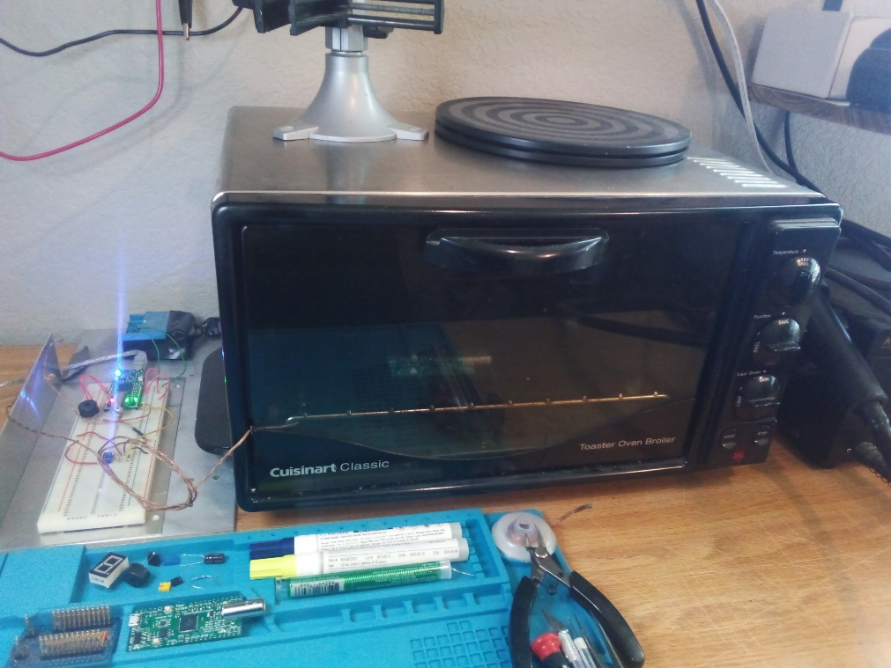

Figure 2B

## Schematic

The schematic for the Toaster Oven Temperature Profile Controller is shown in Figure 3.

*buzzer*

USB

3V3

GND

a0

GND

+V

*K-type thermocouple*

*to 3V solid state relay*

Flea-Scope™

LM358

100k

1k

yellow  
red

a8

a6

BNC

Figure 3

## Configuration

Once the Toaster Oven Temperature Profile Controller is built, the next step is to enter the BASIC program into StickOS on the Flea-Scope board.

When the board is connected to a USB host computer, tablet, or phone, it will present a virtual COM port.

At this point you can use a web-page terminal emulator to connect to the virtual COM port using WebUSB or Web Serial. Simply open: <https://rtestardi.github.io/usbte/stickos-basic.html>

Then Click the "Start Connect" button as shown in Figure 4:

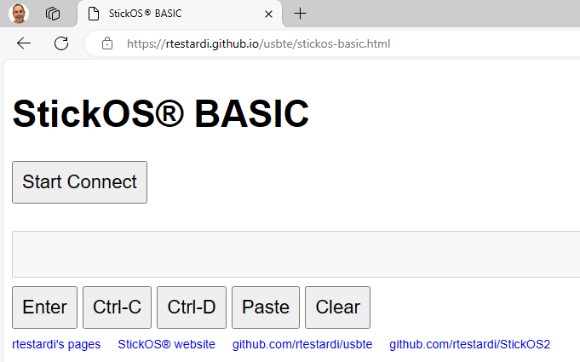  
Figure 4

And select your Flea-Scope in the resulting dialog and click "Connect" again as shown in Figure 5:

Figure 5

You should be connected to the web-page terminal emulator as shown in Figure 6:

Figure 6

You are now ready to enter StickOS commands and/or BASIC program statements.

## The BASIC Control Program

Enter the following BASIC control program at the StickOS command prompt to control the Toaster Oven Temperature Profile Controller:

**10 dim target, secs**

**20 dim thermocouple as pin a8 for analog input**

**30 dim relay as pin a0 for digital output**

**40 dim buzzer as pin a6 for frequency output**

**50 data 512, 90, 746, 105, 894, 20, -1, -1**

**60 configure timer 0 for 1 s**

**70 on timer 0 do gosub adjust**

**80 while target!=-1 do**

**90 sleep secs s**

**100 read target, secs**

**110 endwhile**

**120 off timer 0**

**130 relay = 0, buzzer = 100**

**140 sleep 1 s**

**150 buzzer = 0**

**160 end**

**170 sub adjust**

**180 relay = thermocouple<target**

**190 buzzer = thermocouple**

**200 sleep 100 ms**

**210 buzzer = target**

**220 sleep 100 ms**

**230 buzzer = 0**

**240 endsub**

(You can copy the program to the clipboard and then use the "Paste" button on the web-page user interface to load all the lines to StickOS at once.)

Line 10 declares two simple RAM variables. Line 20 declares a “pin variable” named “thermocouple”, configures Flea-Scope pin “a8” for analog input thru a low-pass filter, and finally binds the pin variable to the corresponding pin; subsequent examination of the pin variables returns in the current ADC values being read, in millivolts (mV). Line 30 declares a digital output pin variable to manipulate the MCU pin attached to the relay; subsequently setting the variable to 1 turns the relay on and setting it to 0 turns the relay off. Line 40 declares a frequency output pin variable to manipulate the MCU pin attached to the buzzer; subsequently setting the variable to a number (in hertz) configures the MCU pin to output that frequency to the buzzer (0 turns the buzzer off).

Line 50 contains the reflow cycle temperature profile ramp target and time information:

* 90 seconds at up to 512 millivolts (125 Celsius)
* 105 seconds at up to 746 millivolts (183 Celsius)
* 20 seconds at up to 894 millivolts (220 Celsius)

Line 60 configures a periodic timer to run every second, and line 70 specifies that when the timer expires, the subroutine "adjust" should be called. The subroutine defined in lines 170 to 240 will first turn on the relay if the thermocouple is below the target voltage (or turn it off otherwise) and then play a brief audio tone of both the current thermocouple value as well as the target value to indicate the cycle progress.

Lines 80 thru 110 simply cycle thru the temperature profile ramp and update the relay and buzzer based on the state of the thermocouple.

Lines 120 to 150 unconfigures the periodic timer and turns off the relay and then plays a short low frequency tone to indicate the end of the cycle.

Then the program ends.

To save the program to the flash filesystem, type:

**save**

To run the program, type:

**run**

To set the program to autorun on MCU power-up, type:

**autorun on**

## Diagnostics

What if your program doesn’t work? What if you have a bug in your op-amp or relay circuitry? StickOS supports fully interactive control of the MCU. You can start running the program by typing “run” and then press <Ctrl-C> to stop it after a minute or two and you will see:

> **run**

**<Ctrl-C>**

STOP at line 90!

At that point you can print the current value of the thermocouple, in millivolts, with:

> **print thermocouple**

609

You can turn on the MCU output connected to the relay with:

> **let relay = 1**

You can then watch the thermocouple voltage increase:

> **print thermocouple**

644

And turn off the MCU output connected to the relay:

> **let relay = 0**

And watch the thermocouple decrease:

> **print thermocouple**

570

You can even continue the program from where it left off:

> **cont**

You can use breakpoints, assertions, watchpoints, single-stepping, execution tracing, live variable and pin examination and manipulation, and even edit-and-continue as part of the StickOS interactive debugging experience.

# Conclusion: “You don’t even need an ‘app’ for that!!!”

Using StickOS BASIC inside your microcontroller, you can then reprogram your microcontroller directly *using only a web-page terminal emulator and high-level BASIC algorithmic statements to manipulate the microcontroller (MCU) pins and peripherals*.

Even better, using just JavaScript and WebUSB and/or Web Serial in a Chromium-based web browser, you can write a *web-page terminal emulator* just once, and deploy it across most USB host computers -- a Windows, Mac, or Linux PC, a Chromebook, or even an Android phone!

“You don’t even need an ‘app’ for that!!!”

What could be easier???

# Toaster Oven Tips

Fine pitched SMT reflow soldering can be an intimidating task to the newcomer, but I have found that I can reliably reflow “Flea-Scopes”, including 0.5mm pitch QFP’s and even 0.5mm QFN’s with just a few tricks:

* To mount a QFN (leadless) package, I first flux the component pins and then tin them with my soldering iron; each pin ends up with a little bump of solder on it. I then flux the board pads and tin them, with a similar and opposing bump (it definitely helps to have a solder mask on the board, but I have done it without). Then I flux everything again and align the bumps on the QFN pads with the opposing bumps on the board, and prepare for reflow using your new Toaster Oven Temperature Profile Controller.
* To mount the QFP (leaded) packages, I use a similar procedure but do not tin the delicate component pins.
* After reflow, if touchup is needed (the typical problem will be “opens”, not “shorts”), I use a generous amount of flux at the pin/pad interface and then drag the ever slightest amount of solder across it with my soldering iron. Note that the flux is critical in this step to avoid any bridging/shorts.
* I used a Weller WES51 soldering iron with an ETP (1/32" screwdriver) tip, Chip Quik SMDLTLFP solder paste, Kester Pocket-Pak lead-free rosin-core solder, a Kester #2331-ZX water soluble flux pen, and a PanaVise PV Jr. Model 201 (to hold things).

# Links

The hackaday page for Flea-Scope™, with full build instructions (give me a like, and make me smile! :-), is here: https://hackaday.io/project/192598-flea-scope-usb-o-scope-18-msps-13-bom-webusb

The Flea-Scope™ StickOS® BASIC Deep Dive User Interface is here: https://rtestardi.github.io/usbte/stickos-basic.html

The StickOS BASIC Quick Reference Guide is here:

https://rtestardi.github.io/StickOS/downloads/quickref.v1.90.pdf

Full StickOS BASIC documentation and downloads for various supported MCUs can be found at: https://rtestardi.github.io/StickOS/

A number of examples of WebUSB and Web Serial usage, ranging from a simple terminal emulator to the Flea-Scope™ GUI are here: https://github.com/rtestardi/usbte

WebUSB documentation is here: https://wicg.github.io/webusb/

Web Serial documentation is here: https://wicg.github.io/serial/

CDC/ACM documentation starts here: https://en.wikipedia.org/wiki/USB_communications_device_class

# About the Author

Richard Testardi has a wife and 17yo daughter and lives in Colorado. He is grateful most of the time and Christian. He loves anything outdoors or math/science related. In the future, he hopes to be teaching high school students. He lives without a cell phone (well, except a sim-less phone for interoperability testing!)!