# Systems Integration Blueprint (ELA)

Date: 2025-10-21

This document presents the systems integration architecture for ELA projects, covering MS Teams, GitHub, IDE with Codex, CI/CD, Secrets, Cloud Environments, Monitoring, and Identity.

High-Level Diagram:

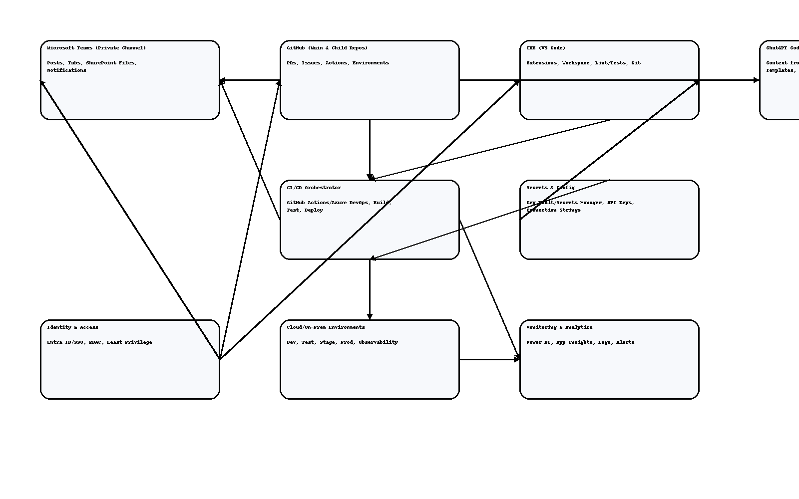

## Key Components & Responsibilities

**Microsoft Teams (Private Channel):**

Project communications, SharePoint file repo, CI/CD & PR notifications.

**GitHub (Main & Child Repos):**

Main repo (ELA-Main) holds templates and shared-libs; child repos per project with branching, PRs, and Actions.

**IDE (VS Code) + Codex:**

Local workspace with Codex prompts and context loader to reuse ELA-Main and project artifacts.

**CI/CD Orchestrator:**

Automated linting, tests, build, deployment; gated releases and rollbacks.

**Secrets & Config:**

Key Vault/Secrets Manager for API keys, connection strings, tokens; injected at build/deploy time.

**Environments:**

Dev/Test/Stage/Prod with infra as code and observability.

**Monitoring & Analytics:**

Application Insights/Logs, Power BI dashboards, alerting.

**Identity & Access:**

Entra ID/SSO, RBAC across Teams, GitHub, IDE, and cloud.