Convolutional Neural Networks for Visual Recognition

Mohammed Ehsan Ur Rahman Kakatiya Institute of Technology and Science, Warangal, 506015, Telangana, INDIA ehsan81181@gmail.com

Abstract— The fields of computer vision, image processing and deep learning from their initial days have been dealing with the problem of visual recognition. Convolutional Neural Networks (CNNs) in machine learning; are deep architectures built as feed-forward neural networks or “perceptrons”, which are inspired by the research done in fields of visual analysis by visual cortex of mammals (specifically humans). As CNNs are a type of neural network they work on same basic principles of generalization, regularization and learning the physical environment through learnable weights and biases, comprising of neurons belonging to a layer, which in turn is part of the complete series of layers or so-called “neural network”. They comprise of layers like convolutional, pooling, fully-connected, etc.; though convolutional layers can exist independently in the complete network, this makes learning slower and lesser time efficient. CNNs find their application not only in visual and video recognition but also in recommender systems and natural language processing (NLP). A great example of a CNN is AlexNet which competed in the ImageNet Large Scale Visual Recognition Challenge (ILSVRC). This work gives a detailed analysis of CNNs for the specific purpose of visual recognition and image classification, along with its mathematical intuition and working; pros and cons, alternatives to CNNs and approaches to improve their performance further.

Keywords—CNN-Convolutional Neural Networks, DNN-Deep Neural Networks, CV-Computer Vision, IP-Image Processing, AI-Artificial Intelligence, ML-Machine learning, ILSVRC-ImageNet Large Scale Visual Recognition Challenge

Introduction
The areas of computer vision[7] are advancing rapidly thanks to the deep learning[3] . Computer vision is now helping self-driving cars[10] in figuring out objects in its environment or receptive field like other cars , people and pedestrians .Face recognition[10] is becoming much better than ever before .Its even enabling art to be created[10] .And brand new applications[26] working on computer vision are becoming possible which were thought to be impossible back in the day .Even the computer vision community is very much creative and innovative in coming up with new neural network architectures[27] and new algorithms [1].
Computer vision problems are for example image classification[8] , object detection [6], neural style transfer, large image processing [8][9], etc . One among them is visual recognition[9] similar to face recognition[6] . Curse of dimensionality hovers over the visual recognition field of CV and generally you don’t want to perform recognition of smaller dimensional images but rather on larger images(almost all of the modern-day images) , a solution to which is the use of convolution operation which is the underlying principle in the CNNs
Neural networks :-
Working on the similar principles , on which the brain works . Consider the brain’s smallest functional unit as neuron , here it acts as the smallest unit for computation , synapses are the connections between neurons in the brains whereas in case of neural networks it’s called propagation(forward or backward),etc. Hence its clear that deep learning is biologically-inspired.
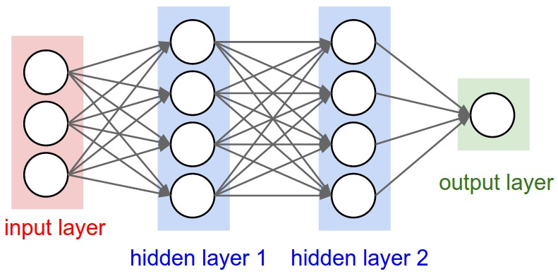
Figure 1 – Showing the traditional structure of a neural network

Components and working
CNNs[1] are made of layers including one input , one output and many hidden layers; those can be pooling , fully connected or convolutional layer. Mathematically convolution is a process performed to two functions to make them a new function which gives information about their effect on each other. Convolution is very much related to cross-correlation ; hence convolution has its applications in multiple fields of science and technology like computer vision , NLP , image and signal processing ,probability, engineering , differential equations and statistics.
A CNN consists of a number of convolutional and subsampling layers optionally followed by fully connected layers. The input to a convolutional layer is a m x m x r image where m is the height and width of the image and r is the number of channels, e.g. an RGB image has r=3. The convolutional layer will have k filters (or kernels) of size n x n x q where n is smaller than the dimension of the image and q can either be the same as the number of channels r or smaller and may vary for each kernel. The size of the filters gives rise to the locally connected structure which are each convolved with the image to produce k feature maps of size m−n+1. Each map is then subsampled typically with mean or max pooling over p x p contiguous regions where p ranges between 2 for small images (e.g. MNIST for hand written digits) and is usually not more than 5 for larger inputs(modern-day images). Either before or after the subsampling layer an additive bias and sigmoidal nonlinearity is applied to each feature map.
Visual recognition :-
Visual recognition[5] is one of the great practical applications of CNNs. It is defined as finding meanings in visual content(images, videos, scenes, etc.) and analysing images for scenes, objects, faces, and other contents to understand what is happening in a scene.
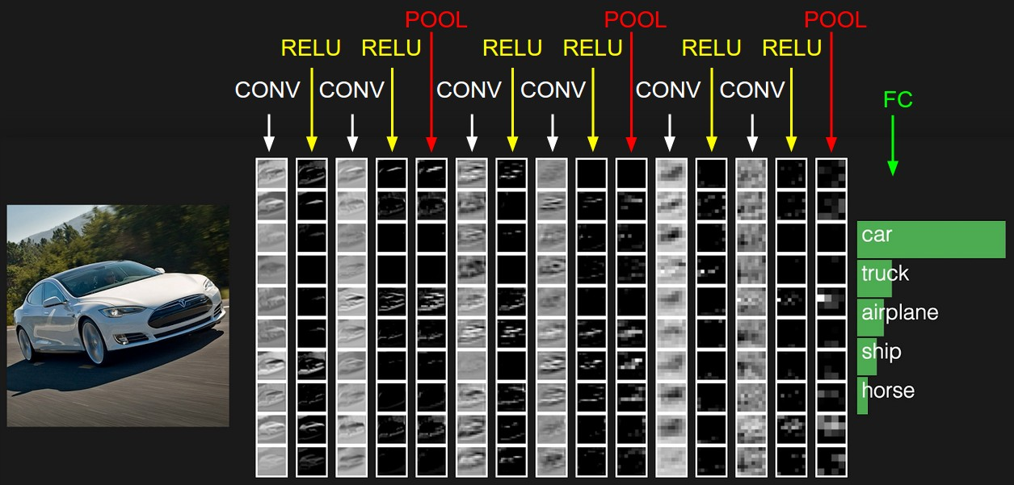
Figure 2 Showing the arrangement of different layers in a typical CNN used for image classification purpose

These layers apply a convolution operation to the input and passing its results to the next layers , basically the way layers of a neural network work , this way they mimic the activity of the neurons in our brain that simulate and analyse visual data(stimuli).
Pooling layers - as the name suggests these layers maps multiple neurons or neuron clusters of previous/prior layer to a single neuron in the next layer .Many types of pooling layers exist like max pooling which uses the maximum valued neuron from the neuron cluster for mapping, average pooling uses the average value from the neuron clusters . Another important concept of CNNs is pooling, which is a form of non-linear down-sampling. There are several non-linear functions to implement pooling among which max pooling is the most common
Fully-connected layers - are layers consisting of "neurons" that perform well on classification tasks as well as on tasks to learn features but require a very large number of neurons due to the large dimensionality of modern-day image; so as to perform well .Convolution operation reduces the number of parameters to be trained and makes it independent of the size of the input images , this also helps in dealing with vanishing gradients or exploding gradients problems which are faced in cases of traditionally used multi-layer neural networks using backpropagation for gradient calculation
Convolutional layers - these layers do the actual work of convolutional networks and hence derive their name from this layer.This layer performs the different differentiable convolution functions on the input values obtained from the prior layers .It contains these functions as filters which can be convolved independent of each other and give a feature map .These filters are initialised randomly and will be tuned as the training proceeds further. Deeper the network i.e. higher the number of hidden convolutional layers , better is the performance .
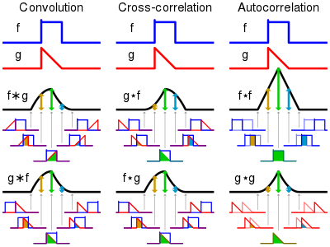
Figure 3 - Depicting differences between convolution and other similar performing mathematical operations

Backpropagation –
It’s a way to calculate gradients for a given loss function so that the function(loss function) finds its optimal minimum in the hyperplane , these gradients are calculated based on the results obtained during the forward propagation through the layers of the neural network and its results are fed into the next iteration of forward pass(propagation) through the layers of the neural net.
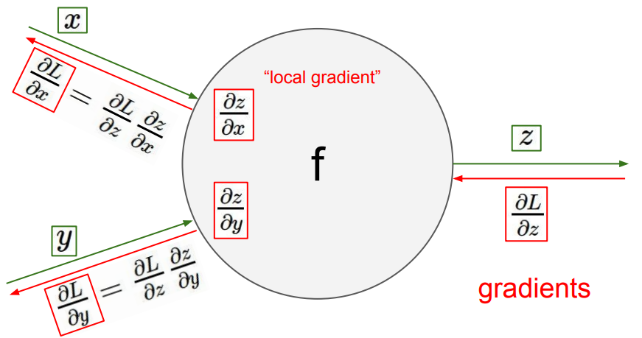
Figure 4 Backpropagation pictorial representation

This method basically is simple as it involves very basic mathematical operations of calculating gradients of finite valued differentiable functions which the convolution functions are and the filters i.e. the matrices can also be dealt with in the same way . This makes finding the optimized objective function values simpler and faster .
One of its best flavours among so many different versions is the Stochastic Gradient Descent (SGD)
……(1)
where is the parameters and is the objective function
……(2)
with a pair (x(i),y(i)) from the training set.
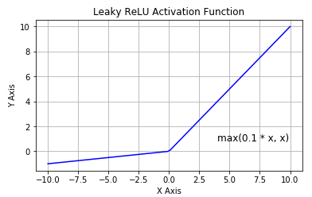
Figure 5 Graph of a Leaky ReLU Activation Function
Edge detection is the most prominent image processing operation performed to analyse and process images and also among the very first steps to perform visual recognition , this uses a filter of some dimension , a filter can also be called as a kernel because its properties are much similar to a kernel function used in calculation of transformations. This filter is convolving the input images through the use of convolution operation/function of your choice which must belong to the set of functions which are differentiable .
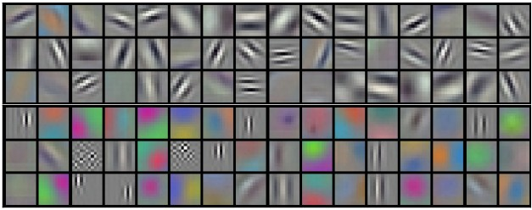
Figure 6 Depicting the learnt weights

Mathematical intuition
The intuition here is that these layers can actually compute results with/out biological-neuron’s analogous “neurons”. But they rather consist of learnable filters consisting of parameters. Every filter is spatially determined by its width and height but extends through the full depth and dimensions of the input volume i.e. the image.

Convolution

Defined as
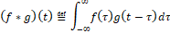
where f and g are two differentiable functions which can evaluate to constant values , f*g is the convolved function[30][29][26]

Hyperparameters[4]
- Number of filters -It’s the number of filters present in each of the layer of the CNN[1] .More number of filters results in analysis of even complex and deeper patterns in the data and results in finer results.
- Filter shape – The dimension of the filter i.e. its width , height and depth[15] (which remains constant for all the filters and depends on the number of channels a given image has)
- Number of epochs –This is the number of times the algorithm must be repeated over the training data in order to obtain the most efficient co-efficient (learnable weights and biases). Generally, 1000 epochs give almost accurate results regarding the performance of the network.
- Max pooling shape – The shape of the CNN’s layer of pooling(max-pooling)
- Batch size—The number of data points in each subsample of the training set .

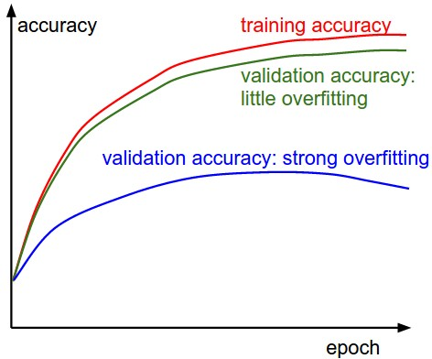
Figure 7 Gives valuable insights into the amount of overfitting in the model

- Learning rate –The improvement towards finding the optimal solution. Also, the step taken through each iteration of the algorithm towards finding its gradient(gradient descent).Effects are shown below:
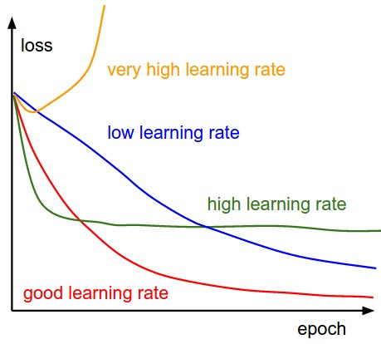
Figure 8 Depicting the effects of different learning rates

- Activation function—The function/filter at each layer is called as activation function[15] , this function triggers signals if the input or processed input exceeds a threshold value . Few examples are ReLU,eLU,sigmoid,etc. and the choice of activation depends on the input data and the type of analysis to be done. Generally for visual recognition leaky ReLU is used as activation function.
- Number of hidden layers and units—Number of layers apart from the input and output layer and number of the units present in each layer. The greater this number the better are the results.
- Weight initialization—The initial values allotted to the weights at the beginning of the first iteration of the algorithm or the gradient descent step , biases are initialised to zero value .Stochastic gradient descent is an optimal algorithm as its initialises the weights at good places in the hyperplane.[15]

Generalization and Regularization
CNNs work on the principle of regularization[2] rather than memorization to a great extent . The two major chunks in its generalization module are :-
Empirical:- This empirical form of generalisation works on the concept of “dropout”. Overfitting takes place because a fully connected layer occupies most of the parameters. One method to reduce overfitting is dropout.[22] At each training step a neuron(also referred as node)is either "dropped out" of the net with probability 1-p not with probability p, so that a reduced network is left; incoming and outgoing connections to a dropped-out neuron are also removed. Only the reduced network is trained on the data in the next stage. The removed neurons are then reinserted into the network with their original weights.
Explicit:- Use of decay of weights principle , and maximizing norm constraints , and optimal number of parameters , generally avoids overfitting by not allowing the network to learn further from the stage at which overfitting may take place.

Alternatives to CNNs
- A new approach is suggested by Hinton et al.[27] recently which is called as “capsule networks”;
- Networks to recognize objects in new situations with less data than regular neural nets must use;
- Using DNN with different hyperparameters sometimes tends to outperform the traditional CNNs in terms of visual recognition’s performance evaluation. Hyperparameters may include : using Nesterov Momentum which is a slightly different version of the momentum update that has recently gained much popularity; for optimization using a group of methods in context of deep learning which are based on Newton’s method;

Lags and Leads
CNNs analysis leads to the knowledge of its advantages and disadvantages over other methods for visual recognition.

Lags
Every coin has two sides and the same is true for CNNs. Though being of paramount importance in visual recognition and other deep learning solvable problems it has loopholes (like every other method which is not perfect). The limitations that this approach faces are as follows.
General discussion is between considering a problem as deterministic or stochastic[27] and whether data plays a crucial role or algorithm .

Sub sampling[26] which is performed due to the confined receptive field caused by selection of filter which are not taking all of the input volume but only a part of it (and also having no overlapping with other filters ) may result in loss of precise global and local spatial relationships which are very much required for identity recognition .

They have harder time in extrapolating[30] their comprehension of the features of images to radically different and new viewpoints .

All these reasons make CNNs doomed to perform well on the ever increasing and newer problems of computer vision.

Leads
There are various reasons behind working with CNNs for visual recognition , and they include
- They are good at doing feature learning i.e. they can capture and learn only the relevant features from the input data and try to discard the useless information.
- Weight sharing is the next important advantage , which is why we need not bother about complexity at each level/stage or layer of the neural network.
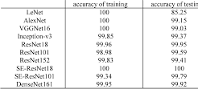
Figure 9 Showing the accuracies of different types of CNNs

- They can perform feature extraction and works at par with data with pre-trained features included .[3]

future scope and improvements
The use of the centred formula for derivative calculation in gradient descent[16]; use of relative error for the comparison between analytic and numerical gradients[17] ; kinks in the objective (kinks stand for the non-differentiable parts of the function )function [28] ; use only few datapoints[1]; etc.
A reliable approach for improvement of the performance of CNNs by a few percent is to train multiple independent models, and add their test predictions. With increase in the number of models in the ensemble(using of combinations of learning algorithms for better performance), the performance also monotonically improves with very negligible enhancement to the current method.[26]
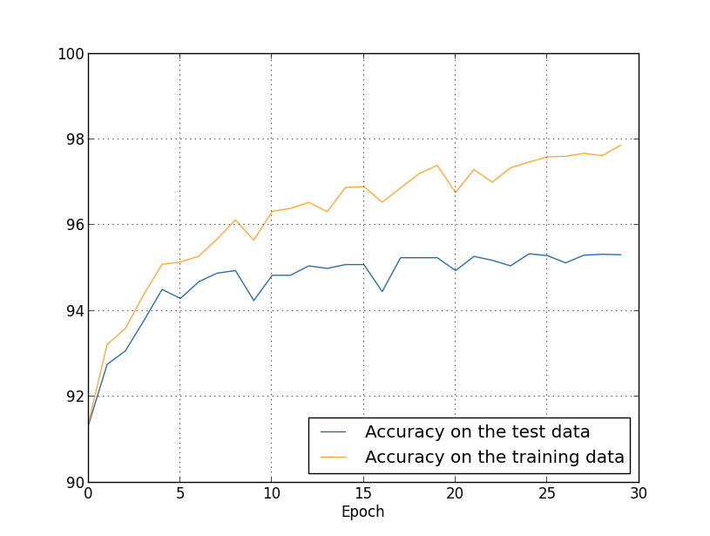
Figure 10 Overfitting leads to poor performance

Speeding up of algorithm is really important as CNNs are slow at processing the data. Using of optimization techniques such as dynamic precision scaling[24] and dropout[22] help in resolving overfitting along with speeding up evaluation of outputs.[23]

References
- https://en.wikipedia.org/wiki/Convolutional_neural_network
- Xinyu Chen, Qiang Guan, Xin Liang, Li-Ta Lo, Simon Su, Trilce Estrada,and James Ahrens. 2017 .TensorView :Visualizing the Training of Convolutional Neural Network Using Paraview. InDIDL’17: DIDL’17: Workshop on Distributed Infrastructures for Deep Learning, December 11–15, 2017, Las Vegas, NV, USA.ACM,NewYork,NY,USA,6pages.https://doi.org/10.1145/ 3154842.3154846
- Deep Learning by Ian Goodfellow, Yoshua Bengio and Aaron Courville
- Hastie T., Tibshirani R., Friedman J. (2009) Neural Networks. In: The Elements of Statistical Learning. Springer Series in Statistics. Springer, New York, NY
- Longfei Zhang, Yanming Guo , Delving into Fully Convolutional Networks Activations for Visual Recognition, ICMIP 2018, March 16-18, 2018, Guiyang, China
- Na Liu, Ye Yuan, Lihong Wan, Hong Huo, and Tao Fang, Comparative Study for Contour Detection Using Deep Convolutional Neural Networks, ICMLC 2018, February 26–28, 2018, Macau, China
- Salman Khan Hossein Rahmani Syed Afaq Ali Shah Mohammed Bennamoun, A Guide to Convolutional Neural Networks for Computer Vision, SYNTHESIS LECTURES ON COMPUTER VISION #15
- Sai Wu ,et al., A New Approach to Compute CNNs for Extremely Large Images, CIKM’17, November 6-10, 2017, Singapore
- Yalong Bai, Kuiyuan Yang, Tao Mei, Wei-ying Ma, and Tiejun Zhao. 2018. Automatic Data Augmentation from Massive Web Images for Deep Visual Recognition. ACM Trans. Multimedia Comput. Commun. Appl. 14, 3, Article 69 (July 2018),
- jinzhuoWang, et al., Deep Alternative Neural Network: Exploring Contexts as Early as Possible for Action Recognition, 30th Conference on Neural Information Processing Systems (NIPS 2016), Barcelona, Spain.
- Yue Wu, Jun Li, Yu Kong, Yun Fu,Deep Convolutional Neural Network with Independent Softmax for Large Scale Face Recognition, MM ’16, October 15-19, 2016, Amsterdam, Netherlands
- Ashwini Kinnikar,et al., Face Recognition Using Gabor Filter And Convolutional Neural Network, ICIA'16, August 25 - 26, 2016, Pondicherry, India
- Nhu-Tai Do, Soo-Hyung Kim, Hyung-Jeong Yang, Guee-Sang Lee, In-Seop Na, Face Tracking with Convolutional Neural Network Heat-Map, ICMLSC 2018, February 2–4, 2018, Phu Quoc Island, Viet Nam
- Hokuto Kagaya, et al., Food Detection and Recognition Using Convolutional Neural Network, MM’14, November 3–7, 2014, Orlando, Florida, USA.
- Pushparaja Murugan, Hyperparameters Optimization in Deep Convolutional Neural Network / Bayesian Approach with Gaussian Process Priors, arXiv:1712.07233v1 [cs.CV] 19 Dec 2017
- Tara N. Sainath, et al., IMPROVEMENTS TO DEEP CONVOLUTIONAL NEURAL NETWORKS FOR LVCSR,
- Kien Nguyen, Clinton Fookes, Sridha Sridharan, IMPROVING DEEP CONVOLUTIONAL NEURAL NETWORKS WITH UNSUPERVISED FEATURE LEARNING,
- Liangliang Cao, et al., Multi-facet Learning using Deep Convolutional Neural Network for Person-Related Categories in Photos, ICMR’15, June 23–26, 2015, Shanghai, China.
- arXiv:1505.00393v1 [cs.CV] 3 May 2015, ReNet: A Recurrent Neural Network Based Alternative to Convolutional Networks
- Tianmei Guo, Jiwen Dong ,Henjian LiˈYunxing Gao, Simple Convolutional Neural Network on Image Classification,
- Sachin Sudhakar Farfade et al., Multi-view Face Detection Using Deep Convolutional Neural Networks, ICMR’15, June 23–26, 2015, Shanghai, China.
- Srivastava, Nitish; C. Geoffrey Hinton; Alex Krizhevsky; Ilya Sutskever; Ruslan Salakhutdinov (2014). "Dropout: A Simple Way to Prevent Neural Networks from overfitting". Journal of Machine Learning Research. 15 (1): 1929–1958.
- Taesik Na and Saibal Mukhopadhyay, Speeding up Convolutional Neural Network Training with Dynamic Precision Scaling and Flexible Multiplier Accumulator, ISLPED ’16, August 08-10, 2016, San Francisco Airport, CA, USA.
- Saad ALBAWI , Tareq Abed MOHAMMED et al., Understanding of a Convolutional Neural Network, ICET2017, Antalya, Turkey
- GiuseppeAmato,FabrizioFalchi,andLuciaVadicamo.2016.Visual recognition of ancient inscription using convolutional neural network and ﬁsher vector. J. Comput. Cult. Herit. 9, 4, Article 21 (December 2016)
- http://cs231n.github.io/
- Aggarwal C.C. (2018) Neural Networks and Deep Learning. Springer, Cham
- http://ufldl.stanford.edu/tutorial/supervised/ConvolutionalNeuralNetwork/
- Koray Kavukcuoglu, et al., Learning Convolutional Feature Hierarchies for Visual Recognition,ICMR-2010,Atlanta,USA
- arXiv:1409.4842v1 [cs.CV] 17 Sep 2014

