Introduction
In this assignment we were tasked with solving the following problems with Particle Swarm Optimization (PSO):
- Continuous optimization – The Egg holder function in 2 dimensions.
- Continuous optimization – The Schwefel function in 4 dimensions.
Particle swarm needs the following components specified:
- Termination criterion
- Swarm size
- φ₁ and φ₂ values (used to calculate the velocity vector)
- Neighborhood topology (i.e., star/global or partial/n neighbors).
- Inertia and/or constriction for the velocity vector (implemented internally).
Given the above inputs, the PSO tries to come up with the optimal solution in a search space, usually continuous.

The Egg holder function
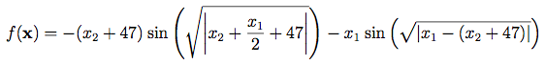

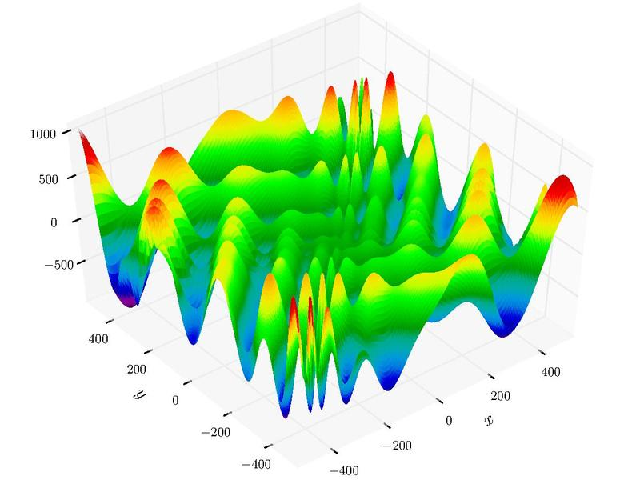
where -512 < x₁, x₂ < +512

Methodology and results
1)
Encoding:
The encoding I used is the same as the one in the previous homework assignments. I represent a particle’s x and p vectors as an array of real numbers. The first element of the array is the x₁ value, while the second element is the x₂ value. An example encoding is shown below:
x₁ | x₂

Particle move operator:
$$x_{id}=x_{id}+v_{id}$$
$$v_{id}=v_{id}+φ_{1} rand\left( \right) \left(p_{id}-x_{id}\right)+φ_{2} rand\left( \right) (p_{gd}-x_{id})$$
where,
i: particle index
d: dimension
g: best particle index

Neighborhood topology:
“Star”/ Global neighborhood.

φ values:
I chose the recommended φ values, φ₁=φ₂=2.

Velocity initialization:
The velocity vector for each particle is randomly initialized to a value within [-5, 5].

Update policy:
Synchronous

Boundary constraint satisfaction:
Initially, if the addition of v_{id} to x_{id} generates a value not in [-512, 512], dimension d is not modified.
First, I am going to examine what happens to the velocity of a particle throughout the execution of PSO. As mentioned previously, all particle velocities are initialized at a random value between [-5, 5], for the X and the Y axis. Fig. 1 shows side-by-side plots of the velocity vector for two random particles of a PSO with 800 particles that ran for 100 iterations. The plots are in logarithmic scale. I notice that the velocity values “explode” very early in the execution. This results in a lot of wasted moves, since the particle would move to the infeasible zone of the function, if it was allowed to take that move. The behavior of PSO with this implementation can be observed in Fig. 2. Notice how many particles are unable to move. This version of PSO it is not efficient.
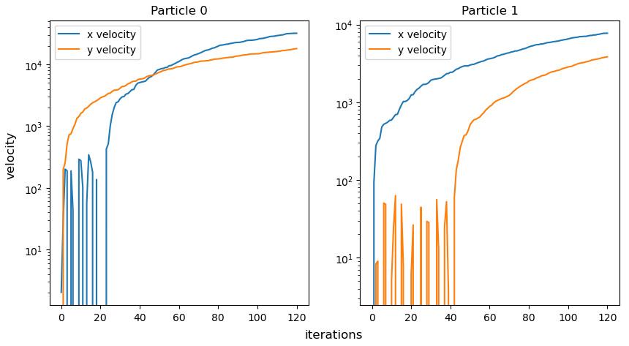

Figure 1. Historical velocity values of two randomly picked particles of a PSO with swarm size=500, iterations=100, star topology, full model. No inertia. No constriction.


Figure 2. Behavior of PSO with swarm size=800, iterations=100, star topology, full model. No inertia. No constriction. Velocity is not restricted.

I decided to restrict the velocity to improve the efficiency of the algorithm. I implemented the approach presented in the work of [1]. They restrict the velocity vectors using the following formulas:

$V_{\max_{d}} = \frac{X_{\max_{d}} - X_{\min_{d}}}{2}$ Eq. 1

$V_{\min_{d}} = -\frac{X_{\max_{d}} - X_{\min_{d}}}{2}$ Eq. 2

where d corresponds to the dimension.
For the Egg holder function, this restriction corresponds to [Vmin, Vmax] = [-512, 512] for all dimensions. Furthermore, if the velocity exceeds a limit, it is divided by the absolute value of the corresponding limit. The division of the velocity with the absolute value of the limit is not something mentioned in the referenced paper, but I found it works very well.
In [1], the authors also reduce these limits through the execution of the algorithm, using the number of iterations. However, this looks a lot like the inertia factor, so I decided to skip this step. After this modification, I inspected the velocity vector through the PSO execution. Its values are illustrated in Fig. 3. The behavior of the PSO can be observed in Fig. 4. This modification allowed me to reduce the number of particles to 250, while not compromising on the quality of the solutions. Fewer moves are discarded, therefore the PSO is more efficient.
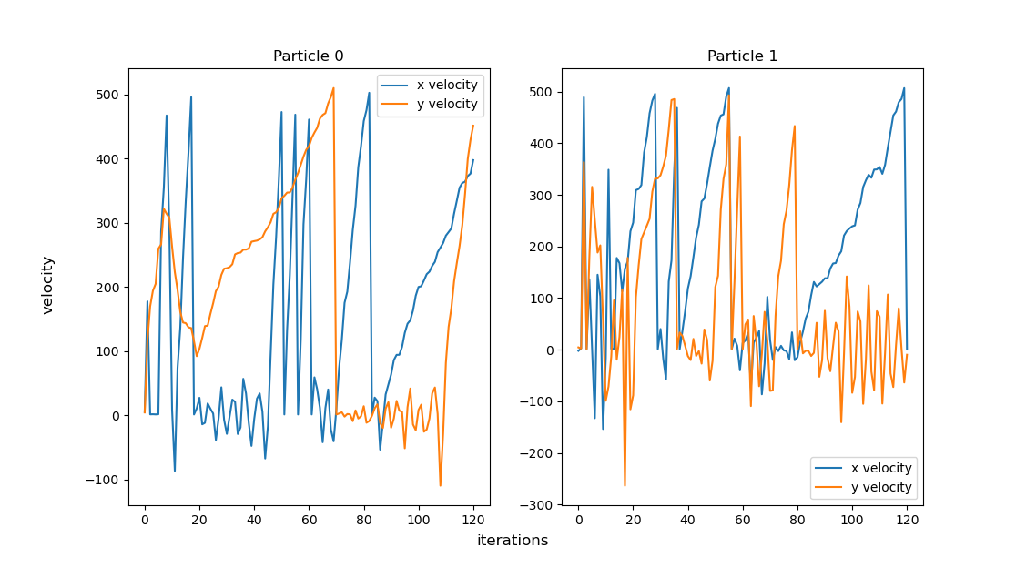


Figure 3. Historical velocity values of two randomly picked particles of a PSO with swarm size=250, iterations=100, star topology, full model. No inertia. No constriction. The velocities are restricted in [-512, 512].
Figure 4. Behavior of PSO with swarm size=250, iterations=100, star topology, full model. No inertia. No constriction. Velocity is restricted in [-512, 512].
2)
I ran the PSO for 10 different random seeds, used to initialize the particles in space. The φ₁ and φ₂ values were set to 2, as recommended in class. To identify a good swarm size and number of iterations, I did sensitivity analysis. Appendix A shows the effect of different swarm sizes on the PSO. Best results are obtained for a swarm size of 750 particles. However, PSO loses its real-time capabilities. As can also be observed in Appendix A, all swarm sizes higher than 100 give good results, but certainly produce some outliers (with the exception of 750). I decided to choose the highest number of particles for which the algorithm still ran in real or near-real time, with the hope of getting rid of all outliers once inertia is implemented. I chose a particle number of 250. Appendix B shows the effect of the number of iterations on the PSO. Best results are obtained for 500 iterations. That said, 200 iterations produce results that are good, while also guaranteeing PSO real-time properties. I chose to use 200 iterations even when it is not the best configuration, knowing that PSO will improve with the implementation of inertia. Table I shows the results acquired by the PSO for a swarm size of 250 particles and 200 iterations. Fig. 5 shows the performance of the PSO with the mentioned configuration. This version of the PSO does not seem to be random-seed-dependent. Convergence happens very quickly in the execution. The solutions are close to the global optimum for all seeds. PSO cannot find the absolute global optimum, because its local search capability is quite poor at this point.

Table I. Results of the PSO for 10 different random seeds and swarm size equal to 250. The algorithm ran for a total of 200 iterations. The configuration is full mode, star topology, φ1 = φ2 =2, no inertia factor, no constriction coefficient.
 |  | Random seeds
iterations | swarm size | 776 | 12 | 234 | 9238 | 123556 | 59933 | 98232 | 85732 | 5432 | 12291
200 | 250 | -959.50 | -958.78 | -958.91 | -958.88 | -958.34 | -958.63 | -959.02 | -958.49 | -958.19 | -958.87

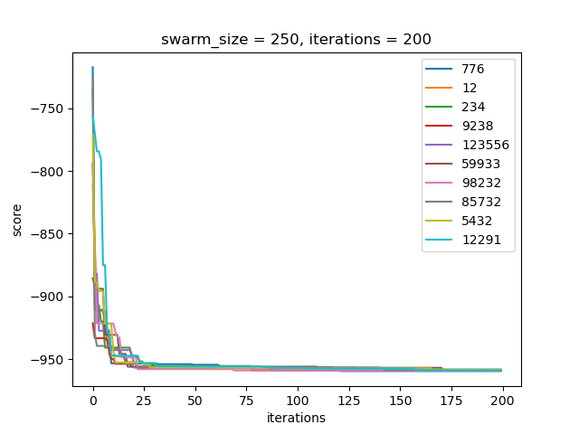
Figure 5. Performance of the PSO algorithm for swarm size=250, iterations=200, φ₁=2, φ₂=2 and star neighborhood topology.
3.1)

I changed the PSO to cognition only, by setting φ₂ to 0. I ran the algorithm again for 10 random seeds. I picked a random seed and observed its behavior, which is illustrated in Fig. 6. The results for all seeds are illustrated in Table II and Fig. 7. The apparent difference from the full model, is that the PSO takes many more iterations to converge. The algorithm appears to not be affected much by the random seed.

Figure 6. Behavior of PSO with swarm size=250, iterations=200, star topology, cognition model. No inertia. No constriction. Velocity is restricted in [-512, 512].

Table II. Results of the PSO for 10 different random seeds and swarm size equal to 250. The algorithm ran for a total of 200 iterations. This configuration is “cognition only”, meaning that φ₂ is set to 0.
 |  | Random seeds
iterations | swarm size | 776 | 12 | 234 | 9238 | 123556 | 59933 | 98232 | 85732 | 5432 | 12291
200 | 250 | -952.78 | -956.87 | -954.97 | -953.31 | -958.30 | -953.56 | -958.36 | -954.11 | -959.45 | -958.66

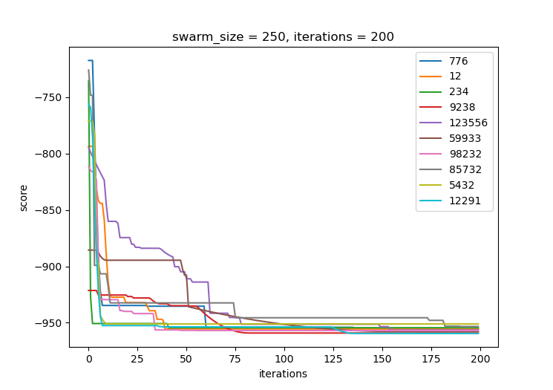
Figure 7. Performance of the PSO algorithm for swarm size=250, iterations=200, φ₁=2, φ₂=0 and star neighborhood topology.

3.2)
I changed the PSO to social only, by setting φ₁ to 0. I ran the algorithm again for 10 random seeds. The results are illustrated in Table III and Fig. 8. In this version, PSO converges fast and typically generates really good results. However, as observed for seed 59933, it can get trapped in a local optimum.

Table III. Results of the PSO for 10 different random seeds and swarm size equal to 250. The algorithm ran for a total of 200 iterations. This configuration is “social only”, meaning that φ₁ is set to 0.
 |  | Random seeds
iterations | swarm size | 776 | 12 | 234 | 9238 | 123556 | 59933 | 98232 | 85732 | 5432 | 12291
200 | 250 | -959.55 | -959.17 | -959.29 | -959.50 | -959.24 | -894.57 | -959.25 | -959.27 | -959.36 | -959.47

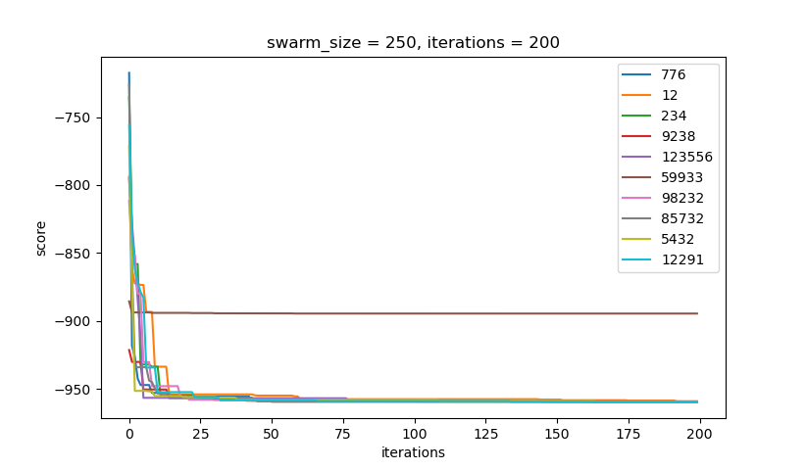

Figure 8. Performance of the PSO algorithm for swarm size=250, iterations=200, φ₁=0, φ₂=2 and star neighborhood topology.

3.3)
I changed the PSO to selfless. I first set φ₁ to 0. Furthermore, the social part of the velocity vector of the particle with the best p-fitness is modified based on the second-best particle in the neighborhood. I ran the algorithm for 10 random seeds. The results are illustrated in Table IV and Fig. 9. The PSO can achieve very good solutions quickly. However, the risk of getting trapped in a local optimum remains, as observed for seeds 12291 and 59933.

Table IV. Results of the PSO for 10 different random seeds and swarm size equal to 250. The algorithm ran for a total of 200 iterations. This configuration is “selfless”, meaning that φ₁ is set to 0 and the velocity of the best particle is adjusted based on the p-vector of the second-best particle in the neighborhood.
 |  | Random seeds
iterations | swarm size | 776 | 12 | 234 | 9238 | 123556 | 59933 | 98232 | 85732 | 5432 | 12291
200 | 250 | -959.42 | -894.58 | -959.43 | -958.82 | -959.16 | -894.57 | -959.48 | -894.58 | -959.63 | -786.52

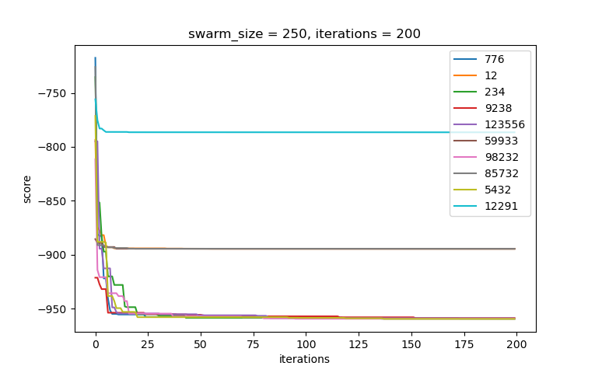
Figure 9. Performance of the PSO algorithm for swarm size=250, iterations=200, φ₁=0, φ₂=2, selfless model, and star neighborhood topology.

3.4)
I changed the PSO to a “ring topology” neighborhood. Each particle “communicates” with two other particles. The social part of the velocity vector is affected by the p-vector of the best neighbor. The neighbors are randomly assigned at the beginning. The neighbors do not change dynamically based on a metric (e.g., Euclidean distance). I ran the algorithm for 10 random seeds. The behavior of PSO can be observed in Fig 10. The results are illustrated in Table V and Fig. 11. A noticeable observation is that this version of PSO converges much slower than the “full”, “social”, and “selfless” models with star neighborhood topology, but faster than the “cognition” model. The main advantage of this version is that it is less likely to be trapped in local optima.

Table V. Results of the PSO for 10 different random seeds and swarm size equal to 250. The algorithm ran for a total of 200 iterations. The neighborhood topology is “ring”. φ₁ = φ₂ = 2.
 |  | Random seeds
iterations | swarm size | 776 | 12 | 234 | 9238 | 123556 | 59933 | 98232 | 85732 | 5432 | 12291
200 | 250 | -958.28 | -956.83 | -957.10 | -956.34 | -956.22 | -957.93 | -958.71 | -957.13 | -956.62 | -955.10


Figure 10. Behavior of PSO with swarm size=250, iterations=200, ring topology, full model. No inertia. No constriction. Velocity is restricted in [-512, 512].
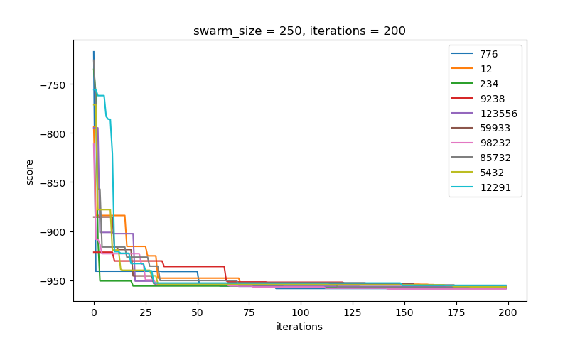
Figure 11. Performance of the PSO algorithm for swarm size=250, iterations=200, φ₁=2, φ₂=2, and ring topology with 2 neighbors.

3.5)
I added the inertia factor ω to the velocity vector calculation. The new velocity vector formula is shown in Equation 3. The inertia factor is initialized to 1.0 and is gradually reduced over time. The inertia of the next iteration (ω΄) is the current inertia (ω) multiplied by 0.99, as illustrated in Equation 4.

$v_{id}=ω v_{id}+φ_{1} rand\left( \right) \left(p_{id}-x_{id}\right)+φ_{2} rand\left( \right) (p_{gd}-x_{id})$ Eq. 3
$ω' = 0.99ω$ Eq. 4

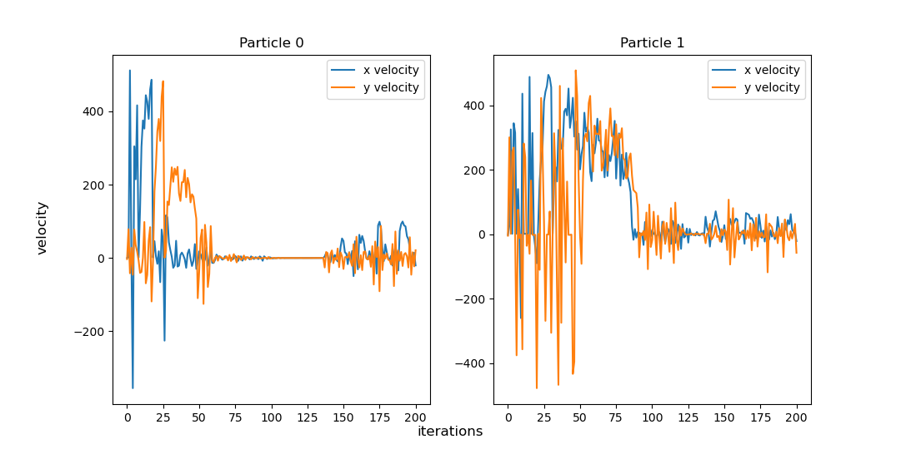
Adding the inertia factor drastically changes the behavior of the velocity vector throughout the runs. Fig. 12 illustrates the historical velocity vector values of two randomly picked particles. As can be observed, velocity experiences a short controlled “explosion” (within [-512, 512]) at the start of PSO but stabilizes over time. This behavior is more desirable, compared to the behavior shown in Fig. 2, because particles get better at local search through the iterations.

Figure 12. Historical velocity values of two randomly picked particles of a PSO with swarm size=250, iterations=200, star topology, full model. This version of the algorithm implements the inertia factor.

I ran the algorithm for 10 random seeds. The results are illustrated in Table VI and Fig. 13. The behavior of the particles is observable in Fig.14. As PSO reaches the iteration limit, the search transitions from a global to a local search, which helps fine-tune the particle’s position to a local or global minimum.

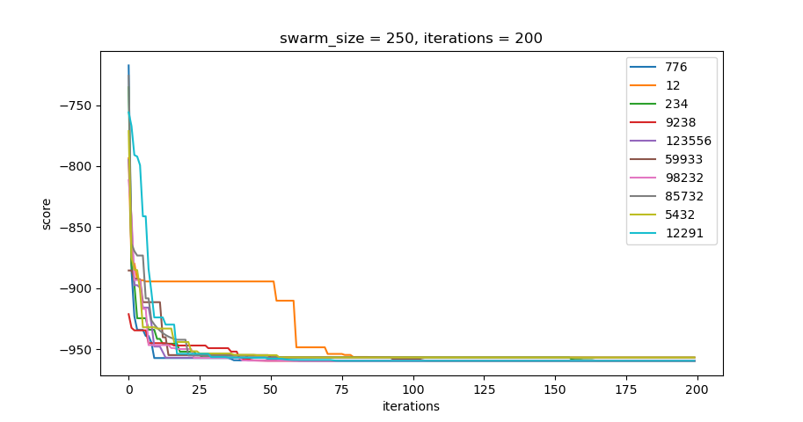
Table VI. Results of the PSO for 10 different random seeds and swarm size equal to 250. The algorithm ran for a total of 200 iterations. The neighborhood topology is “star”. φ₁ = φ₂ = 2. The inertia factor was implemented
 |  | Random seeds
iterations | swarm size | 776 | 12 | 234 | 9238 | 123556 | 59933 | 98232 | 85732 | 5432 | 12291
200 | 250 | -959.64 | -956.92 | -959.64 | -956.92 | -959.64 | -959.64 | -959.64 | -959.64 | -956.92 | -959.64


Figure 13. Performance of the PSO algorithm for swarm size=250, iterations=200, φ₁=2, φ₂=2, and star topology with inertia factor.

Figure 14. Behavior of PSO with swarm size=250, iterations=200, ring topology, full model, and inertia. No constriction. Velocity is restricted in [-512, 512].
3.6)
I removed the inertia factor and added the constriction coefficient K. The new velocity vector calculation is shown in Equation 3. The constriction coefficient K is calculated by the formula shown in Equation 4.

$v_{id}=K\left[v_{id}+φ_{1} rand\left( \right) \left(p_{id}-x_{id}\right)+φ_{2} rand\left( \right) \left(p_{gd}-x_{id}\right)\right]$ (3)
Where $K=\frac{2}{\left|2-φ-\sqrt{φ^{2}-4φ}\right|}$ and $φ=φ_{1}+φ_{2}$, and $φ>4$ (4)

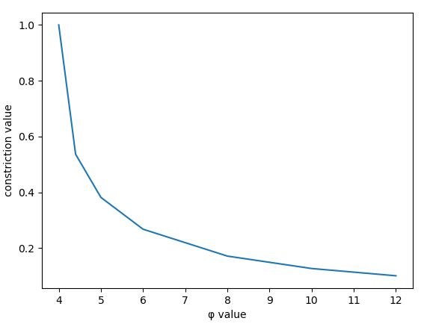
First, I tried different values of φ and calculated the constriction value K to see what happens. A plot of the K value for different φ values is illustrated in Fig. 15. K is not defined for φ<4. For φ=4, K is equal to 1. Also, as φ increases, Κ approximates 0.

Figure 15. Constriction value K over different φ values.

I set φ₁ = φ₂ = 2.2 to get a constriction coefficient K of 0.536675. Fig. 16 illustrates the historical velocity vector values of two randomly picked particles in linear scale. Velocity increases rapidly for the first few iterations and then drops close to 0. Fig. 16 shows the same effect, with emphasis on what happens when the velocities drop close to 0, using logarithmic scale. As can be seen, velocity does not truly drop to 0, but oscillates between very small values.
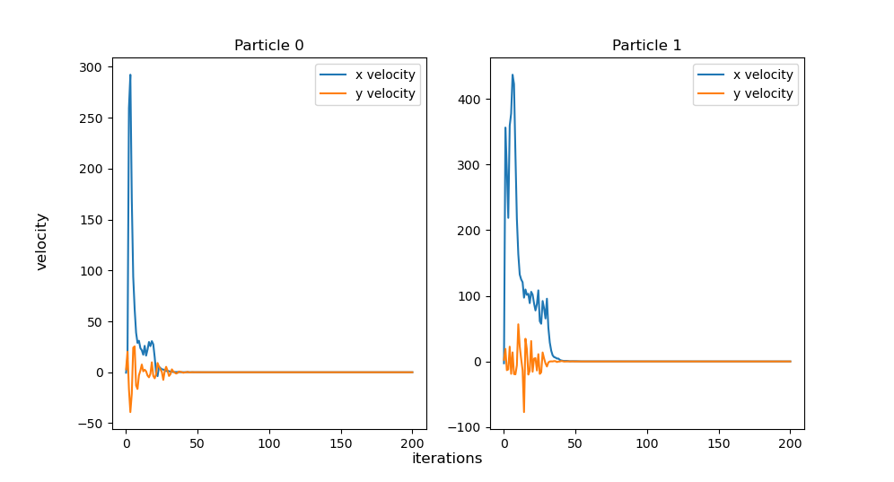

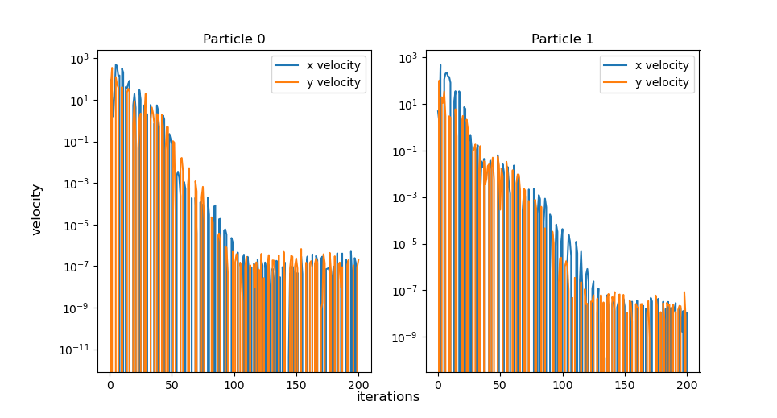
Figure 16. Particle velocities with constriction coefficient K=0.536675. (Linear scale).

Figure 17. Particle velocities with constriction coefficient K=0.536675. (Logarithmic scale).

I ran the PSO for 10 different seeds. The results are illustrated in Table VII and Fig. 18. I observe rapid convergence for the first iterations, getting very close to the global optimum for most of the runs. Sometimes, PSO gets stuck to a local minimum (e.g., for seed 234).

Table VII. Results of the PSO for 10 different random seeds and swarm size equal to 250. The algorithm ran for a total of 200 iterations. The neighborhood topology is “star”. φ₁ = φ₂ = 2.2. The constriction coefficient K is implemented.
 |  | Random seeds
iterations | swarm size | 776 | 12 | 234 | 9238 | 123556 | 59933 | 98232 | 85732 | 5432 | 12291
200 | 250 | -959.64 | -956.92 | -959.64 | -956.92 | -956.92 | -956.92 | -956.92 | -959.64 | -959.64 | -959.64
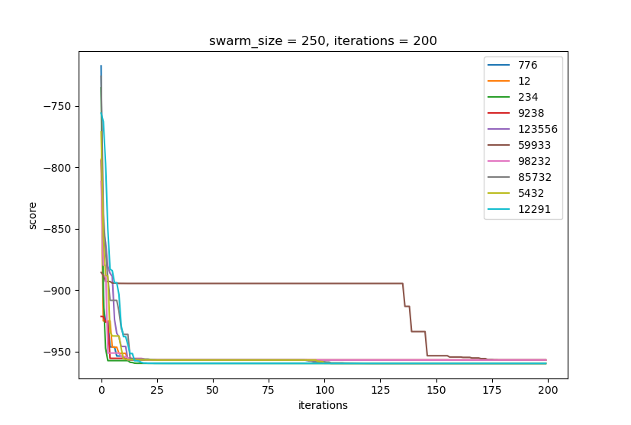

Figure 18. Performance of the PSO algorithm for swarm size=250, iterations=200, φ₁=2.2, φ₂=2.2, and star topology with the constriction coefficient.

3.7)
I added the inertia factor again. This time PSO runs with both inertia and constriction. I ran the algorithm for 10 random seeds. Results are displayed in Table VIII and Fig. 19. I did not find this version of PSO to be the best. I observed that in this configuration the algorithm is susceptible to sticking to local optima. I believe the velocity dampening is more than required.
Table VIII. Results of the PSO for 10 different random seeds and swarm size equal to 250. The algorithm ran for a total of 200 iterations. The neighborhood topology is “star”. φ₁ = φ₂ = 2.2. Both the inertia factor and the constriction coefficient K are implemented.
 |  | Random seeds
iterations | swarm size | 776 | 12 | 234 | 9238 | 123556 | 59933 | 98232 | 85732 | 5432 | 12291
200 | 250 | -956.92 | -894.58 | -894.58 | -956.92 | -956.92 | -894.58 | -956.92 | -956.92 | -959.64 | -894.58

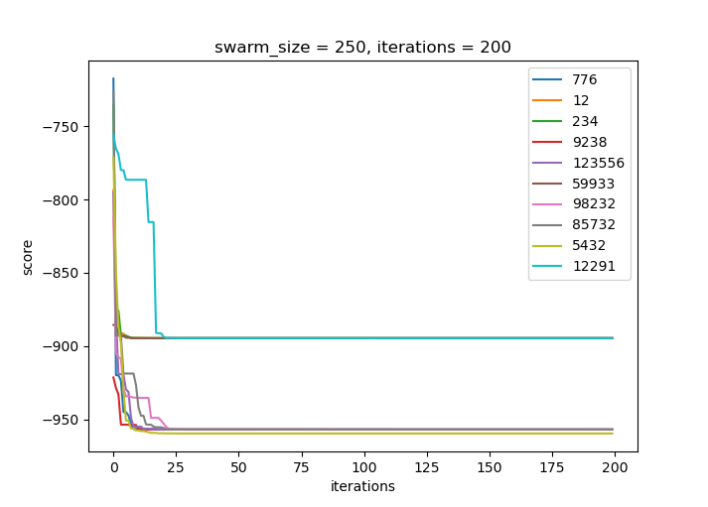
Figure 19. Performance of the PSO algorithm for swarm size=250, iterations=200, φ₁=2.2, φ₂=2.2, and star topology with inertia factor and constriction coefficient.

3.8)
I ran the PSO with inertia and constriction for 3 different swarm sizes, namely 100, 250, and 500. Results are displayed in Table IX and Fig. 20. Appendix A shows how the swarm size affects the quality of the solution. Results are not good for swarm size equal to 100. However, concerning the other two swarm sizes, the boxplot does not provide good insight. Table IX shows that for a swarm size of 250, only 1 outlier is produced, where for a swarm size of 500, two outliers are generated. Increasing the swarm size does not seem to improve PSO.
Table IX. Results of the PSO for 10 different random seeds and swarm size equal to 100, 200, and 500. The algorithm ran for a total of 200 iterations. The neighborhood topology is “star”. φ₁ = φ₂ = 2.2. Both the inertia factor and the constriction coefficient K are implemented.
 |  | Random seed
iterations | swarm size | 776 | 12 | 234 | 9238 | 123556 | 59933 | 98232 | 85732 | 5432 | 12291
200 | 100 | -956.918 | -894.579 | -956.914 | -959.641 | -935.338 | -894.579 | -959.641 | -786.526 | -718.167 | -956.918
200 | 250 | -956.918 | -956.918 | -959.641 | -959.641 | -956.918 | -956.918 | -956.918 | -956.918 | -956.918 | -894.579
200 | 500 | -956.918 | -894.579 | -959.641 | -956.918 | -956.918 | -956.918 | -956.918 | -959.641 | -894.579 | -956.918

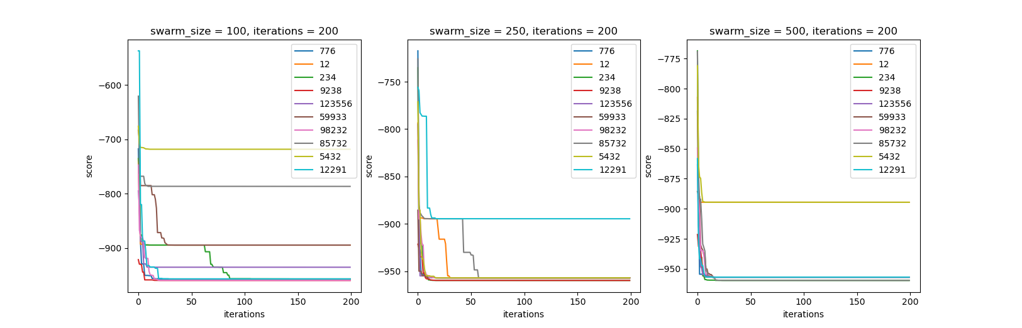

Figure 20. Performance of the PSO algorithm for swarm size=100, 250, and 500, iterations=200, φ₁=2.2, φ₂=2.2, and star topology with inertia factor and constriction coefficient.

3.9) Best PSO version:
I acquired the best results for a PSO of 500 particles that ran for 300 iterations. I restricted the velocities and restarted them by dividing with the absolute value of the boundary when velocities exceeded it. I used inertia, but no constriction, with φ₁=φ₂= 2. The results acquired by the best version of PSO are illustrated in Table X and in Fig. 21. PSO consistently finds the global optimum for all seeds. This version does not run real-time on my computer. Each run takes nearly 4 seconds.

Table X. Results of the PSO for 10 different random seeds and swarm size equal to 500. The algorithm ran for a total of 300 iterations. The neighborhood topology is “star”. φ₁ = φ₂ = 2.0. The inertia factor is implemented.
 |  | Random seeds
iterations | swarm size | 776 | 12 | 234 | 9238 | 123556 | 59933 | 98232 | 85732 | 5432 | 12291
300 | 500 | -959.64 | -959.64 | -959.64 | -959.64 | -959.64 | -959.64 | -959.64 | -959.64 | -959.64 | -959.64

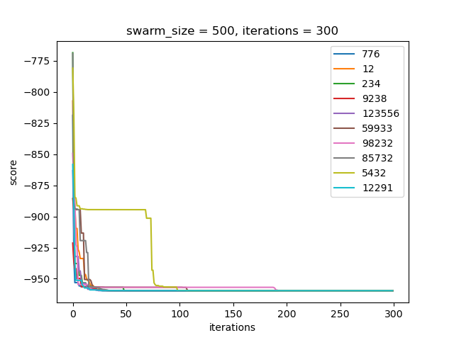

Figure 20. Performance of the best PSO algorithm for swarm size=500, iterations=300, φ₁=φ₂=2, and star topology with inertia factor.

Conclusions:
- PSO is very effective in continuous space, achieving almost real time convergence.
- Different models give the ability for a completely different search strategy.
- The cognition model and the ring neighborhood full model converge slower than the rest of the models but are not as susceptible to sticking to local optima.
- Inertia makes PSO transition towards a local search as the termination criterion is met.
- The inertia reduction rate must be set carefully, according to the termination criterion. If inertia is too high at the end of the execution, local search is weak. If inertia reduces too fast, particles lose their exploration capability early in the execution.
- I am not convinced about the usefulness of constriction. Constriction makes my PSO worse. I believe that a gradual reduction of velocity bounds, using the inertia factor could be as effective.
- Fine-tuning particle velocities and managing infeasible moves is the most effective way to get a potent PSO algorithm.
- Increasing the number of particles certainly helps but comes at a notable performance cost.
- Increasing the number of iterations hinders performance and is not as significant as the rest of the parameters.

The Schwefel function
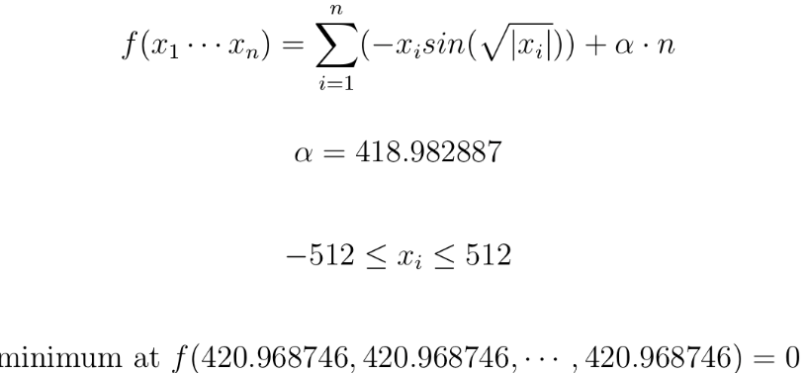

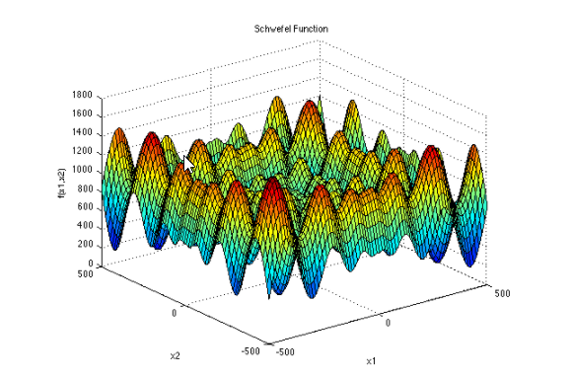
Methodology and results
1)
Encoding:
The encoding I used is the same as the one in the previous homework assignments. I represent a particle’s x and p vectors as an array of real numbers. An example encoding is shown below:
x₁ | x₂ | x₃ | x₄

Particle move operator:
$$x_{id}=x_{id}+v_{id}$$
$$v_{id}=v_{id}+φ_{1} rand\left( \right) \left(p_{id}-x_{id}\right)+φ_{2} rand\left( \right) (p_{gd}-x_{id})$$
where,
i: particle index
d: dimension
g: best particle index

Neighborhood topology:
“Star”/ Global neighborhood.

φ values:
I chose the recommended φ values, φ₁=φ₂=2.

Velocity initialization and restriction:
The velocity vector for each particle is randomly initialized to a value within [-5, 5]. Velocities are restricted to [-512, 512] for each dimension. If a velocity exceeds the bound, it is divided by the absolute value of the bound.

Update policy:
Synchronous

Boundary constraint satisfaction:
If the addition of v_{id} to x_{id} generates a value not in [-512, 512], dimension d is not modified.

2)
I ran the PSO for 10 different random seeds, used to initialize the particles in space. The φ₁ and φ₂ values were set to 2. Table I shows the results acquired by the PSO for a swarm size of 500 particles and 300 iterations. Fig. 1 shows the performance of the PSO with the mentioned configuration. This version of the PSO does not seem to be random-seed-dependent. Convergence happens very quickly in the execution for all seeds except 12291. The solutions are close to the global optimum. PSO cannot find the absolute global optimum, because its local search capability is quite poor at this point.
Table I. Results of the PSO for 10 different random seeds and swarm size equal to 500. The algorithm ran for a total of 300 iterations. The configuration is full mode, star topology, φ1 = φ2 =2, no inertia factor, no constriction coefficient.
 |  | Random seeds
iterations | swarm size | 776 | 12 | 234 | 9238 | 123556 | 59933 | 98232 | 85732 | 5432 | 12291
300 | 500 | 0.7169 | 0.6021 | 1.1276 | 0.4884 | 0.0542 | 0.4543 | 0.0932 | 0.3250 | 0.6037 | 0.2428
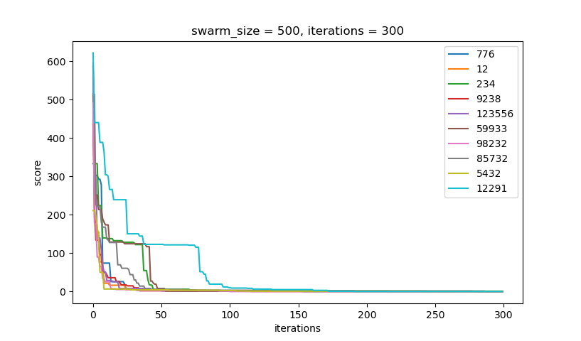
Figure 1. Performance of the PSO algorithm for swarm size=500, iterations=300, φ₁=2, φ₂=2 and star neighborhood topology.

3.1)
I changed the PSO to cognition only, by setting φ₂ to 0. I ran the algorithm again for 10 random seeds. The results are illustrated in Table II and Fig. 2. The apparent difference from the full model, is that the PSO takes many more iterations to converge. This is different than getting stuck to local optima. I believe that, given more iterations, the algorithm would be able to find the global optimum.

Table II. Results of the PSO for 10 different random seeds and swarm size equal to 500. The algorithm ran for a total of 250 iterations. This configuration is “cognition only”, meaning that φ₂ is set to 0.
 |  | Random seeds
iterations | swarm size | 776 | 12 | 234 | 9238 | 123556 | 59933 | 98232 | 85732 | 5432 | 12291
300 | 500 | 122.170 | 50.395 | 38.524 | 26.317 | 3.245 | 58.910 | 12.769 | 5.958 | 57.092 | 134.415

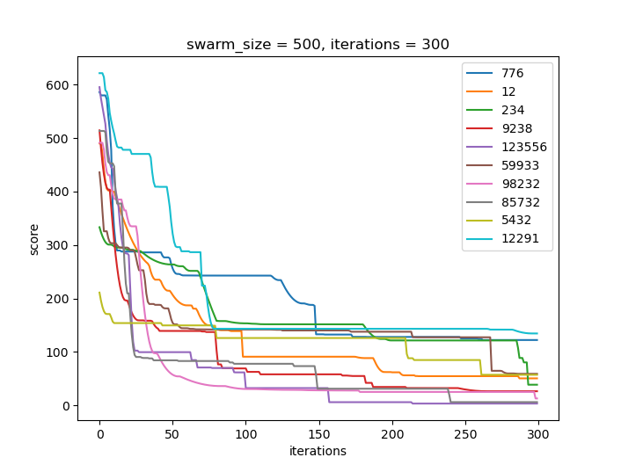
Figure 2. Performance of the PSO algorithm for swarm size=500, iterations=300, φ₁=2, φ₂=0 and star neighborhood topology.

3.2)
I changed the PSO to social only, by setting φ₁ to 0. I ran the algorithm again for 10 random seeds. The results are illustrated in Table III and Fig. 3. In this version, PSO converges fast and typically generates really good results. However, it depends on the random seed. As observed in Fig. 3, for seeds 234 and 5432, the algorithm takes many iterations to converge. For seeds 776 and 12 the PSO gets stuck to local optima.

Table III. Results of the PSO for 10 different random seeds and swarm size equal to 500. The algorithm ran for a total of 300 iterations. This configuration is “social only”, meaning that φ₁ is set to 0.
 |  | Random seeds
iterations | swarm size | 776 | 12 | 234 | 9238 | 123556 | 59933 | 98232 | 85732 | 5432 | 12291
300 | 500 | 115.00 | 118.472 | 0.939 | 0.210 | 0.766 | 0.123 | 0.349 | 0.094 | 0.171 | 0.982

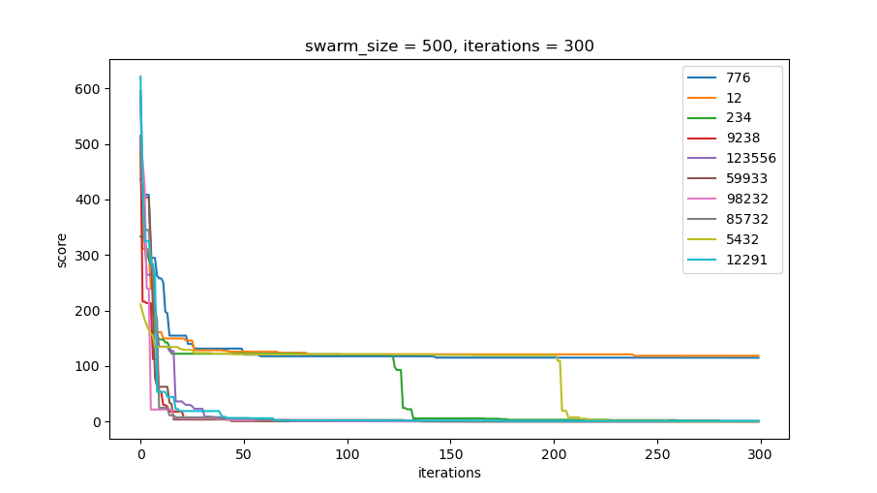
Figure 3. Performance of the PSO algorithm for swarm size=500, iterations=300, φ₁=0, φ₂=2 and star neighborhood topology.

3.3)
I changed the PSO to selfless. I first set φ₁ to 0. Furthermore, the social part of the velocity vector of the particle with the best p-fitness is modified based on the second-best particle in the neighborhood. I ran the algorithm for 10 random seeds. The results are illustrated in Table IV and Fig. 4. The PSO can achieve very good solutions quickly. However, the risk of getting trapped in a local optimum remains, as observed for seed 5432.

Table IV. Results of the PSO for 10 different random seeds and swarm size equal to 500. The algorithm ran for a total of 300 iterations. This configuration is “selfless”, meaning that φ₁ is set to 0 and the velocity of the best particle is adjusted based on the p-vector of the second-best particle in the neighborhood.
 |  | Random seeds
iterations | swarm size | 776 | 12 | 234 | 9238 | 123556 | 59933 | 98232 | 85732 | 5432 | 12291
300 | 500 | 0.4384 | 0.3270 | 0.2567 | 0.2991 | 0.3429 | 0.1610 | 0.3461 | 0.7731 | 116.5832 | 0.1641

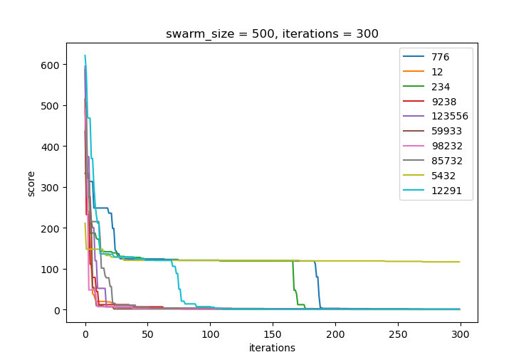
Figure 4. Performance of the PSO algorithm for swarm size=500, iterations=300, φ₁=0, φ₂=2, selfless model, and star neighborhood topology.

3.4)
I changed the PSO to a “ring topology” neighborhood. Each particle “communicates” with two other particles. The social part of the velocity vector is affected by the p-vector of the best neighbor. The neighbors are randomly assigned at the beginning. The neighbors do not change dynamically based on a metric (e.g., Euclidean distance). I ran the algorithm for 10 random seeds. The results are illustrated in Table V and Fig. 5. A noticeable observation is that this version of PSO converges much slower than the “full”, “social”, and “selfless” models with star neighborhood topology, but faster than the “cognition” model. The main advantage of this version is that it is less likely to be trapped in local optima.

Table V. Results of the PSO for 10 different random seeds and swarm size equal to 500. The algorithm ran for a total of 300 iterations. The neighborhood topology is “ring”. φ₁ = φ₂ = 2.
 |  | Random seeds
iterations | swarm size | 776 | 12 | 234 | 9238 | 123556 | 59933 | 98232 | 85732 | 5432 | 12291
300 | 500 | 3.3495 | 3.4995 | 2.7530 | 1.9555 | 0.8543 | 1.7260 | 2.6590 | 2.8821 | 3.6390 | 1.6673

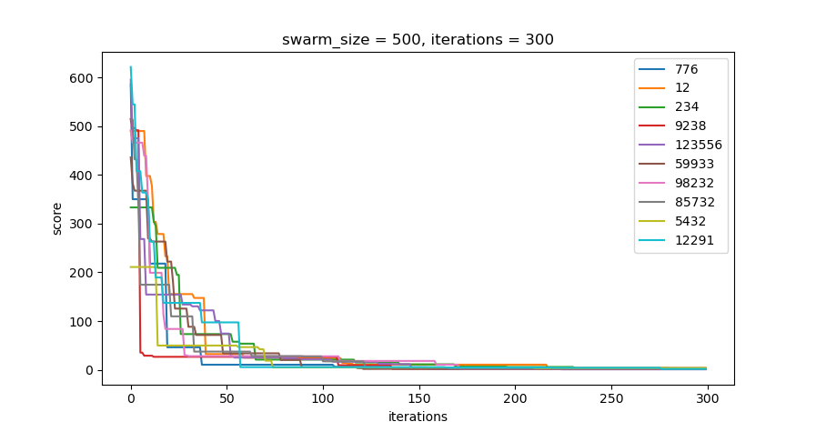

Figure 5. Performance of the PSO algorithm for swarm size=500, iterations=300, φ₁=2, φ₂=2, and ring topology with 2 neighbors.

3.5)
I added the inertia factor ω to the velocity vector calculation. The new velocity vector formula is shown in Equation 3. The inertia factor is initialized to 1.0 and is gradually reduced over time. The inertia of the next iteration (ω΄) is the current inertia (ω) multiplied by 0.99.
I ran the algorithm for 10 random seeds. The results are illustrated in Table VI and Fig. 6. As PSO reaches the iteration limit, the search transitions from a global to a local search, which helps fine-tune the particle’s position to a local or global minimum. PSO consistently reaches the global optimum, since a fine local search was the only missing component.

Table VI. Results of the PSO for 10 different random seeds and swarm size equal to 500. The algorithm ran for a total of 300 iterations. The neighborhood topology is “star”. φ₁ = φ₂ = 2. The inertia factor was implemented.
 |  | Random seeds
iterations | swarm size | 776 | 12 | 234 | 9238 | 123556 | 59933 | 98232 | 85732 | 5432 | 12291
300 | 500 | 0.0000 | 0.0000 | 0.0000 | 0.0000 | 0.0000 | 0.0000 | 0.0000 | 0.0000 | 0.0000 | 0.0000

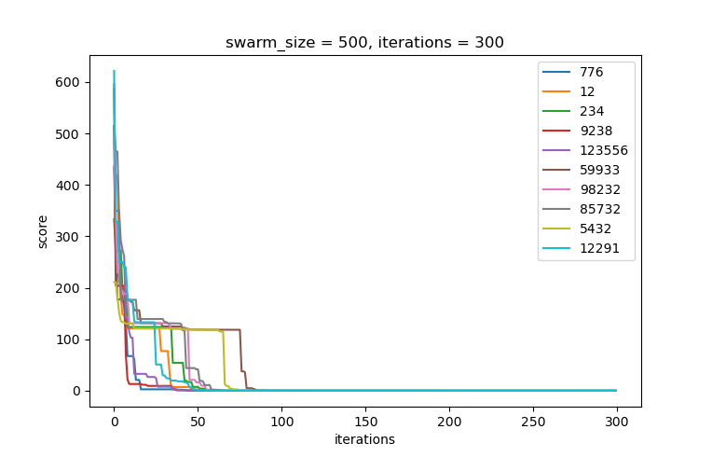
Figure 6. Performance of the PSO algorithm for swarm size=500, iterations=300, φ₁=2, φ₂=2, and star topology with inertia factor.

3.6)
I removed the inertia factor and added the constriction coefficient K, as implemented in the Egg holder function.
I ran the PSO for 10 different seeds. The results are illustrated in Table VII and Fig. 7. I observe rapid convergence for the first iterations, reaching the global optimum for most of the runs. Sometimes, PSO gets stuck to a local minimum (e.g., for seeds 776, 234).

Table VII. Results of the PSO for 10 different random seeds and swarm size equal to 500. The algorithm ran for a total of 300 iterations. The neighborhood topology is “star”. φ₁ = φ₂ = 2.05. The constriction coefficient K is implemented.
 |  | Random seeds
iterations | swarm size | 776 | 12 | 234 | 9238 | 123556 | 59933 | 98232 | 85732 | 5432 | 12291
300 | 500 | 118.438 | 0.000 | 114.761 | 0.000 | 0.000 | 0.000 | 0.000 | 0.000 | 0.000 | 0.000

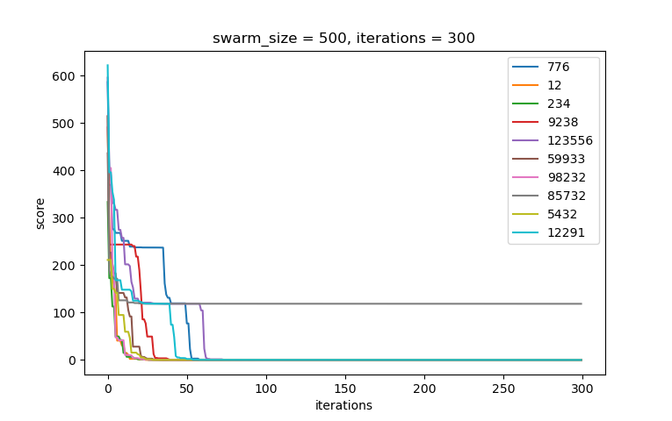
Figure 7. Performance of the PSO algorithm for swarm size=500, iterations=300, φ₁=2.05, φ₂=2.05, and star topology with the constriction coefficient.

3.7)

I added the inertia factor again. This time PSO runs with both inertia and constriction. I ran the algorithm for 10 random seeds. Results are displayed in Table VIII and Fig. 8. I did not find this version of PSO to be the best. I observed that in this configuration the algorithm is susceptible to sticking to local optima.
Table VIII. Results of the PSO for 10 different random seeds and swarm size equal to 500. The algorithm ran for a total of 300 iterations. The neighborhood topology is “star”. φ₁ = φ₂ = 2.05. Both the inertia factor and the constriction coefficient K are implemented.
 |  | Random seeds
iterations | swarm size | 776 | 12 | 234 | 9238 | 123556 | 59933 | 98232 | 85732 | 5432 | 12291
300 | 500 | 0.000 | 0.000 | 0.000 | 0.000 | 0.000 | 0.000 | 0.000 | 0.000 | 0.000 | 118.438

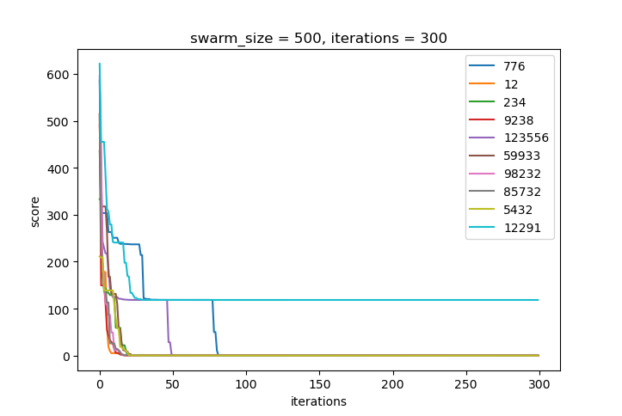
Figure 8. Performance of the PSO algorithm for swarm size=250, iterations=200, φ₁=2.2, φ₂=2.2, and star topology with inertia factor and constriction coefficient.

3.8)
I ran the PSO with inertia and constriction for 3 different swarm sizes, namely 250, 500 and 1000. Results are displayed in Table IX and Fig. 9. This time, for a swarm size of 250, the algorithm gets stuck at a local optimum twice. For a swarm size of 500, PSO finds the global optimum for all seeds. For a swarm size of 1000, PSO finds the global optimum for all seeds. The main difference is that for a large particle number, convergence happens very early in the execution, but at the cost of space complexity.
Table IX. Results of the PSO for 10 different random seeds and swarm size equal to 250, 500, and 1000. The algorithm ran for a total of 300 iterations. The neighborhood topology is “star”. φ₁ = φ₂ = 2.05. Both the inertia factor and the constriction coefficient K are implemented.
 |  | Random seed
iterations | swarm size | 776 | 12 | 234 | 9238 | 123556 | 59933 | 98232 | 85732 | 5432 | 12291
300 | 250 | 118.438 | 0.000 | 0.000 | 0.000 | 0.000 | 0.000 | 0.000 | 0.000 | 0.000 | 118.438
300 | 500 | 0.000 | 0.000 | 0.000 | 0.000 | 0.000 | 0.000 | 0.000 | 0.000 | 0.000 | 0.000
300 | 1000 | 0.000 | 0.000 | 0.000 | 0.000 | 0.000 | 0.000 | 0.000 | 0.000 | 0.000 | 0.000

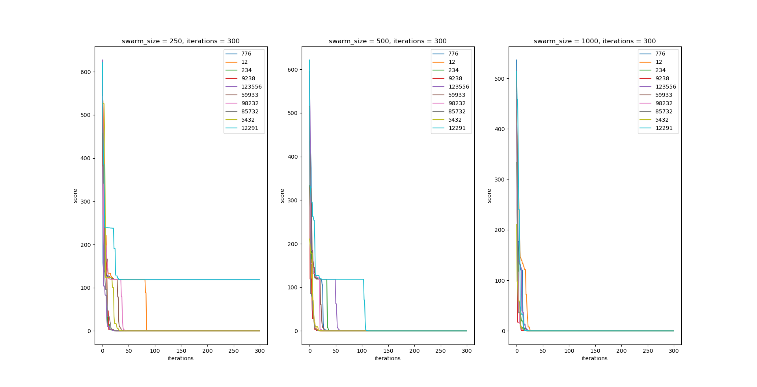
Figure 9. Performance of the PSO algorithm for swarm size=300, 500, and 1000, iterations=300, φ₁=2.05, φ₂=2.05, and star topology with inertia factor and constriction coefficient.

Conclusions:
- The same as in the Egg holder function.

References:
[1] Barrera, J., Álvarez-Bajo, O., Flores, J. J., & Coello Coello, C. A. (2016). Limiting the velocity in the particle swarm optimization algorithm. Computación y Sistemas, 20(4), 635-645.

Appendix A
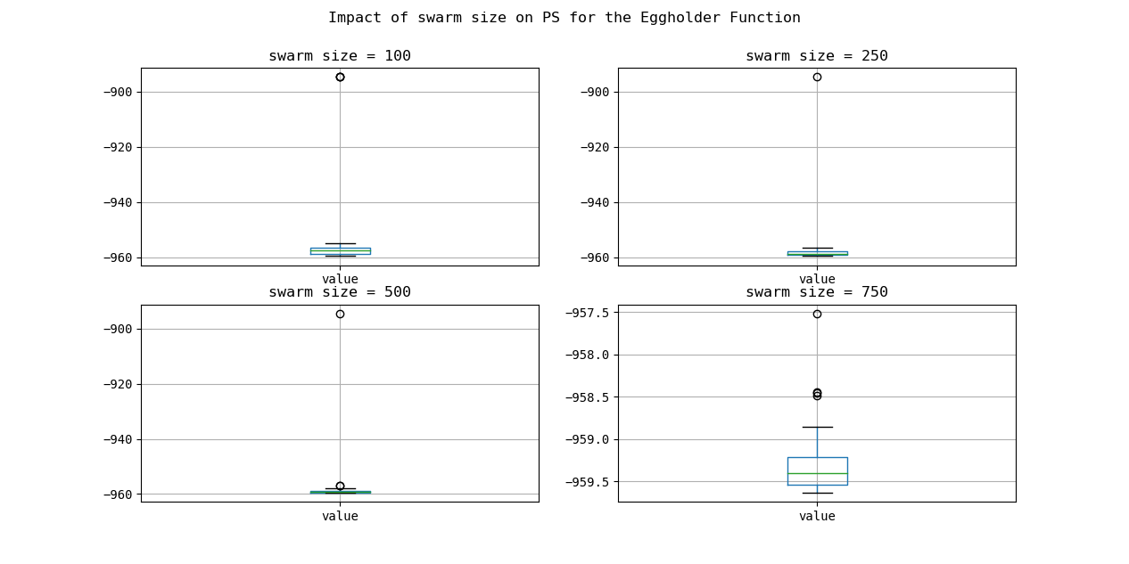
This appendix shows the impact of the number of iterations on the PSO algorithm.

Appendix B
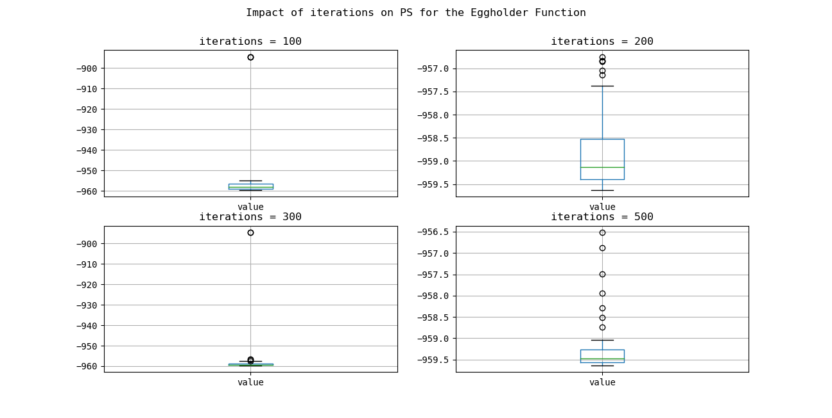
This appendix shows the impact of the number of particles (swarm size) on the PSO algorithm.

Appendix C
This appendix shows the code I wrote to implement PSO.

import numpy as np
from random import sample

import os
import matplotlib.pyplot as plt
import imageio
import math
import matplotlib.pyplot as plt

class ParticleSwarm:

def __init__(self, is_debug):
self.is_debug = is_debug

def calculate_constriction(self,phi1, phi2):
phi = phi1 + phi2
K = 2 / abs(2 - phi - math.sqrt(phi**2 - 4*phi))
return K

def calculate_particle_velocity_limits(self, boundaries):
limits = []
for boundary in boundaries:
x_min = np.min(boundary)
x_max = np.max(boundary)
limit = (x_max-x_min)/2
limits.append(limit)
# print(limits)
return limits

def create_particle_position_gif(self, particles, iterations, seed, model, neighborhood_topology):
filenames = []
x_pos = []
y_pos = []
for i in range(iterations):
for particle in particles:
# if i== iterations-1:
# print(particle.historical_x[-1])
x_pos.append(particle.historical_x[i][0])
y_pos.append(particle.historical_x[i][1])

# print(x_pos, y_pos)
# plot the line chart
plt.title("Iteration: {}".format(i))
plt.scatter(x_pos, y_pos)
plt.ylim(-600,600)
plt.xlim(-600,600)
plt.xlabel("x1 value")
plt.ylabel("x2 value")

# create file name and append it to a list
filename = f'./gifs/{i}.png'
filenames.append(filename)

# save frame
plt.savefig(filename)
plt.close()
x_pos = []
y_pos = []
# build gif
with imageio.get_writer(f'./gifs/{seed}_{model}_{neighborhood_topology}_inertia.gif', mode='I') as writer:
for filename in filenames:
image = imageio.imread(filename)
writer.append_data(image)

# Remove files
for filename in set(filenames):
os.remove(filename)

def pso(self, init_pos_f, iterations, eval_f, seed,
swarm_size, phi1, phi2, neighborhood_topology = "star", model="full",
inertia=True, constriction=True, boundaries=[[-512,512], [-512,512]], velocity_restriction=True, generate_gifs=False):

"""Particle Swarm Optimization algorithm

Parameters:
iterations : maximum number of iterations
eval_f : evaluation function
seed: Random seed for particle initialization
swarm_size: Number of particles in the swarm
phi1: the φ1 value
phi2: the φ2 value
neighborhood_topology: "star" or "ring"
model: "full", "cognition", "social", or "selfless"
inertia: Whether to apply intertia to the velocity vector or not.
constriction: Whether to apply constriction to the velocity vector or not.
boundaries: list of lists with function boundaries for each dimension.
velocity_restriction: Whether or not to restrict the max velocity of the particles.

Returns:
best_list : list of historical best solutions through the iterations
"""

print("Running the particle swarm optimization algorithm...")

# initialization
swarm_list = []
best_list = []
ω = 1
K = 1
particle_velocity_limits=[]

if constriction:
K = self.calculate_constriction(phi1, phi2)

print("Constriction: ",K)

if velocity_restriction:
particle_velocity_limits = self.calculate_particle_velocity_limits(boundaries)

# Generate the particles
initial_positions = init_pos_f(seed, swarm_size)
for i in range(swarm_size):
swarm_list.append(Particle(self.is_debug, initial_positions[i], eval_f, phi1, phi2, model, velocity_restriction))

if neighborhood_topology == "ring":
for particle in swarm_list:
particle.set_neighbors(sample(swarm_list, 2))

if self.is_debug:
print("Swarm size: ", len(swarm_list))
print("PSO will run for {} iterations.".format(iterations))
print("Swarm details:")
for idx, particle in enumerate(swarm_list):
print("Particle number: {}\n Particle x: {}\n Particle v: {}\n"
.format(idx, particle.x_vector, particle.v_vector))

for _ in range(iterations):

for particle in swarm_list:
particle.evaluate()

sorted_particles = sorted(swarm_list, key=lambda particle: particle.p_fitness)
best_particle = sorted_particles[0]
second_best_particle = sorted_particles[1]
if self.is_debug:
print("Best particle X vector: ", best_particle.x_vector)
print("Best particle X fitness: ", best_particle.x_fitness)
print("Best particle P vector: ", best_particle.p_vector)
print("Best particle P fitness: ", best_particle.p_fitness)
best_list.append(best_particle.p_fitness)

for particle in swarm_list:
particle.adjust_v(best_particle, ω, K, second_best_particle, particle_velocity_limits)
particle.move()

if inertia:
ω*=0.99

random_particles = sample(swarm_list,2)
print("Final interia: ", ω)

if generate_gifs:
self.create_particle_position_gif(swarm_list, iterations, seed, model, neighborhood_topology)

return best_list, random_particles

class Particle:

def __init__(self, is_debug, position, eval_f, phi1, phi2, model, velocity_restriction):
self.is_debug = is_debug
self.model = model
self.velocity_restriction = velocity_restriction
self.historical_v = []
self.historical_x = []
self.eval_f = eval_f
self.x_vector = position # Initial position
self.p_vector = self.x_vector
self.v_vector = self.initialize_v_vector(len(position)) # Gradient
self.historical_v.append(self.v_vector)
self.x_fitness = 1e50
self.p_fitness = 1e50
self.neighbors = None

if model == "social" or model == "selfless":
self.phi1 = 0
self.phi2 = phi2
elif model == "cognition":
self.phi1 = phi1
self.phi2 = 0
else:
self.phi1 = phi1
self.phi2 = phi2

def move(self):

for i in range(len(self.x_vector)):
tmp = self.x_vector[i] + self.v_vector[i]
if -512 <= tmp <= 512:
self.x_vector[i] = tmp

def evaluate(self):
self.x_fitness = self.eval_f(self.x_vector)
if self.x_fitness < self.p_fitness:
self.p_fitness = self.x_fitness
self.p_vector = self.x_vector.copy()

# print(self.p_fitness)
self.historical_x.append(self.x_vector.copy())

def adjust_v(self, best_particle, ω, K, second_best_particle, limits):

if self.neighbors:
best_neighbor = sorted(self.neighbors, key=lambda particle: particle.p_fitness)[0]
self.v_vector = [self.v_vector[i] +
self.phi1*np.random.uniform(0,1)*(self.p_vector[i] - self.x_vector[i]) +
self.phi2*np.random.uniform(0,1)*(best_neighbor.p_vector[i] - self.x_vector[i])
for i in range(len(self.x_vector))]
else:
if self.model != "selfless" :
self.v_vector = [K*(ω*self.v_vector[i] +
self.phi1*np.random.uniform(0,1)*(self.p_vector[i] - self.x_vector[i]) +
self.phi2*np.random.uniform(0,1)*(best_particle.p_vector[i] - self.x_vector[i]))
for i in range(len(self.x_vector))]
else:
if best_particle != self:
self.v_vector = [self.v_vector[i] +
self.phi1*np.random.uniform(0,1)*(self.p_vector[i] - self.x_vector[i]) +
self.phi2*np.random.uniform(0,1)*(best_particle.p_vector[i] - self.x_vector[i])
for i in range(len(self.x_vector))]
else:
self.v_vector = [self.v_vector[i] +
self.phi1*np.random.uniform(0,1)*(self.p_vector[i] - self.x_vector[i]) +
self.phi2*np.random.uniform(0,1)*(second_best_particle.p_vector[i] - self.x_vector[i])
for i in range(len(self.x_vector))]

if self.velocity_restriction:
for i in range(len(self.v_vector)):
if self.v_vector[i] < -limits[i]:
self.v_vector[i] = self.v_vector[i]/limits[i]
elif self.v_vector[i] > limits[i]:
self.v_vector[i] = self.v_vector[i]/limits[i]

self.historical_v.append(self.v_vector)

def initialize_v_vector(self, size):
return np.ndarray.tolist(np.random.uniform(-5,5,size))

def set_neighbors(self, neighbors):
self.neighbors = neighbors

def generate_init_positions(seed, swarm_size):
"""
Generates the initial particle position within function limits.
"""
rng = np.random.default_rng(seed)
return [np.ndarray.tolist(rng.uniform(-512,512,2)) for _ in range(swarm_size)]

def eval_func(particle):
"""
Evaluates the current state by
calculating the function result.
"""
# print(particle)

x1 = particle[0]
x2 = particle[1]
f = -(x2+47)*math.sin(math.sqrt(abs(x2 + x1/2 +47))) -x1*math.sin(math.sqrt(abs(x1-(x2+47))))
return f

if __name__ == "__main__":
PSO = ParticleSwarm(is_debug=False)
best_list, random_particles = PSO.pso(init_pos_f=generate_init_positions, iterations=200,
eval_f=eval_func, seed=776, swarm_size=250, phi1=2.2, phi2=2.2,
neighborhood_topology = "star", model="full", inertia=False, constriction=True,
boundaries=[[-512,512], [-512,512]], velocity_restriction=True)

fig, ax = plt.subplots(1,2)
fig.text(0.5, 0.04, 'iterations', ha='center', fontsize=12)
fig.text(0.04, 0.5, 'velocity', va='center', rotation='vertical', fontsize=12)
for idx, particle in enumerate(random_particles):
x_v, y_v = map(list, zip(*particle.historical_v))
ax.flatten()[idx].set_title('Particle {}'.format(idx), fontsize=12)
ax.flatten()[idx].plot(range(len(x_v)),x_v, label="x velocity")
ax.flatten()[idx].plot(range(len(y_v)),y_v, label="y velocity")
ax.flatten()[idx].set_yscale('log')
ax.flatten()[idx].legend()

plt.show()

def constriction_experimentation():
PSO = ParticleSwarm(is_debug=False)
phi_list = [(2,2), (2.2,2.2), (2.5,2.5), (3,3), (4,4), (5,5), (6,6)]
constriction_list = []
phi_total_list = []
for phis in phi_list:
phi_total_list.append(phis[0] + phis[1])
constriction_list.append(PSO.calculate_constriction(phis[0],phis[1]))

plt.ylabel("constriction value")
plt.xlabel("φ value")
plt.plot(phi_total_list, constriction_list)
plt.show()

import numpy as np
from particle_swarm import ParticleSwarm
import matplotlib.pyplot as plt
import math
import pandas as pd

class EGGHOLDER:

def __init__(self, is_debug):
self.is_debug = is_debug

def generate_init_positions(self, seed, swarm_size):
"""
Generates the initial particle position within function limits.
"""
rng = np.random.default_rng(seed)
return [np.ndarray.tolist(rng.uniform(-512,512,2)) for _ in range(swarm_size)]

def eval_func(self, particle):
"""
Evaluates the current state by
calculating the function result.
"""
x1 = particle[0]
x2 = particle[1]
f = -(x2+47)*math.sin(math.sqrt(abs(x2 + x1/2 +47))) -x1*math.sin(math.sqrt(abs(x1-(x2+47))))
return f

def solve_eggholder(self):
"""
Calls the PS for the eggholder function problem and plots the results.
"""

# fig = plt.figure(figsize=(10, 5))
PS = ParticleSwarm(is_debug=self.is_debug)
data = []

headers = ['iterations', 'swarm_size', 776, 12, 234, 9238, 123556, 59933, 98232, 85732, 5432, 12291]
# seeds = [123556]
seeds = [776, 12, 234, 9238, 123556, 59933, 98232, 85732, 5432, 12291]
# iterations_list=[50,100,200,300]
iterations_list=[100, 200, 300, 500]
phi_list = [2.05, 2.05]
# t_size_list=[9, 10, 11]
# swarm_size_list=[100,200,400,800]
swarm_size_list=[100, 250, 500, 750]

for iterations in iterations_list:
for idx, swarm_size in enumerate(swarm_size_list):
# plt.subplot(len(swarm_size_list)//2,3,idx+1)
# plt.title('swarm_size = {:}, iterations = {:}'.format(swarm_size, iterations))
# plt.xlabel('iterations')
# plt.ylabel('score')
best_per_seed = []
for seed in seeds:
best_list, _ = PS.pso(init_pos_f = self.generate_init_positions, swarm_size=swarm_size, iterations=iterations, eval_f=self.eval_func,
seed=seed, phi1=phi_list[0], phi2=phi_list[1],
neighborhood_topology="star", model="full", inertia=False, constriction=False,
boundaries = [[-512, 512], [-512,512]], velocity_restriction = True, generate_gifs=False)

# plt.plot(range(len(best_list)), best_list, label=str(seed))
# plt.legend()

print("Best solution: ", best_list[-1])
best_per_seed.append(best_list[-1])

tmp = [iterations, swarm_size]
tmp.extend(best_per_seed)
data.append(tmp)
# plt.show()
df= pd.DataFrame(data=data, columns= list(map(str, headers)))
print(df)
df.to_excel("../pso_sensitivity_analysis.xlsx")

if __name__ == "__main__":
EGGHOLDER = EGGHOLDER(is_debug=False)

# -959.6407
print("Global optimum is: ", EGGHOLDER.eval_func([512, 404.2319]))

EGGHOLDER.solve_eggholder()

import numpy as np
from particle_swarm import ParticleSwarm
import matplotlib.pyplot as plt
import math
import pandas as pd

class SCHWEFEL:

def __init__(self, is_debug):
self.is_debug = is_debug

def generate_init_positions(self, seed, swarm_size):
"""
Generates the initial particle position within function limits.
"""
rng = np.random.default_rng(seed)
return [np.ndarray.tolist(rng.uniform(-512,512,4)) for _ in range(swarm_size)]

def eval_func(self, particle):
"""
Evaluates the current state by
calculating the function result.
"""

# print (np.sin(np.sqrt(np.abs(particle))))
f = np.sum(np.multiply(np.negative(particle), np.sin(np.sqrt(np.abs(particle))))) + 418.982887*4
return f

def solve_schwefel(self):
"""
Calls the PS for the schwefel function and plots the results.
"""

# fig = plt.figure(figsize=(10, 5))
PS = ParticleSwarm(is_debug=self.is_debug)
data = []

headers = ['iterations', 'swarm_size', 776, 12, 234, 9238, 123556, 59933, 98232, 85732, 5432, 12291]
# seeds = [123556]
seeds = [776, 12, 234, 9238, 123556, 59933, 98232, 85732, 5432, 12291]
# iterations_list=[50,100,200,300]
iterations_list=[300]
phi_list = [2.05, 2.05] #2.05
# t_size_list=[9, 10, 11]
# swarm_size_list=[100,200,400,800]
swarm_size_list=[250, 500, 1000]

for iterations in iterations_list:
for idx, swarm_size in enumerate(swarm_size_list):
plt.subplot(len(swarm_size_list)//2,3,idx+1)
plt.title('swarm_size = {:}, iterations = {:}'.format(swarm_size, iterations))
plt.xlabel('iterations')
plt.ylabel('score')
best_per_seed = []
for seed in seeds:
best_list, _ = PS.pso(init_pos_f = self.generate_init_positions, swarm_size=swarm_size, iterations=iterations, eval_f=self.eval_func,
seed=seed, phi1=phi_list[0], phi2=phi_list[1],
neighborhood_topology="star", model="full", inertia=True, constriction=True,
boundaries = [[-512, 512], [-512,512], [-512, 512], [-512,512]], velocity_restriction = True, generate_gifs=False)

plt.plot(range(len(best_list)), best_list, label=str(seed))
plt.legend()

print("Best solution: ", best_list[-1])
best_per_seed.append(best_list[-1])

tmp = [iterations, swarm_size]
tmp.extend(best_per_seed)
data.append(tmp)
plt.show()
df= pd.DataFrame(data=data, columns= list(map(str, headers)))
print(df)
df.to_excel("../schwefel_300it_vs_10seeds_full_star_incon.xlsx")

if __name__ == "__main__":
SCHWEFEL = SCHWEFEL(is_debug=False)

# 0
print("Global optimum is: ", SCHWEFEL.eval_func([420.968746,420.968746,420.968746,420.968746]))

SCHWEFEL.solve_schwefel()

