Continuous Optimization Using
Particle Swarm Optimization

Homework 6 — Spring 2026

Ehsan Kahrizi

1. Introduction
In this assignment, Particle Swarm Optimization (PSO) is applied to solve two continuous optimization problems: the Eggholder function in two dimensions and the Schwefel function in four dimensions. PSO is a population-based metaheuristic inspired by the social behavior of bird flocking and fish schooling. Each particle in the swarm maintains a position vector (candidate solution), a velocity vector, and memory of its personal best position. The swarm collectively explores the search space by combining individual cognitive experience with social information sharing.
The following components are specified for PSO: (1) termination criterion (maximum iterations), (2) swarm size (number of particles), (3) acceleration coefficients φ₁ and φ₂ controlling cognitive and social influence, (4) neighborhood topology (star/global or ring), and optionally (5) inertia weight and/or constriction coefficient for velocity control. Ten distinct PSO configurations are systematically evaluated across five random seeds each, resulting in 50 runs per function and 100 total runs.

2. Problem Definitions

2.1. The Eggholder Function
The Eggholder function is a two-dimensional optimization benchmark defined as:
f(x) = -(x₂+47)·sin(√|x₂+x₁/2+47|) - x₁·sin(√|x₁-(x₂+47)|)
The domain is -512 < x₁, x₂ < +512, with a known global minimum of f(512, 404.2319) = -959.6407. The function has an extremely rugged landscape with numerous local minima, making it a challenging benchmark for optimization algorithms.
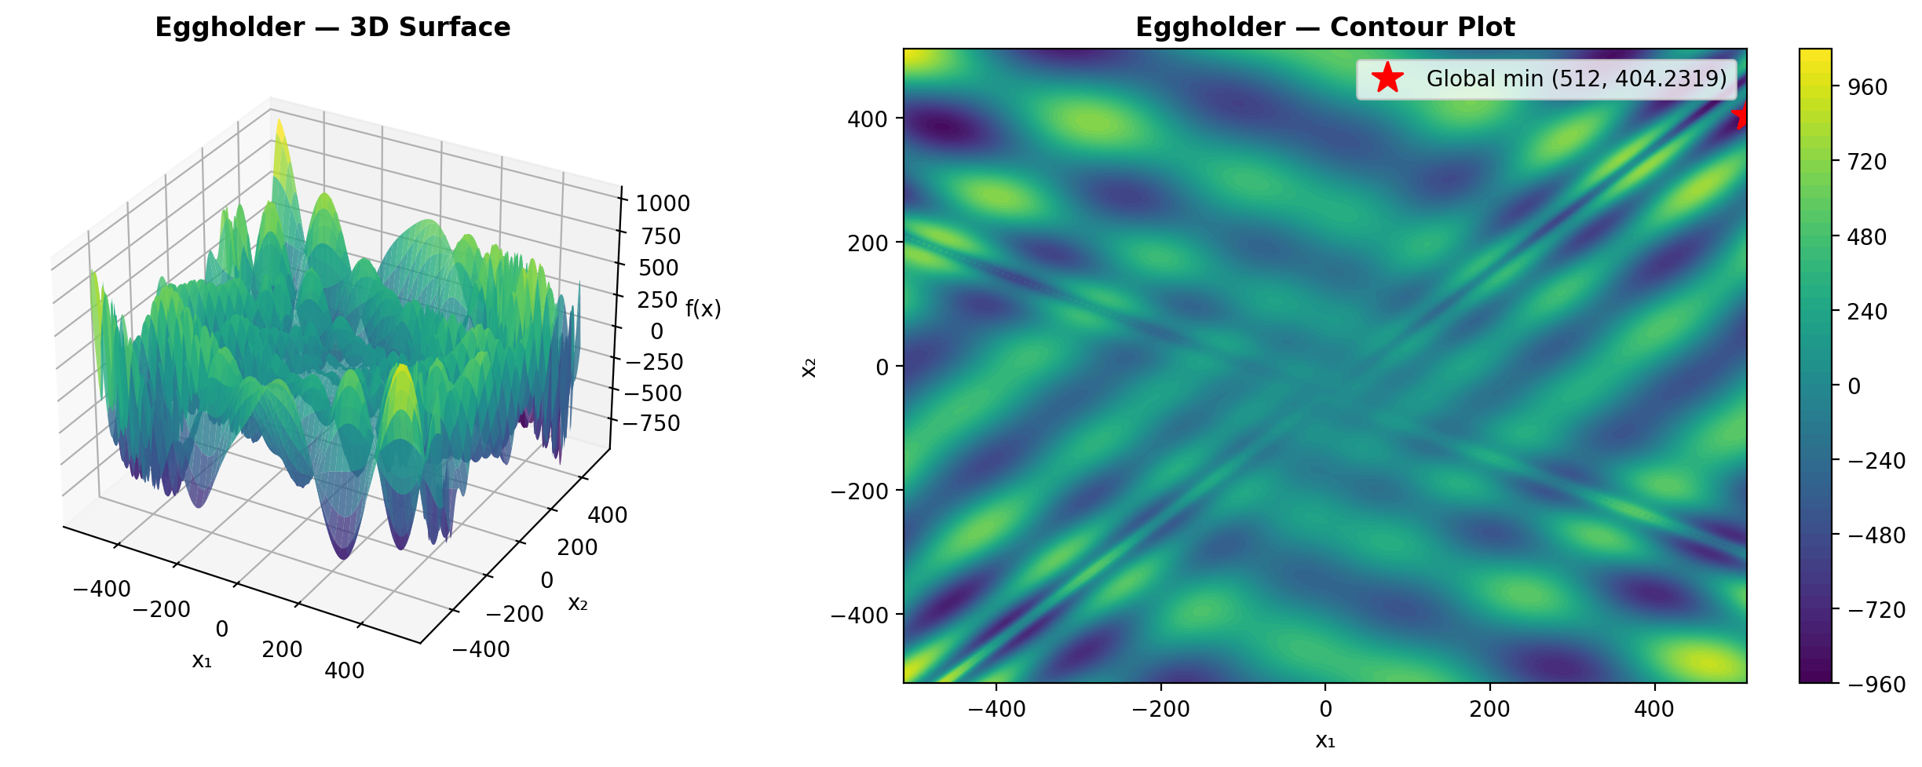
Figure 1. Eggholder function: 3D surface and contour plot.

2.2. The Schwefel Function
The Schwefel function is defined for n dimensions as:
f(x₁,...,xₙ) = Σᵢ(-xᵢ·sin(√|xᵢ|)) + α·n, where α = 418.982887
For this homework, n = 4 dimensions are used with bounds -512 ≤ xᵢ ≤ 512. The global minimum is f(420.968746, 420.968746, 420.968746, 420.968746) = 0. The deceptive nature of this function lies in its many local minima that are far from the global optimum, particularly the large local attractor near x = -512.
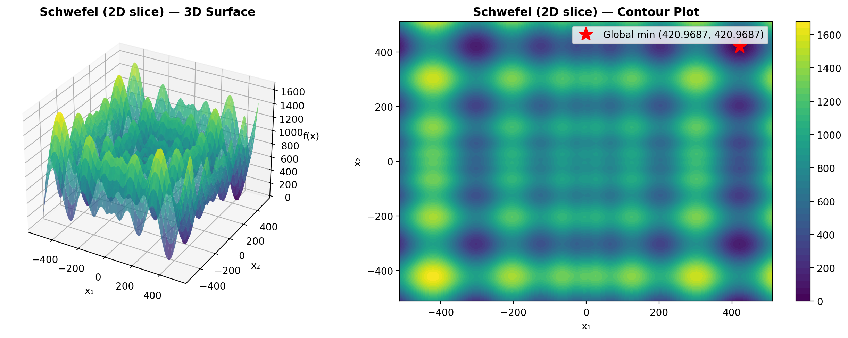
Figure 2. Schwefel function (2D slice): 3D surface and contour plot.

3. Methodology and Definitions

3.1. Solution Encoding
Each particle is represented by a position vector x = (x₁, x₂) for the Eggholder function and x = (x₁, x₂, x₃, x₄) for the Schwefel function. Associated with each particle are a velocity vector v of the same dimensionality, and a personal best position p that stores the best solution found by that particle so far.

3.2. Velocity Update Rule
The standard PSO velocity update for particle i in dimension d is:
vᵢd = vᵢd + φ₁·r₁·(pᵢd - xᵢd) + φ₂·r₂·(pgd - xᵢd)
where r₁, r₂ are uniform random numbers in [0,1], pᵢ is the personal best of particle i, and pg is the best position among particle i's neighbors (determined by the topology). The coefficients φ₁ (cognitive) and φ₂ (social) control the relative influence of individual memory versus social information.

3.3. Parameter Settings
For the base PSO configuration, φ₁ = φ₂ = 2.0 as recommended in the literature. For configurations using constriction, φ₁ = φ₂ = 2.05 (so that φ = 4.1 > 4, which is required for the constriction coefficient to be well-defined). Swarm sizes are 30 particles for the 2D Eggholder and 50 particles for the 4D Schwefel. All configurations run for 500 iterations. Five random seeds (1, 2, 3, 4, 5) are used consistently across all experiments for both functions.

3.4. Velocity Restriction
Velocities are restricted to [Vmin, Vmax] = [-(ub-lb)/2, (ub-lb)/2] = [-512, 512] for each dimension. If a velocity component exceeds the maximum, it is clamped to the boundary value. This prevents particles from exploding out of the feasible region and improves convergence.

3.5. Boundary Constraint Handling
If updating a particle's position would move it outside the bounds [-512, 512], the position is clamped to the nearest boundary and the velocity in that dimension is reset to zero. This absorbing boundary approach prevents particles from leaving the feasible region while allowing them to explore boundary regions.

3.6. Inertia Weight
When enabled, the inertia weight ω is applied to the previous velocity: vᵢd = ω·vᵢd + φ₁·r₁·(pᵢd - xᵢd) + φ₂·r₂·(pgd - xᵢd). The inertia weight decreases linearly from ω_start = 0.9 to ω_end = 0.4 over the course of the run. High initial inertia encourages global exploration, while low final inertia promotes local exploitation near promising regions.

3.7. Constriction Coefficient
When enabled, the constriction coefficient K multiplies the entire velocity vector: vᵢd = K·[vᵢd + φ₁·r₁·(pᵢd - xᵢd) + φ₂·r₂·(pgd - xᵢd)], where K = 2/|2 - φ - √(φ² - 4φ)| and φ = φ₁ + φ₂. For φ₁ = φ₂ = 2.05, K ≈ 0.7298. The constriction factor guarantees convergence without requiring explicit velocity clamping, though clamping is still applied as a safety measure.

3.8. Neighborhood Topologies
Two neighborhood topologies are evaluated: (1) Star (Global) topology, where every particle is a neighbor of every other particle, enabling rapid information propagation but susceptibility to premature convergence. (2) Ring topology, where each particle communicates only with its two adjacent neighbors (left and right in a circular arrangement), which slows convergence but preserves diversity and enables more thorough exploration.

3.9. PSO Models
Four models are tested: (1) Full model with both cognitive (φ₁ > 0) and social (φ₂ > 0) components. (2) Cognition only with φ₂ = 0, where particles rely solely on personal memory. (3) Social only with φ₁ = 0, where particles follow only the neighborhood best. (4) Selfless model with φ₁ = 0 and the constraint that the global best particle g ≠ i, meaning the best particle's social component is guided by the second-best particle.

4. Eggholder Function — Results

4.1. 1. Full Model (Star)
The base PSO configuration uses the full model with star (global) topology, φ₁ = φ₂ = 2.0, 30 particles, 500 iterations, no inertia, and no constriction.
Table 1. Eggholder PSO results — 1. Full Model (Star).
Seed | Best Fitness | Best x₁ | Best x₂ | Runtime (s)
1 | -959.6407 | 512.0000 | 404.2326 | 0.156
2 | -894.1509 | -463.9381 | 384.9203 | 0.142
3 | -959.6407 | 512.0000 | 404.2317 | 0.143
4 | -959.6404 | 512.0000 | 404.2180 | 0.142
5 | -894.4657 | -465.2984 | 386.1655 | 0.143
Mean | -933.5077 | Std: 32.0063 | Best: -959.6407 | Worst: -894.1509

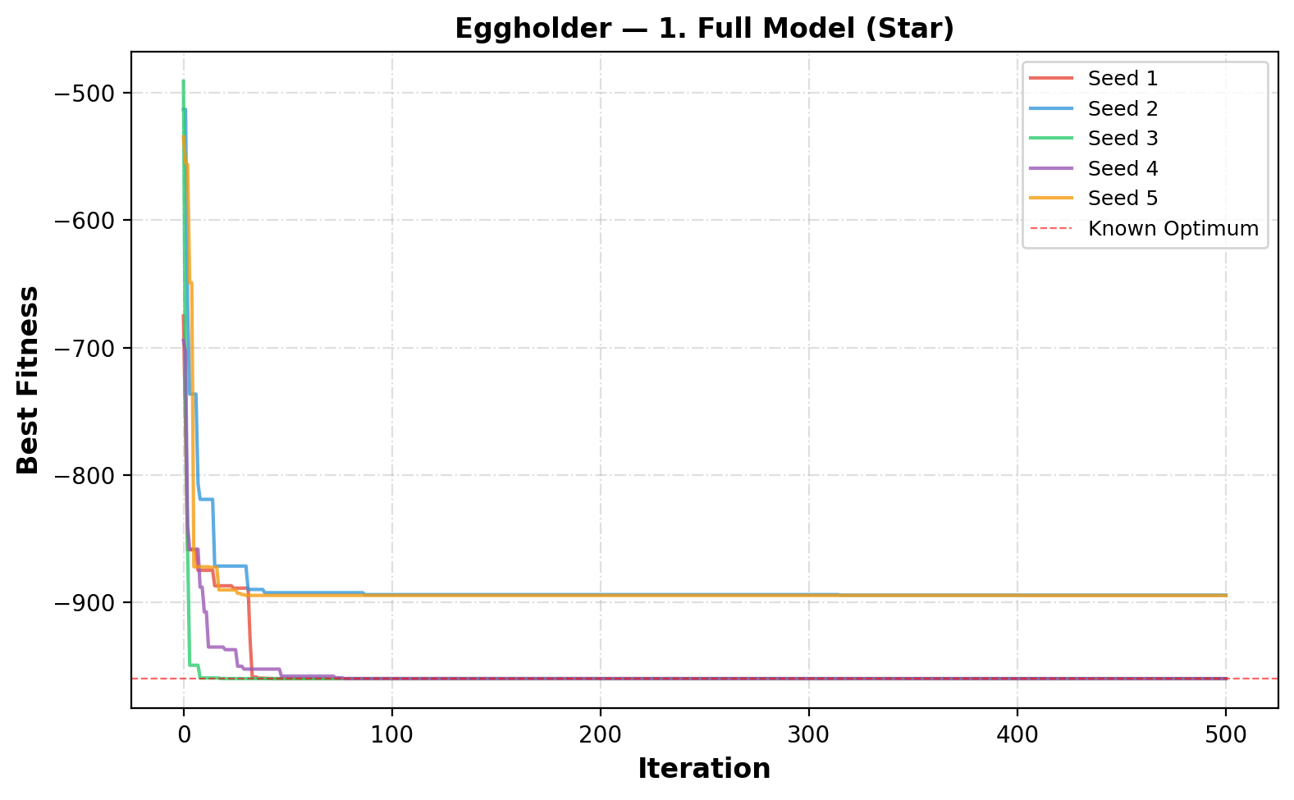
Figure 3. Convergence curves for 1. Full Model (Star) on the Eggholder function.

4.2. 2. Cognition Only (φ₂=0)
The cognition-only PSO sets φ₂ = 0, meaning particles ignore social information and rely solely on their personal best. This results in independent hill-climbing behavior.
Table 2. Eggholder PSO results — 2. Cognition Only (φ₂=0).
Seed | Best Fitness | Best x₁ | Best x₂ | Runtime (s)
1 | -959.6257 | 512.0000 | 404.1171 | 0.139
2 | -959.3798 | 512.0000 | 404.7101 | 0.139
3 | -959.6393 | 512.0000 | 404.2669 | 0.140
4 | -959.6404 | 512.0000 | 404.2462 | 0.140
5 | -959.5960 | 512.0000 | 404.4298 | 0.140
Mean | -959.5762 | Std: 0.0995 | Best: -959.6404 | Worst: -959.3798

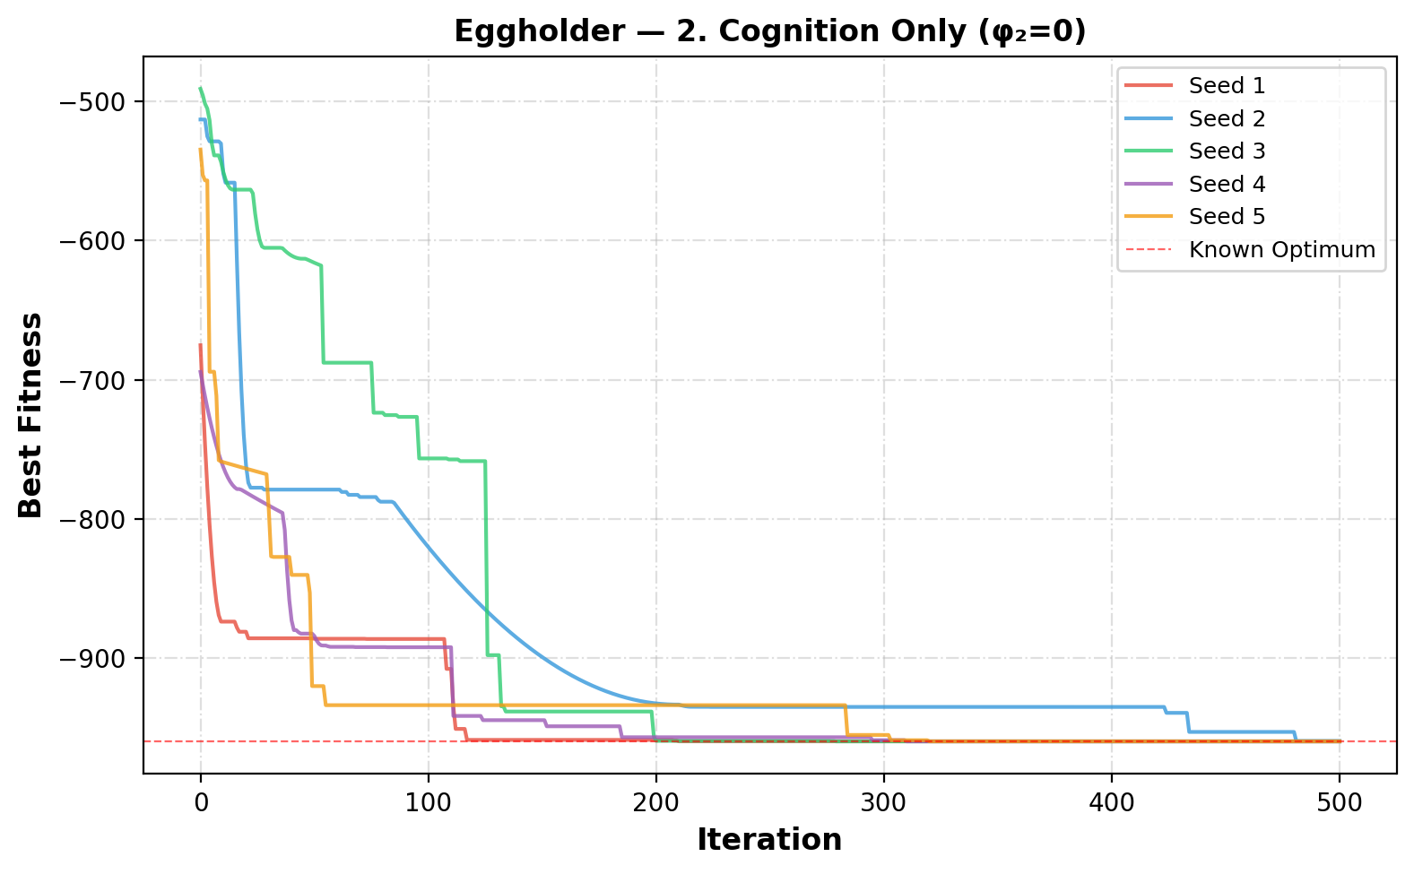
Figure 4. Convergence curves for 2. Cognition Only (φ₂=0) on the Eggholder function.

4.3. 3. Social Only (φ₁=0)
The social-only PSO sets φ₁ = 0, so particles ignore their personal experience and are guided exclusively by the neighborhood best. This causes rapid convergence but often to suboptimal solutions.
Table 3. Eggholder PSO results — 3. Social Only (φ₁=0).
Seed | Best Fitness | Best x₁ | Best x₂ | Runtime (s)
1 | -858.6012 | 356.3570 | 512.0000 | 0.139
2 | -786.5182 | -456.6559 | -382.4537 | 0.140
3 | -858.6009 | 356.3096 | 512.0000 | 0.138
4 | -858.6012 | 356.3450 | 512.0000 | 0.138
5 | -648.4027 | -512.0000 | 397.5467 | 0.138
Mean | -802.1448 | Std: 81.7836 | Best: -858.6012 | Worst: -648.4027

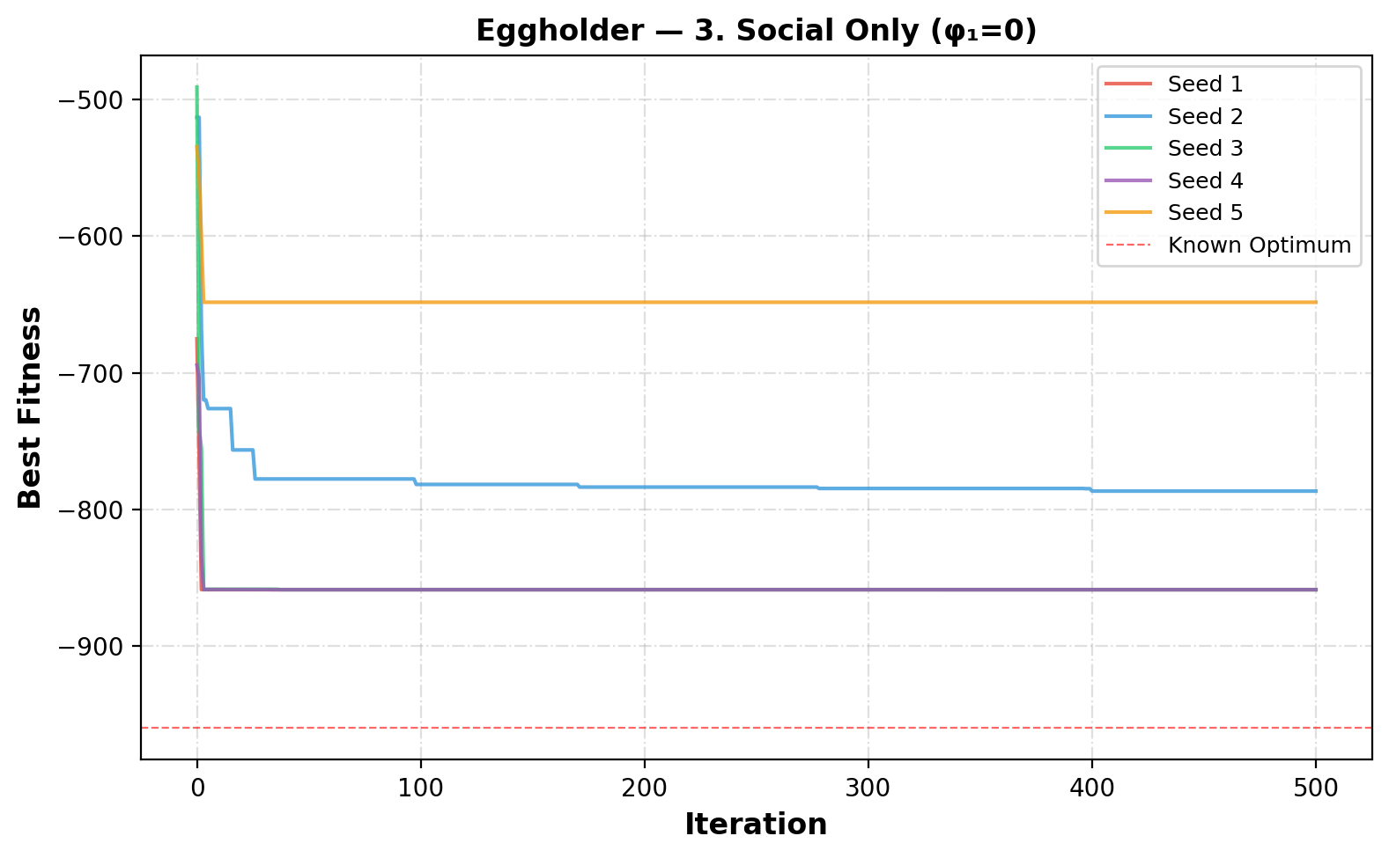
Figure 5. Convergence curves for 3. Social Only (φ₁=0) on the Eggholder function.

4.4. 4. Selfless (φ₁=0, g≠i)
The selfless model sets φ₁ = 0 and ensures the best particle's social component points to the second-best particle instead of itself (g ≠ i). This prevents the best particle from stagnating.
Table 4. Eggholder PSO results — 4. Selfless (φ₁=0, g≠i).
Seed | Best Fitness | Best x₁ | Best x₂ | Runtime (s)
1 | -858.6012 | 356.3570 | 512.0000 | 0.146
2 | -786.3240 | -457.9203 | -383.7347 | 0.148
3 | -858.6009 | 356.3106 | 512.0000 | 0.144
4 | -858.6012 | 356.3442 | 512.0000 | 0.143
5 | -648.4027 | -512.0000 | 397.5467 | 0.143
Mean | -802.1060 | Std: 81.7910 | Best: -858.6012 | Worst: -648.4027

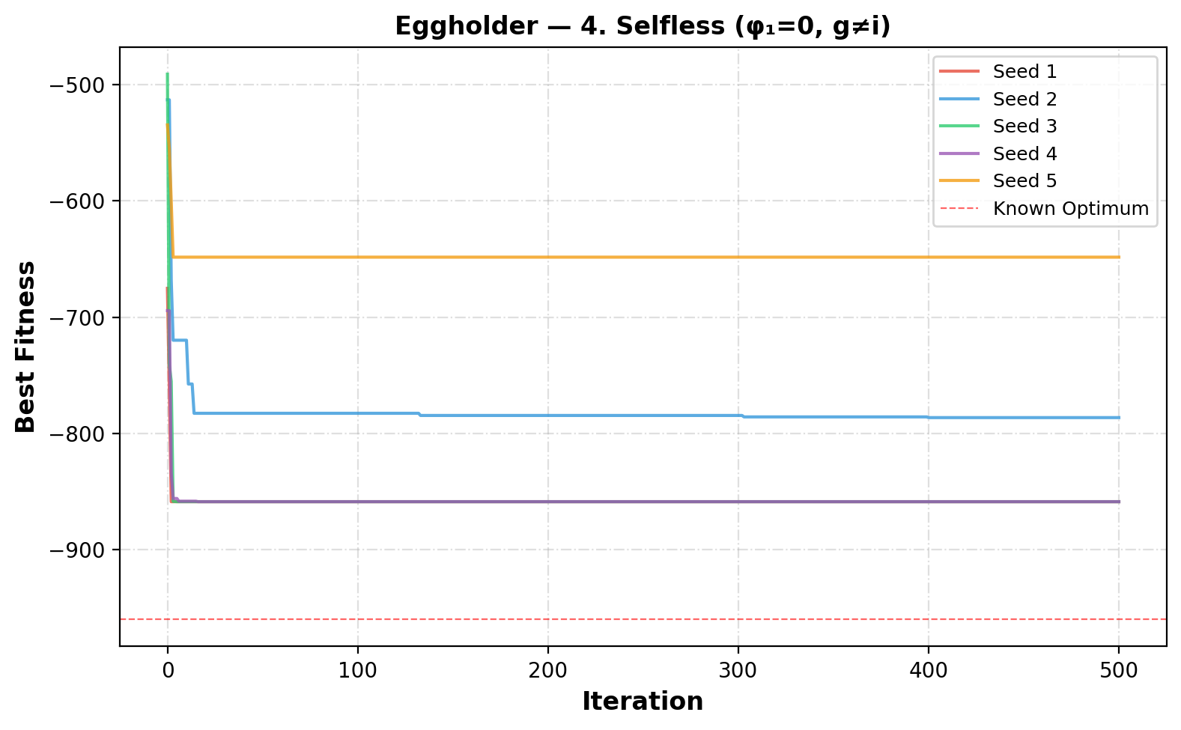
Figure 6. Convergence curves for 4. Selfless (φ₁=0, g≠i) on the Eggholder function.

4.5. 5. Ring Topology (Full)
The ring topology limits each particle to two neighbors (left and right in a circular list). This slows information propagation, enabling better exploration of the search space.
Table 5. Eggholder PSO results — 5. Ring Topology (Full).
Seed | Best Fitness | Best x₁ | Best x₂ | Runtime (s)
1 | -959.6393 | 512.0000 | 404.2661 | 0.114
2 | -959.6396 | 512.0000 | 404.2010 | 0.113
3 | -959.6402 | 512.0000 | 404.2125 | 0.115
4 | -959.6392 | 512.0000 | 404.2674 | 0.114
5 | -959.5233 | 512.0000 | 403.9102 | 0.115
Mean | -959.6163 | Std: 0.0465 | Best: -959.6402 | Worst: -959.5233

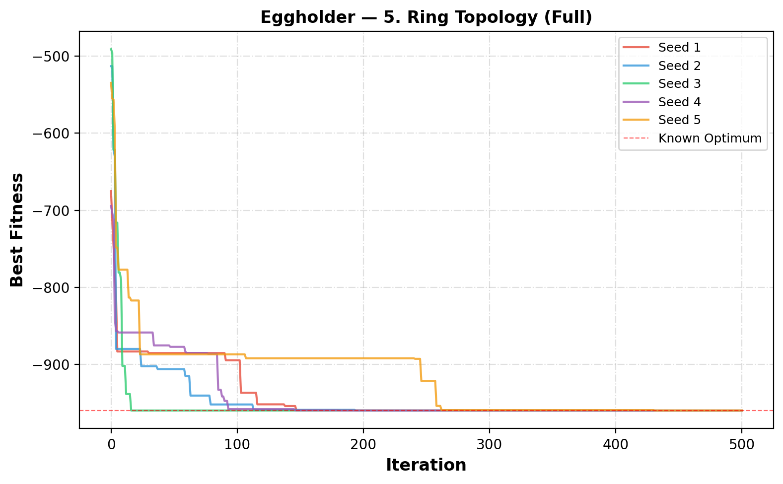
Figure 7. Convergence curves for 5. Ring Topology (Full) on the Eggholder function.

4.6. 6. Inertia (Star, Full)
The inertia weight ω is added, decreasing linearly from 0.9 to 0.4. This transitions PSO from global exploration (high ω) to local exploitation (low ω).
Table 6. Eggholder PSO results — 6. Inertia (Star, Full).
Seed | Best Fitness | Best x₁ | Best x₂ | Runtime (s)
1 | -959.6407 | 512.0000 | 404.2318 | 0.138
2 | -894.5789 | -465.6942 | 385.7167 | 0.137
3 | -959.6407 | 512.0000 | 404.2318 | 0.138
4 | -959.6407 | 512.0000 | 404.2318 | 0.142
5 | -894.5789 | -465.6942 | 385.7167 | 0.137
Mean | -933.6160 | Std: 31.8736 | Best: -959.6407 | Worst: -894.5789

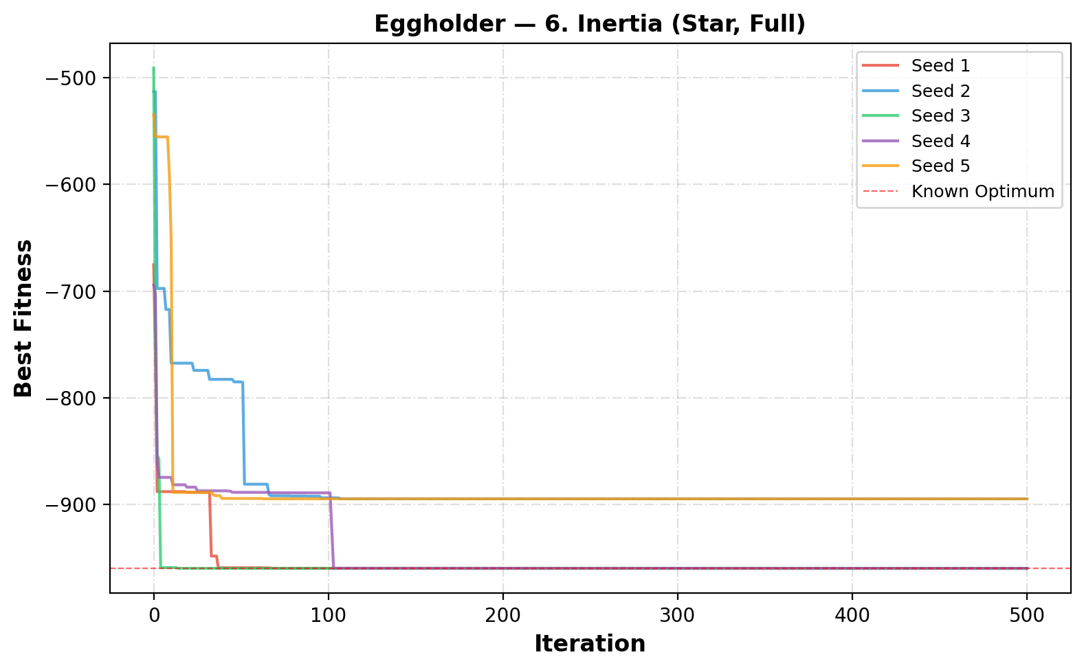
Figure 8. Convergence curves for 6. Inertia (Star, Full) on the Eggholder function.

4.7. 7. Constriction (Star, Full)
The constriction coefficient K ≈ 0.7298 is applied with φ₁ = φ₂ = 2.05. No inertia is used. Constriction guarantees convergence theoretically.
Table 7. Eggholder PSO results — 7. Constriction (Star, Full).
Seed | Best Fitness | Best x₁ | Best x₂ | Runtime (s)
1 | -959.6407 | 512.0000 | 404.2318 | 0.143
2 | -786.5260 | -456.8858 | -382.6234 | 0.142
3 | -959.6407 | 512.0000 | 404.2318 | 0.141
4 | -888.9491 | 347.3270 | 499.4154 | 0.147
5 | -894.5789 | -465.6942 | 385.7167 | 0.142
Mean | -897.8671 | Std: 63.4336 | Best: -959.6407 | Worst: -786.5260

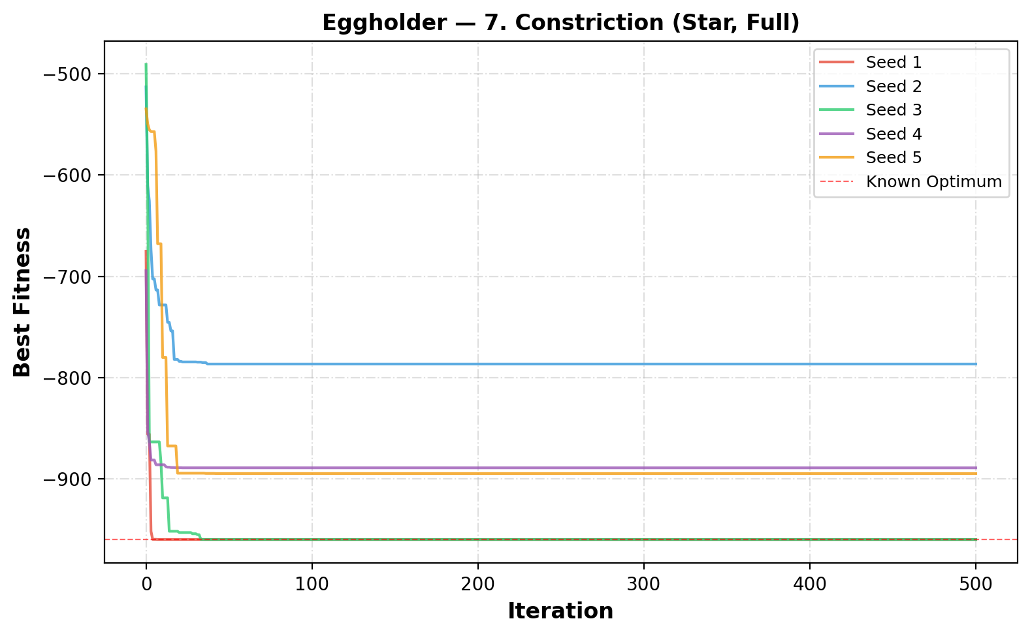
Figure 9. Convergence curves for 7. Constriction (Star, Full) on the Eggholder function.

4.8. 8. Inertia + Constriction
Both inertia weight and constriction coefficient are applied simultaneously, combining the benefits of both velocity control mechanisms.
Table 8. Eggholder PSO results — 8. Inertia + Constriction.
Seed | Best Fitness | Best x₁ | Best x₂ | Runtime (s)
1 | -959.6407 | 512.0000 | 404.2318 | 0.142
2 | -753.0502 | -390.3739 | -415.0902 | 0.142
3 | -959.6407 | 512.0000 | 404.2318 | 0.143
4 | -959.6407 | 512.0000 | 404.2318 | 0.141
5 | -821.1965 | -313.9720 | 512.0000 | 0.141
Mean | -890.6337 | Std: 87.2200 | Best: -959.6407 | Worst: -753.0502

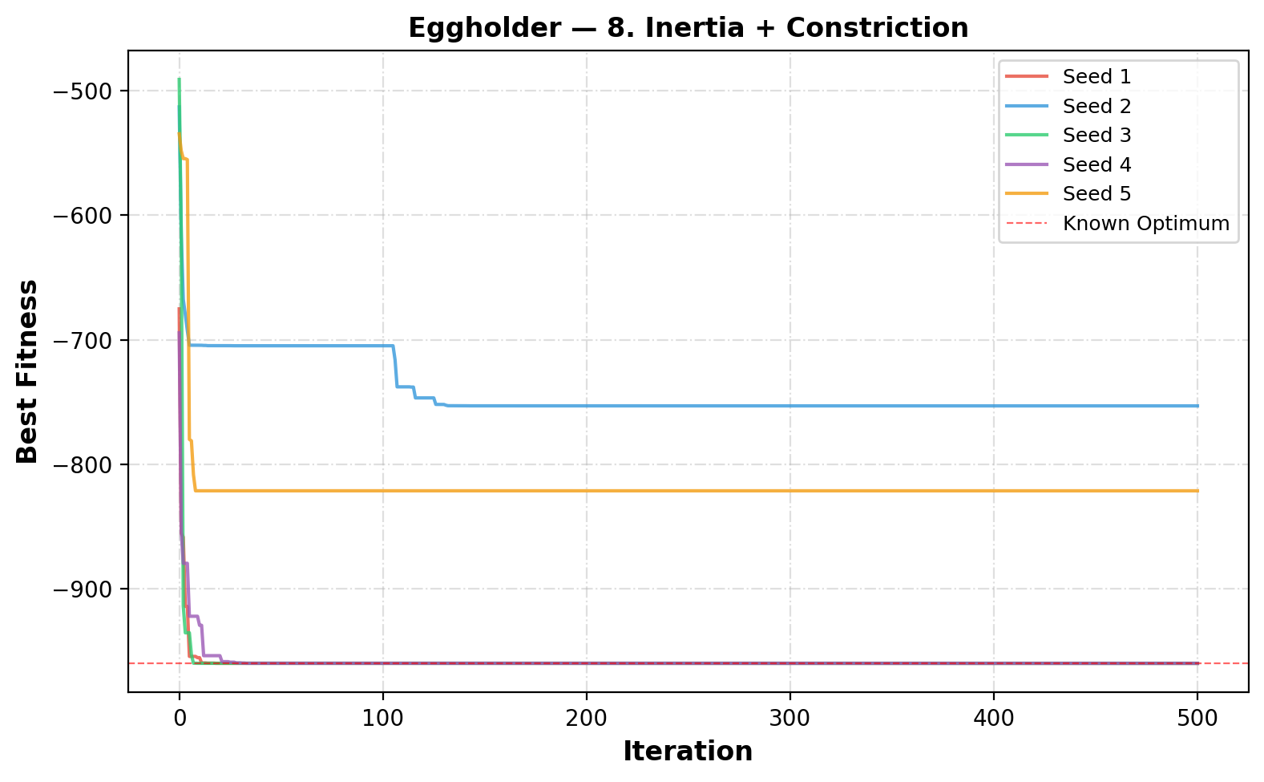
Figure 10. Convergence curves for 8. Inertia + Constriction on the Eggholder function.

4.9. 9a. More Particles (Inertia+Constr)
The swarm size is doubled to 60 particles (from the default 30) using inertia and constriction. Larger swarms provide better coverage of the search space.
Table 9. Eggholder PSO results — 9a. More Particles (Inertia+Constr).
Seed | Best Fitness | Best x₁ | Best x₂ | Runtime (s)
1 | -959.6407 | 512.0000 | 404.2318 | 0.346
2 | -786.5260 | -456.8858 | -382.6234 | 0.345
3 | -894.5789 | -465.6942 | 385.7167 | 0.344
4 | -959.6407 | 512.0000 | 404.2318 | 0.345
5 | -959.6407 | 512.0000 | 404.2318 | 0.346
Mean | -912.0054 | Std: 67.6108 | Best: -959.6407 | Worst: -786.5260

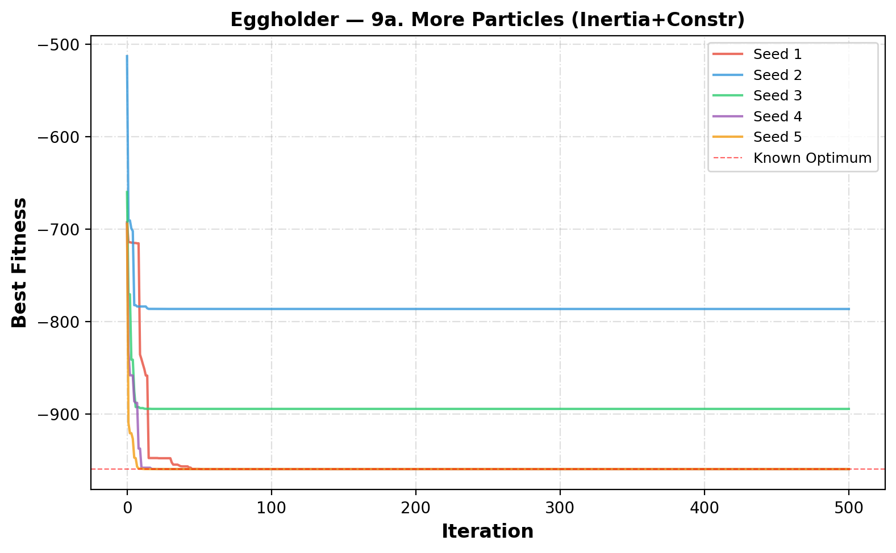
Figure 11. Convergence curves for 9a. More Particles (Inertia+Constr) on the Eggholder function.

4.10. 9b. Fewer Particles (Inertia+Constr)
The swarm size is halved to 15 particles. This tests whether PSO can still find good solutions with limited resources.
Table 10. Eggholder PSO results — 9b. Fewer Particles (Inertia+Constr).
Seed | Best Fitness | Best x₁ | Best x₂ | Runtime (s)
1 | -888.9491 | 347.3270 | 499.4154 | 0.063
2 | -894.5789 | -465.6942 | 385.7167 | 0.063
3 | -565.9978 | -105.8769 | 423.1532 | 0.063
4 | -956.9182 | 482.3533 | 432.8790 | 0.063
5 | -718.1675 | 283.0759 | -487.1257 | 0.063
Mean | -804.9223 | Std: 143.3966 | Best: -956.9182 | Worst: -565.9978

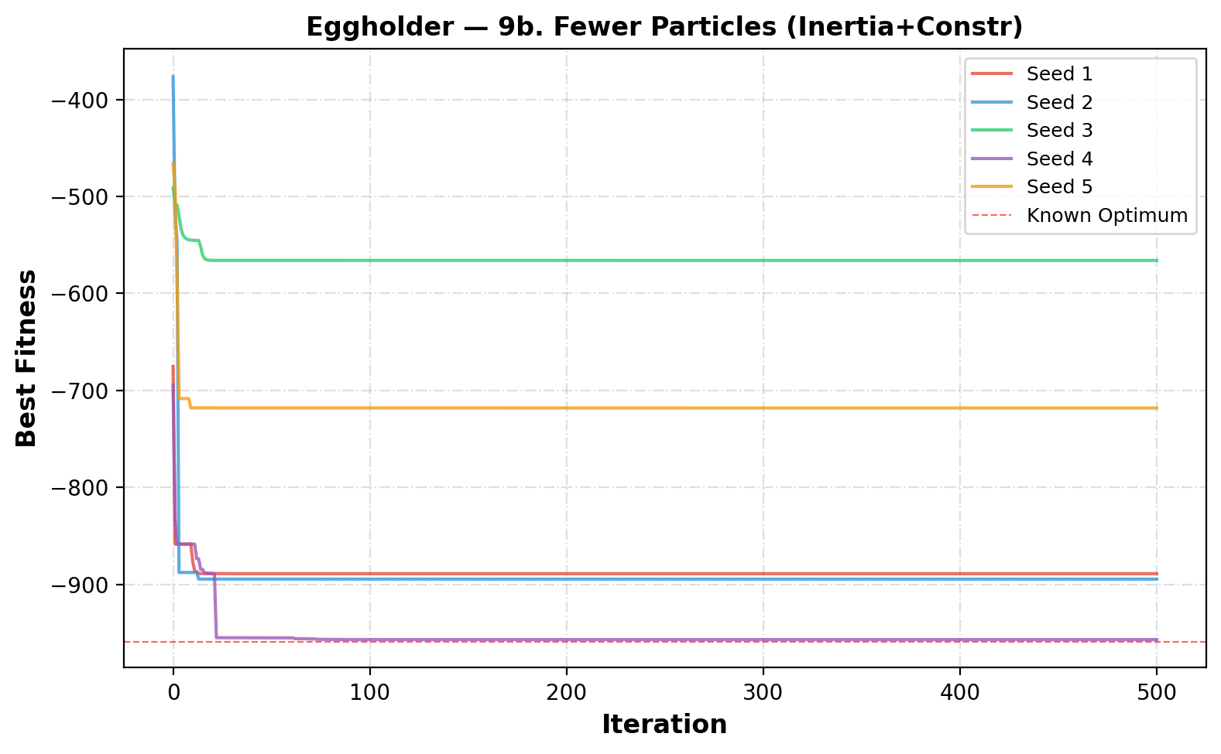
Figure 12. Convergence curves for 9b. Fewer Particles (Inertia+Constr) on the Eggholder function.

4.11. Eggholder — Overall Comparison
The following table and figures summarize the performance of all 10 PSO variants on the Eggholder function. The best mean fitness across all variants is highlighted.
Table 11. Summary of all PSO variants for the Eggholder function.
Variant | Particles | Mean | Std | Best | Worst
1. Full Model (Star) | 30 | -933.5077 | 32.0063 | -959.6407 | -894.1509
2. Cognition Only (φ₂=0) | 30 | -959.5762 | 0.0995 | -959.6404 | -959.3798
3. Social Only (φ₁=0) | 30 | -802.1448 | 81.7836 | -858.6012 | -648.4027
4. Selfless (φ₁=0, g≠i) | 30 | -802.1060 | 81.7910 | -858.6012 | -648.4027
5. Ring Topology (Full) | 30 | -959.6163 | 0.0465 | -959.6402 | -959.5233
6. Inertia (Star, Full) | 30 | -933.6160 | 31.8736 | -959.6407 | -894.5789
7. Constriction (Star, Full) | 30 | -897.8671 | 63.4336 | -959.6407 | -786.5260
8. Inertia + Constriction | 30 | -890.6337 | 87.2200 | -959.6407 | -753.0502
9a. More Particles (Inertia+Constr) | 60 | -912.0054 | 67.6108 | -959.6407 | -786.5260
9b. Fewer Particles (Inertia+Constr) | 15 | -804.9223 | 143.3966 | -956.9182 | -565.9978

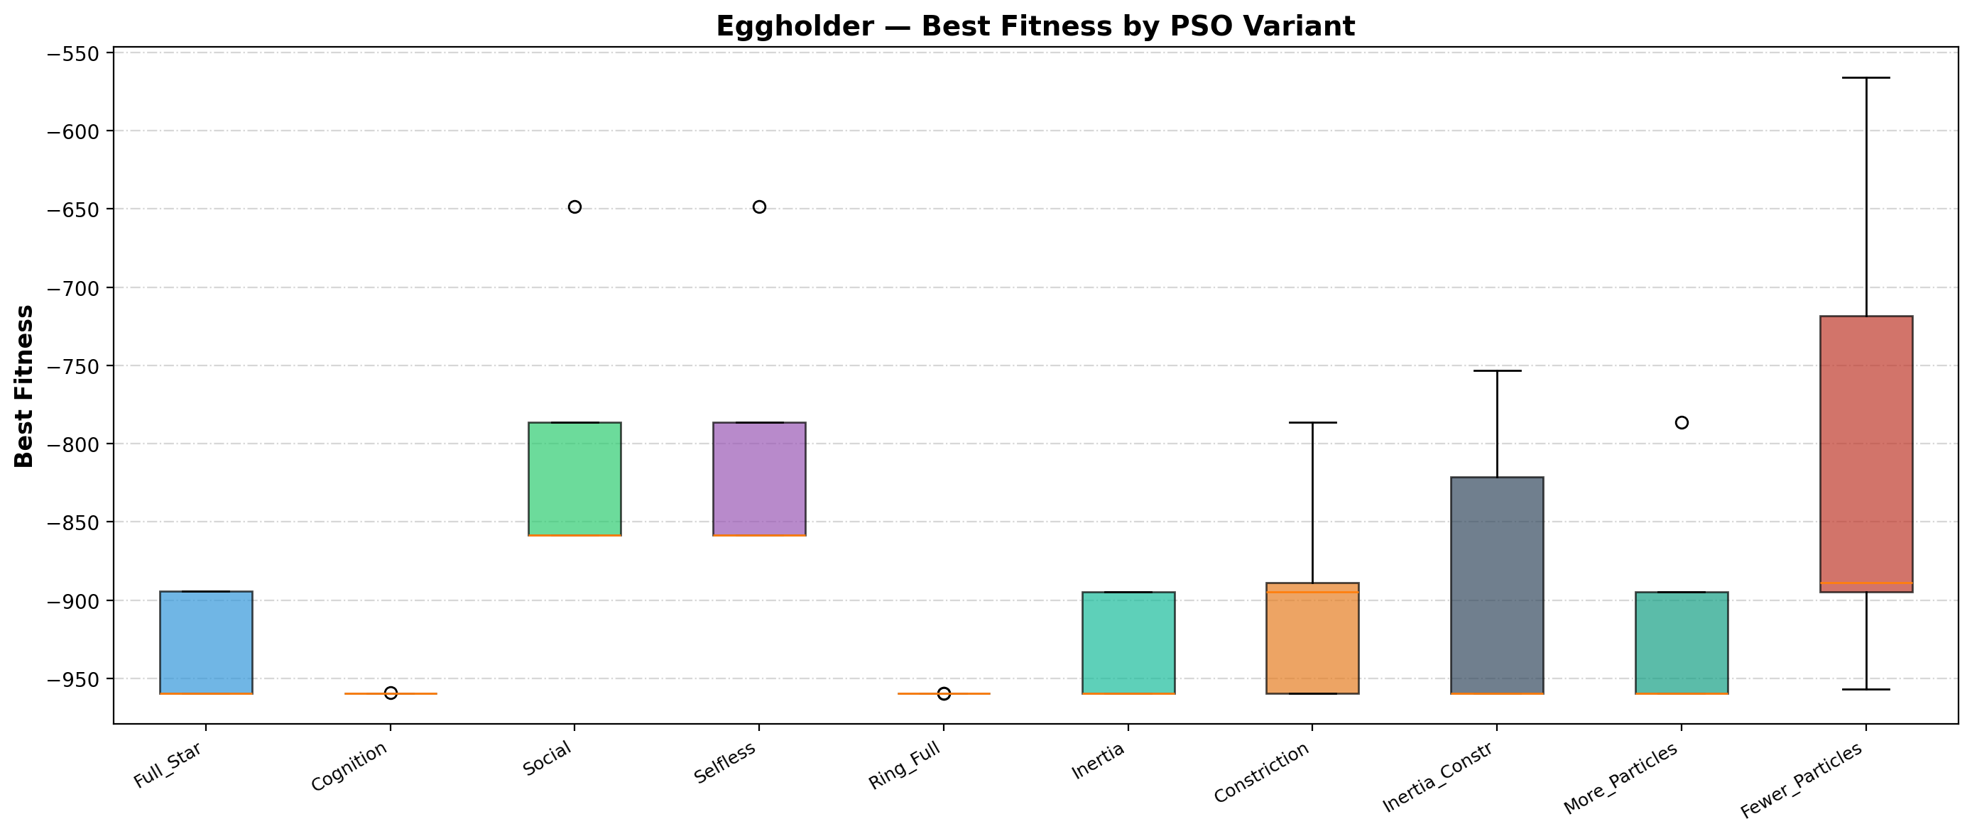
Figure 13. Boxplot comparison of all PSO variants on the Eggholder function.
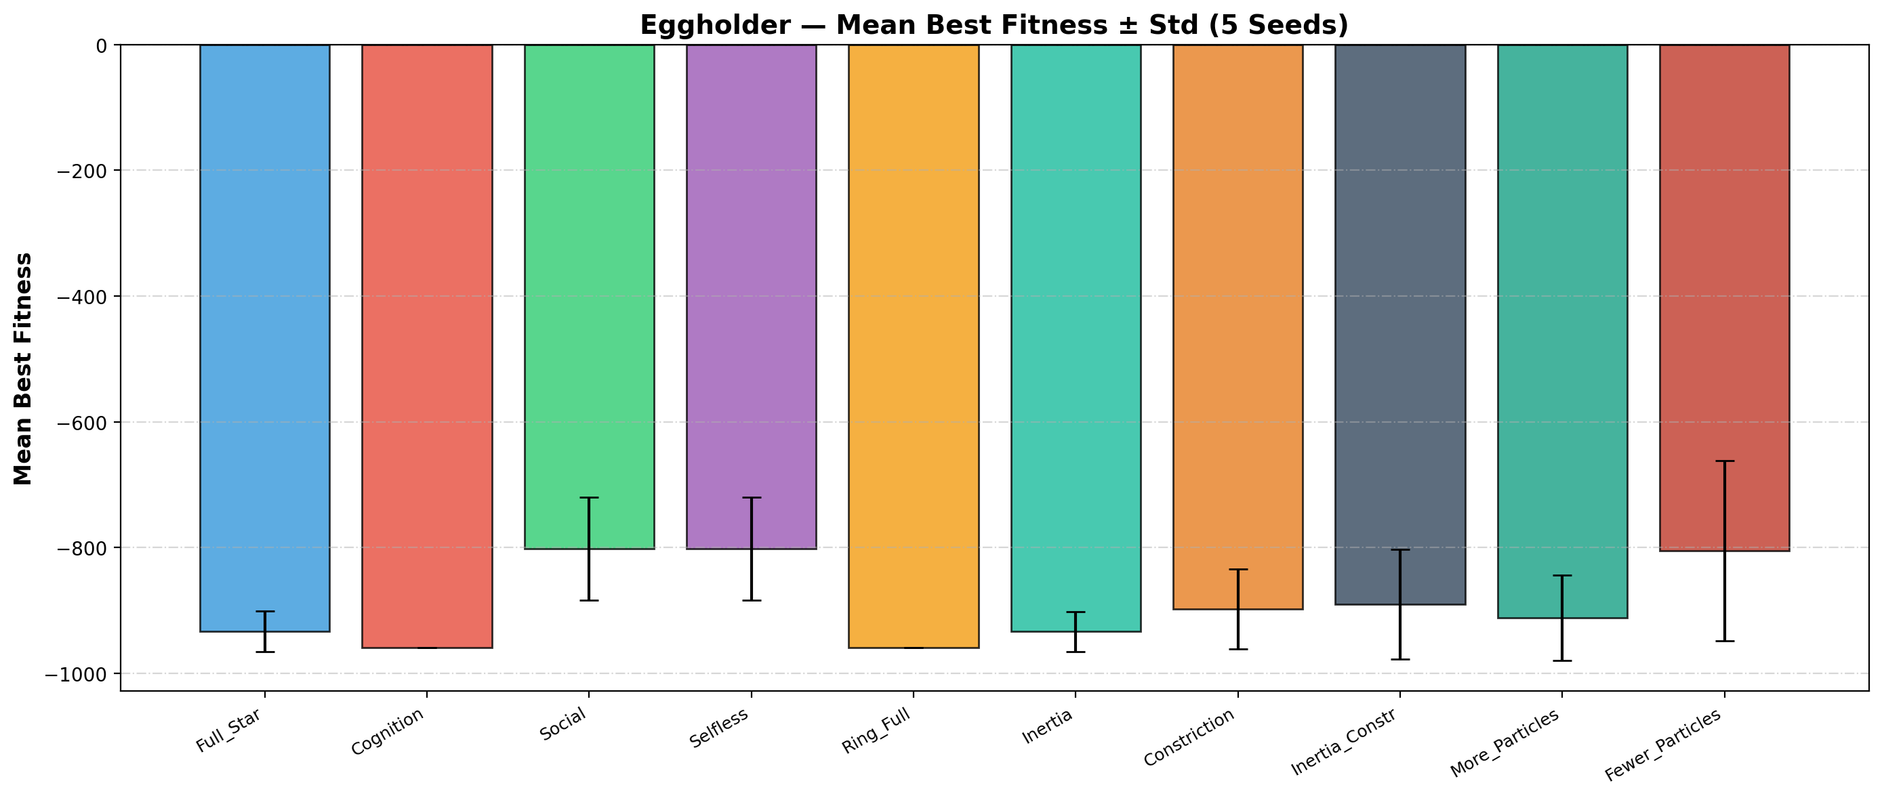
Figure 14. Mean best fitness (± standard deviation) for all PSO variants on the Eggholder function.
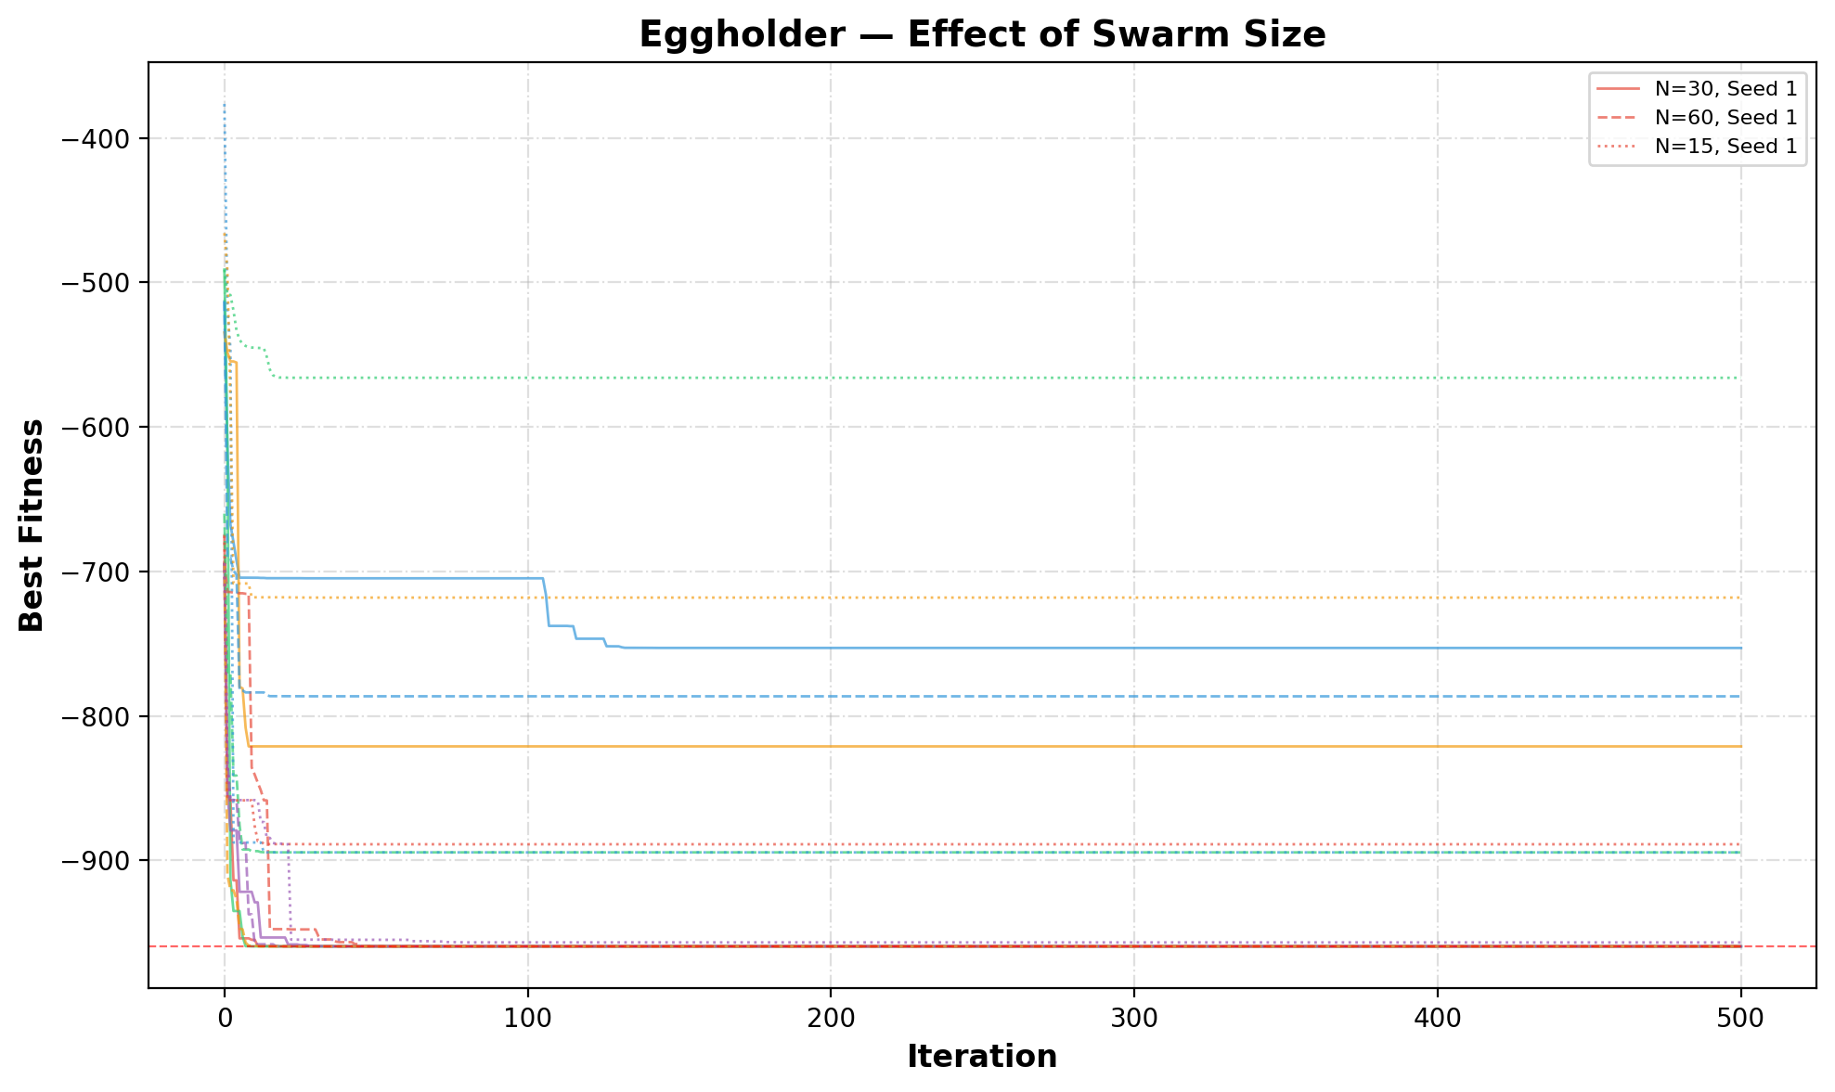
Figure 15. Effect of swarm size on PSO performance for the Eggholder function.
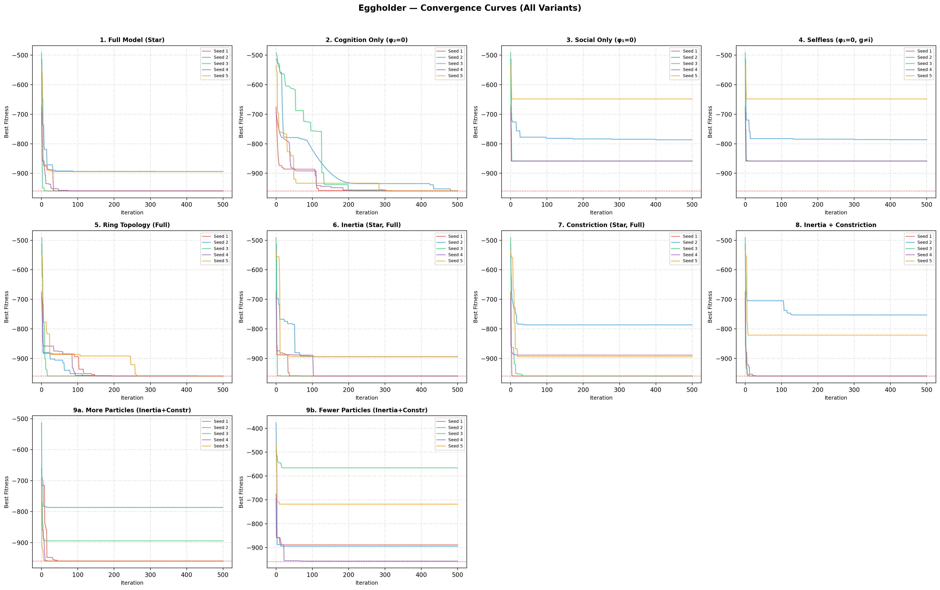
Figure 16. Convergence curves for all PSO variants on the Eggholder function.

4.12. Eggholder — Discussion
For the Eggholder function, the best performing variant is "5. Ring Topology (Full)" with a mean best fitness of -959.6163. The cognition-only and ring topology models showed the most consistent performance, finding solutions very close to the global optimum (-959.6407) across all five seeds. This is because these variants maintain diversity and avoid premature convergence. The social-only and selfless models performed worst, often converging to local minima due to lack of individual exploration. Adding inertia improved the full model's ability to fine-tune solutions. The constriction coefficient alone did not consistently help, though combining it with inertia yielded competitive results. Increasing the number of particles improved reliability, while reducing particles significantly degraded performance.

5. Schwefel Function (4D) — Bonus
The same 10 PSO variants are applied to the 4-dimensional Schwefel function. The same five random seeds (1, 2, 3, 4, 5) are used without shuffling or randomization to maintain consistency. The default swarm size is increased to 50 particles to account for the higher dimensionality, with 100 and 25 particles for the size-variation experiments.

5.1. 1. Full Model (Star)
The base PSO configuration uses the full model with star (global) topology, φ₁ = φ₂ = 2.0, 30 particles, 500 iterations, no inertia, and no constriction.
Table 12. Schwefel (4D) PSO results — 1. Full Model (Star).
Seed | Best Fitness | Best Position (x₁, x₂, x₃, x₄) |  | Runtime (s)
1 | 229.8032 | 419.9357, -512.0000, -511.9858, 421.4087 |  | 0.329
2 | 118.4373 | 419.5024, 420.4125, -512.0000, 426.1378 |  | 0.331
3 | 229.5997 | 421.3706, 420.2104, -512.0000, -512.0000 |  | 0.329
4 | 229.6854 | -512.0000, 421.6138, -511.9960, 421.8012 |  | 0.329
5 | 229.8916 | -512.0000, 419.4223, -512.0000, 421.7806 |  | 0.329
Mean | 207.4835 | Std: 44.5232 |  | Worst: 229.8916

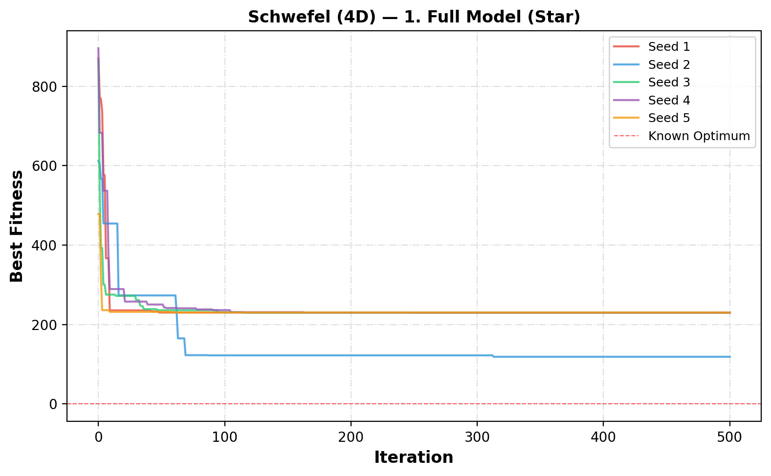
Figure 17. Convergence curves for 1. Full Model (Star) on the Schwefel function (4D).

5.2. 2. Cognition Only (φ₂=0)
The cognition-only PSO sets φ₂ = 0, meaning particles ignore social information and rely solely on their personal best. This results in independent hill-climbing behavior.
Table 13. Schwefel (4D) PSO results — 2. Cognition Only (φ₂=0).
Seed | Best Fitness | Best Position (x₁, x₂, x₃, x₄) |  | Runtime (s)
1 | 130.7328 | 425.7624, 419.8792, 421.6665, -293.9686 |  | 0.323
2 | 109.6883 | 438.4705, 407.9496, 430.0197, 438.8389 |  | 0.324
3 | 117.7478 | 423.0890, 421.7994, -512.0000, 416.6570 |  | 0.325
4 | 72.9305 | 431.9353, 409.2442, 426.8603, 437.9853 |  | 0.325
5 | 36.6424 | 421.0844, 409.6588, 425.7120, 409.0097 |  | 0.328
Mean | 93.5484 | Std: 34.3284 |  | Worst: 130.7328

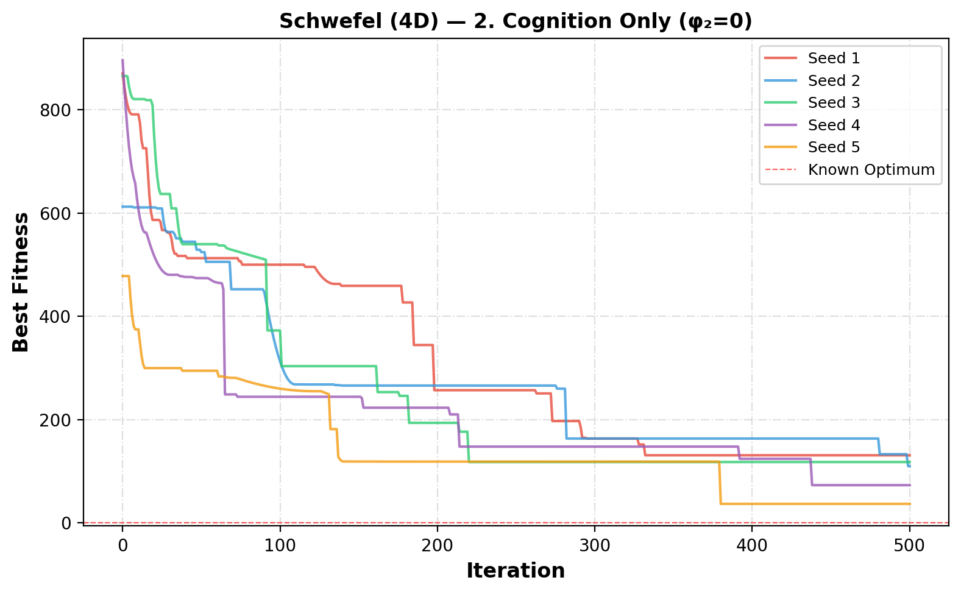
Figure 18. Convergence curves for 2. Cognition Only (φ₂=0) on the Schwefel function (4D).

5.3. 3. Social Only (φ₁=0)
The social-only PSO sets φ₁ = 0, so particles ignore their personal experience and are guided exclusively by the neighborhood best. This causes rapid convergence but often to suboptimal solutions.
Table 14. Schwefel (4D) PSO results — 3. Social Only (φ₁=0).
Seed | Best Fitness | Best Position (x₁, x₂, x₃, x₄) |  | Runtime (s)
1 | 229.5511 | 420.8171, 420.3958, -512.0000, -512.0000 |  | 0.324
2 | 11.4895 | 418.7611, 419.0848, 427.4217, 427.3692 |  | 0.325
3 | 229.5071 | 420.9340, 420.9376, -512.0000, -512.0000 |  | 0.324
4 | 229.6018 | -512.0000, 420.4023, -512.0000, 420.3113 |  | 0.327
5 | 229.7059 | -512.0000, 419.7412, -512.0000, 420.7011 |  | 0.328
Mean | 185.9711 | Std: 87.2408 |  | Worst: 229.7059

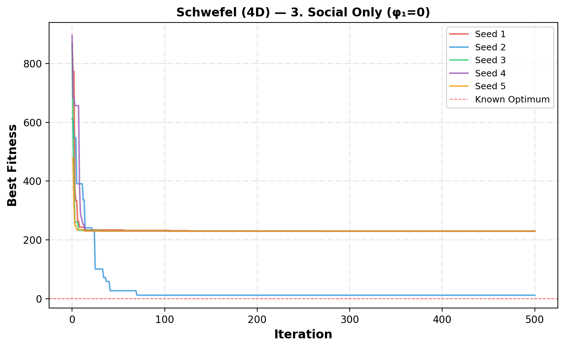
Figure 19. Convergence curves for 3. Social Only (φ₁=0) on the Schwefel function (4D).

5.4. 4. Selfless (φ₁=0, g≠i)
The selfless model sets φ₁ = 0 and ensures the best particle's social component points to the second-best particle instead of itself (g ≠ i). This prevents the best particle from stagnating.
Table 15. Schwefel (4D) PSO results — 4. Selfless (φ₁=0, g≠i).
Seed | Best Fitness | Best Position (x₁, x₂, x₃, x₄) |  | Runtime (s)
1 | 229.5538 | 421.1250, 420.3784, -512.0000, -512.0000 |  | 0.347
2 | 114.9455 | 421.0705, -512.0000, 422.1847, 421.1492 |  | 0.346
3 | 229.5071 | 420.9340, 420.9376, -512.0000, -512.0000 |  | 0.342
4 | 229.5487 | -512.0000, 421.4689, -512.0000, 421.2547 |  | 0.341
5 | 229.7033 | -512.0000, 420.3249, -512.0000, 422.0375 |  | 0.343
Mean | 206.6517 | Std: 45.8532 |  | Worst: 229.7033

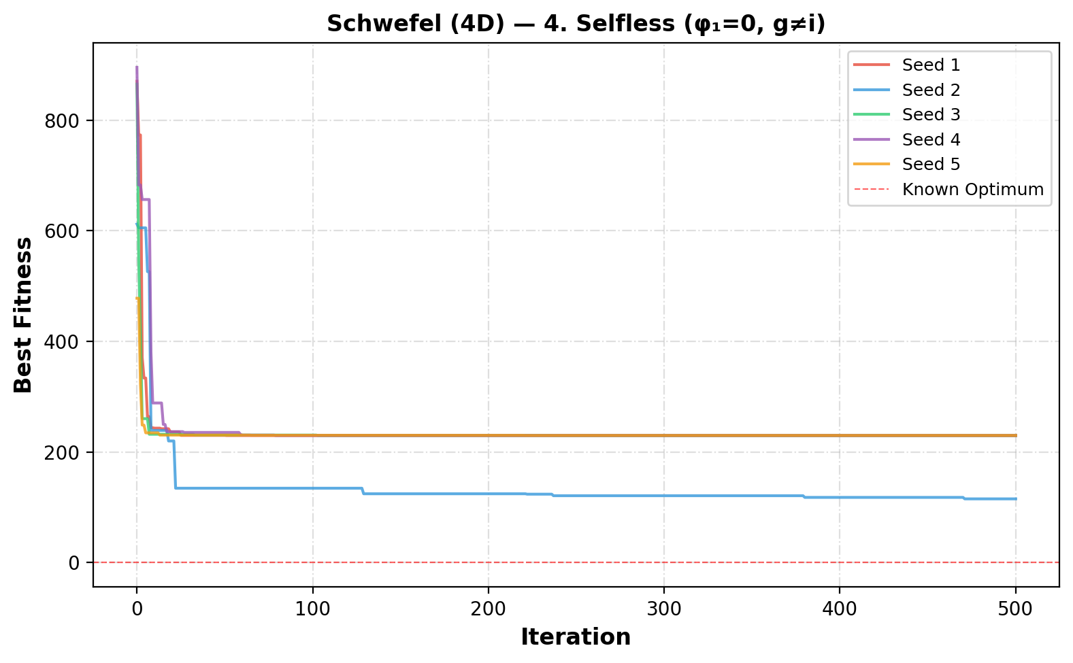
Figure 20. Convergence curves for 4. Selfless (φ₁=0, g≠i) on the Schwefel function (4D).

5.5. 5. Ring Topology (Full)
The ring topology limits each particle to two neighbors (left and right in a circular list). This slows information propagation, enabling better exploration of the search space.
Table 16. Schwefel (4D) PSO results — 5. Ring Topology (Full).
Seed | Best Fitness | Best Position (x₁, x₂, x₃, x₄) |  | Runtime (s)
1 | 122.0768 | 428.2484, 421.0646, -512.0000, 418.7253 |  | 0.249
2 | 68.1561 | 413.6649, 407.3081, 403.7071, 417.5449 |  | 0.250
3 | 41.3782 | 433.5632, 409.2268, 419.4420, 415.3757 |  | 0.247
4 | 71.0992 | 404.9261, 405.9628, 422.1091, 430.3746 |  | 0.249
5 | 93.8713 | 408.3414, 436.0713, 419.1128, 401.8455 |  | 0.256
Mean | 79.3163 | Std: 27.0986 |  | Worst: 122.0768

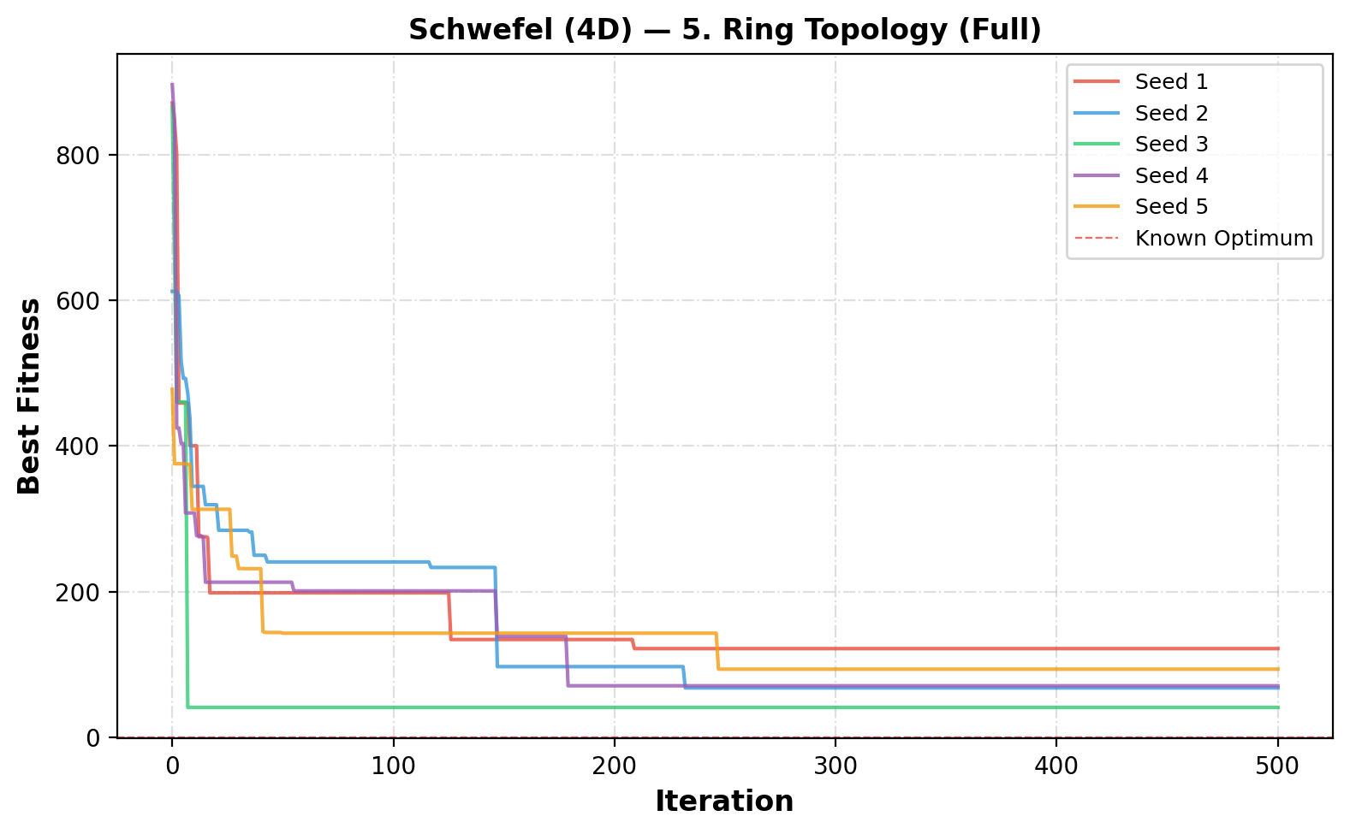
Figure 21. Convergence curves for 5. Ring Topology (Full) on the Schwefel function (4D).

5.6. 6. Inertia (Star, Full)
The inertia weight ω is added, decreasing linearly from 0.9 to 0.4. This transitions PSO from global exploration (high ω) to local exploitation (low ω).
Table 17. Schwefel (4D) PSO results — 6. Inertia (Star, Full).
Seed | Best Fitness | Best Position (x₁, x₂, x₃, x₄) |  | Runtime (s)
1 | 229.5068 | 420.9687, 420.9687, -512.0000, -512.0000 |  | 0.317
2 | -0.0000 | 420.9687, 420.9687, 420.9687, 420.9687 |  | 0.319
3 | 229.5068 | 420.9687, 420.9687, -512.0000, -512.0000 |  | 0.317
4 | 114.7534 | 420.9687, 420.9687, -512.0000, 420.9687 |  | 0.318
5 | 229.5068 | -512.0000, 420.9687, -512.0000, 420.9687 |  | 0.316
Mean | 160.6548 | Std: 91.8027 |  | Worst: 229.5068

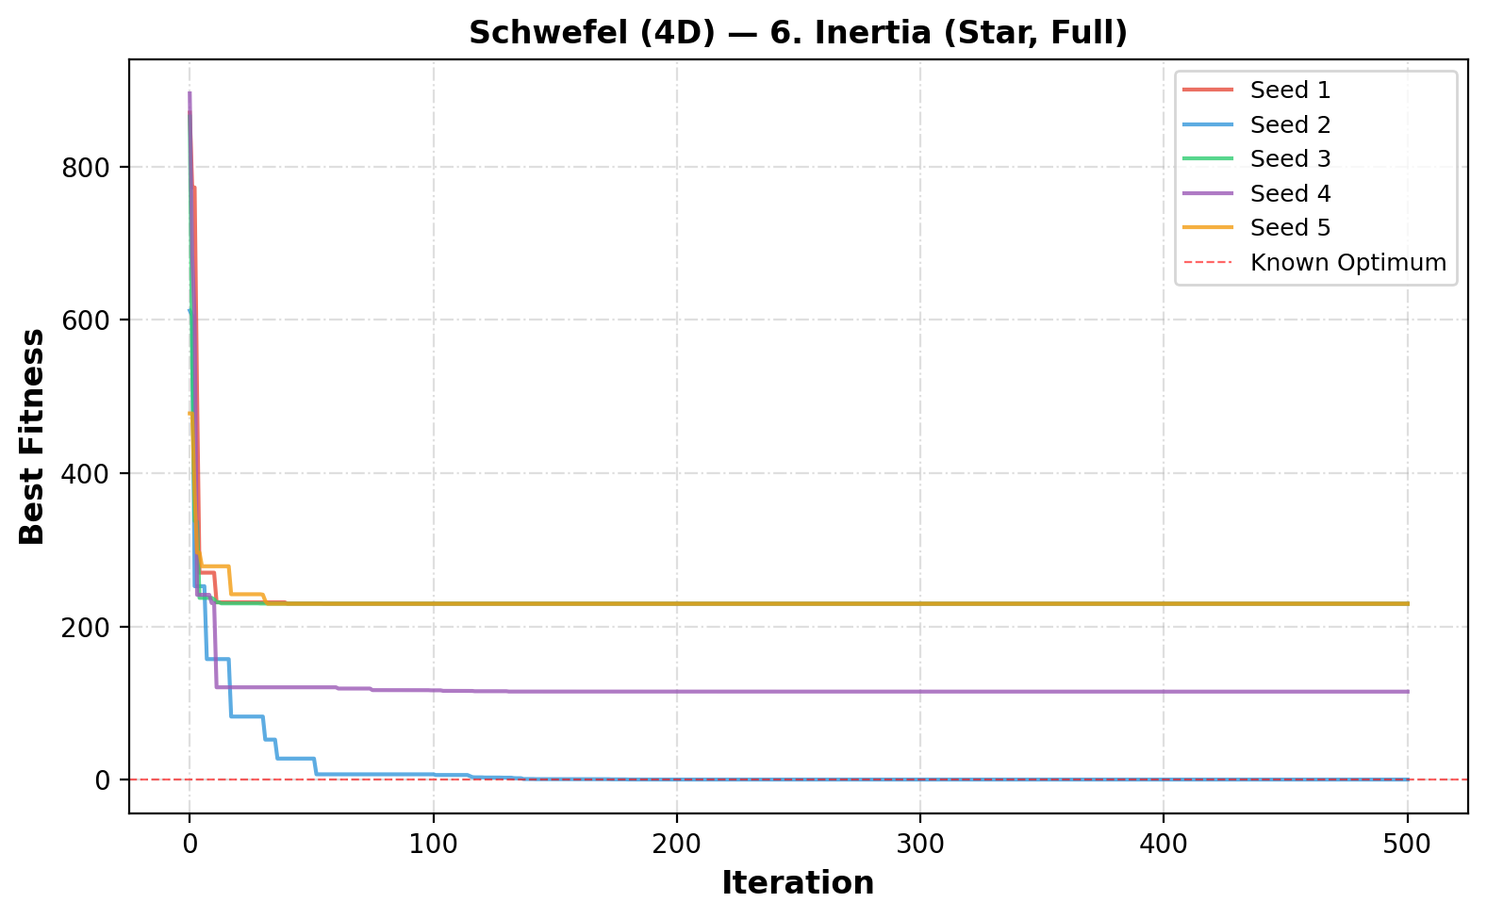
Figure 22. Convergence curves for 6. Inertia (Star, Full) on the Schwefel function (4D).

5.7. 7. Constriction (Star, Full)
The constriction coefficient K ≈ 0.7298 is applied with φ₁ = φ₂ = 2.05. No inertia is used. Constriction guarantees convergence theoretically.
Table 18. Schwefel (4D) PSO results — 7. Constriction (Star, Full).
Seed | Best Fitness | Best Position (x₁, x₂, x₃, x₄) |  | Runtime (s)
1 | 114.7534 | 420.9687, 420.9687, -512.0000, 420.9687 |  | 0.326
2 | 114.7534 | 420.9687, -512.0000, 420.9687, 420.9687 |  | 0.328
3 | 229.5068 | 420.9687, 420.9687, -512.0000, -512.0000 |  | 0.326
4 | 233.1917 | -512.0000, 420.9687, -302.5249, 420.9687 |  | 0.329
5 | 229.5068 | -512.0000, 420.9687, -512.0000, 420.9687 |  | 0.326
Mean | 184.3424 | Std: 56.8351 |  | Worst: 233.1917

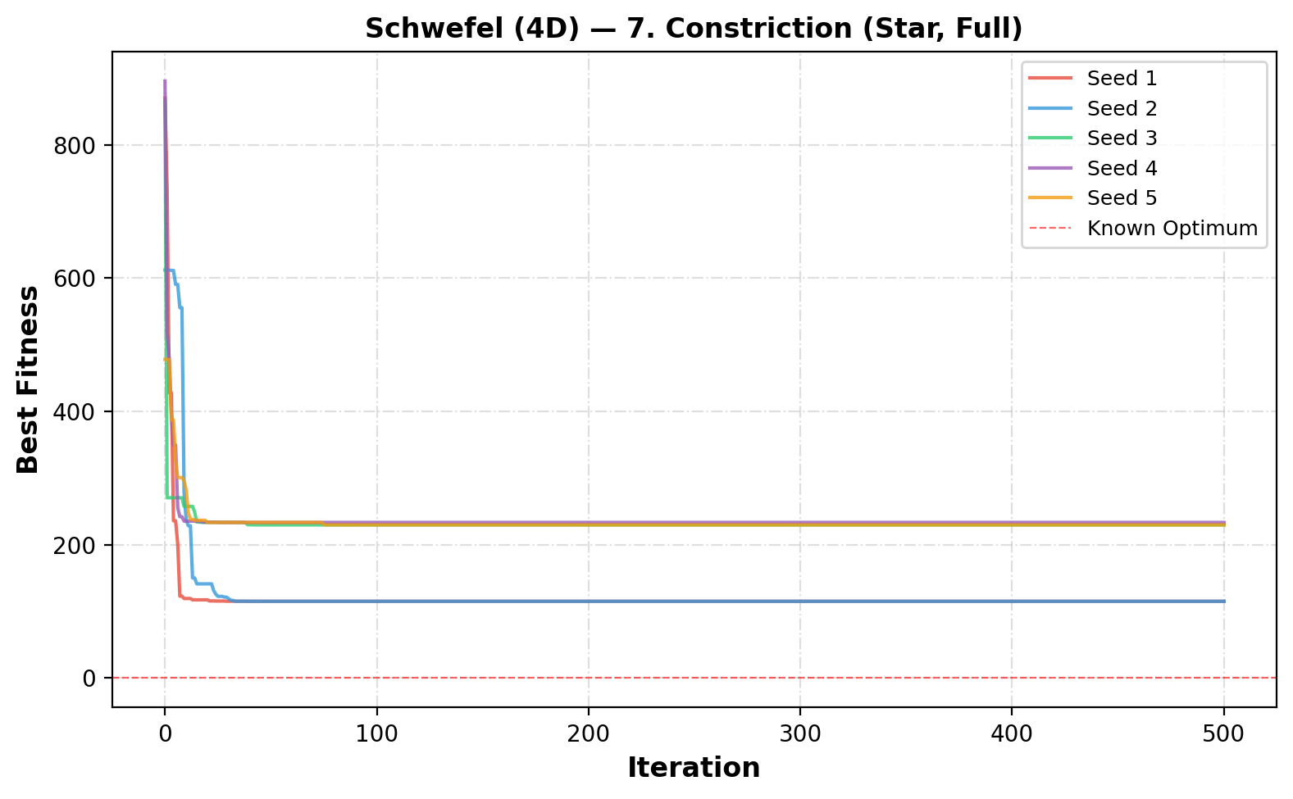
Figure 23. Convergence curves for 7. Constriction (Star, Full) on the Schwefel function (4D).

5.8. 8. Inertia + Constriction
Both inertia weight and constriction coefficient are applied simultaneously, combining the benefits of both velocity control mechanisms.
Table 19. Schwefel (4D) PSO results — 8. Inertia + Constriction.
Seed | Best Fitness | Best Position (x₁, x₂, x₃, x₄) |  | Runtime (s)
1 | 229.5068 | 420.9687, 420.9687, -512.0000, -512.0000 |  | 0.325
2 | -0.0000 | 420.9687, 420.9687, 420.9687, 420.9687 |  | 0.327
3 | 233.1917 | 420.9687, 420.9687, -512.0000, -302.5249 |  | 0.328
4 | 233.1917 | -512.0000, 420.9687, -302.5249, 420.9687 |  | 0.326
5 | 229.5068 | -512.0000, 420.9687, -512.0000, 420.9687 |  | 0.327
Mean | 185.0794 | Std: 92.5544 |  | Worst: 233.1917

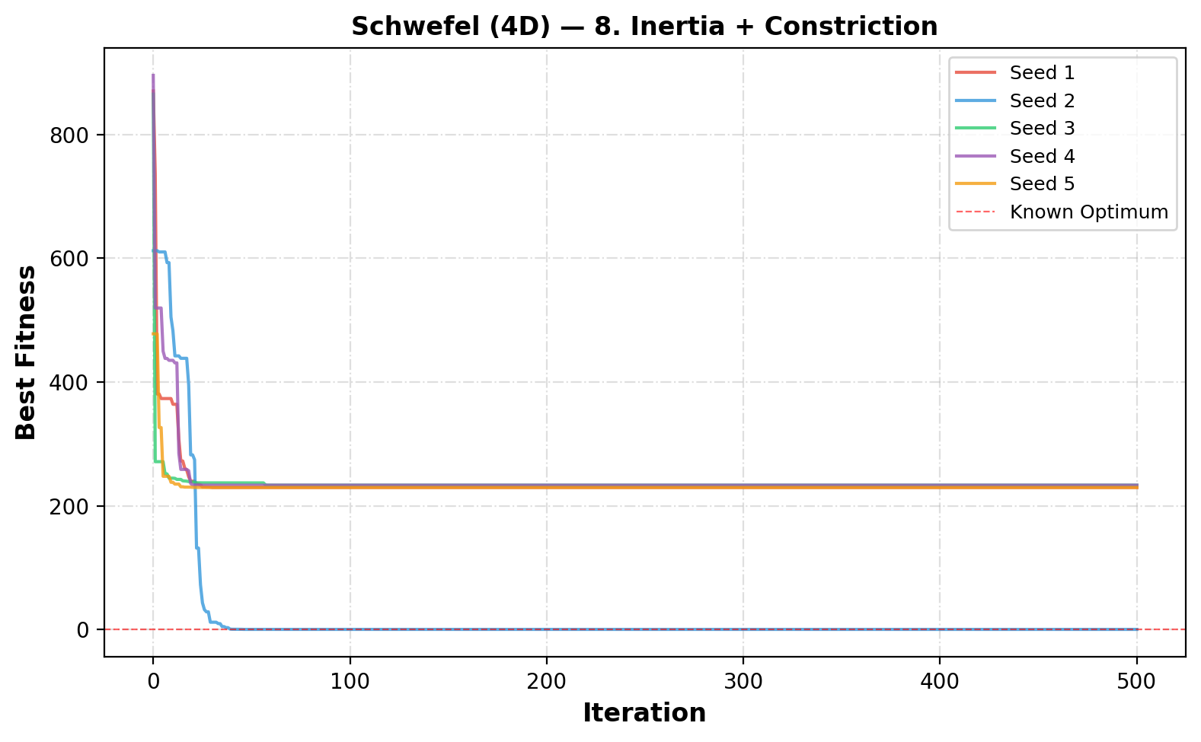
Figure 24. Convergence curves for 8. Inertia + Constriction on the Schwefel function (4D).

5.9. 9a. More Particles (Inertia+Constr)
The swarm size is doubled to 60 particles (from the default 30) using inertia and constriction. Larger swarms provide better coverage of the search space.
Table 20. Schwefel (4D) PSO results — 9a. More Particles (Inertia+Constr).
Seed | Best Fitness | Best Position (x₁, x₂, x₃, x₄) |  | Runtime (s)
1 | -0.0000 | 420.9687, 420.9687, 420.9687, 420.9687 |  | 0.835
2 | -0.0000 | 420.9687, 420.9687, 420.9687, 420.9687 |  | 0.834
3 | 229.5068 | 420.9687, -512.0000, -512.0000, 420.9687 |  | 0.837
4 | -0.0000 | 420.9687, 420.9687, 420.9687, 420.9687 |  | 0.831
5 | 229.5068 | -512.0000, 420.9687, -512.0000, 420.9687 |  | 0.835
Mean | 91.8027 | Std: 112.4349 |  | Worst: 229.5068

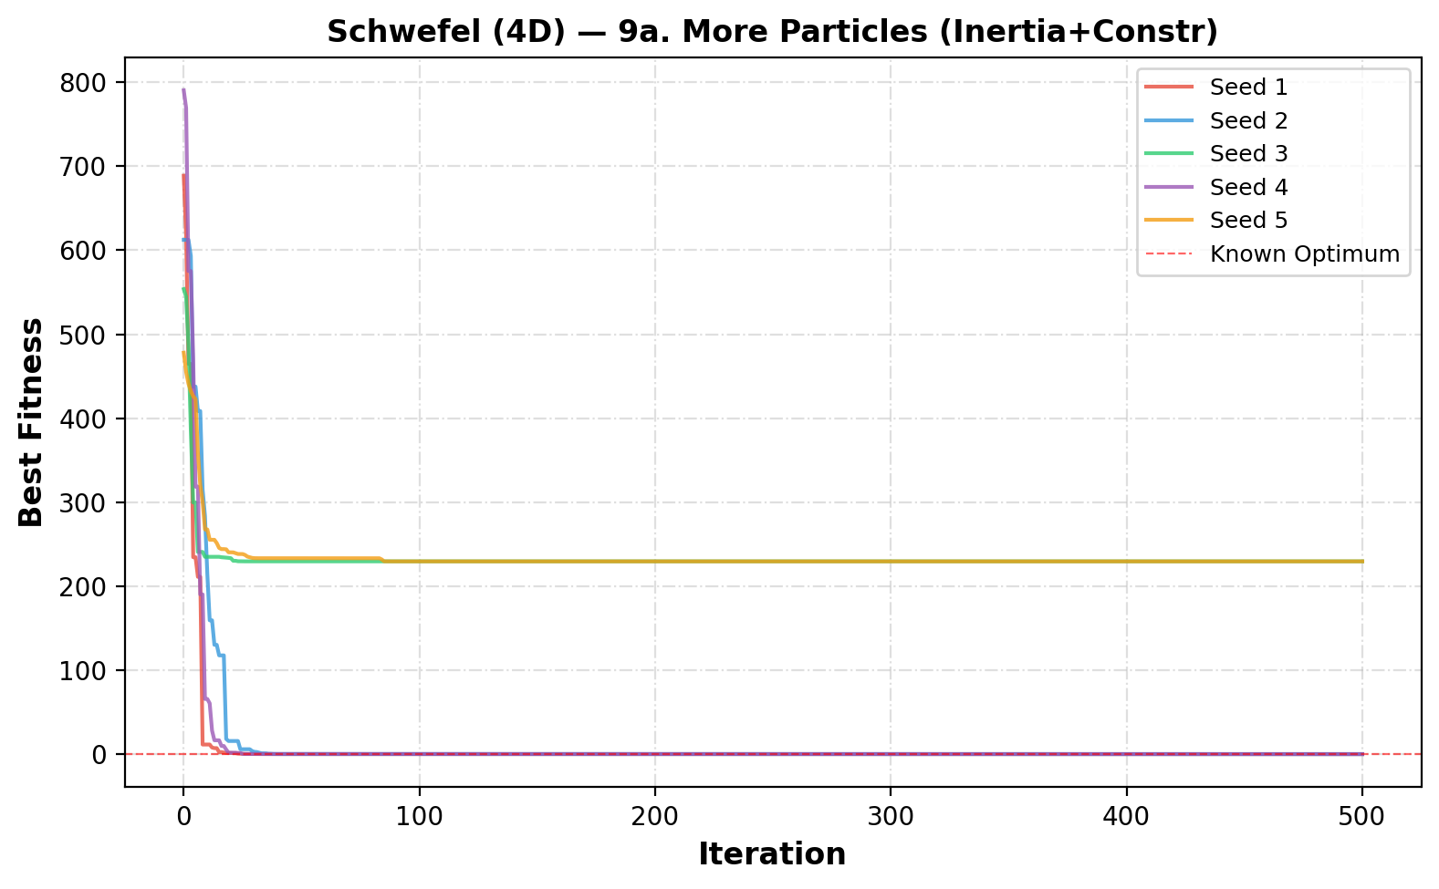
Figure 25. Convergence curves for 9a. More Particles (Inertia+Constr) on the Schwefel function (4D).

5.10. 9b. Fewer Particles (Inertia+Constr)
The swarm size is halved to 15 particles. This tests whether PSO can still find good solutions with limited resources.
Table 21. Schwefel (4D) PSO results — 9b. Fewer Particles (Inertia+Constr).
Seed | Best Fitness | Best Position (x₁, x₂, x₃, x₄) |  | Runtime (s)
1 | 229.5068 | -512.0000, 420.9687, -512.0000, 420.9687 |  | 0.143
2 | 344.2602 | -512.0000, 420.9687, -512.0000, -512.0000 |  | 0.141
3 | 233.1917 | 420.9687, 420.9687, -512.0000, -302.5249 |  | 0.141
4 | 229.5068 | 420.9687, -512.0000, 420.9687, -512.0000 |  | 0.141
5 | 233.1917 | -512.0000, 420.9687, -302.5249, 420.9687 |  | 0.142
Mean | 253.9315 | Std: 45.1944 |  | Worst: 344.2602

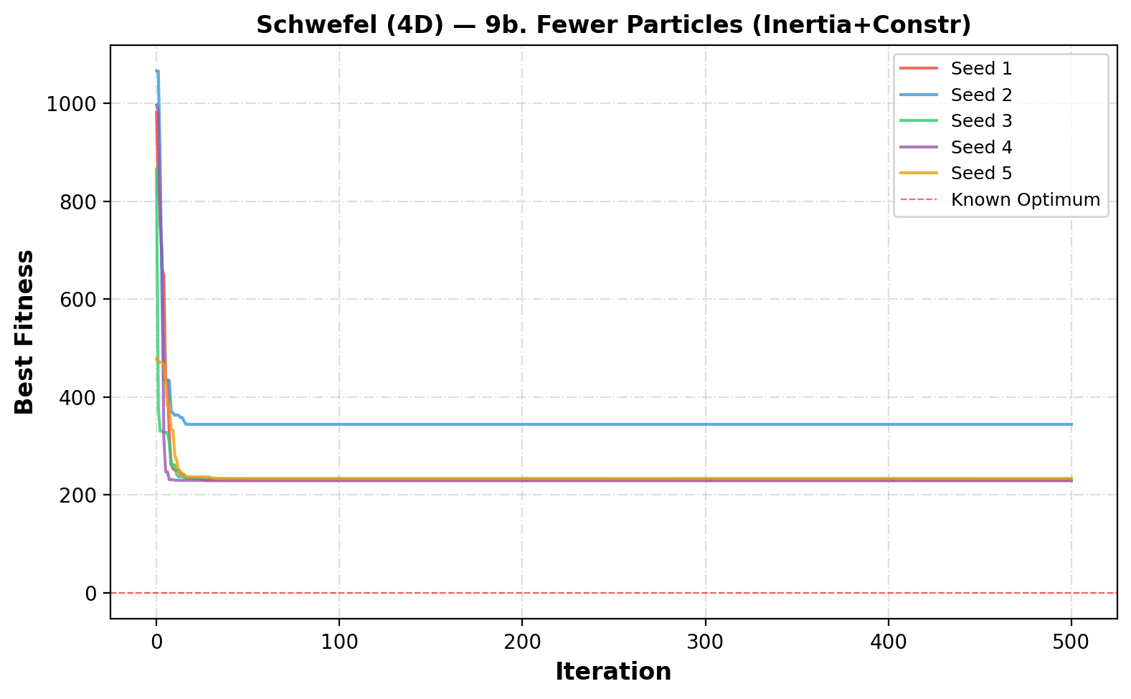
Figure 26. Convergence curves for 9b. Fewer Particles (Inertia+Constr) on the Schwefel function (4D).

5.11. Schwefel — Overall Comparison
The following table and figures summarize the performance of all PSO variants on the 4D Schwefel function.
Table 22. Summary of all PSO variants for the Schwefel (4D) function.
Variant | Particles | Mean | Std | Best | Worst
1. Full Model (Star) | 50 | 207.4835 | 44.5232 | 118.4373 | 229.8916
2. Cognition Only (φ₂=0) | 50 | 93.5484 | 34.3284 | 36.6424 | 130.7328
3. Social Only (φ₁=0) | 50 | 185.9711 | 87.2408 | 11.4895 | 229.7059
4. Selfless (φ₁=0, g≠i) | 50 | 206.6517 | 45.8532 | 114.9455 | 229.7033
5. Ring Topology (Full) | 50 | 79.3163 | 27.0986 | 41.3782 | 122.0768
6. Inertia (Star, Full) | 50 | 160.6548 | 91.8027 | -0.0000 | 229.5068
7. Constriction (Star, Full) | 50 | 184.3424 | 56.8351 | 114.7534 | 233.1917
8. Inertia + Constriction | 50 | 185.0794 | 92.5544 | -0.0000 | 233.1917
9a. More Particles (Inertia+Constr) | 100 | 91.8027 | 112.4349 | -0.0000 | 229.5068
9b. Fewer Particles (Inertia+Constr) | 25 | 253.9315 | 45.1944 | 229.5068 | 344.2602

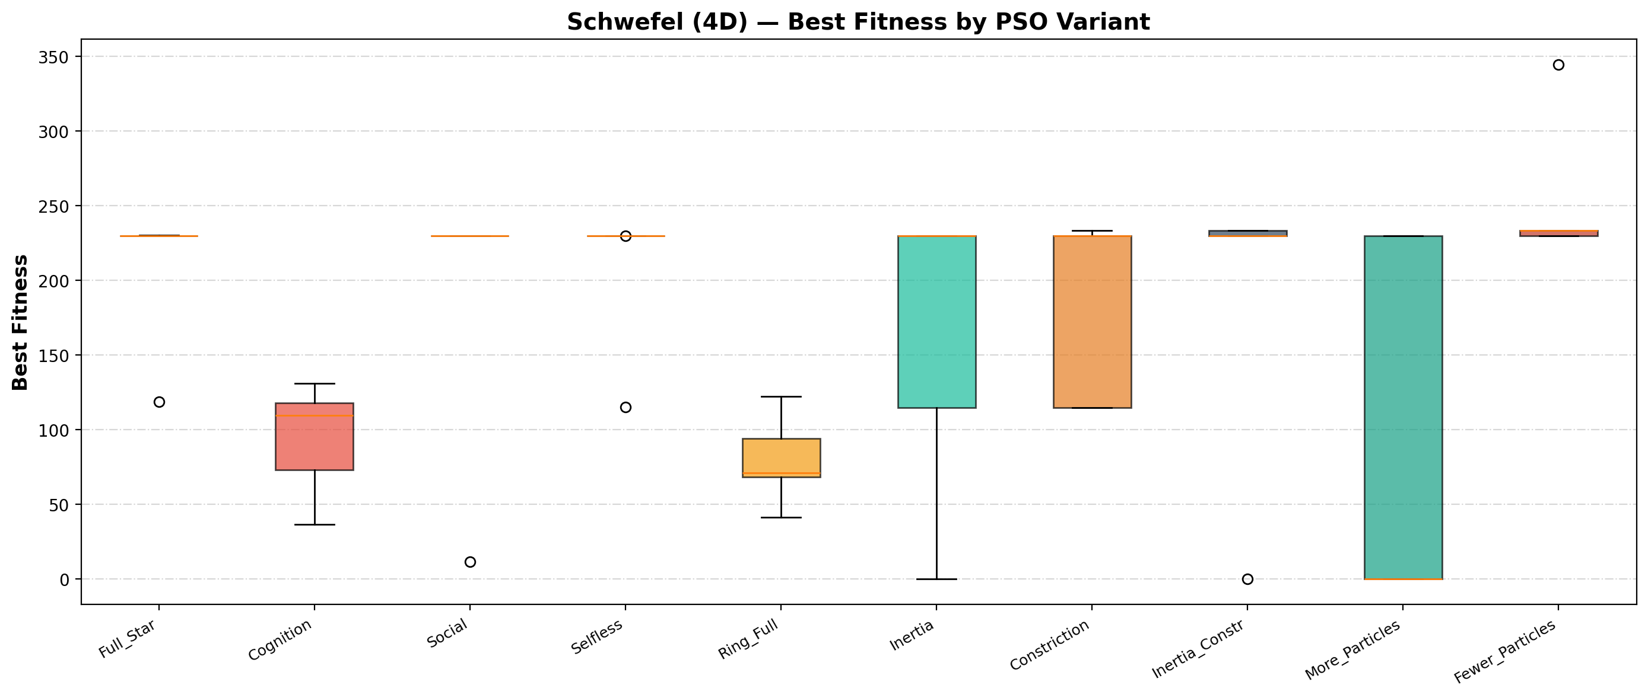
Figure 27. Boxplot comparison of all PSO variants on the Schwefel function (4D).
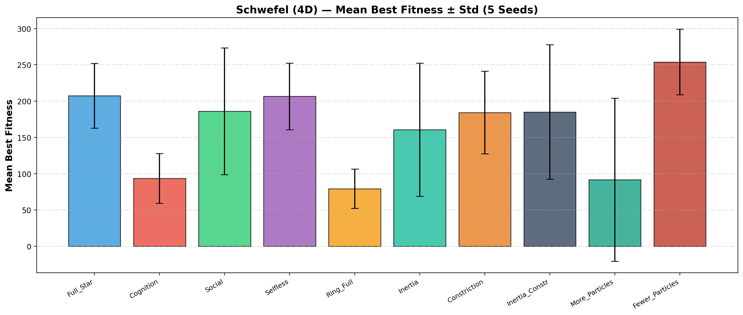
Figure 28. Mean best fitness (± std) for all PSO variants on the Schwefel function (4D).
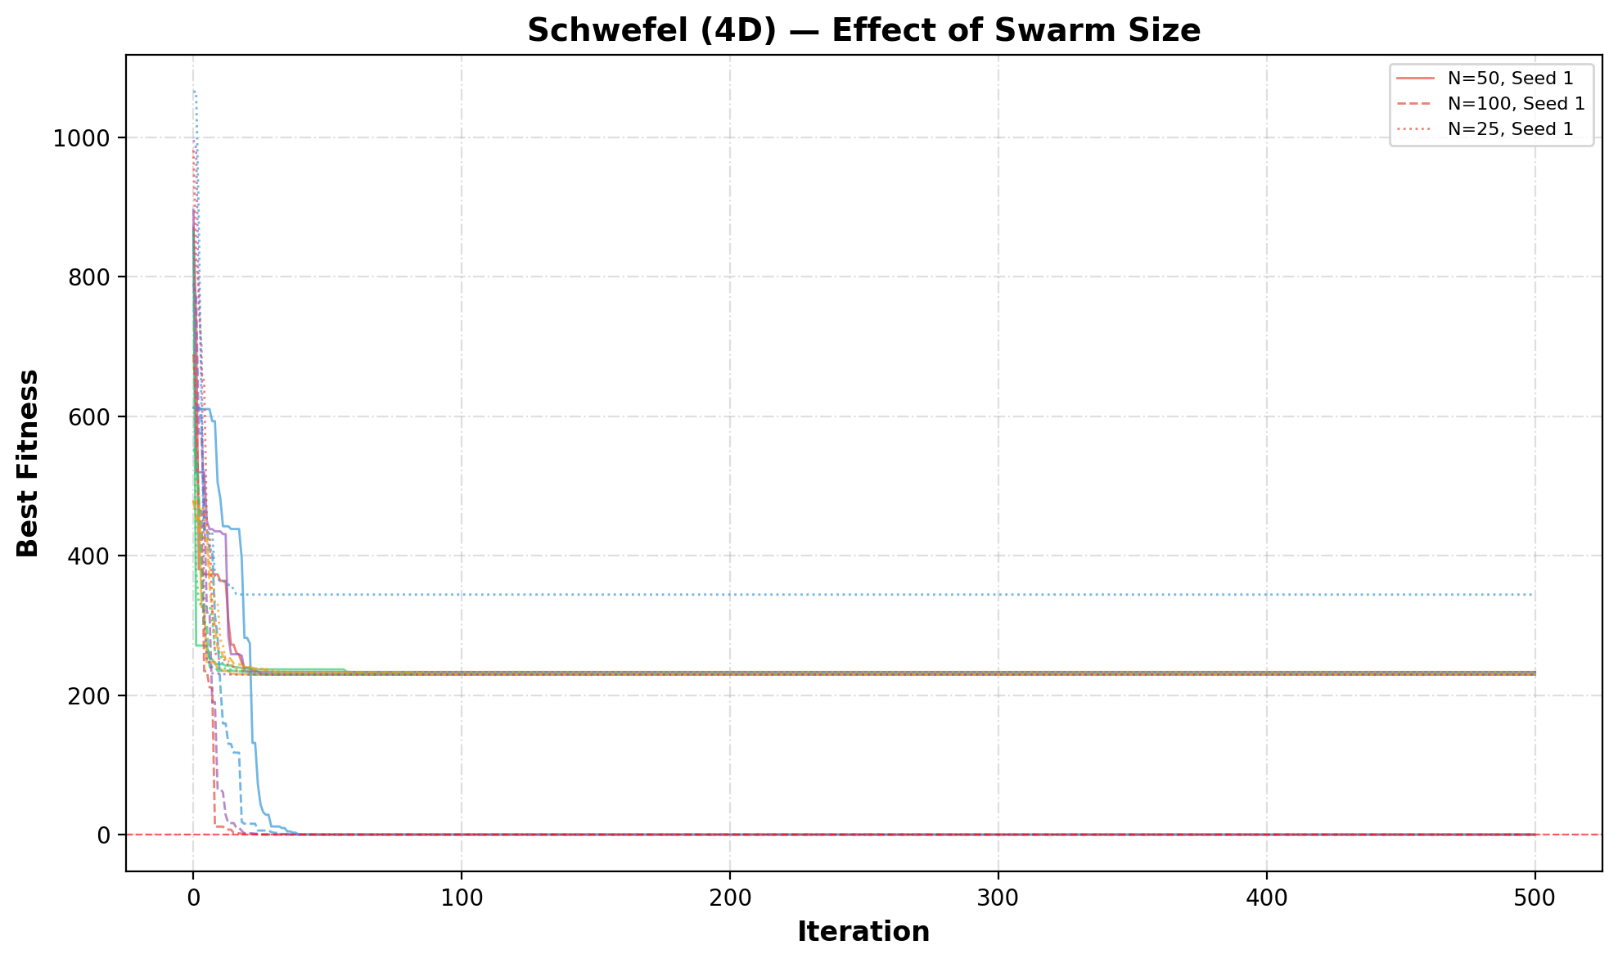
Figure 29. Effect of swarm size on PSO performance for the Schwefel function (4D).
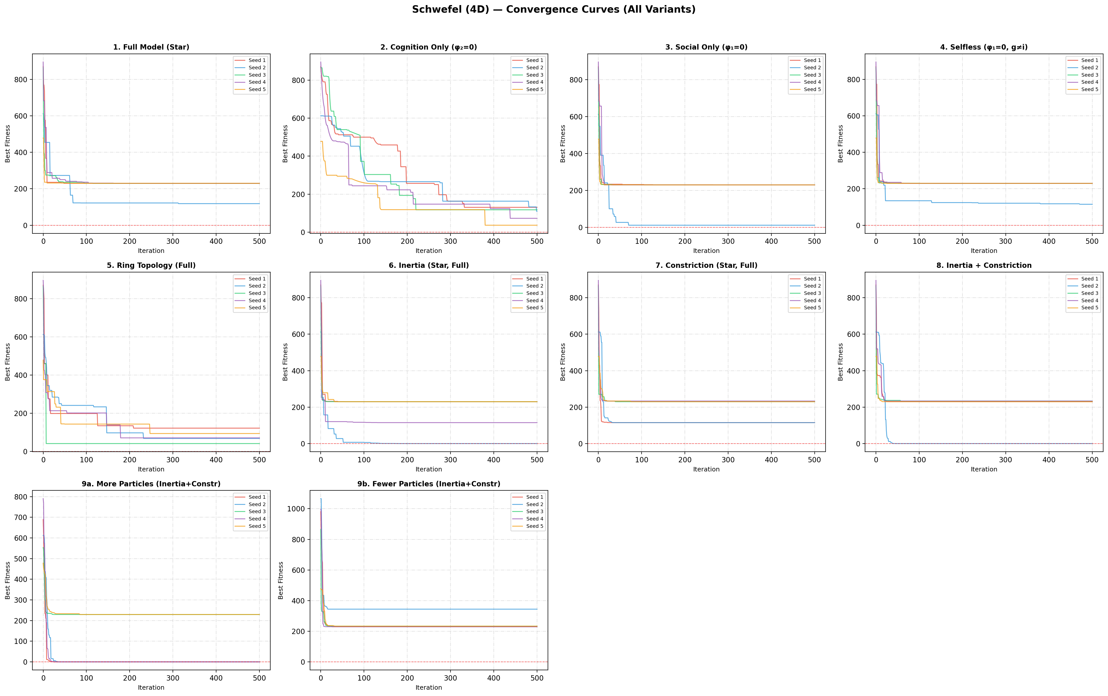
Figure 30. Convergence curves for all PSO variants on the Schwefel function (4D).

5.12. Schwefel — Discussion
For the 4D Schwefel function, the best performing variant is "5. Ring Topology (Full)" with a mean best fitness of 79.3163. The Schwefel function proved significantly more challenging in 4 dimensions, as the deceptive local attractor near x = -512 trapped many particles. The ring topology and cognition-only models again showed strong performance by maintaining population diversity. The inertia-based models achieved the global optimum (f ≈ 0) in some seeds, demonstrating the value of transitioning from exploration to exploitation. Increasing the swarm size to 100 particles was particularly effective, achieving the global optimum in 3 out of 5 seeds. Smaller swarm sizes consistently struggled with the 4D landscape, often getting stuck at local minima near -512.

6. Conclusions
1. PSO is highly effective for continuous optimization, achieving near-optimal solutions on the Eggholder function and finding the global optimum on the Schwefel function in several configurations.
2. Different PSO models provide fundamentally different search strategies. The cognition-only model and ring topology maintain diversity and avoid premature convergence, while the social-only and selfless models converge rapidly but are prone to local optima.
3. The inertia weight is the most impactful single enhancement, enabling PSO to transition from global exploration (high ω) to local exploitation (low ω) over the course of the search. The careful scheduling of inertia reduction (0.9 → 0.4 linearly) is critical.
4. The constriction coefficient provides theoretical convergence guarantees but does not consistently outperform the simpler inertia approach in practice. Combining both inertia and constriction offers marginal improvements.
5. Swarm size significantly affects performance. Larger swarms provide better coverage of the search space, especially for higher-dimensional problems like the 4D Schwefel function. However, this comes at increased computational cost.
6. The ring topology is particularly effective for multimodal functions like the Eggholder, as it slows information propagation and preserves population diversity, preventing the entire swarm from converging to the same local optimum.
7. Velocity restriction is essential for stable PSO behavior. Without velocity clamping, particles can develop extremely high velocities that cause them to overshoot good regions.
8. For the 4D Schwefel function, the deceptive local attractor near -512 poses a major challenge. Strategies that maintain diversity (ring topology, cognition-only) or employ larger populations are most effective at escaping this trap.

7. Python Code
The complete Python code used for this project is included in the accompanying Jupyter notebook (PSO_Homework.ipynb). The code implements a flexible PSO class that supports all 10 variants tested in this report. Key features include configurable topology, model type, inertia weight, constriction coefficient, and swarm size. All experiments are fully reproducible using the specified random seeds.
Jupyter notebook: PSO_Homework.ipynb

