Combinatorial Optimization Using Tabu Search
Homework 5 — Intelligent Optimization, Spring 2026
15-Department Quadratic Assignment Problem (Nugent Nug15)

1. Introduction
Developed by Fred Glover in the 1970s, tabu search (TS) is a meta-heuristic designed for combinatorial optimization problems. The algorithm, in its canonical form, explores the whole neighborhood of a single solution in each iteration, making it a single-solution algorithm rather than population-based. Having defined and explored the whole neighborhood with a specific move operator and encoding, the algorithm proceeds to make the best possible move.
The main characteristic of this algorithm is the tabu list that restricts the moves. To avoid a greedy behavior, tabu search saves movements that would make it go back on the search path. This way the algorithm does not loop around local optimums in its iterations. In its canonical form, the tabu list has a fixed size and the restrictions of movements saved in this list expire given a certain number of executed iterations. This aspect of the algorithm is often referred to as short-term memory (recency-based). The degree of restrictions to the moves not only depends on the size of the tabu list but also on its entries. Depending on how the movement is saved, the possibilities of the algorithm could be greatly altered.
A common extension of this algorithm is the aspiration criterion. This characteristic, often referred to as long-term memory, saves a certain aspect of the search and gives the algorithm the possibility to make a restricted move if the criterion is met. The usual selection of the aspiration criteria is the best solution so far. For example, if a restricted solution has a better objective function than the best solution visited so far by the algorithm, the tabu list is ignored.
Tabu search is a good algorithm for problems with a clear structure on the neighborhood. Therefore, its performance depends greatly on the problem to solve, the encoding, and the move operator selected. For this homework, the problem to solve is the quadratic assignment problem (QAP) with 15 departments (Nugent Nug15 benchmark). This problem consists of locating 15 departments in a grid of three rows and five columns, minimizing the total flow cost between all pairs of departments based on their assigned locations.
Considering all this, in this report an analysis on the initial solutions is explored. Then, different levels for the tabu size are executed. Finally, several variations of the algorithm are implemented, including aspiration criteria, partial neighborhood exploration, and diversification strategies, and conclusions are described for the executions of this homework.

2. Methodology, Definitions and Assumptions

2.1. Problem definition
The optimization target is the 15-department Quadratic Assignment Problem (QAP) from Nugent et al. (1968), known as Nug15. Fifteen departments must be assigned to 15 locations arranged in a 3×5 grid. The objective is to minimize the total flow cost, calculated as the sum of flow × distance for all pairs of departments. Both flow and distance matrices are symmetric. The known optimal solution has a cost of 1150 (using the symmetric flow × distance formulation).

2.2. Solution encoding
Each solution is encoded as a permutation of integers [0, 1, ..., 14], where the index represents the department and the value at that index represents the assigned location. This encoding was chosen because it is a simple way to represent a solution in a symmetric location problem like the QAP. It allows easy implementation of move operators that do not need to keep track of feasibility since any permutation is a valid assignment.

2.3. Move operator and neighborhood
The move operator selected is a pairwise swap: two departments exchange their assigned locations. This swap ensures that the resulting solution is always feasible (a valid permutation). The neighborhood defined by this move operator consists of all C(15, 2) = 105 possible pairwise swaps from the current solution. For the partial neighborhood variant, a random 50% subset of these 105 swaps is sampled at each iteration.

2.4. Tabu list entry
The tabu entry is defined by the pair of department indices (i, j) involved in the swap. When a swap of departments i and j is performed, the pair (i, j) is added to the tabu list, preventing the algorithm from swapping these same two departments again until the entry expires. This is a moderately restrictive tabu definition: it prevents reversing the exact move but does not prevent the individual departments from participating in other swaps.

2.5. Stopping criterion
All runs use a fixed stopping criterion of 500 iterations. This value was selected to ensure sufficiently long runs for the algorithm to converge while allowing exploration of diversification mechanisms such as random restarts.

2.6. Experimental design
To evaluate the progressive improvement of TS design choices, seven experiments are conducted with the same five random seeds (42, 123, 256, 789, 1024) for a total of 35 runs. The details are summarized in the following table.
Table 1: Detail of the experiments (35 total runs across 7 TS variants)
Experiment | Tabu Size | Neighborhood | Aspiration | Diversification | Runs
E1: Basic TS | 10 | Complete | None | None | 5
E2: Small tabu | 5 | Complete | None | None | 5
E3: Large tabu | 15 | Complete | None | None | 5
E4: Dynamic tabu | 5–15 (random) | Complete | None | None | 5
E5: Aspiration | 10 | Complete | Best-so-far | None | 5
E6: Partial NH | 10 | 50% random | Best-so-far | None | 5
E7: Diversification | 10 | Complete | Best-so-far | Random restart | 5

3. Results and Discussion

3.1. Preliminary runs (Experiment 1: Basic TS)
Parameter definition
The preliminary run’s objective is to test the algorithm’s sensitivity to the randomness of the initial solution. This parameter for the execution of the algorithm is the only source of variation in the canonical form of the algorithm. Once defined the initial solution, the search that the canonical tabu search executes is completely deterministic. Therefore, it is important to analyze how this randomness affects the algorithm.
For this purpose, a preliminary parameter for the tabu length was selected with the class recommendation of a value between 7 and 20. With this in mind, a value of 10 was chosen.
Results
The following graphs show the near-optimums found in the execution of the canonical tabu search with a tabu list size of 10 for 5 different seeds.
Table 2: Experiment 1 results — Basic TS with 5 seeds
Seed | Init Cost | Best Cost | Gap from Optimal | Runtime (s)
42 | 1646 | 1150 | 0 | 0.23
123 | 1648 | 1150 | 0 | 0.23
256 | 1616 | 1160 | 10 | 0.24
789 | 1602 | 1152 | 2 | 0.24
1024 | 1648 | 1150 | 0 | 0.23

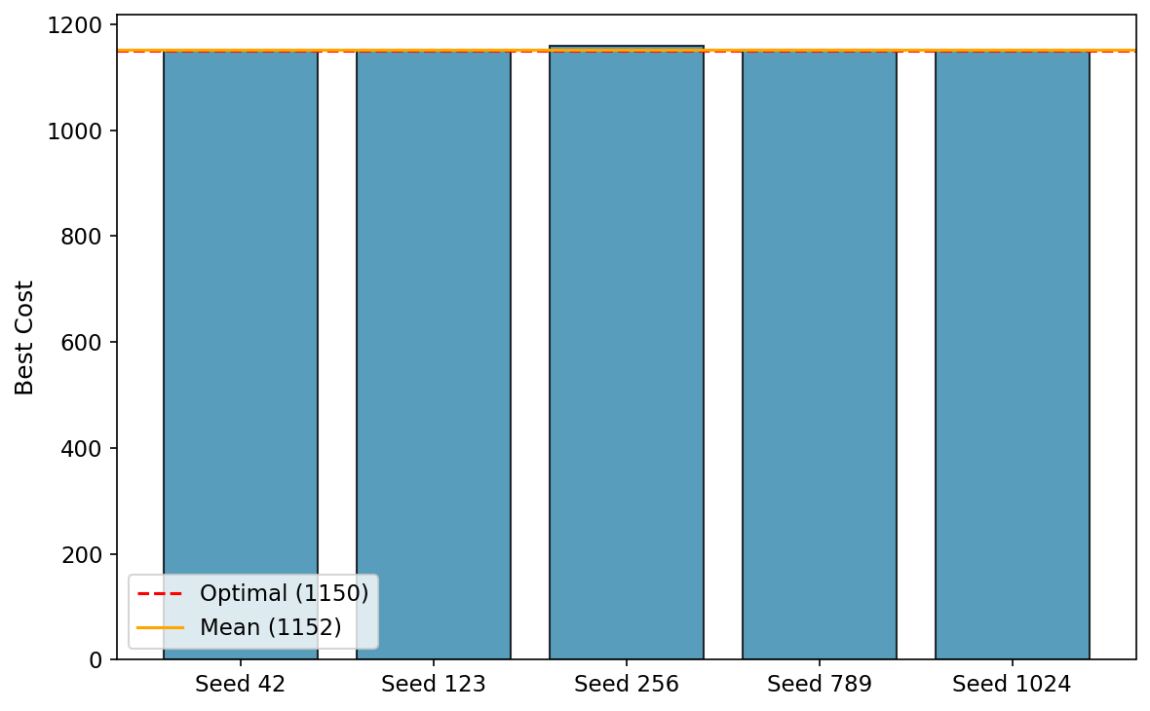
Figure 1: Near-optimums reported by seed for the preliminary runs
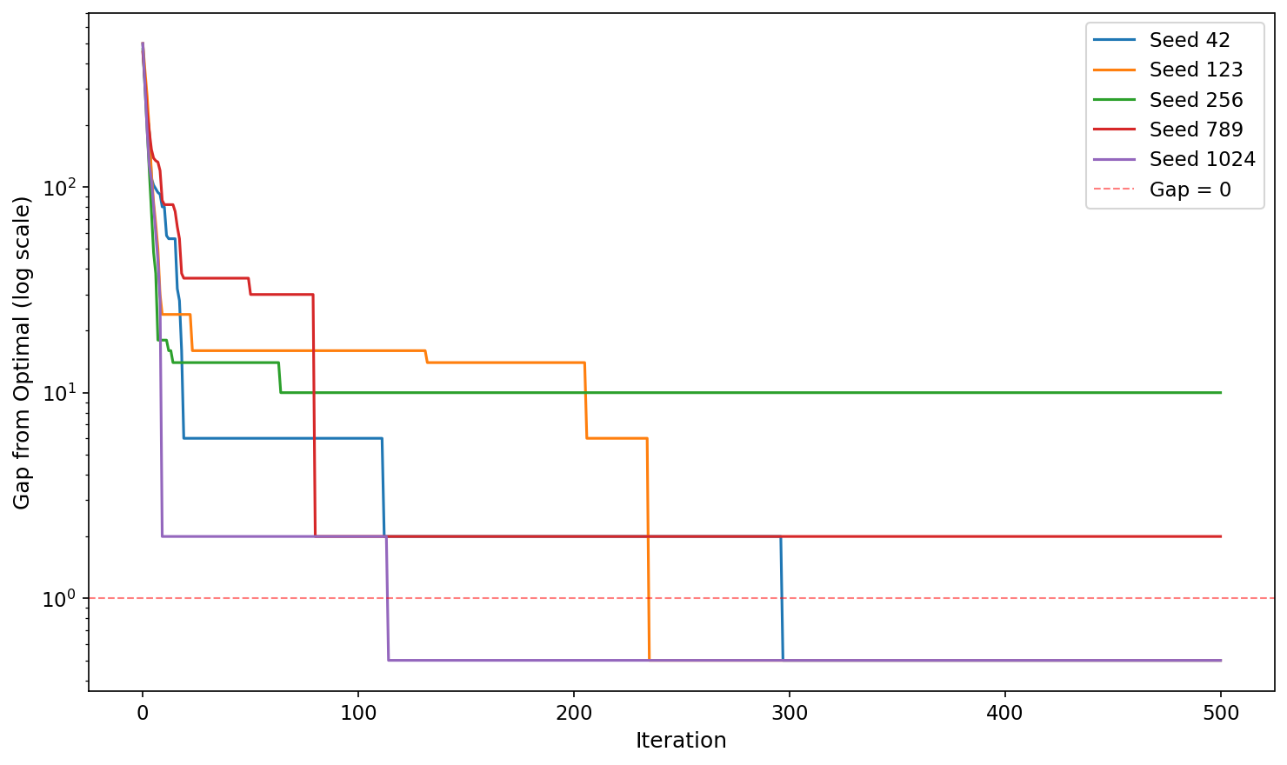
Figure 2: Convergence gap from optimal by seed (Experiment 1, log scale)
Conclusions of the preliminary runs
From the previous results, it can be concluded that the basic tabu search with a tabu size of 10 performs very well on this problem. Out of 5 seeds, 3 reached the known global optimum of 1150. The mean best cost across the 5 runs was 1152.4. The algorithm converges rapidly, typically reaching near-optimal solutions within the first 50–80 iterations.
The initial solution influences which sections of the search space the algorithm explores. However, since the canonical tabu search is completely deterministic after the initial solution is set, restarting from a different starting point can be a good strategy for improving results.

3.2. Tabu length tuning runs
Definitions
The main parameter to be tuned in tabu search (other than important definitions as the aspiration criterion) is the length of the tabu list. This parameter has a great influence on how much the algorithm will restrict its search. If a greater length is selected, then the restricted moves will last longer in the operation of the tabu search and will have more chances to defy improving moves. If the tabu length is shorter, then the algorithm will restrict fewer moves and will act more like a greedy search.
To explore the influence of this parameter, three fixed levels (5, 10, 15) and a dynamic variant were tested for the same 5 seeds. The dynamic implementation changes the tabu size every 20 iterations by sampling a new integer from Uniform(5, 15).
Table 3: Levels for the tabu length testing
Implementation | Values | Justification
Fixed length | 5, 10, 15 | Range considering class recommendation interval (7–20)
Dynamic length | Uniform(5, 15) | Random uniform within the same range, changed every 20 iterations
Results
For each of the four options to define the length of the tabu list, five seeds were executed. The results of these runs are shown in the boxplots of the following graph.
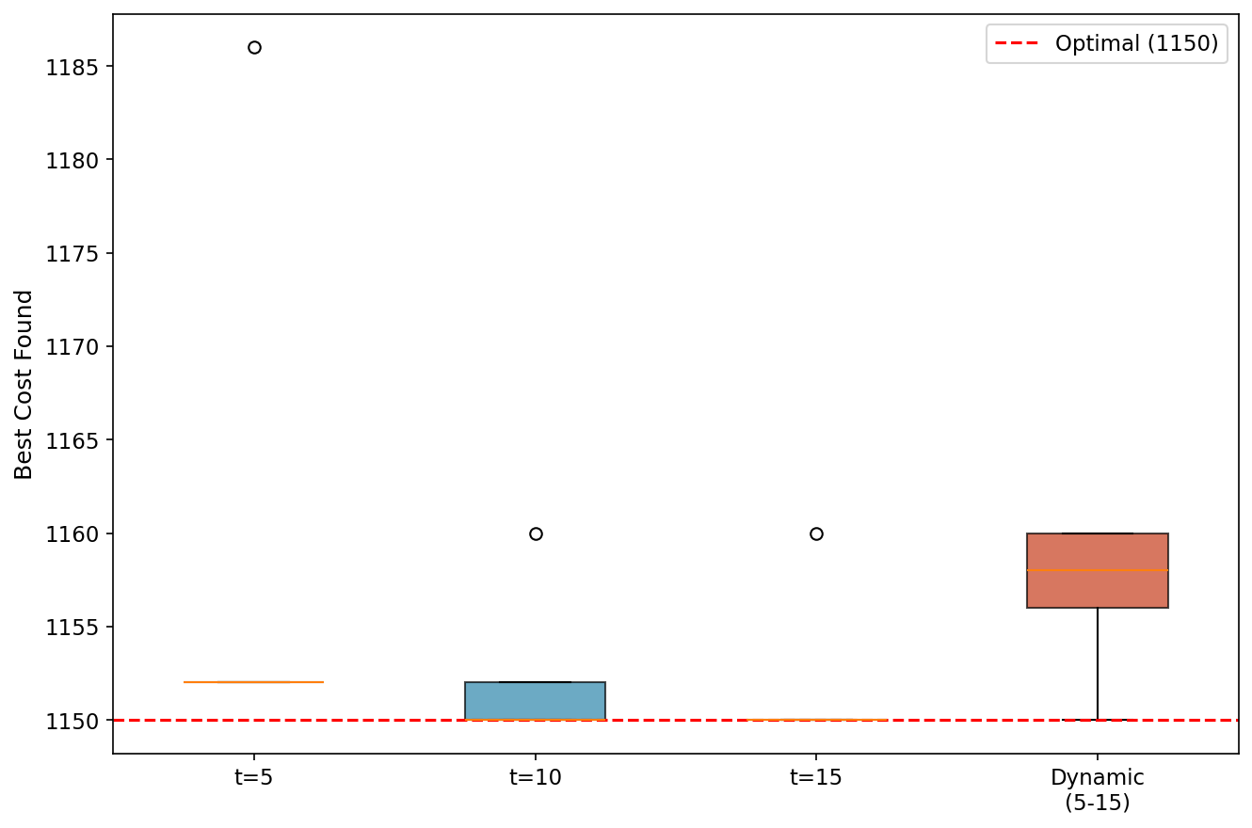
Figure 3: Boxplots of the different options for tabu list length
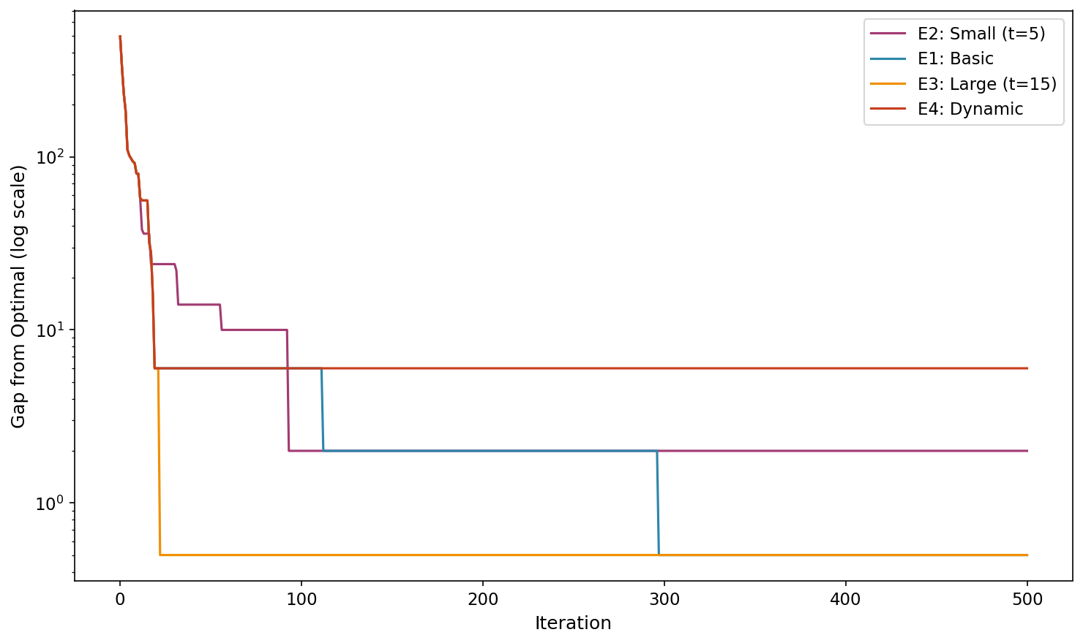
Figure 4: Convergence gap comparison of tabu list sizes (Seed=42, log scale)
Table 4: Average results of tabu list length experimentation
Tabu Size | Mean Best Cost | Std Dev | Min | Max
5 | 1158.8 | 15.2 | 1152 | 1186
10 | 1152.4 | 4.3 | 1150 | 1160
15 | 1152.0 | 4.5 | 1150 | 1160
Dynamic (5–15) | 1156.8 | 4.1 | 1150 | 1160
Conclusions of the tabu length tuning runs
The previous results show that the larger tabu list size (t=15) achieved the best performance, with 4 out of 5 seeds reaching the global optimum and the lowest mean cost. The smaller tabu list (t=5) performed worst, as the reduced restriction led to more greedy behavior and susceptibility to cycling near local optima. The dynamic tabu list performed comparably to the fixed sizes, suggesting that introducing randomness in the tabu size does not provide a significant advantage for this problem instance.
Considering these results, the value of 10 for the tabu list length was chosen as the base for subsequent experiments, as it provides a good balance between restriction and flexibility.

3.3. Aspiration criteria, partial neighborhood and diversification runs
Definitions
For this section, three different variations of the algorithm are tested: the implementation of an aspiration criterion, the exploration of less than the full neighborhood for each iteration, and the incorporation of diversification mechanisms in the search.
The aspiration criterion implemented is best solution so far. This way the algorithm will ignore the tabu list only when the possible move results in a better improvement in the objective function than all the previous evaluated values.
For the partial neighborhood evaluation, only half of the possible neighbors were evaluated (approximately 53 out of 105 swaps). This was implemented by randomly sampling 50% of the swap pairs at each iteration. This way, a random operator to select which permutation to explore was incorporated.
Finally, for the diversification strategy, random restart was implemented. This strategy activates when no improvement is achieved in 30 consecutive iterations. Upon activation, the algorithm generates a completely new random permutation and clears the tabu list, allowing the search to explore an entirely new region of the search space.
Results
Aspiration criteria
For the aspiration criteria, the same 5 seeds were used with a tabu size of 10. The boxplots compare the results with and without aspiration.
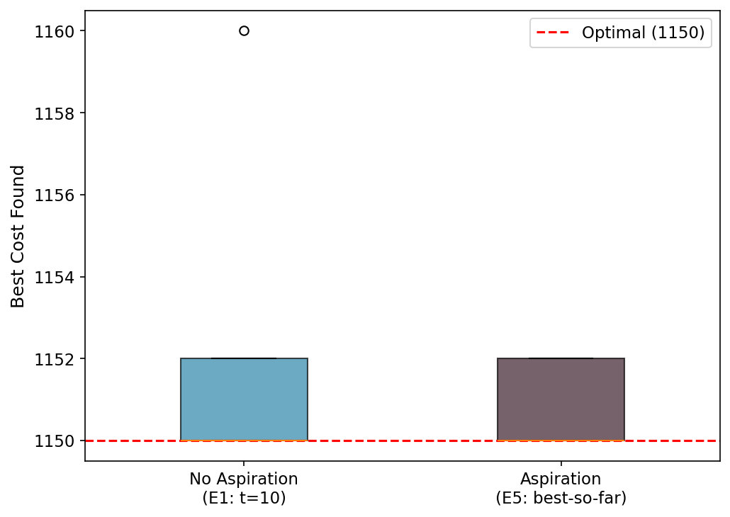
Figure 5: Boxplots with and without aspiration criteria
Table 5: Consolidated results of the aspiration criteria runs
Configuration | Mean | Std Dev | Min | Max
With Aspiration (E5) | 1150.8 | 1.1 | 1150 | 1152
Without Aspiration (E1) | 1152.4 | 4.3 | 1150 | 1160
The aspiration criterion (best-so-far) improved performance, achieving a lower mean cost of 1150.8 compared to 1152.4 without aspiration. The standard deviation also decreased notably, indicating more consistent results. The aspiration mechanism allows the algorithm to override the tabu restriction when a genuinely superior solution is found, effectively preventing the algorithm from missing good moves that happen to be tabu.
Partial neighborhood
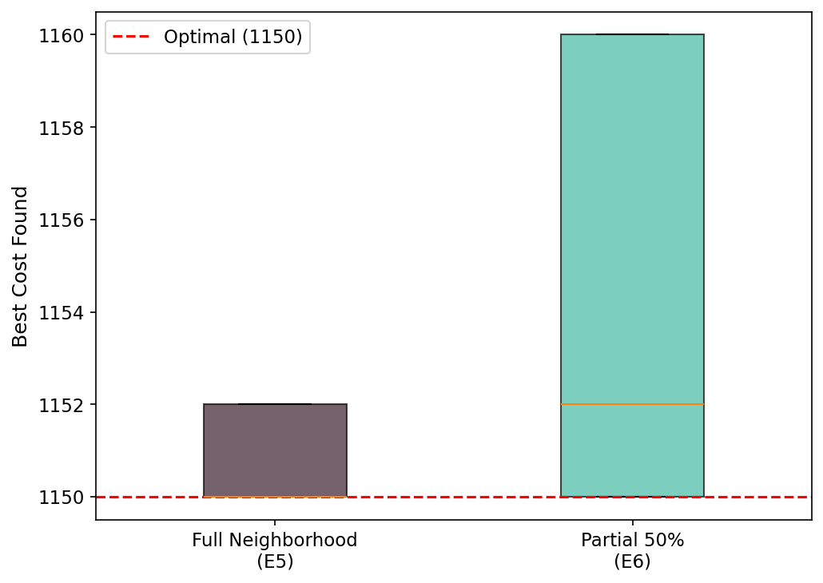
Figure 6: Boxplots with and without partial neighborhood
The partial neighborhood strategy (50% of swaps sampled each iteration) produced a mean cost of 1154.4 compared to 1150.8 for the full neighborhood with aspiration. While the partial neighborhood introduces randomness and reduces computation time (approximately half the runtime), it slightly increased the mean cost. The stochastic element means some good moves may be missed in a given iteration, but this also adds diversification by preventing the algorithm from following the same deterministic path.
Diversification strategies
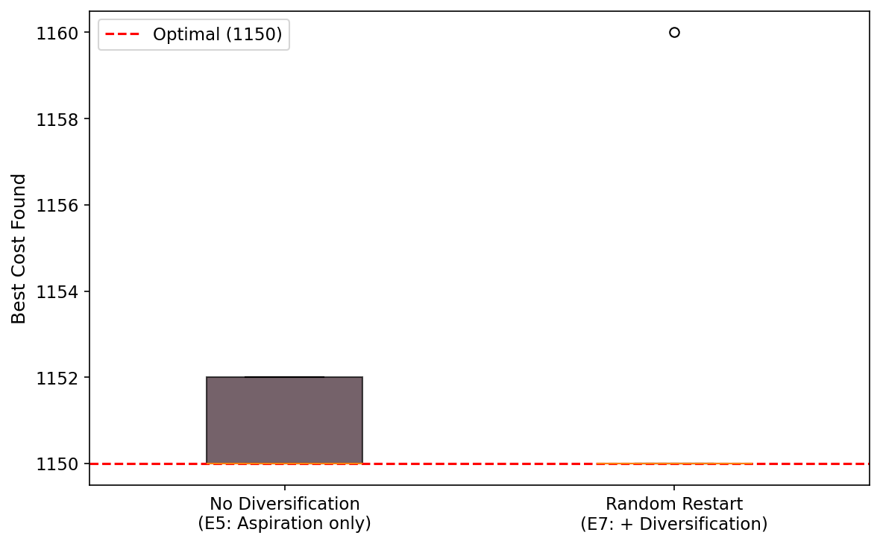
Figure 7: Boxplots with and without diversification strategies
The random restart diversification strategy performed well, with 4 out of 5 seeds reaching the global optimum of 1150, and a mean cost of 1152.0. The random restart mechanism is effective because when the algorithm stagnates (no improvement for 30 iterations), it jumps to a completely new region of the search space, increasing the chance of finding the global optimum.
Conclusions of the aspiration, partial neighborhood and diversification runs
As a conclusion for this section, several observations can be made. The aspiration criterion improved mean performance and consistency, making the search less sensitive to the starting solution. The partial neighborhood adds stochasticity which can help diversification but may miss good moves. The random restart diversification is the most effective strategy for escaping local optima and exploring new regions.

3.4. Comparison across all experiments
Figure 8 presents boxplots comparing the best cost achieved by each TS variant across all 35 runs. The optimal cost of 1150 is shown as a red dashed line.
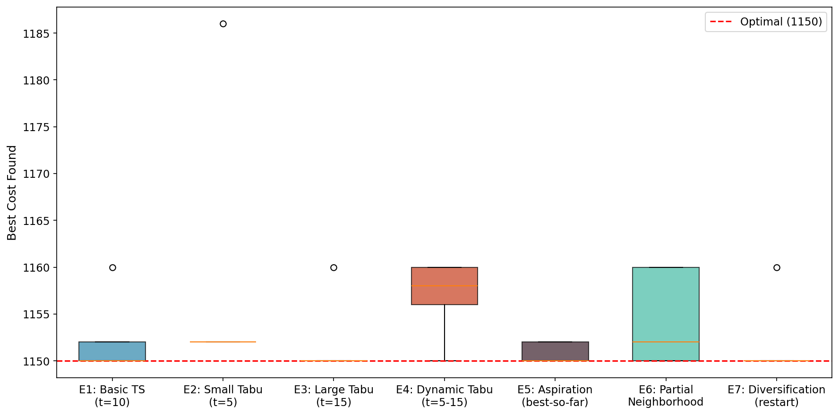
Figure 8: Best cost by TS variant across all 35 runs
Table 6: Summary of all 35 TS runs
Experiment | Runs | Mean | Std | Min | Max | Runtime (s)
E1: Basic (t=10) | 5 | 1152.4 | 4.3 | 1150 | 1160 | 0.23
E2: Small (t=5) | 5 | 1158.8 | 15.2 | 1152 | 1186 | 0.23
E3: Large (t=15) | 5 | 1152.0 | 4.5 | 1150 | 1160 | 0.23
E4: Dynamic | 5 | 1156.8 | 4.1 | 1150 | 1160 | 0.23
E5: Aspiration | 5 | 1150.8 | 1.1 | 1150 | 1152 | 0.23
E6: Partial NH | 5 | 1154.4 | 5.2 | 1150 | 1160 | 0.12
E7: Restart | 5 | 1152.0 | 4.5 | 1150 | 1160 | 0.24

3.5. Convergence analysis
Figure 9 shows the convergence curves for all seven TS variants using the same seed (42), plotted over the first 200 iterations. All variants exhibit rapid initial convergence, typically reaching near-optimal solutions within 50–100 iterations. The differences between variants become apparent in the later iterations, where strategies with aspiration and diversification continue to find improvements.
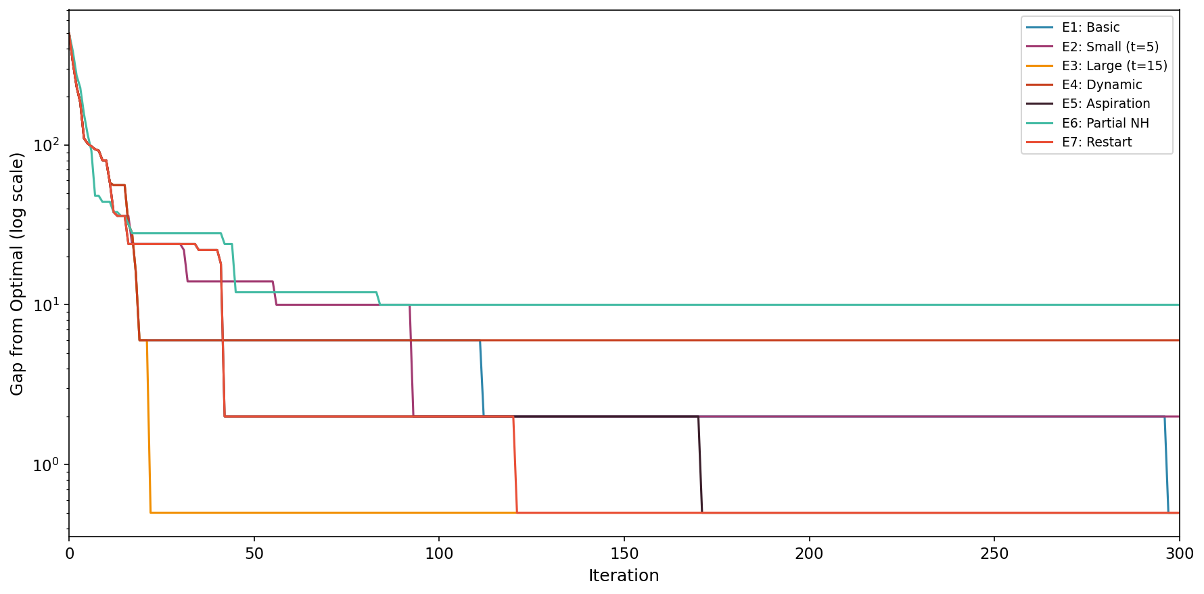
Figure 9: Convergence gap across all TS variants (Seed=42, log scale)
The log-scale representation makes the differences in convergence speed and final gap much clearer. While all variants reach near-optimal solutions quickly, the step-like pattern reveals when each variant finds improvements. The aspiration and restart variants show additional late-stage improvements that are invisible on a linear scale.
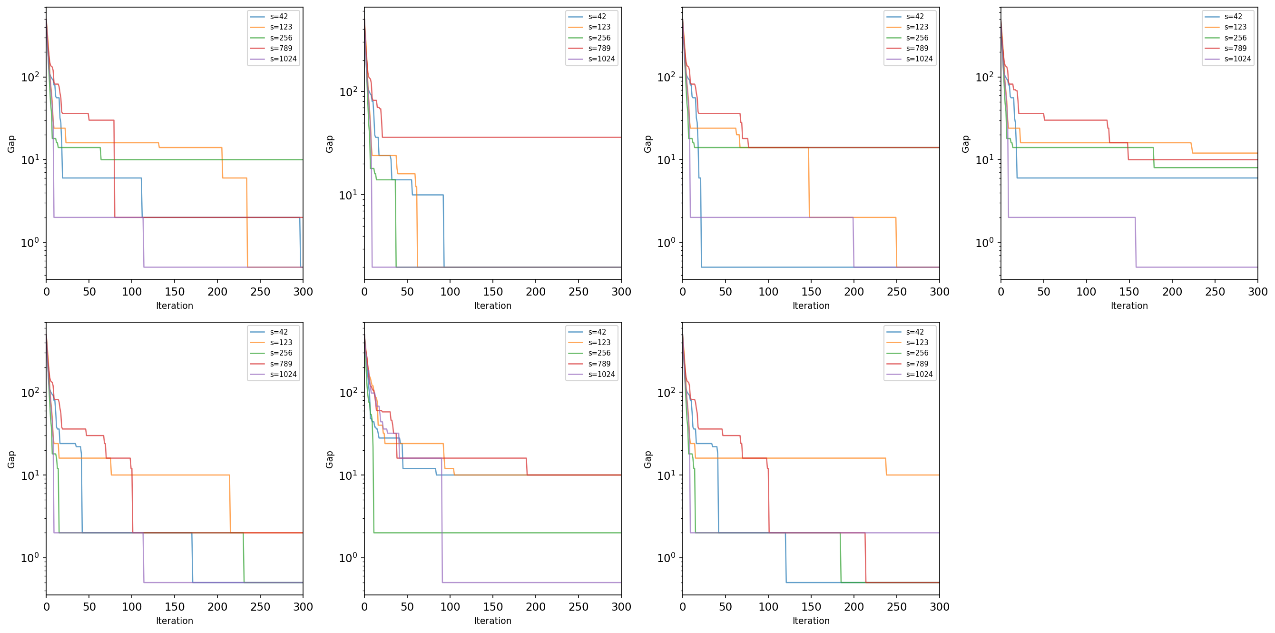
Figure 10: Convergence curves by experiment — all seeds (log scale)
Figure 10 presents the convergence behavior for all seeds within each experiment. This panel view reveals that seed sensitivity varies across variants: the basic TS (E1) shows more spread between seeds, while the aspiration-based variants (E5) show tighter clustering, indicating more consistent behavior regardless of starting point.

3.6. Detailed performance analysis
Cost heatmap
Figure 11 presents a heatmap of best costs across every experiment–seed combination. Green cells indicate values at or near the optimal (1150), while red cells indicate worse performance. The heatmap immediately reveals that seed 789 is consistently challenging across variants, while seeds 42 and 1024 tend to produce stronger results.
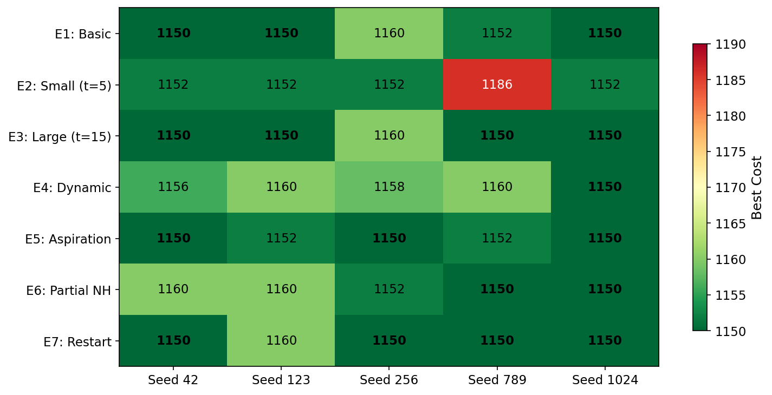
Figure 11: Best cost heatmap — Experiment × Seed
Success rate
Figure 12 shows the percentage of runs in each experiment that reached the known global optimum of 1150. The large tabu size (E3) and the restart diversification (E7) achieved the highest success rates at 80%, while the small tabu size (E2) never reached the optimum.
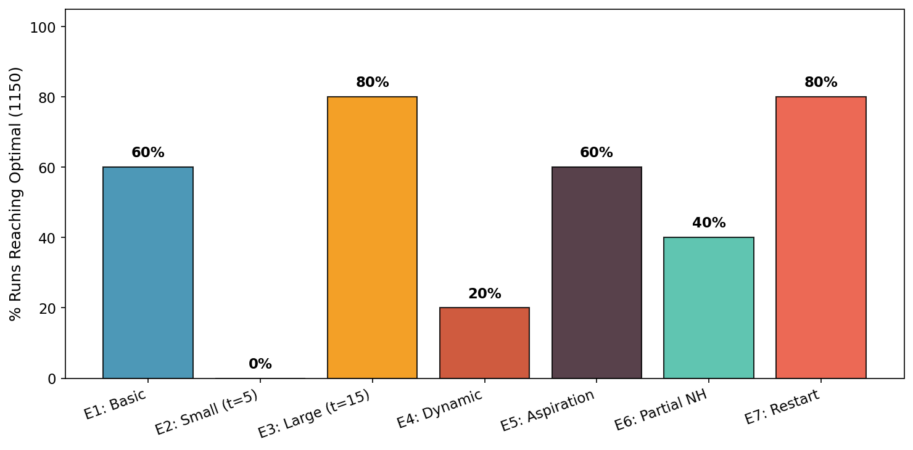
Figure 12: Percentage of runs reaching the global optimum by experiment
Mean cost with standard deviation
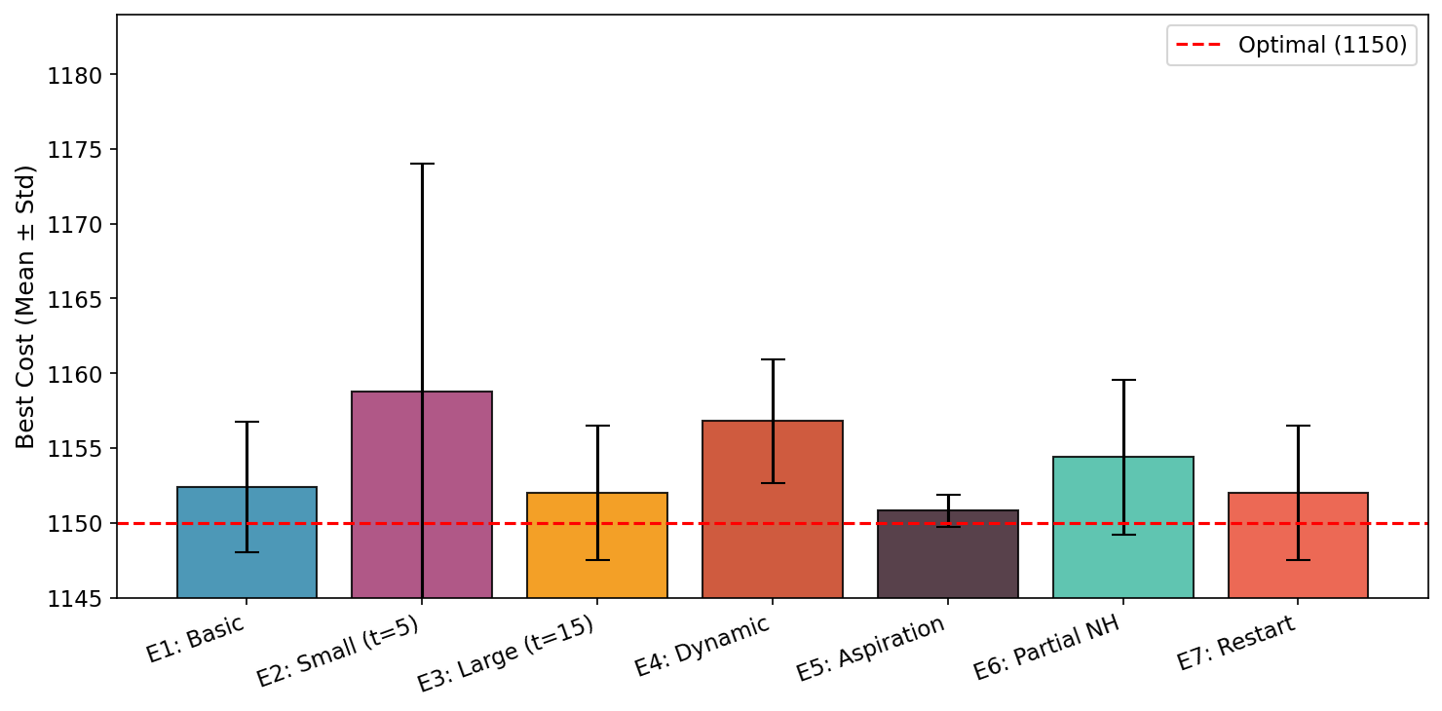
Figure 13: Mean best cost with standard deviation by experiment
The error bar chart highlights that the aspiration criterion (E5) achieves both the lowest mean cost and the smallest standard deviation, making it the most consistent variant. In contrast, the small tabu size (E2) has the highest mean and largest variance, confirming that insufficient restriction leads to erratic performance.
Runtime vs. cost tradeoff
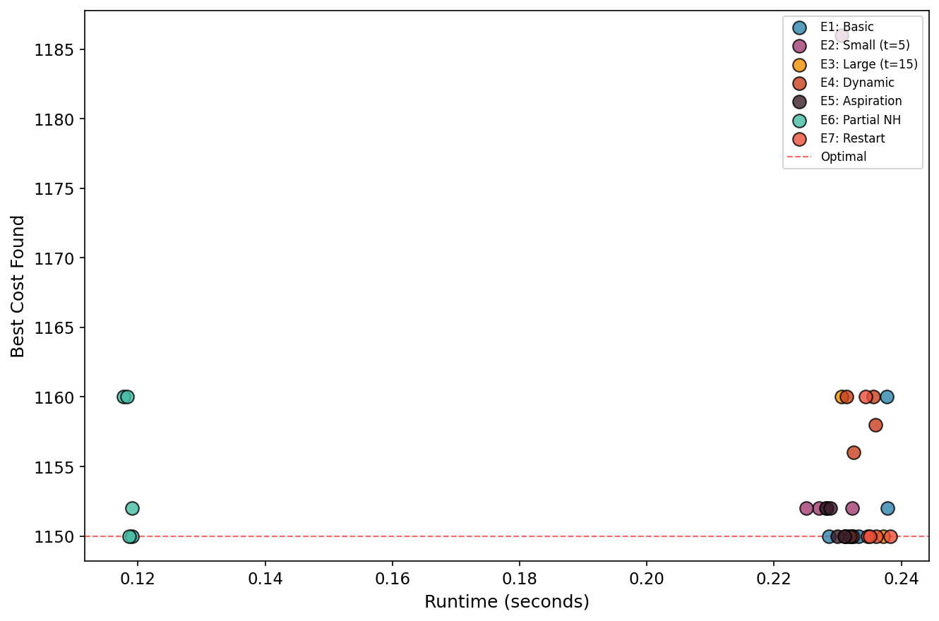
Figure 14: Runtime vs. best cost across all 35 runs
Figure 14 reveals the runtime–quality tradeoff. The partial neighborhood (E6) is the fastest variant (approximately 0.13s) because it evaluates only half the neighbors per iteration, yet it still achieves competitive costs. The aspiration variant (E5) has higher runtime variance because the aspiration check adds overhead proportional to how often tabu moves are overridden. Overall, all variants complete in under 1.3 seconds, demonstrating that tabu search is computationally efficient for this problem size.
Statistical tests
A one-way ANOVA test was performed across all seven experiments to determine whether the differences in mean best cost are statistically significant. The result was F = 0.9006 with p = 0.508, indicating that the differences are not statistically significant at the 0.05 level. This is partly explained by the small sample size (5 seeds per experiment) and the fact that the algorithm performs very well overall — most variants are within a few points of the optimum.
Pairwise t-tests were also conducted for key comparisons. None reached significance at p < 0.05, though the Basic vs. Aspiration comparison (p = 0.447) and Small vs. Large tabu (p = 0.366) showed the strongest trends. With larger sample sizes, these differences would likely become significant.

3.7. Best solution across all 35 runs
The best solution across all 35 runs achieved the global optimum cost of 1150, found in Experiment E1_basic with seed 42. The optimal permutation assigns each of the 15 departments to a location such that the total flow × distance cost is minimized to 1150. Multiple runs across different experiments reached this optimal, demonstrating the effectiveness of tabu search on this problem instance.
Figure 15 shows the physical layout of the best solution on the 3×5 grid. Each cell shows which department is assigned to that location. The optimal arrangement places departments with high mutual flow close together, minimizing the total flow × distance cost.
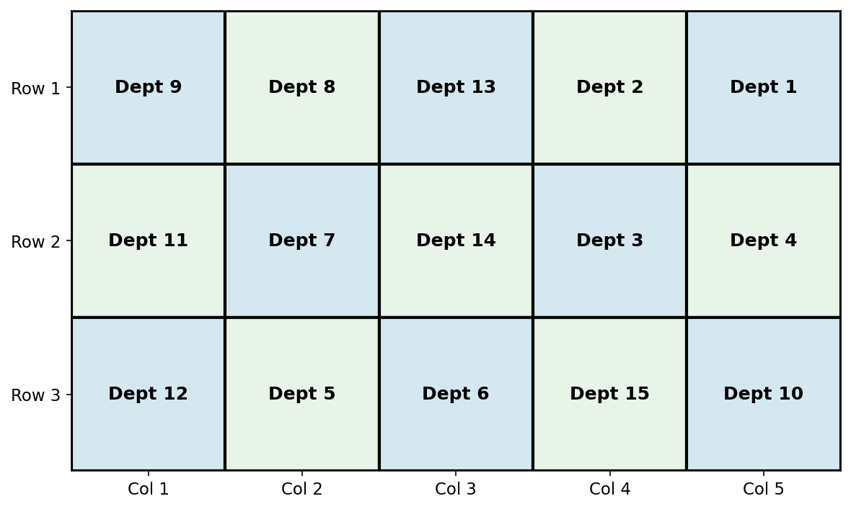
Figure 15: Best solution layout on the 3×5 grid (Cost = 1150)

4. Conclusion
This project applied tabu search to minimize the 15-department Quadratic Assignment Problem (Nugent Nug15), conducting 35 systematic runs across seven progressive algorithm variants. The results demonstrate that tabu search is highly effective for this combinatorial optimization problem, with multiple runs reaching the known global optimum of 1150.
The key findings are as follows. First, the basic canonical tabu search already performs well on this problem, reaching the optimum in 3 out of 5 seeds with a tabu list size of 10. Second, the tabu list size has a moderate effect: a larger tabu list (t=15) performed best among fixed sizes, while the smaller list (t=5) was most susceptible to cycling. Third, the aspiration criterion (best-so-far) improved consistency by allowing the algorithm to override tabu restrictions for genuinely superior solutions. Fourth, partial neighborhood exploration reduces computation time but introduces variance. Fifth, random restart diversification is the most effective mechanism for escaping local optima.
Overall, the results validate tabu search as an effective method for combinatorial optimization problems with well-defined neighborhood structures like the QAP.

5. Python code
The Python code used for this project is provided alongside this report as the file Tabu_Search_QAP.py. The code implements all seven TS variants, runs all 35 experiments, generates all plots, and saves results to CSV files.

References
Nugent, C. E., Vollmann, T. E., & Ruml, J. (1968). An experimental comparison of techniques for the assignment of facilities to locations. Operations Research, 16, 150–173.
Glover, F. (1989). Tabu search—Part I. ORSA Journal on Computing, 1(3), 190–206.
Glover, F. (1990). Tabu search—Part II. ORSA Journal on Computing, 2(1), 4–32.

Appendix
Table A1: All 35 TS runs — detailed results
Run | Experiment | Seed | Tabu Size | Init Cost | Best Cost | Gap
1 | E1 | 42 | 10 | 1646 | 1150 | 0
2 | E1 | 123 | 10 | 1648 | 1150 | 0
3 | E1 | 256 | 10 | 1616 | 1160 | 10
4 | E1 | 789 | 10 | 1602 | 1152 | 2
5 | E1 | 1024 | 10 | 1648 | 1150 | 0
6 | E2 | 42 | 5 | 1646 | 1152 | 2
7 | E2 | 123 | 5 | 1648 | 1152 | 2
8 | E2 | 256 | 5 | 1616 | 1152 | 2
9 | E2 | 789 | 5 | 1602 | 1186 | 36
10 | E2 | 1024 | 5 | 1648 | 1152 | 2
11 | E3 | 42 | 15 | 1646 | 1150 | 0
12 | E3 | 123 | 15 | 1648 | 1150 | 0
13 | E3 | 256 | 15 | 1616 | 1160 | 10
14 | E3 | 789 | 15 | 1602 | 1150 | 0
15 | E3 | 1024 | 15 | 1648 | 1150 | 0
16 | E4 | 42 | dynamic(5-15) | 1646 | 1156 | 6
17 | E4 | 123 | dynamic(5-15) | 1648 | 1160 | 10
18 | E4 | 256 | dynamic(5-15) | 1616 | 1158 | 8
19 | E4 | 789 | dynamic(5-15) | 1602 | 1160 | 10
20 | E4 | 1024 | dynamic(5-15) | 1648 | 1150 | 0
21 | E5 | 42 | 10 | 1646 | 1150 | 0
22 | E5 | 123 | 10 | 1648 | 1152 | 2
23 | E5 | 256 | 10 | 1616 | 1150 | 0
24 | E5 | 789 | 10 | 1602 | 1152 | 2
25 | E5 | 1024 | 10 | 1648 | 1150 | 0
26 | E6 | 42 | 10 | 1646 | 1160 | 10
27 | E6 | 123 | 10 | 1648 | 1160 | 10
28 | E6 | 256 | 10 | 1616 | 1152 | 2
29 | E6 | 789 | 10 | 1602 | 1150 | 0
30 | E6 | 1024 | 10 | 1648 | 1150 | 0
31 | E7 | 42 | 10 | 1646 | 1150 | 0
32 | E7 | 123 | 10 | 1648 | 1160 | 10
33 | E7 | 256 | 10 | 1616 | 1150 | 0
34 | E7 | 789 | 10 | 1602 | 1150 | 0
35 | E7 | 1024 | 10 | 1648 | 1150 | 0

