

American International University-Bangladesh (AIUB)

**Project Proposal / Documentation**

**Blogging Web Application**

Submitted By

|  |  |  |
| --- | --- | --- |
| Student Name | Student Id | Department |
| Ehsanul Mostofa | 18-38383-2 | CSE |
| Shameem Shahriar | 18-36342-1 | CSSE |
| Ahnaf Tahmid Ul Huq | 19-39849-1 | CSE |
| Md. Arman Joarder | 18-37882-2 | CSE |
| Sadia Afrin Swarna | 18-36522-1 | CSE |

Supervised By

**MIR MD. KAWSUR**

Lecturer, Faculty of Science and Technology

American International University-Bangladesh

April 18, 2022

Contents

Introduction 3

Objective 3

System Features 4

Software Development Life Cycle (SDLC) 6

Diagram 7

UX/UI Design 9

Effort Estimation 11

Conclusion 12

# Introduction

A blogging platform is software or services for managing and publishing content on the Internet in the form of blogs. A blog (short for weblog) is a record of a user's online posts. The blogging platform allows users to create, organize, and publish written and visual content online on their blogs. Although there is a bunch of blogging platforms that exist right away such as medium, word press, wix, blogger, tumblr etc. and they have millions of users all over the world. Our platform is working for students who is at university level. Our main goal is create a platform where students can express themselves in a safe online environment. We gives them a platform to explore and share their feelings about a topic like their ideas, discuss certain arguments that relate to a student’s life, keeping other students informed, and generally influencing. It also help them to increase their writing, communication, analysis, and interpretation skills. By sharing their thoughts, they are learning how to express themselves to the world. We will provide a student blogging service under a simple system both in Android and Web versions.

# Objective

The objective of the project is to create a blogging website targeted for the students of AIUB. Through materializing this blogging website, the students will get a fairly familiar yet open platform to participate, which in return would elevate their writing skills. The students are not prone to writing out of their academic needs, which results in a lack of practice of writing. Proficiency in this field is required since it is a critical talent that contributes significantly to career advancement. This project would provide the platform to the students of AIUB to participate and engage with their creativity and enhance their competence in writing.

# System Features

1. **Login and Signup**
   1. Users will be able to sign up with an email
   2. User will be able to login once they signed up

Priority Level: High

Precondition: Must have a valid email.

1. **System Access**
   1. The system can be accessed by any browser on pc/tablet/mobile

Priority Level: Low

Precondition: None

1. **User Profile Management**
   1. Users can update their profile information. e.g. Profile picture/Bio.

Priority Level: Medium

Precondition: Users must verify their profile through their email.

1. **Reverse Order Post**
   1. User Posts must be in reverse order. New posts must be in top.

Priority Level: High

Precondition: Must be a valid user.

1. **Commenting on Post**
   1. Users will be able to comment on a post.

Priority Level: High

Precondition: Must be a valid user.

1. **Multiple Authorship**
   1. Multiple authors will be able to contribute to a blog.

Priority Level: High

Precondition: Valid User and main author must give permission to sub- authors.

1. **Social Sharing Option**
   1. Blog posts should be shareable in other social medias

Priority Level: Medium

Precondition: None

1. **Scheduling**
   1. Authors will be able schedule blog posts.

Priority Level: Medium

Precondition: None

1. **Follow**
   1. Users will be able to follow other users.

Priority Level: Medium

Precondition: None

1. **Search**
   1. Users will be able to search other users.

Priority Level: Medium

Precondition: None

# Software Development Life Cycle (SDLC)

Waterfall Model :

In Our media blogging platform we will follow waterfall model. This is a software development methodology which is intended to improve software quality and responsiveness to changing customer requirements. Waterfall project management is is sequential, linear process of project management. It consist of several discrete phases. The advantages of waterfall methodology are that: requirements are completed early in the project, enabling the team to define the entire project scope, create a complete schedule and design the overall application. So waterfall model would be the perfect for our system.

It improves resource utilization because tasks can be split to be worked in parallel or grouped to leverage resource skills.

It is a better application design because there is a more complete understanding of all the requirements and deliverables.

The project status is more easily measured based on a complete schedule and resource plan. In the coding phase software design is translated into source code using any suitable programming language. Thus each designed module is coded. The aim of the unit testing phase is to check whether each module is working properly or not.

In this project, the requirements are very well known, clear and fixed, product definition is stable, technology is understood. There are no ambiguous requirements, ample resources with required expertise are available freely and the project is short. We can update the software for the betterment of the system in the maintenance phase. To put it in a nutshell, I pen down saying that waterfall would be the best option for this project.

# Diagram

Use Case Diagram :

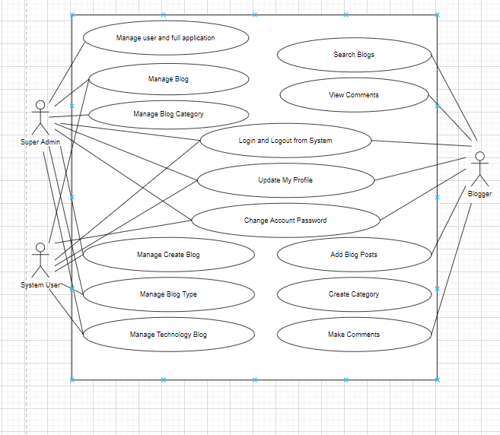

Class Diagram :

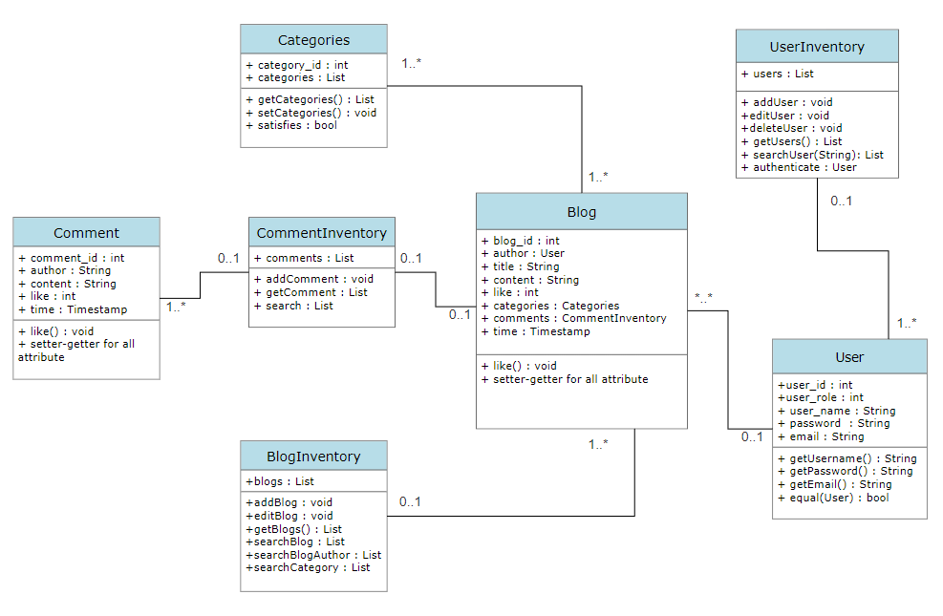

Activity Diagram :

|  |
| --- |
|  |

# UX/UI Design

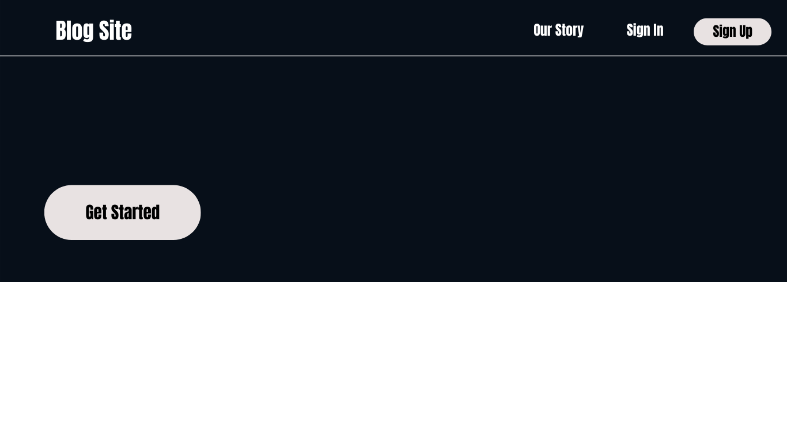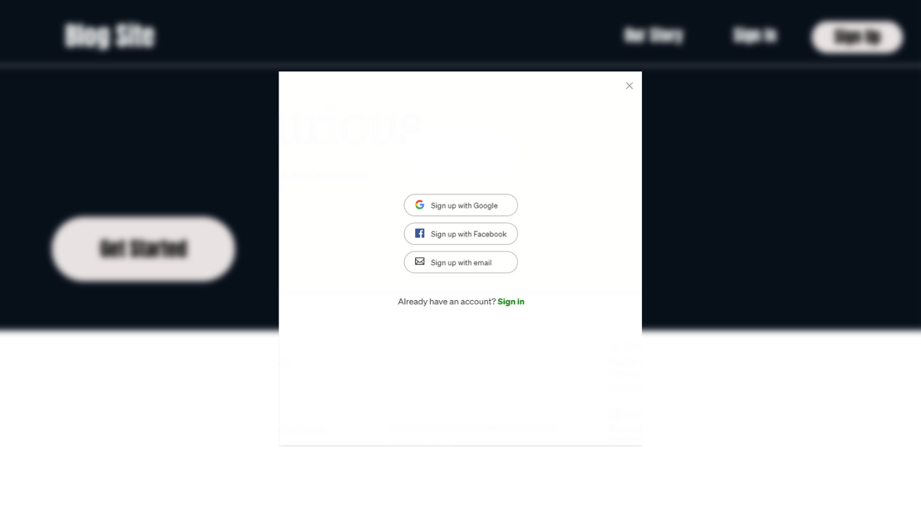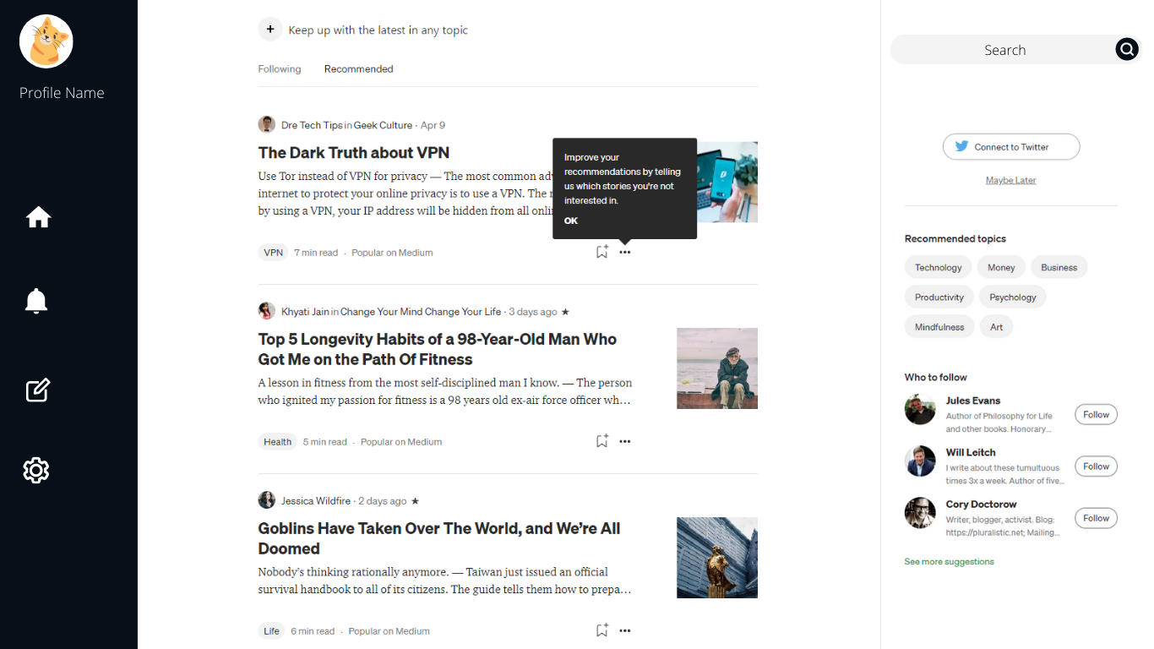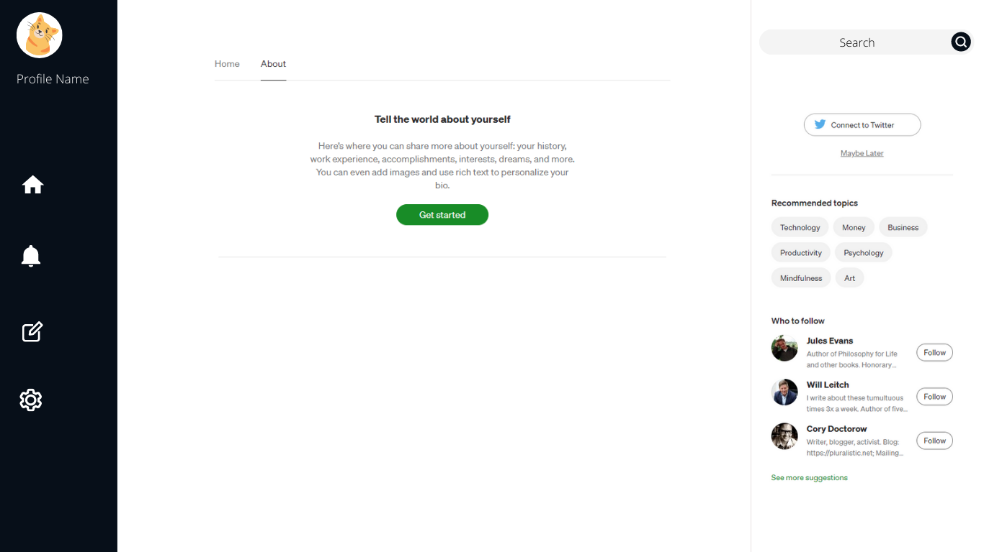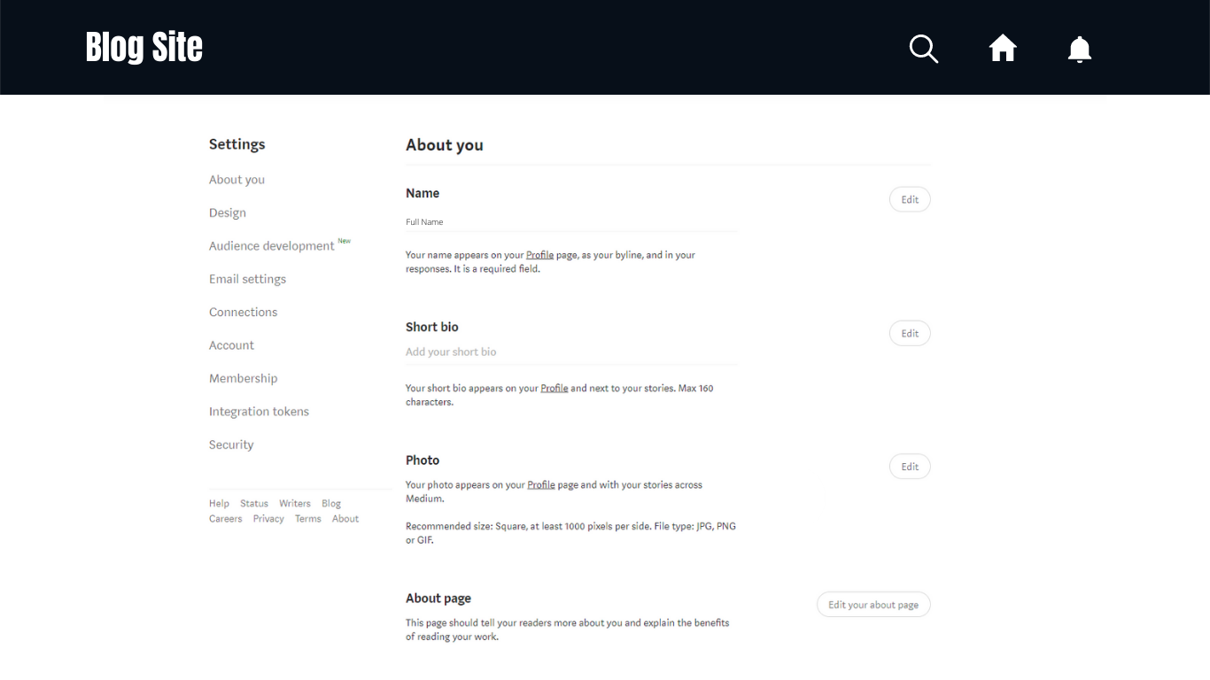

# Effort Estimation

SLOC (source Line Of Code) = XXYY

Our project is a blogging type project. So, the values will be as follows

Project complexity, P = 1.05

SLOC-dependent coefficient, T = 0.38

Coefficient = 2.4

Effort = E = Coefficient*( XXYY /1000)^p

= 2.4*( XXYY /1000)^1.05

= AB People-month

Development Time, D = 2.50*(E)^T

= 2.50*AB^0.38

= Z month

Required Number of Peoples = AB/Z

= X peoples

# Conclusion

In this report we have presented a documentation on blogging web application which will be a real-world blogging project. This project will be based on university and its students as well as faculties where any valid student or teacher will be able to write any blog on our app and publish it online. Viewers and readers from all disciplines will be able to read those blogs thoroughly. They will also be able to like,comment and share those blogs and if any misleading information is found they will also be able to report those blogs and admin will take proper action against those blogs. It is to be noted this will be a knowledge sharing medium for students and teachers so there will no AdSense or any money making source for both students and teachers so there will be no Advertisement on this site. As a result this will be treated as voluntary work. This report contains all the necessary document for a complete blog site which will be ready for production.