**Commented Code:**

#! /usr/bin/python

mystring = "this is a variable"

mylist = ['a', 'b', 3, 4] # Here we have declared list.Lists are used to store multiple items in a single variable.

mytuple = ('a', 'b', 3, 4) # tuple is a collection. Tuples are used to store multiple items in a single variable.

mymarks = {"webProg":80, "OOSD":70, "POC":68, "NOS": 50} #Sets are used to store multiple items in a single variable. Sets are written with curly brackets.

#sequence

myset = set("this is a book") #To intialize a set with values, you can pass in a list to set().

#list operations

print(mylist) # print statement is used to print text or variables

mylist.insert(2,'c')#To insert a list item at a specified index, use the insert() method. The insert() method inserts an item at the specified index:

mylist.append(5)#append() method is used to add an item at the end of the list

print(mylist) # print value of my list on console

#typle operations

print(mytuple[0]) #We can access tuple items by referring to the index number, inside square brackets:

print(mytuple[1]) #along with print statement we can accrss the specific tuple item and print it.

#string operations

print (mystring[::3])

#dictionary operations

print(mymarks['webProg']) #Prints the value of single item webProg

print(mymarks.keys()) #Prints all keys for mymarks

print(mymarks.values()) #Prints all values for mymarks

#A for loop is used for iterating over a sequence (that is either a list, a tuple, a dictionary, a set, or a string).

for key in mymarks.keys():# This loop will interate through teh mymarks set one by one and print till the last item

print("Key: ", key, " Value: ", mymarks[key])

print(myset) #This will print myset Sets are unordered, that is why we are not sure in which order the items will appear.

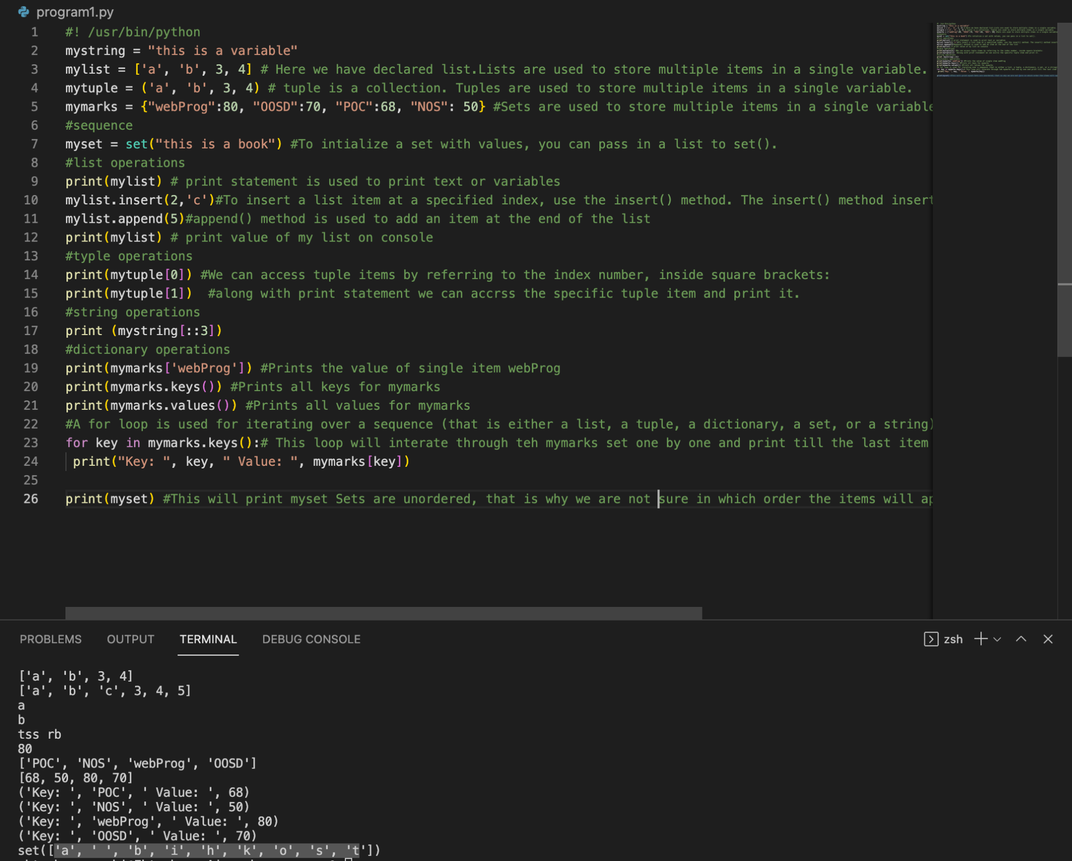

Running program1.py

Go to the command line.

Check python installation: python --version

Run python file: python program1.py

**Output:**

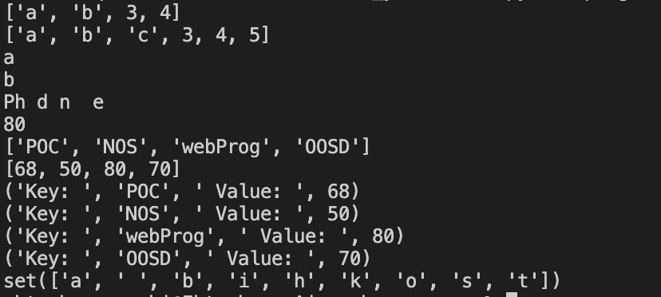

Indentation refers to spaces at the beginning of a code line.

In Python it is very important because it indicates a block of code and Python will give an error if indentation is skipped.Also same number of spaces in the same block of code.

Comments start with a #

#This is a comment.

In python a variable is created when you first assign a value to it. Also variables do not need to be declared with any particular *type*, and can even change type after they have been set.