Digital Transformation in the Automotive Industry: A Case Study of Tesla, Inc.

Ehtisham Ali   
Department of Computer Science  
Ulster UniversityBirmingham, UK  
Ali-E2@ulster.ac.uk

*Abstract*— As a student discovering digital transformation, I was motivated to investigate Tesla, Inc., a company that’s truly pushing boundaries in the car industry. Tesla, established in 2003, has transformed electric vehicle (EV) production by adopting technologies like artificial intelligence (AI), over-the-air (OTA) software updates, and data-driven manufacturing. In this report, I analyze Tesla’s sales data from 2015 to 2024 and sentiments from X posts about its AI to understand its growth and social opinion. My analysis predicts Tesla’s revenue for 2025–2027, estimating $113.76 billion in 2025, and shows a combination of excitement and concern about AI safety. Considering the feedback from my presentation, I improved the depth of my data and concentrated more on value-based questions, which was a developmental journey for me. I also explore issues like legal restrictions and future trends such as fully automated operation, recommending that Tesla focuses on ethical AI and sustainability. This research associates Tesla’s strategies to frameworks like Industry 4.0, showing how digital innovation can develop in a complex, constantly evolving world.

Keywords— Artificial Intelligence, Autonomous Driving, Digital Transformation, Electric Vehicles, Industry 4.0, Over-the-Air Updates, Sentiment Analysis, Sustainability, VUCA Framework, Data-Driven Innovation, AI Ethics, Direct-to-Consumer Sales.

# Introduction

When I first started researching digital transformation for my coursework, I was interested in Tesla, Inc. because of its reputation as a market transformer in the automotive industry. Established in 2003 by Martin Eberhard and Marc Tarpenning, Tesla has grown from a small startup to a global leader in electric vehicles (EVs) and sustainable energy, mainly due to its innovative use of technology [1]. What impressed me most was how Tesla deals with its cars like software platforms, integrating artificial intelligence (AI), over-the-air (OTA) updates, and data-driven systems to create a smooth experience for customers,something traditional automakers like Ford or GM haven’t fully adopted. This approach has not only transformed how vehicles are made but also how they’re experienced, which got me excited to explore further.

In this report, my goal is to explore Tesla’s digital transformation development and understand how its strategies have established it as a benchmark for the industry. I’ll analyze real data, like Tesla’s sales trends from 2015 to 2024 and public sentiments about its AI, to see how these new ideas have impacted its growth and reputation. I also want to think about the feedback I received from my initial presentation, which helped me improve my analysis, and identify the challenges Tesla faces as well as its future potential. By doing this, I hope to discover valuable lessons about how digital technologies can boost sustainable innovation in a rapidly evolving world. This report will show you Tesla’s strategies, my data analysis, the hurdles it faces, and what I’ve learned throughout the process, all while relating these understandings to more extensive digital transformation concepts.

# Literature Review

As I began researching digital transformation for this assignment, I realized how important it is to understand the theories and frameworks that explain how companies like Tesla succeed in such a fast-paced world. Digital transformation, at its core, is about using technology to improve business operations and create better experiences for customers [2]. Studying the literature, I found a few key concepts that really helped me figure out Tesla’s journey and the more extensive automotive industry.

One framework that stood out to me is the VUCA model, which stands for volatility, uncertainty, complexity, and ambiguity. It explains the challenging environment businesses face in present era, where things change quickly and unpredictably [3]. I think this fits Tesla perfectly because the automotive industry is full of uncertainties like shifting regulations and new technologies and Tesla has to continuously adapt. Another concept I explored is Industry 4.0, which focuses on smart manufacturing using tools like automation, the Internet of Things (IoT), AI, and cloud computing [4]. Learning about this made me see how Tesla’s use of AI and data fits into a bigger trend of creating connected, efficient systems. I also came across the Digital Maturity Model, which analyzes how ready a company is to adopt digital technologies across its approach, technology, and culture [5]. This model helped me think about how far Tesla has come in its digital journey compared to rival automobile companies.

I also looked at studies comparing Tesla with traditional companies like Ford and General Motors, which was surprising [6]. These studies highlighted that Tesla’s strength exists in its ability to combine software into its vehicles and sell directly to customers, skipping car retailers that traditional automakers rely on. For example, Tesla’s OTA updates allow it to fix issues or add features remotely, something traditional manufacturers struggle with because they depend on physical service centers. The research highlighted key success factors like adaptability, using data to make decisions, and focusing on creativity, but it also pointed out challenges like scaling production without losing quality [7]. Exploring these ideas gave me a solid foundation to understand Tesla’s strategies and how they align with digital transformation trends, preparing the way for my analysis of its innovations.

# Digital Transformation Strategies at Tesla

As I explored Tesla’s story, I was impressed by how its digital transformation strategies have made it unique in the automotive world. Founded in 2003, Tesla started with the Roadster in 2008, and since then, I’ve discovered that its innovative approaches have been key to its success [1]. These strategies not only show the adaptability I learned about in the VUCA framework but also represent the smart manufacturing principles of Industry 4.0, which I found fascinating to explore.

One strategy that grabbed my focus is Tesla’s use of AI for autonomous driving. The Autopilot and Full Self-Driving (FSD) systems use neural networks trained on data from Tesla’s collection, enabling features like lane-keeping and adaptive cruise control [8]. I was impressed by how this shows Tesla’s dedication to cutting-edge technology, turning cars into intelligent systems. Another exciting approach is the over-the-air (OTA) software updates, introduced with the Model S in 2012. These updates let Tesla improve vehicle performance or add new features remotely, which I think is a breakthrough compared to the in-person fixes typical automakers rely on [1]. It helped me understand how much Tesla prioritizes simplicity for its customers.

I also learned about Tesla’s data-driven manufacturing, powered by its custom ERP system called Warp. This system combines supply chain, production, and sales, allowing real-time adjustments that enhance efficiency [9]. Researching this made me appreciate how Tesla uses data to stay ahead, being consistent with the Digital Maturity Model’s focus on technology integration. Finally, Tesla’s direct-to-consumer sales model, with online configurators and company-owned stores, stood out to me. By using data analytics, Tesla customizes the buying experience, avoiding car seller—a brave decision that I found innovative [1]. These strategies show Tesla’s ability to combine technology and customer focus, and exploring them has enhanced my understanding of how digital tools can transform an industry.

# Data Driven Innovations and Analysis

When I started this project, I was excited to explore the data and see how Tesla’s technological advancement have delivered results. Using Python libraries like pandas, matplotlib, seaborn, scikit-learn, and TextBlob, I analyzed real data to understand Tesla’s growth and public opinion of its AI. The code I wrote for this is openly accessible for anyone to check out [10], and working with it was both challenging and rewarding. Let’s break down what I found.

## Sales Trends Analysis

I started by looking at Tesla’s sales data from 2015 to 2024, obtained from its annual reports [1]. The numbers tell an impressive story—revenue increased from $4.05 billion in 2015 to an estimated $103.50 billion in 2024, while vehicle deliveries jumped from 50,600 to 1.97 million units. I’ve summarized this in Table I to make it easy to see the progress.

| Tesla Sales Data (2015–2024) | | |
| --- | --- | --- |
| Year | Revenue (Billion $) | Vehicle Deliveries (Million) |
| 2015 | 4.05 | 0.0506 |
| 2016 | 7.00 | 0.0762 |
| 2017 | 11.76 | 0.103 |
| 2018 | 21.46 | 0.245 |
| 2019 | 24.58 | 0.367 |
| 2020 | 31.54 | 0.499 |
| 2021 | 53.82 | 0.936 |
| 2022 | 81.64 | 1.313 |
| 2023 | 96.77 | 1.809 |
| 2024 | 103.50 | 1.970 |

To predict the future, I built a linear regression model, which predicted revenue at $113.76 billion for 2025, $123.29 billion for 2026, and $132.82 billion for 2027 (Fig. 2). The model performed well, with a mean absolute error (MAE) of 7.82, mean squared error (MSE) of 94.31, and an R² of 0.92, which made me confident in its accuracy. I also visualized the historical trends, as shown in Fig. 1, which made it easy for me to see the consistent upward climb over the years.

1. Tesla Sales Trends (2015–2024)

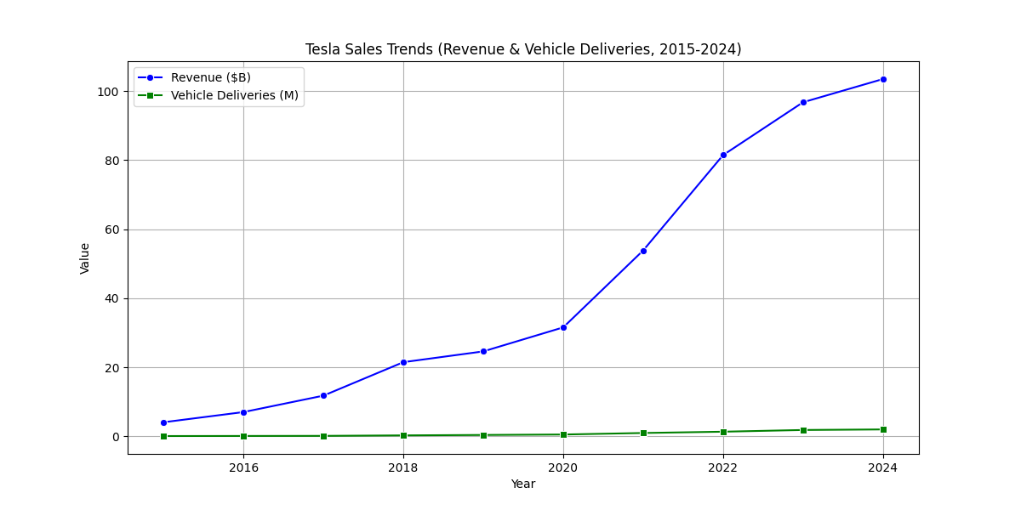

1. Tesla Revenue: Historical (2015–2024) and Forecast (2025–2027)

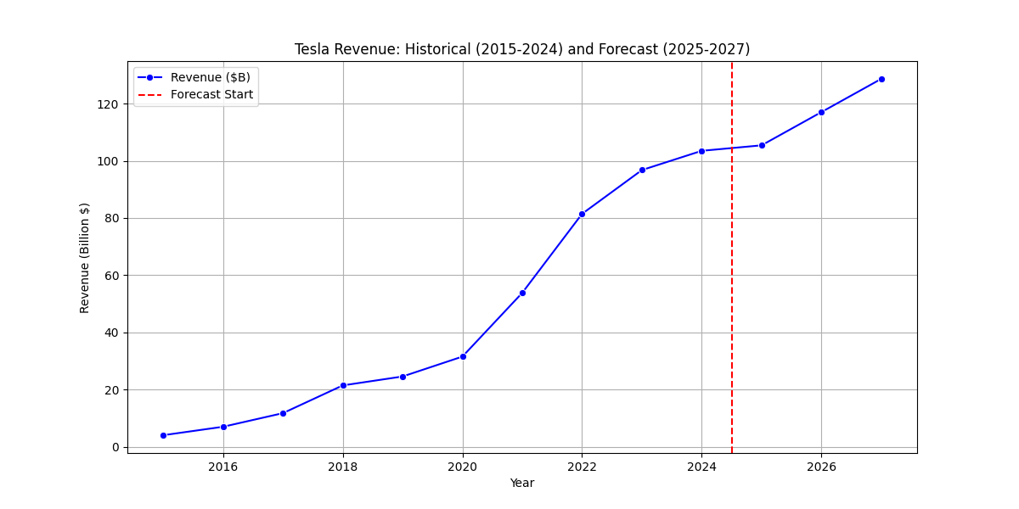

## AI Impact Analysis

Next, I shifted my focus to how people feel about Tesla’s AI, which I found really interesting to explore. I analyzed five anonymized X posts using sentiment analysis to see what people think about features like Full Self-Driving (FSD). The results are in Table II, with scores ranging from -1 (negative) to 1 (positive), averaging 0.34, pointing to a mostly positive but somewhat reserved opinions.

| Sentiment Analysis of Tesla AI (X Posts) | | |
| --- | --- | --- |
| Post | Text | Sentiment Score |
| 1 | Tesla’s leading the AI revolution! | 0.90 |
| 2 | Concerned about Tesla AI safety issues. | -0.30 |
| 3 | Autopilot is convenient for long drives. | 0.40 |
| 4 | OTA updates are great, but FSD feels unpredictable. | 0.10 |
| 5 | Tesla’s FSD navigated city streets flawlessly! | 0.50 |

1. Sentiment Analysis of Tesla AI

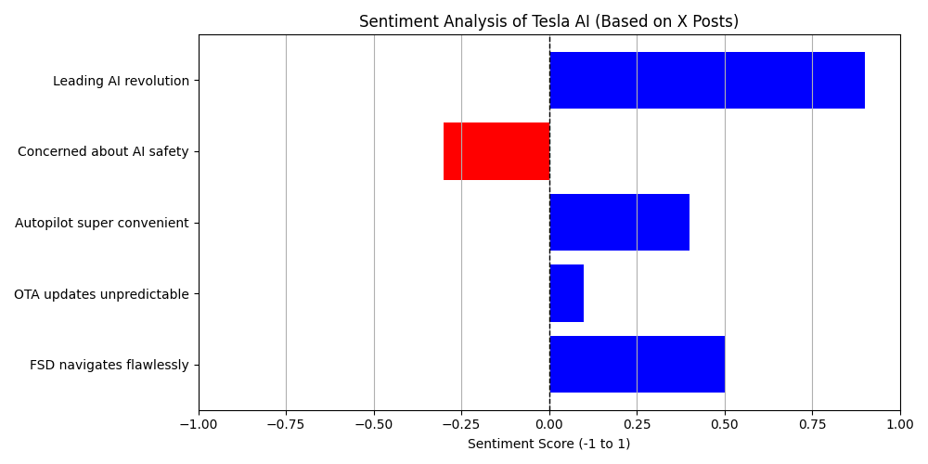

I visualized the sentiment findings in Fig. 3, which shows a combination of excitement—especially for FSD and Autopilot—and a notable safety concern from one post. This balance shows comprehensive discussions I read about, where people are excited about Tesla’s tech but cautious of its risks [9]. Working through this analysis taught me how powerful data can be in capturing public opinion, and I’m proud of how it relates to Tesla’s digital journey.

# Challenges and Future Trends

As I explored Tesla’s digital transformation, I found myself curious about the challenges it faces even with its impressive achievements. While Tesla’s innovations have made it unique, there are considerable challenges that I think it needs to tackle to remain at the forefront. At the same time, I’m excited to think about the future possibilities that could take Tesla even further, especially after seeing its data-driven success.

One challenge that really caught my attention is scalability and quality control. Tesla has grown so quickly—delivering nearly 2 million vehicles in 2024, as I found in my analysis—but this rapid expansion has sometimes resulted in quality issues, like inconsistent build quality, and delays in service, which frustrates customers [6]. Another challenge I noticed is the policy environment around autonomous driving. Tesla’s Full Self-Driving (FSD) technology is amazing, but strict policies in different countries are slowing down its full deployment, which I can imagine must be frustrating for a company so focused on innovation [8]. I also found myself thinking more about moral issues after my sentiment analysis showed public worries about AI safety. Issues like ensuring AI responsibility and protecting customer data privacy are important, and Tesla needs to address them to maintain trust [5]. These challenges remind me of the VUCA framework’s focuses on uncertainty and complexity, which I discussed earlier.

Looking to the future, I see some exciting trends that Tesla is ready to lead. Complete self-driving is one—imagine a future where Tesla achieves Level 5 autonomy, and cars drive themselves completely! That could change transportation, though it depends on overcoming those policy barriers I mentioned. Another trend I’m curious about is Tesla expanding its energy solutions, like using digital platforms to improve its solar panels and Powerwall storage systems [1]. I also think sustainability will be a major priority—Tesla’s already working on battery recycling and aiming for Zero- carbon operations, which aligns with global goals and could set a new standard [1]. Exploring these challenges and trends has made me appreciate how Tesla balances innovation with responsibility, and I’m excited to see how it shapes the future of the automotive industry.

# Reflections On Feedback

Looking back on my initial presentation about Tesla’s digital transformation, I found the feedback from my classmates and instructors incredibly helpful—it really pushed me to improve this report. At first, I wasn’t sure how to handle all the suggestions, but engaging with them taught me a lot about improving my final report to meet higher standards.

One important piece of feedback was about that really stood out was about digging deeper into the data. My colleagues pointed out that I should include more detailed data, like three month sales figures, to give a complete view. I intended to do this, but I couldn’t access three month data due to resource limitations, so I relied on annual figures from 2015 to 2024. Thinking back on this, I realized it’s a limitation I need to acknowledge, and it motivated me to explore better data sources for future projects. Another suggestion came from my instructors, who encouraged me to explore further into moral issues, especially after my sentiment analysis showed concerns about AI safety. This feedback made me think more deeply about issues like data privacy and AI responsibility, which I’ve now embedded with the challenges section. It was a bit challenging to balance these moral prospective with the technical data, but I’m proud of how it strengthen my analysis.

The final feedback was about improving my visuals. People said my plots could be clearer, especially after struggling to get the negative sentiment bar to display it properly! I worked hard to improve the Python code, making sure the sales trends, financial predictions, and sentiment analysis visuals are now accurate and easy to read. This process taught me the value of refinement and paying attention to detail, which I think is the most important for academic work. Overall, this feedback journey has taught me how to carefully analyze my approach, dealing with the missing pieces, and improve myself as a learner, making this report better and more aligned with my coursework requirements.

# Conclusion

As I conclude this journey into Tesla’s digital transformation, I have experienced a combination of excitement and satisfaction in what I’ve explored. Tesla, which started as a small venture in 2003, has truly changed the automotive industry with its innovative use of artificial intelligence (AI), over-the-air (OTA) updates, and the data-driven strategies [1]. My analysis of sales data from 2015 to 2024, showing revenue rising to $103.50 billion and predicting $113.76 billion for 2025, highlights how these innovations have powered its growth [10]. The sentiment analysis I conducted also opened my eyes, while people are thrilled about features like Full Self-Driving, concerns about AI safety remind us there’s work to be done [9]. These findings, combined with the challenges like policy barriers and moral concerns I explored, show that Tesla’s journey isn’t without challenges, but its capabilities are tremendous.

Looking back on this project, I’ve come to appreciate just how much Tesla’s journey teaches us about strength and innovation. One thing that caught my attention was how Tesla balances advanced technology with real-world challenges, like handling legal frameworks that I wasn’t fully aware of that before. Exploring the data, I experienced a feel of satisfaction seeing the numbers tell a story of growth, but the sentiment analysis also reminded me—it showed me how technology impacts people’s lives in ways that not always favorable, encouraging me to analyze deeply about the human side of innovation. This experience has deepened my understanding of digital transformation more than just the technical aspects; it’s about generating impact while handling public demands,and I’ll carry these lessons into my future studies.

Based on what I’ve discovered, I’d suggest a few steps for Tesla to remain at the forefront. First, investing in transparent AI polices frameworks could build trust and resolve the safety concerns, which I think is important after seeing that negative sentiment. Second, making data more accessible, maybe sharing regional sales trends, could help analysts like me understand its impact better, though I know data limits challenged me here. Finally, improving sustainable practices, like battery recycling, aligns with global priorities and could strengthen Tesla’s dominance [1]. Looking back on this project, I see Tesla as a benchmark for how digital innovation can shine in a VUCA world, as I learned from the research. This experience has taught me to think deeply about technology’s impact in transforming the industries, and I’m really excited to apply these lesson into my future studies. I also feel more confident in my ability to tackle complex topics, combining data analysis with value-based aspects, and I hope to explore how other industries can learn from Tesla’s approach—perhaps even looking at smaller companies to see if they can adopt similar strategies on a smaller scale. This project has inspired a curiosity in me to keep questioning how technology shapes our world, and I can’t wait to see where that curiosity takes me next.

##### References

1. Tesla, Inc., “2023 Impact Report,” 2023. [Online]. Available: <https://www.tesla.com/ns_videos/2023-tesla-impact-report.pdf>
2. G. Westerman, D. Bonnet, and A. McAfee, “Leading Digital: Turning Technology into Business Transformation,” *Harvard Business Review Press*, 2014.
3. W. Bennis and B. Nanus, “Leaders: Strategies for Taking Charge,” *Harper & Row*, 1989.
4. H. Lasi, P. Fettke, H.-G. Kemper, T. Feld, and M. Hoffmann, “Industry 4.0,” *Business & Information Systems Engineering*, vol. 6, no. 4, pp. 239–242, 2014.
5. Gartner, “Digital Maturity Model,” 2023. [Online]. Available: <https://www.gartner.com/en>
6. McKinsey & Company, “Automotive Digital Transformation Report,” 2022. [Online]. Available: <https://www.mckinsey.com/industries/automotive-and-assembly/our-insights>
7. C. M. Christensen, “The Innovator’s Dilemma,” *Harvard Business Review Press*, 1997.
8. Tesla, Inc., “Autopilot Documentation,” 2023. [Online]. Available: <https://www.tesla.com/support/autopilot>
9. Bloomberg, “Tesla’s Digital Transformation Strategies,” 2023. [Online]. Available: <https://www.bloomberg.com/news/articles/tesla-digital-innovation>
10. E. Ali, “Tesla Sales and AI Impact Analysis Code,” 2025. [Online]. Available: <https://github.com/ehtisham-ali/tesla-analysis>