Tiago Rodrigues

13/11/2022

Foundations of Programming, Python

Assignment 05

# Introduction

In this module I will talk about dictionaries and about the script requested for this assignment.

# Dictionaries

Dictionaries are used to store data values in key:value pairs. Dictionaries are ordered, changeable and do not allow duplicates.

There are some built-in methods that assist working with dictionaries.

* list(d) - return a list of all the keys used in the dictionary d
* len(d) - return the number of items in the dictionary d
* d[key] - return the item of d with key key
* Set d[key] to value key in d: - return True if d has a key key, else False. key not in d: Equivalent to not key in d.
* clear() - remove all items from the dictionary
* items() - return a new view of the dictionary's items((key, value) pairs)
* keys() - return a new view fo the dictionary's keys
* values() - return a new view of the dictionary's values

# Assignment05

In this assignment I’ve used the previous script and replaced the 2D data structure to use dictionaries. We use the same scheme in the menu we show to the user a list of commands “add”, “display”, “save”, “read”, “delete” or “exit” the program.

Figure - Code

Figure 2 – Code

Here I’ve added data into a List before upload to the file.

Figure 3 - Adding data to the dictionarie

Here I’ve added the data into de “MyData.txt” file and display in the console.

Figure 4 - Save and Read data from file

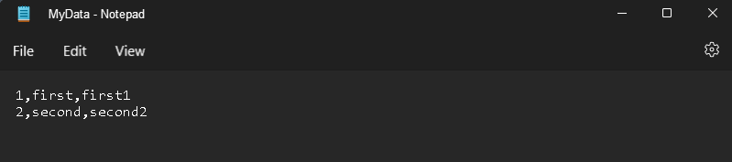

Figure 5 - .Txt file with the added data

Here I’ve deleted from the “MyData.txt” file de cd with de id: 1.

Figure 6 - Deleting data from the file

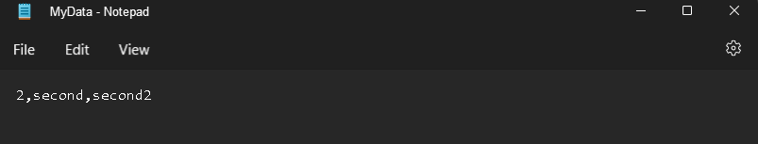

Figure 7 - .Txt file with the deleted data

Run the code in terminal windows.

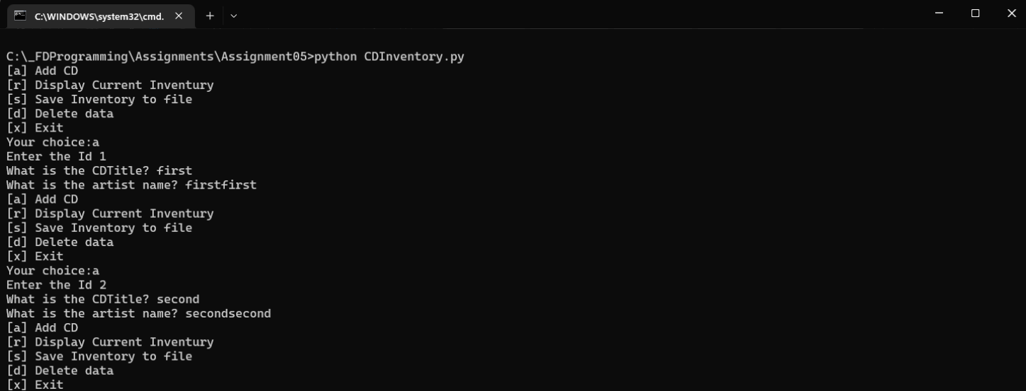

Figure 8 - Adding data to the dictionarie

Here I’ve added data into a List before upload to the file.

Figure 9 - Save and Read data from file

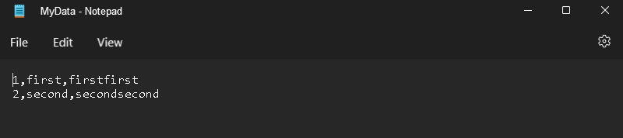

Figure 10 - .Txt file with the added data

Here I’ve deleted from the “MyData.txt” file de cd with de id: 1.

Figure 11 - Deleting data from the file

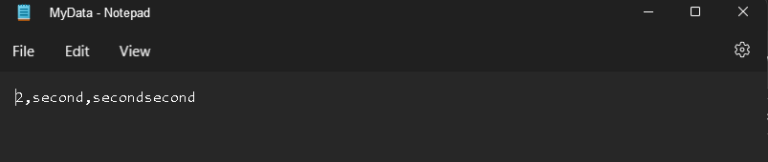

Figure 12 - .Txt file with the deleted data

# Summary

In this assignment I’ve learned work with dictionaries can I store and delete data inside a .txt file.

Here is the GitHub url:

<https://github.com/Ehz10/Assignment_05.git>