Individual scheduling approach for multi-class airline cabin crew with manpower requirement heterogeneity - Online Appendix

- Aviation Rules and Regulations
To ensure the safety level of flights and reduce the fatigue level of cabin crews, governmental authorities, labor union, and airlines have prescribed many rigid regulations on cabin crews, which influences the development of duties and pairings. In this study, we consider the following rules based on the practical operations of CAD 371. Firstly, two consecutive flights could be connected and operated by the same cabin crew only when the arrival airport of the first flight is the departure airport of the second flight, with a legal transit (minimum 75 minutes and maximum 240 minutes) between these two flights. Secondly, the briefing period before a duty lasts 60 minutes while the debriefing period after a duty lasts 30 minutes, with a maximum of three flights in a duty. Regarding the longest length of a duty period, it varies according to the local starting time and the number of flights of the duty, as explained in Table S1. For example, if a duty starts at 07:30 in local time with two flight legs, the longest duty period is then 12.25 hours. Thirdly, regarding the connection of two duties to be flown by the same cabin crew, the arrival airport of the first duty should be the departure airport of the second duty. Besides, there should be a rest period lasting from 720 minutes to 2160 minutes between the two duties if the former duty lasts no more than 12 hours; otherwise, a minimum of 840 minutes of rest should be assigned to the cabin crew. Lastly, maximum 5 duties, 12 flights, and 7200 minutes of TAFB (elapsed time) are allowed for a pairing.

Table S1. Maximum duty periods (in hours).
Local starting time | No. of flight legs
 | 1 | 2 | 3
07:00-07:59 | 13 | 12.25 | 11.5
08:00-12:59 | 14 | 13.25 | 12.5
13:00-17:59 | 13 | 12.25 | 11.5
18:00-21:59 | 12 | 11.25 | 10.5
22:00-06:59 | 11 | 10.25 | 9.5

- Supplementary Tables
Table S2 lists the features of the selected eight weekly flight schedules (small scale). We collect the flight data, for example, flight number, departure time, arrival time, and aircraft type used, from the website of the Airways, spanning from 19, Nov 2017 to 13, Jan 2018. The considered HKG-SIN route averagely takes 235.7 minutes, involving five aircraft types of Airbus Industrie A330-300, Airbus Industrie A350-900, Boeing 777-200/200ER, Boeing 777-300, and Boeing 777-300ER, denoted as Type 1, Type 2, Type 3, Type 4, and Type 5, respectively.
Table S2. Number of flights and aircraft types contained in the selected small-scale flight schedules.
Week | No. of flights |  | No. of aircrafts of each type contained
 |  |  | Type 1 | % | Type 2 | % | Type 3 | % | Type 4 | % | Type 5 | %
Week 1 | 105 |  | 13 | 12.4% | 29 | 27.6% | 3 | 2.9% | 24 | 22.9% | 36 | 34.3%
Week 2 | 106 |  | 11 | 10.4% | 32 | 30.2% | 5 | 4.7% | 26 | 24.5% | 32 | 30.2%
Week 3 | 100 |  | 7 | 7.0% | 34 | 34.0% | 7 | 7.0% | 30 | 30.0% | 22 | 22.0%
Week 4 | 103 |  | 22 | 21.4% | 28 | 27.2% | 3 | 2.9% | 32 | 31.1% | 18 | 17.5%
Week 5 | 104 |  | 13 | 12.5% | 38 | 36.5% | 8 | 7.7% | 28 | 26.9% | 17 | 16.4%
Week 6 | 100 |  | 20 | 20.0% | 39 | 39.0% | 5 | 5.0% | 16 | 16.0% | 20 | 20.0%
Week 7 | 109 |  | 30 | 27.5% | 39 | 35.8% | 7 | 6.4% | 7 | 6.4% | 26 | 23.9%
Week 8 | 110 |  | 28 | 25.5% | 41 | 37.3% | 5 | 4.6% | 19 | 17.3% | 17 | 15.5%

Table S3 summarizes the number of seats, doors and sections of each aircraft type and layout. Note that the number in brackets represents the number of sections in the corresponding cabin class. Let’s take Type 5 as an example. Type 5 has two different cabin layouts (Type 5-1 and Type 5-2) with 340 and 275 seats in total, respectively. Type 5-1 has three cabin classes of a Business Class (40 seats), a Premium Economy Class (32 seats), and an Economy Class (268 seats). The Business Class has two sections, while the Premium Economy Class has only one section, and the Economy Class is divided into three sections. Therefore, Type 5-1 aircraft totally has six cabin sections with 10 doors.
Table S3. Layout of the aircrafts involved in the selected flight schedules.
Aircraft type and layout | Number of seats |  |  |  |  |  | Number of
 | First Class | Business Class | Premium Economy Class | Economy Class | Total |  | Doors | Cabin sections
Type 1-1 | 0 | 24 (1) | 0 | 293 (3) | 317 |  | 8 | 4
Type 1-2 | 0 | 39 (2) | 0 | 223 (2) | 262 |  | 8 | 4
Type 1-3 | 0 | 39 (2) | 21 (1) | 191 (2) | 251 |  | 8 | 5
Type 2 | 0 | 38 (2) | 28 (1) | 214 (2) | 280 |  | 8 | 5
Type 3 | 0 | 42 (1) | 0 | 293 (2) | 335 |  | 8 | 3
Type 4 | 0 | 42 (1) | 0 | 356 (3) | 398 |  | 10 | 4
Type 5-1 | 0 | 40 (2) | 32 (1) | 268 (3) | 340 |  | 10 | 6
Type 5-2 | 6 (1) | 53 (2) | 34 (1) | 182 (2) | 275 |  | 10 | 6

Apart from the minimum requirements imposed by aviation authorities (e.g., at least one cabin crew for each pair of airplane doors, for each separate cabin section, and for every 50 passengers), the Airways establishes a higher service level by assigning more cabin crews to the flights. In this study, we utilize the following standards: Every 4 passengers in the First Class, every 10 passengers in the Business Class, every 20 passengers in the Premium Economy Class, and every 40 passengers in the Economy Class are equipped with one cabin crew. Classes 1 and 2 cabin crews are usually assigned with jobs in the First Class cabin and the Business Class cabin, while Classes 3 and 4 cabin crews are generally allocated with those in the Premium Economy Class cabin and the Economy Class cabin. Accordingly, we obtain the number of cabin crews of each class required for each aircraft type and layout, as summarized in Table S4.
Table S4. Cabin crew requirements for the aircraft types and layouts in the small-scale flight schedules.
Aircraft type and layout | Number of cabin crews required
 | Class 1 | Class 2 | Class 3 | Class 4 | Total
Type 1-1 | 1 | 2 | 4 | 4 | 11
Type 1-2 | 2 | 2 | 3 | 3 | 10
Type 1-3 | 2 | 2 | 3 | 4 | 11
Type 2 | 2 | 2 | 4 | 4 | 12
Type 3 | 2 | 3 | 4 | 4 | 13
Type 4 | 2 | 3 | 4 | 5 | 14
Type 5-1 | 2 | 2 | 4 | 5 | 13
Type 5-2 | 3 | 5 | 3 | 4 | 15

Table S5 depicts the details of scenarios when the derived cabin crew availability levels (Level 1, Level 2, and Level 3) are applied in each MICCPP-ACCS small-scale instance.
Table S6 summarizes the computation time of MICCPP-ACCS under each availability level for each small instance by using CG+MIP. The overall average computation time for the three availability levels is 24.193s.

Table S5. Details of the scenarios corresponding to I-instances.
Availability level | Instance | Scenario | Manpower shortage | CCS | Extra manpower | Total extra crew demand
Level 1 | I1 | 8 |  |  |  | 0
 | I2 | 8 |  |  |  | 0
 | I3 | 8 |  |  |  | 0
 | I4 | 8 |  |  |  | 0
 | I5 | 8 |  |  |  | 0
 | I6 | 8 |  |  |  | 0
 | I7 | 8 |  |  |  | 0
 | I8 | 8 |  |  |  | 0
Level 2 | I1 | 4 | √ | √ | √ | 3
 | I2 | 5 | √ | √ |  | 0
 | I3 | 3 | √ |  | √ | 15
 | I4 | 4 | √ | √ | √ | 7
 | I5 | 4 | √ | √ | √ | 36
 | I6 | 4 | √ | √ | √ | 13
 | I7 | 3 | √ |  | √ | 46
 | I8 | 3 | √ |  | √ | 37
Level 3 | I1 | 5 | √ | √ |  | 0
 | I2 | 5 | √ | √ |  | 0
 | I3 | 7 | √ | √ | √ | 1
 | I4 | 5 | √ | √ |  | 0
 | I5 | 2 | √ | √ | √ | 19
 | I6 | 7 | √ | √ | √ | 2
 | I7 | 2 | √ | √ | √ | 29
 | I8 | 2 | √ | √ | √ | 20

Table S6. Computation times of MICCPP-ACCS for I-instances using CG+MIP.
Instance | Level 1 - Computation time (s) |  |  |  | Level 2 - Computation time (s) |  |  |  | Level 3 -Computation time (s)
 | Column generation | Pricing problem | Branch-and-Bound | Total | Column generation | Pricing problem | Branch-and-Bound | Total | Column generation | Pricing problem | Branch-and-Bound | Total
I1 | 20.779 | 19.444 | 0.342 | 21.121 | 37.666 | 35.391 | 0.527 | 38.193 | 19.796 | 18.395 | 0.651 | 20.447
I2 | 19.321 | 17.885 | 0.632 | 19.953 | 32.749 | 31.010 | 10.019 | 42.768 | 18.182 | 16.690 | 0.894 | 19.076
I3 | 12.409 | 11.293 | 0.147 | 12.556 | 14.782 | 13.687 | 0.210 | 14.992 | 11.722 | 10.662 | 0.760 | 12.482
I4 | 23.296 | 21.587 | 0.368 | 23.664 | 42.613 | 40.475 | 0.990 | 43.603 | 23.485 | 21.854 | 1.776 | 25.261
I5 | 19.638 | 17.980 | 0.163 | 19.801 | 25.105 | 23.235 | 0.494 | 25.599 | 23.806 | 22.150 | 0.748 | 24.554
I6 | 12.747 | 11.621 | 0.050 | 12.797 | 13.637 | 12.493 | 0.868 | 14.505 | 8.155 | 7.212 | 0.616 | 8.771
I7 | 33.996 | 32.301 | 6.008 | 40.004 | 34.040 | 32.041 | 0.873 | 34.913 | 37.435 | 35.140 | 0.444 | 37.879
I8 | 19.723 | 17.817 | 3.164 | 22.887 | 20.047 | 18.145 | 0.328 | 20.375 | 24.131 | 21.604 | 0.296 | 24.427
Average | 20.239 | 18.741 | 1.359 | 21.598 | 27.580 | 25.810 | 1.789 | 29.369 | 20.839 | 19.213 | 0.773 | 21.612

- Special Scenarios 1 and 6
Observing that for each class,${ MM}_{r}$ is smaller than ${MC}_{r}$ in the derived I-instances. In order to test the special Scenarios 1 and 6, we construct a set of semi-artificial instances by modifying all flight manpower requirements of each class to one for the originally derived instances. The semi-artificial instances are denoted by A-IX. In the second and fourth columns of Table S7, all${ MC}_{r}$ equal ${MM}_{r}$ for each semi-artificial instance. We arbitrarily set the cabin crew availability as 18, 13, 14, and 15 (Level 5, $TA=60$) to form Scenarios 1 and 6. The fifth column in the table concludes the scenario that each semi-artificial instance corresponds to under Level 5. For example, $TA$(60) is larger than $MS$(56) in A-I1, while the availability for Class 2 is lower than ${MC}_{2}({MM}_{2})$. Therefore, A-I1 under Level 5 corresponds to Scenario 6. Although there is exceeding manpower in other classes, they could not be used for substitution since${ MM}_{2}={MC}_{2}$. Therefore, one Class 2 extra crew is needed. For A-I5, $TA$ is lower than $MS$(68), and $d_{r}<{MC}_{r}({MM}_{r})$ for Classes 2, 3, and 4 (Scenario 1). Similarly, although there is an exceeding cabin crew in Class 1 ($d_{1}=$18>${MC}_{1}=$17), no substitution will occur due to the equality between ${ MM}_{r}$ and ${MC}_{r}$ for the three classes under “insufficiency”. Accordingly, the number of ${MM}_{r}- d_{r}$ extra manpower is necessary for each of the three insufficient classes (i.e., Classes 2, 3, and 4).
Table S7. Special scenarios in MICCPP-ACCS under Level 5 for the semi-artificial instances.
Instance | $${MC}_{r}$$ | $$MS$$ | $${MM}_{r}$$ | Scenario | Extra manpower used |  |  |  | CCS
 |  |  |  |  | Class 1 | Class 2 | Class 3 | Class 4
A-I1 | 14 | 56 | 14 | 6 | 0 | 1 | 0 | 0 | 0
A-I2 | 14 | 56 | 14 | 6 | 0 | 1 | 0 | 0 | 0
A-I3 | 15 | 60 | 15 | 6 | 0 | 2 | 1 | 0 | 0
A-I4 | 14 | 56 | 14 | 6 | 0 | 1 | 0 | 0 | 0
A-I5 | 17 | 68 | 17 | 1 | 0 | 4 | 3 | 2 | 0
A-I6 | 16 | 64 | 16 | 1 | 0 | 3 | 2 | 1 | 0
A-I7 | 19 | 76 | 19 | 3 | 1 | 6 | 5 | 4 | 0
A-I8 | 18 | 72 | 18 | 3 | 0 | 5 | 4 | 3 | 0

- Details of the Proposed Genetic Algorithm
Due to the high complexity and large scale of the proposed MICCPP-ACCS, we propose a Four-stage Genetic Algorithm to solve large-scale problems. In the literature, Genetic Algorithm (GA) has seen its wide applications in scheduling and assignment problems. Our proposed MICCPP-ACCS applies the individual modelling approach for cabin crews, which is much more complicated than the traditional team modelling approach. This is because each cabin crew member in a flight requires his/her own pairing. For example, Figure 1 shows a sample set of flights, in which the first flight requires 11 cabin crew members. This means that Flight 1 requires 11 individual pairings. However, in the team modelling approach, only one team pairing is needed.
As the individual crew pairing approach with CCS proposed in this study is new in the literature, we develop a new Four-stage Genetic Algorithm as the solution approach. To enhance searching ability, we construct novel searching ranges as well as a probability-based flight selection rule. Besides, two novel mutation approaches (i.e., workload balance and flight combination diversity) are proposed to increase solution diversity. For brevity, we use “pairing” to refer to “individual pairing” in the following description.

Flight No. | 1 | 2 | 3 | . | . | 10
Crew Class 1 | 2 | 1 | 3 | . | . | 1
Crew Class 2 | 2 | 2 | 3 | . | . | 1
Crew Class 3 | 3 | 3 | 4 | . | . | 2
Crew Class 4 | 4 | 3 | 4 | . | . | 3
Figure 1. Manpower requirement details of sample flights.

4.1 Chromosome Encoding and Decoding
Figure 2 shows a sample encoding of chromosome, which is a $n×m$ dimensional matrix. The total number of rows ($n$) is equal to the summation of max{manpower requirement for Class 1 of each flight}, max{manpower requirement for Class 2 of each flight }, max{manpower requirement for Class 3 of each flight }, and max{manpower requirement for Class 4 of each flight }, while m is equal to the total number of flights. For each flight, a pairing is assigned to each unit of manpower requirement. The numbers in the cells (i.e., genes) represent the index of the assigned pairing, and 0 means that no pairing is assigned. Since at least one crew member must come from the originally required crew class and the rest is substitutable by other classes if needed, the chromosome is divided into two parts: i) basic and ii) substitutable. In this sample, since F1 requires two Class 1 cabin crews (as shown in Figure 1), one pairing (i.e., Pairing 1) is assigned to the basic part and another one (i.e., Pairing 7) is assigned to the substitutable part. The rest of the genes for Class 1 of F1 is assigned a 0 (i.e. the second gene in substitutable part). In the view of pairing, Pairing 1 contains F1 and F3. During the chromosome generation, invalid chromosome is not allowed.
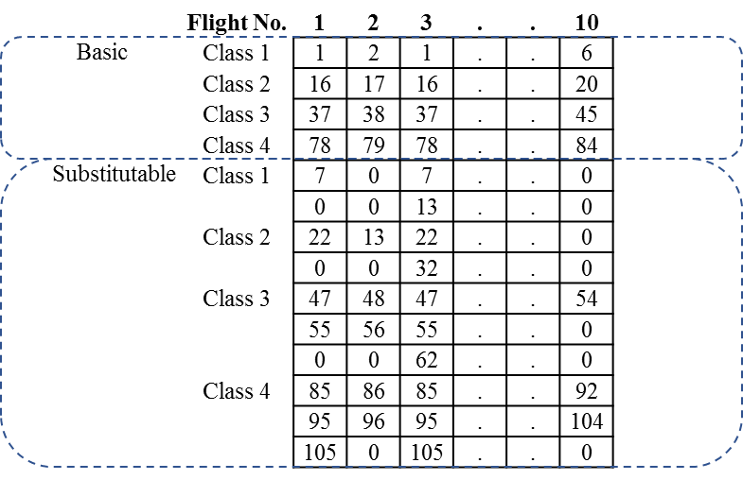
Figure 2. Encoding of chromosome for the individual modelling approach.

4.2 Evolution Outline
The evolution is divided into four stages as outlined in Figure 3. In Stage 1, a set of initial chromosomes is generated to form an initial solution pool. Then in Stage 2, the aim is to reduce the usage of extra crew by combining up pairings within the same cabin class. When the genetic algorithm cannot further reduce the usage of extra crew, the solution becomes stable. The algorithm then moves to the next stage. In Stage 3, CCS is applied to further reduce the usage of extra crew. The idea is to apply available manpower from any other class to replace the extra manpower used by some pairings. Lastly in Stage 4, to further refine the solution quality, we examine if any of the substituted crew members on certain flights can be replaced by the manpower from the originally required class. Note that Stages 2 and 3 are in the pairing level, while Stage 4 is in the flight level.

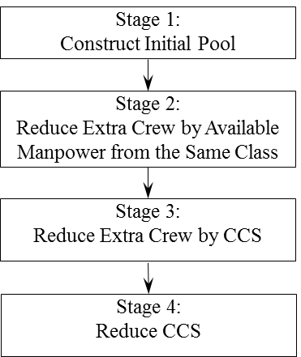
Figure 3. Outline of the genetic evolution.

4.3 Evolution Stages

4.3.1 Stage 1 - Construction of Initial Pool
First, flights are sequenced according to the scheduled departure time from the earliest to the latest. Then, the initial pool is formed by grouping the flights into different pairings. Each legal pairing starts with a flight departing from the home base, and keeps on connecting with other feasible subsequent flights until reaching the home base. It is worth noting that even if the connected flight is the next earliest departure flight, it is not guaranteed that the optimal solution is resulted. Therefore, every later flight departing from the arrival airport of a flight can be connected with that flight (if working rules and regulations are satisfied). However, we can still enhance the genetic searching ability by limiting the searching range to avoid infeasible search, which is discussed in the following.
We define $Ω_{f}^{p}$ as the set of feasible subsequent flights for Flight $f$ in Pairing $p$. Applying the maximum TAFB regulation, we can limit the size of $Ω_{f}^{p}$ by only involving the flights that adding its operation will not violate the TAFB constraint of Pairing $p$. This translates into ${el}_{f}^{p}+{tw}_{f}^{\hat{f}}≤MaxTAFB$ ($\hat{f}∈Ω_{f}^{p}$), where ${el}_{f}^{p}$ is the time elapsed of Pairing $p$ after completing Flight $f$, ${tw}_{f}^{\hat{f}}$ represents the time between the completion of the subsequent Flight $\hat{f}$ and the completion of Flight $f$, while $MaxTAFB$ stands for the maximum TAFB allowed for a pairing as regulated by authorities. Although it is not guaranteed that connection with the next earliest feasible departing flight can lead to an optimal solution, the chance of generating a shorter pairing is higher. On the contrast, if the next connected flight is very far away from the current time point, the final elapse time of the pairing may usually be longer. Therefore, we define the probability ${Pr}_{f,p}^{\hat{f}}$ of selecting Flight $\hat{f}$ in $Ω_{f}^{p}$ as in Eq. (19).

$${Pr}_{f,p}^{\hat{f}}=\left(1 – {{deptim}_{\hat{f}}}/{\sum_{\hat{f}∈Ω_{f}^{p}}{{deptim}_{\hat{f}}}}\right)⁡$$ | (19)
In Eq. (19),${deptim}_{\hat{f} }$is the departure time of Flight $\hat{f}$. For example, as shown in Figure 4, after the arrival of F1, the next feasible connected flight can be F3, F4, or F6. Assuming that the maximum TAFB regulation is satisfied, Figure 4 shows the case of selecting F3, while Figure 5 shows the case of selecting F4. The probability of selecting F3 is higher than that of selecting F4. It is noted that if the available manpower of a certain class is used up, extra manpower will be applied instead of CCS in this stage.
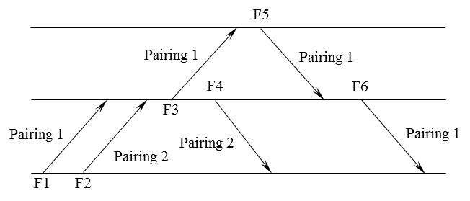
Figure 4. Sample pairing result for selecting F3.

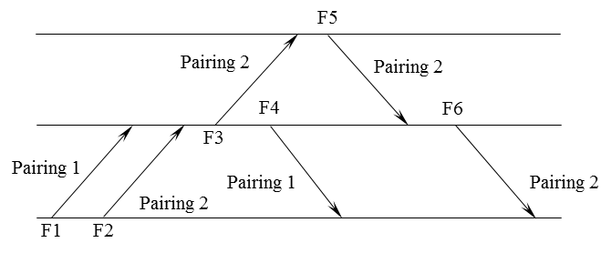
Figure 5. Sample pairing result for selecting F4.

4.3.2 Stage 2 - Reduction of Extra Crew
In this stage, reduction of the usage of extra crew is the focus. To be specific, within the same cabin crew class, the pairings applying extra manpower will be combined with other pairings. Intuitively, the chance of success to combine two pairings is higher if they are close to each other in time, and short in elapse time. We propose two novel mutation approaches (i.e., Mutation Type I and Mutation Type II) to increase the diversity of solution pool to better serve the objective of reducing the employment of extra manpower, as described in the following.

Mutation Type I – Workload balance
The idea of this mutation is to increase the diversity of the pairings existing in the solution pool by changing pairing combinations. Balancing workload serves two purposes: i) fairness of manpower workload, and ii) guidance of the genetic search. The first purpose is obviously for the benefits of crew members. For the second one, it is reasonable that for a pairing with long elapse time, adding more flights may lead to infeasibility due to the maximum TAFB regulation. For a short pairing, the chance of forming a new good pairing is higher. Therefore, our mechanism here is to cut long pairings into two, while combining up short pairings into one, with the aim of reducing the usage of extra crew members. We define “workload” as the elapse time of a pairing, and use ${aw}_{β}$ to represent the average workload of the pairings contained in the solution pool in the $β^{th}$ evolution. If the elapse time of a pairing is longer than ${aw}_{β}$, and if the pairing consists of one or more home base flight(s) between the starting and the ending flights, those home base flights will be randomly selected as a cutting point. Otherwise, the pairing will not be cut. We call this operation as Mutation Type IA. Figure 6 shows an example (City 1 is the home base), in which home base flights F3 and F5 can serve as the cutting points. Assuming that this pairing (Pairing 1) is randomly cut at F3, the two newly generated shorter pairings are shown in Figure 7.

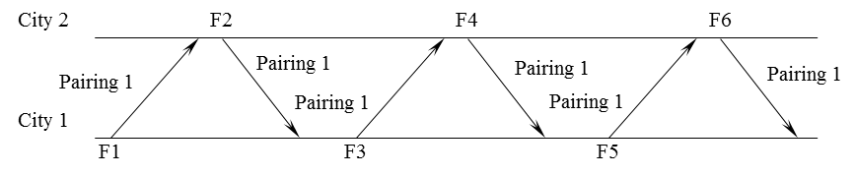
Figure 6. Sample pairing with multiple home base flights between the starting and ending flights.

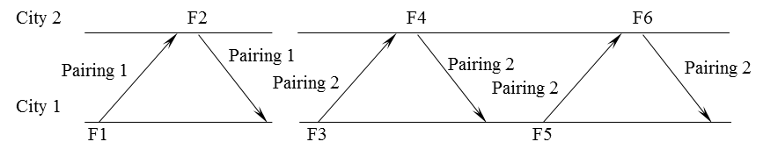
Figure 7. Sample pairings after Mutation Type IA.

If the elapse time of a pairing is shorter than ${aw}_{β}$, the algorithm will randomly search another pairing (whose elapse time $≤{aw}_{β}$) to combine. This operation is called Mutation Type IB. For a selected pairing, we can i) combine with later pairings, or (ii) combine with previous pairings. For the selected Pairing $p$, we define $Ψ_{p}^{L}$ as the set of later feasible pairings, and $Ψ_{p}^{B}$ as the set of previous feasible pairings to combine. By applying the maximum TAFB regulation, we can limit the sizes of $Ψ_{p}^{L}$ and $Ψ_{p}^{B}$ to improve the genetic searching ability. For $Ψ_{p}^{L}$, the pairings satisfy ${te}_{p}+{tb}_{p}^{\hat{p}}≤MaxTAFB$ are contained, when the pairing connection rules (e.g., legal transit/rest time between the last flight of Pairing $p$ and the first flight of the later Pairing $\hat{p}$) are not violated. ${te}_{p}$ is the time elapsed after the completion of Pairing $p$, and ${tb}_{p}^{\hat{p}}$ represents the time between the completion of later Pairing $\hat{p}$ and the completion of Pairing $p$. A similar rule is applied for $Ψ_{p}^{B}$. An example is shown in Figure 8. Specifically, we assume that Pairing 2 for Class 1 is using extra manpower, while Pairing 1 for Class 1 is using available manpower. If these two pairings can be connected legally, Pairing 1 is thus an element in $Ψ_{p}^{B}$ for Pairing 2. Once Pairing 2 is combined with Pairing 1, the usage of extra crew by Pairing 2 is eliminated by the available manpower from the same cabin crew class.

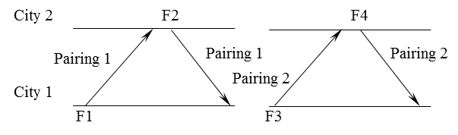
Figure 8. Sample pairings with below-average elapse time.

Mutation Type II – Flight combination diversity
The idea of this mutation is to increase the diversity of flight combinations in pairings. Here, a flight is randomly selected based on a predefined mutation rate. If the randomly selected flight can connect with other later flights, it will randomly select one. An example is illustrated in Figure 9 and Figure 10. The immediate subsequent flight for F1 changes from F4 in Figure 9 to F5 in Figure 10.
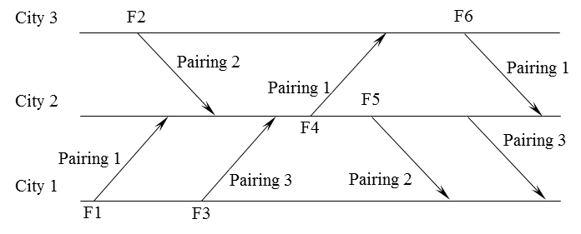
Figure 9. Sample pairings mutation of flight (before).

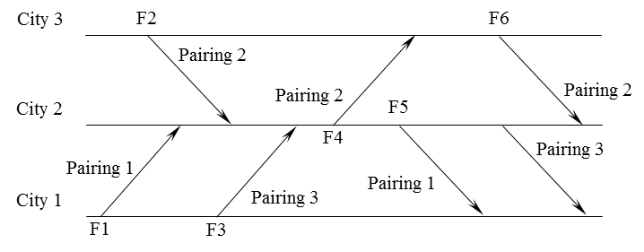
Figure 10. Sample pairings mutation of flight (after).

Crossover
As flights are grouped into pairings, we use pairing as a unit for crossover to retain the inherited pairing structure. We will apply multiple points crossover. During the crossover, a number of pairings will be randomly selected, and swapped between two selected chromosomes. When Pairing p is swapped from one parent (e.g., Parent 2) to another parent (e.g., Parent 1), the pairings in Parent 1 that involve the flights contained in Pairing p will be eliminated. After crossover, the unassigned flights will be assigned to new pairing(s). Figure 11 shows an example of two selected chromosomes for crossover. The number in each cell represents the pairing that covers the corresponding flight. Pairing 3 from Parent 1 and Pairing 1 from Parent 2 are randomly selected. We illustrate our idea by using Offspring 1, which inherits Pairing 1 from Parent 2. Since Pairing 1 from Parent 2 covers F1, F3 and F5, Pairings 1 and 3 in Parent 1 will then be eliminated. As a result, F4, F9 and F10 become unassigned after crossover as shown in Figure 12. Lastly, a new pairing is constructed for these unassigned flights as shown in Figure 13.

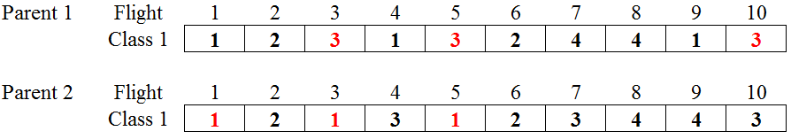
Figure 11. Sample crossover of two selected chromosomes.

Figure 12. Offspring 1 after crossover.

Figure 13. Offspring 1 after validation.

4.3.3 Stage 3 - Reduction of Extra Crew by CCS
If the genetic algorithm cannot further reduce the usage of extra crew in Stage 2, it implies that the solution becomes stable. We thus move to Stage 3 which aims to replace the usage of extra crew by available manpower from other classes. As discussed, this strategy is named as controlled crew substitution (CCS). For each pairing using extra manpower, our aim is to combine it with another pairing using available manpower like in Stage 2. Differently, in this stage, we look for pairings that are not from the originally required class. For example, in Figure 8, if Pairing 1 is using Class 2 available manpower, Pairing 1 can be connected with Pairing 2. Accordingly, the usage of extra crew by Pairing 2 is eliminated by the substitution of available manpower from another cabin crew class. Besides, the searching range is the same as in Stage 2.

4.3.4 Stage 4 - Reduction of CCS
Lastly, we reduce the application of CCS in the solution. Specifically, one of the flights using CCS will be randomly selected. The substituted manpower will be changed to the originally require class. Then, all the pairings in the chromosome for the concerned cabin crew class will be reformed to check if the changed flight can be handled. Besides, we also check whether the usage of extra manpower can be further reduced by examining if the extra manpower assigned to certain flights can be changed to available manpower from other classes.

CAD 371: The Avoidance of Fatigue in Aircrews published by the Civil Aviation Department of the Government of the Hong Kong Special Administrative Region.

