Hi all,

I’ve put together an interactive Rmarkdown tool based on the hazard layers Ani provided for the IGP:

[​Folder icon Climate Prioritization IGP](https://cgiar-my.sharepoint.com/:f:/g/personal/p_steward_cgiar_org/ErZTDzmQmJxCrEj5szXuHUgBhIQBA4zkKCcBtB5FPySt1w?e=6TkkmJ)  
  
It’s not as comprehensive or as well documented and designed as I would like, but we only had a few days to put it together. Your feedback as users is critical for the development of this tool, please record comments [​docx icon here](https://cgiar-my.sharepoint.com/:w:/g/personal/p_steward_cgiar_org/EZfY6xKarLxEmH9ahOWBTj8BTYKiGZAIMPFWcc7ELFD8RQ?e=AcxFsj). The tool will serve as use-case and prototype for the Adaptation Atlas (on-line portal).  
  
If you’re struggling to install the tool or there a major bugs, you should be able to get hold of me on Teams. I haven’t had any chance to test it out on other people’s machine yet.

**Installation:**  
I recommend that you update R, RStudio and your packages to their most versions, you may also need to have Rtools installed.  
  
Open the project file in RStudio



Open the markdown script



Change line 18 from knitr::opts_knit$set(root.dir = "C:/Documents/OneDrive - CGIAR/Projects/EiA/Climate Prioritization IGP") to the directory where you have downloaded the folder to.



Run the markdown . Note that you might need to install some additional packages, just follow the prompts Rstudio provides.

This should open a window with the tool

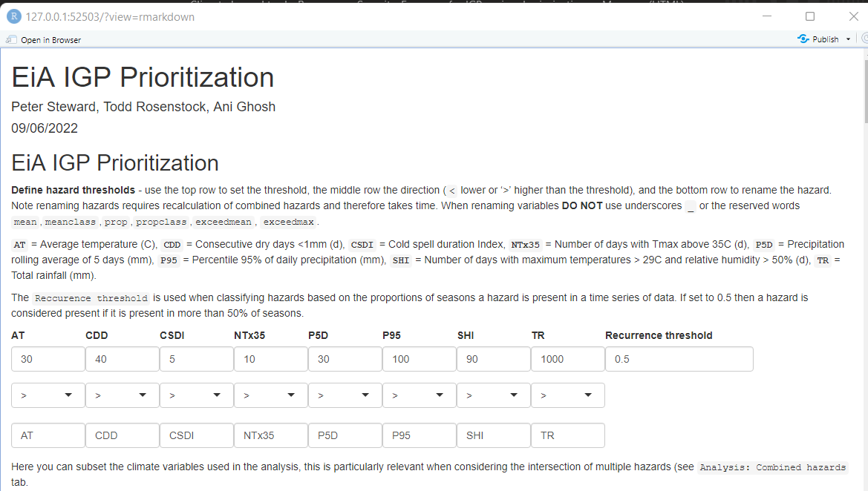

**Use:**  
In the tool you can create hazards by specifying thresholds for different climate variables and then explore the distribution, recurrence and severity of these hazards and their intersection with crop production. There’s a lot of on-fly-calculation that happens when you change parameters as such you need to be patient whilst the tool is calculating values.   
  
I hope there is enough documentation in the tool for you to be able to understand it, please provide feedback.  
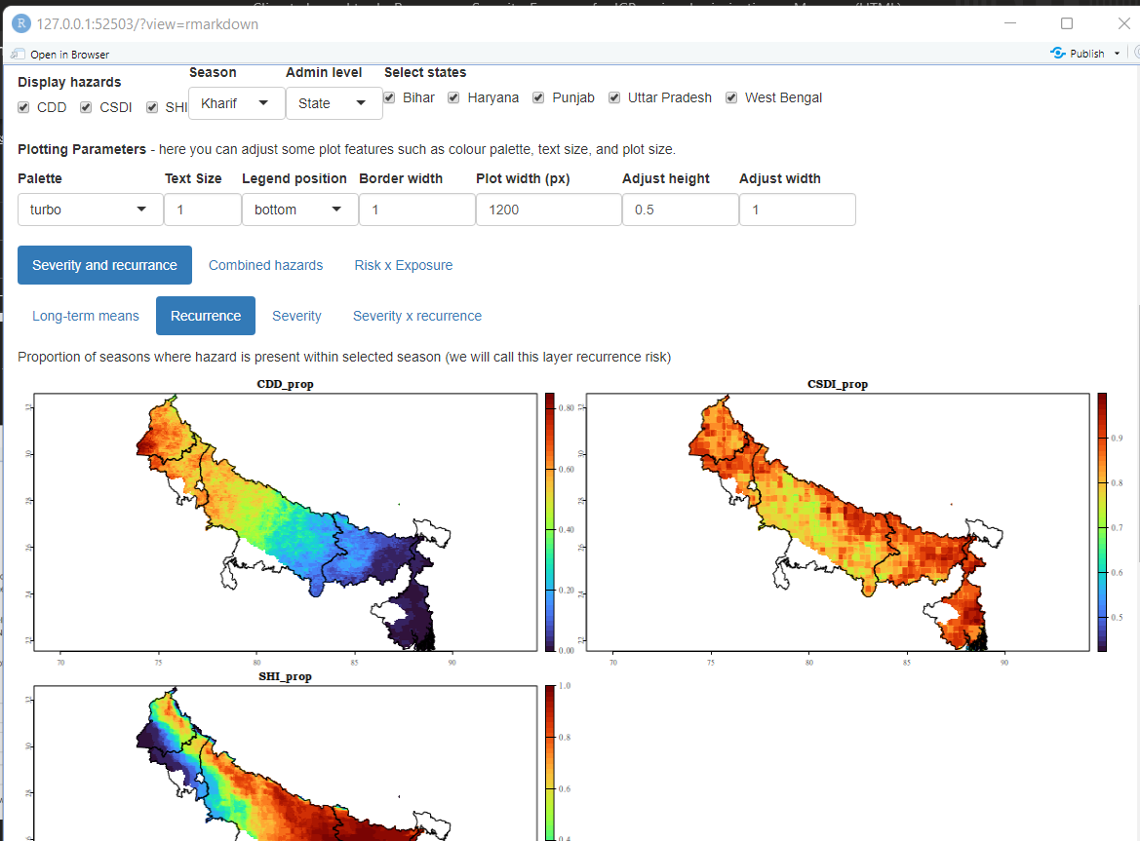

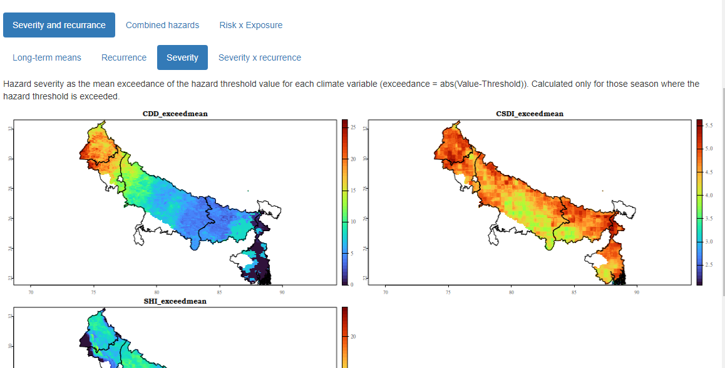

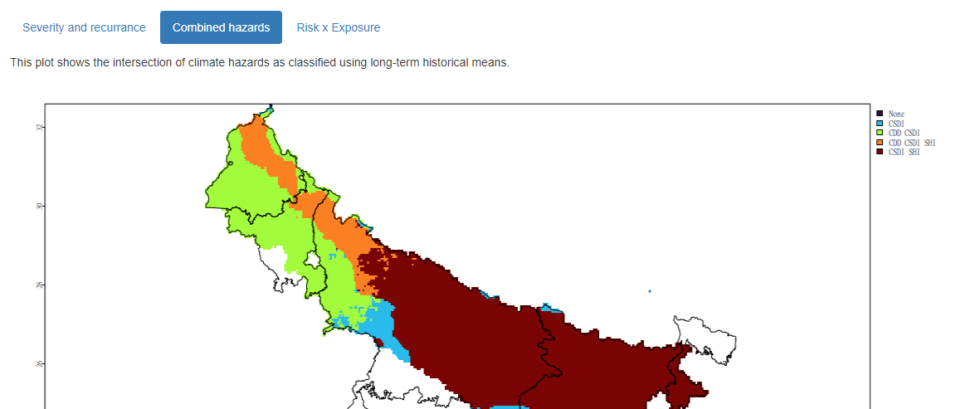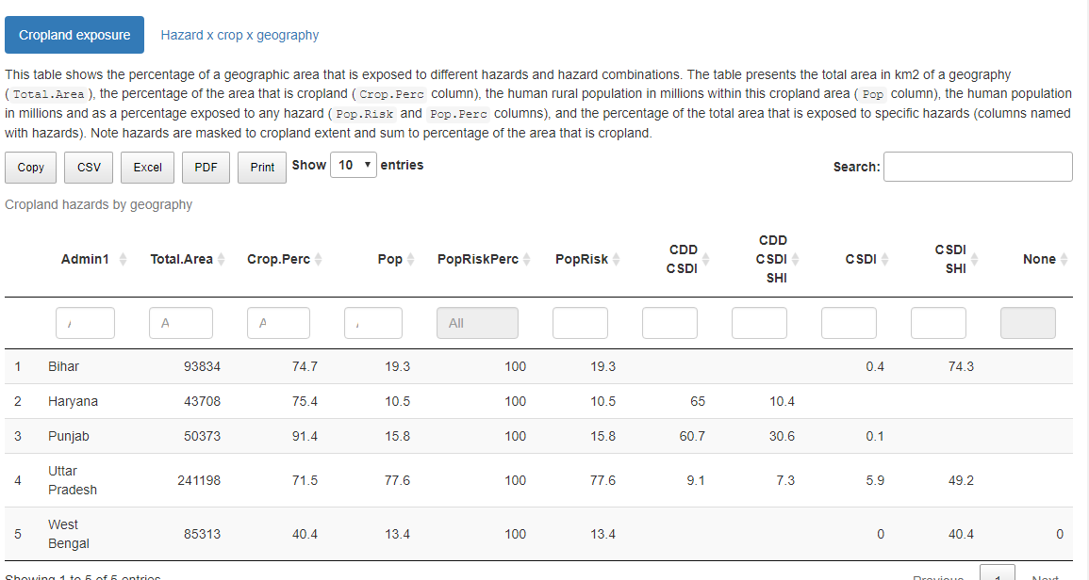

Best,

Pete

**Peter Steward (PhD)**

Scientist II │ Climate Action Lever

**Alliance of Bioversity International and CIAT**

c/o icipe, Duduville Complex │ P.O. Box 823, 00621 │ Nairobi, Kenya

✉ [p.steward@cgiar.org](mailto:p.steward@cgiar.org) │ 📞 (+254) 799556165│ Skype: peetmate



The **Alliance** of **Bioversity International** and the **International Center for Tropical Agriculture (CIAT)**  
delivers research-based solutions that harness agricultural biodiversity and sustainably transform  
food systems to improve people’s lives in a climate crisis.

The **Alliance** is part of **CGIAR**, a global research partnership for a food-secure future.

[**bioversityinternational.org**](https://www.bioversityinternational.org/)[**ciat.cgiar.org**](https://ciat.cgiar.org/)