1. **Using this week's lectures as a guide, construct a half-adder and test it. Check its correctness by testing and filling out a truth table like the following. Add the circuit screenshot and the table to your submission document:**

|  |  |  |  |
| --- | --- | --- | --- |
| A | B | Sum Output | Carry Output |
| 0 | 0 | 0 | 0 |
| 0 | 1 | 1 | 0 |
| 1 | 0 | 1 | 0 |
| 1 | 1 | 0 | 1 |

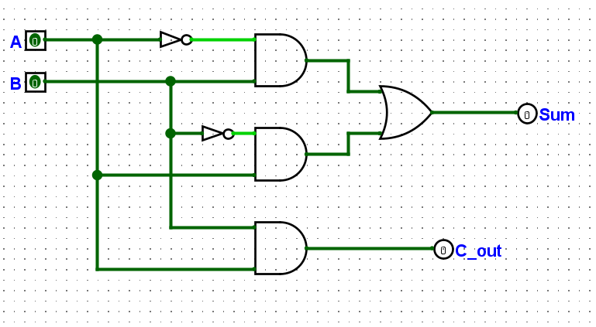

1. **Now extend your half-adder to a full-adder, which in addition to the two input pins, also handles a carry-in bit. Check its correctness by testing and filling out a truth table like the following. Add the circuit screen shot and the table to your submission document:**

|  |  |  |  |  |
| --- | --- | --- | --- | --- |
| Input | | | Output | |
| A | B | C_in | Sum | C_out |
| 0 | 0 | 0 | 0 | 0 |
| 0 | 1 | 0 | 1 | 0 |
| 1 | 0 | 0 | 1 | 0 |
| 1 | 1 | 0 | 0 | 1 |
| 0 | 1 | 1 | 0 | 1 |
| 1 | 0 | 1 | 0 | 1 |
| 0 | 0 | 1 | 1 | 0 |
| 1 | 1 | 1 | 1 | 1 |

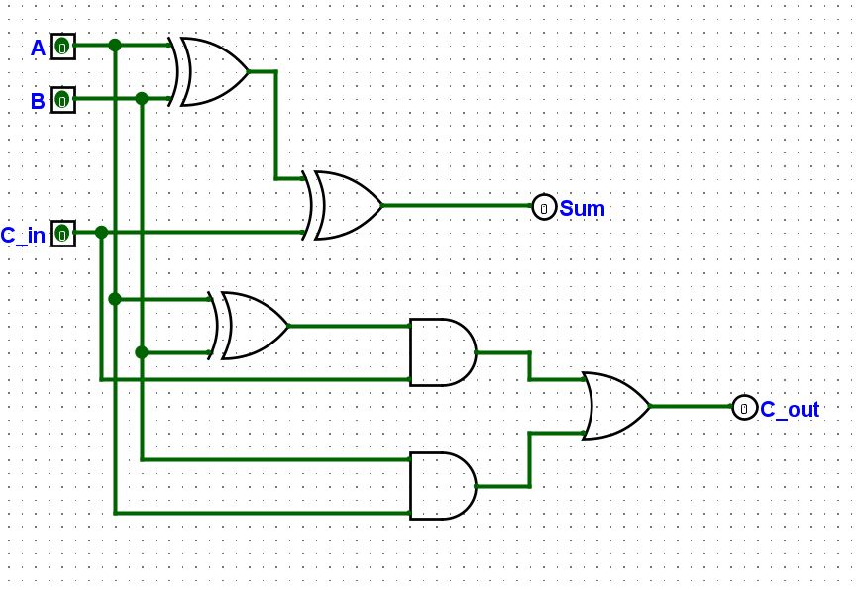

1. **Once complete, check its correctness by testing and filling out a truth table like the following (over page). Add the circuit screen shot and the table to your submission document:**

|  |  |  |
| --- | --- | --- |
| **Input A** | **Input B** | **Ouput** |
| 0101 | 0000 | 00101 |
| 0101 | 0001 | 00110 |
| 0101 | 0010 | 00111 |
| 0101 | 0011 | 01000 |
| 0101 | 0100 | 01001 |
| 0101 | 0101 | 01010 |
| 0101 | 0110 | 01011 |
| 0101 | 0111 | 01100 |
| 0101 | 1000 | 01101 |
| 0101 | 1001 | 01110 |
| 0101 | 1010 | 01111 |
| 0101 | 1011 | 10000 |
| 0101 | 1100 | 10001 |
| 0101 | 1101 | 10010 |
| 0101 | 1110 | 10011 |
| 0101 | 1111 | 10100 |

