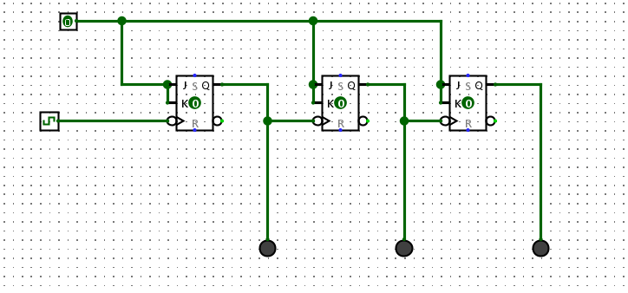**3-Bit Ripple Counter**

**3-Bit Count-down Ripple Counter**

**3-Bit Common-Clock Counter**

**3-Bit Common-Clock MOD 6 counter**

**3-Bit MOD 6 No illegal state counter with HEX Display**