**Excercise 8.2.1**

***What happens if you enter a number that takes the number of matchsticks remaining beyond 0 (i.e., into negative values) ?  What do you think is going on here ?  Hint - take a look at the value in the register!***

* It will represent the negative number in the 2’s complement.

**Excercise 8.2.2**

**Question 8.2.2(a) - What is the condition that needs to be satisifed in order for this loop to occur ?  Write this as a comparison using an inequality (ie., less than, greater than, less than or equal, greater than or equal)**

* The condition for this loop to occur is the input number is greater than 3 and less than 1.

**Question 8.2.2(b) - What two ARM assembly instructions could be used to create a branch that only occurs under this condition ?**

* We could uses CMP then BGT or BLT.

**Question 8.2.2(c) - Based on the instructions you outlined in 8.2.2(b), what status bit would be set to 1 if the loop was to repeat ?**

* When CMP 1 with input (in this case V1 is 1 and V2 is input number), the loop will occur when the N bit is set to 1.
* When CMP input with 3 (in this case V1 is 3 and V2 is input number), the loop will occur when the N bit is set to 1.

**Question 8.2.2(d)  - What are all the modifications needed to the current program to implement this feature?   Make the required modifications to your program to perform the task.**

* A black text on a white background

  Description automatically generatedWe need to create a label for the input, add 2 CMP and 1 BGT, BLT to branch back to that label. I also added a branch to display error message.

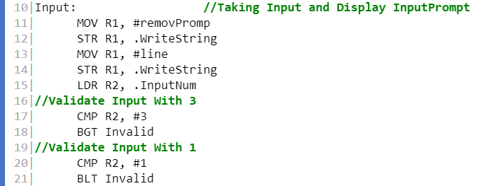

**Excercise 8.3.1**

**Question 8.3.1(a)  What bit-wise operation can we perform on the register holding the 32 bit pattern to set all bits in the register to zero except  the least signficant 2 bits ?  Write this as a single line of code.**

* We can perform AND operation with 3, which is 0x00000003 or 0b00000000000000000000000000000011.
* AND R0, #3.

**Question 8.3.1(b)  Using a label named "select:"  Write the code needed to repeatedly sample a random number (from .Random) until the value is in the range 1-3.  For now, just write this as a seperate program and test it.**

**Question 8.3.2(a)  -  Write the ARM assembly code that implements the algorithm expressed in the psuedo code above.   Implement this as a seperate stand alone program and initialise R0 with a number at the start of your program to allow you to test the functionality.  You wil want to test it using different values in R0.**

