Programming Exercise 6 Technical Design
Name: Ean Eichelbaum | Date: October 8, 2026 | Course: COP 2373
This program uses regular expressions to check phone number, Social Security number, and ZIP code formats. It prompts for all three values and reports each result; a repeatable test mode checks valid and invalid examples.

Program rules
- Phone: ten digits, with optional leading country code 1; spaces, periods, or hyphens may separate groups, and parentheses may surround the area code.
- SSN: exactly three digits, a hyphen, two digits, a hyphen, and four digits. The program validates format only.
- ZIP: five digits, optionally followed by a hyphen and four digits.
- Each check matches the whole input, so extra characters and extensions are rejected.

Function design
Function | Parameters | Variables | Logical steps | Return
_matches(pattern, value) | pattern: regex string; value: input string | pattern, value | Use re.fullmatch to compare the entire input. | Boolean
is_valid_phone(phone) | phone: input string | pattern | Apply the accepted US phone formats, then call _matches. | Boolean
is_valid_ssn(ssn) | ssn: input string | pattern | Require the NNN-NN-NNNN digit and hyphen layout, then call _matches. | Boolean
is_valid_zip(zip_code) | zip_code: input string | pattern | Require five digits and optional hyphen plus four digits, then call _matches. | Boolean
run_tests() | None | cases, failures, label, validator, sample, expected, actual, status | Run 12 representative cases, print expected and actual results, and count mismatches. | True when all tests pass; otherwise False
main() | None; reads command line and user input | phone, ssn, zip_code | Run test mode for --test; otherwise prompt for three values and display each validation result. | Process exit code (0 on success; test mode returns 1 on failure)

Testing
Run the repeatable checks with: python programming_exercise_6.py --test. The 12 cases cover standard and alternate phone formats, malformed phone values, valid and malformed SSNs, and five-digit and ZIP+4 values. All cases passed.
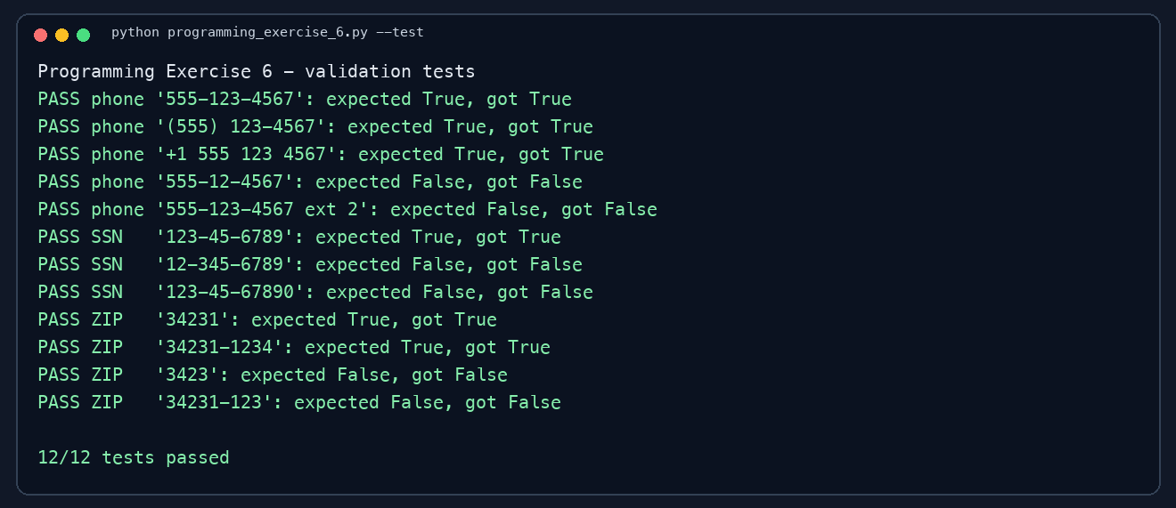
Figure 1. Output from the program test run.

Repository
COP 2373 repository: https://github.com/Eichelbaum156/COP-2373-

