Android App – Points of Interest with Liquid Content

Google Maps allows you to store and share location data and provides APIs for developer to implement map related features in mobile apps. This works for generic and simple use cases but will not fit CMS requirements especially the case needs seamless integration. Evoq Liquid Content now becomes a perfect solution to fulfill more and more flexible and extensible CMS needs since it can publish content to any channels/devices easily and smoothly.

As a sample scenario, assume you have some geolocation data stored in CMS already (Evoq Liquid Content in this case) and want to show them on Android device. To implement this, we walk you through couple steps to build a simple Android app called Points of Interest. It will communicate with Evoq Liquid Content through APIs to get your geolocation data from cloud and display it on the map. By following our step by step instructions, no matter having mobile app development experience or not, you should be able to build this app and get to know more about Evoq Liquid Content.

In order to build this app, you need to have Android Studio installed on your machine, a Google API key for rendering map and the last but not least, you need the Evoq Liquid Content API Key. If everything is good, you can see the UI on your Android device like this,

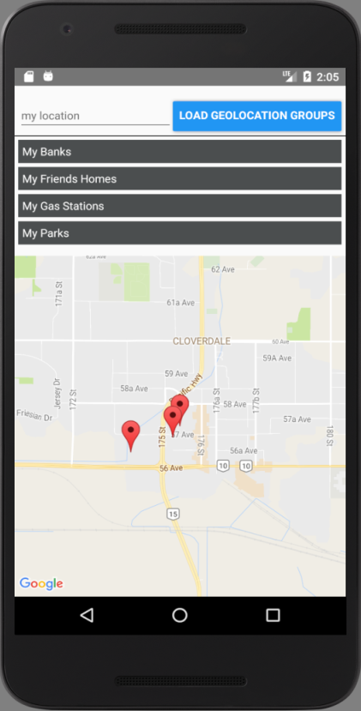

This is just a beginning. You definitely can improve it to support points editing/deleting by calling other Evoq Liquid Content APIs. You can also try to integrate it with your existing business logic of CMS. For more information of Evoq Liquid Content, please refer to DNN Documentation Center,

<http://www.dnnsoftware.com/docs/>