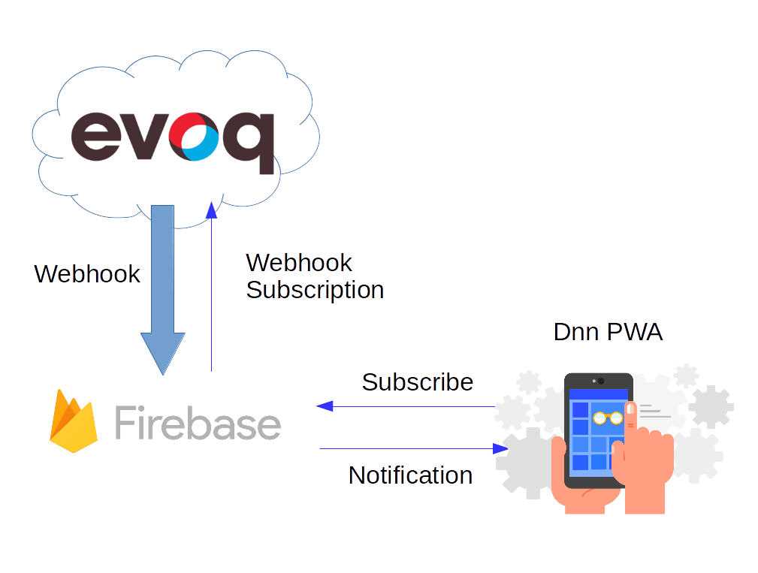

# Introduction.

Progressive Web Apps (PWA) is a new way of deliver applications to mobile device users. Think in applications running in any platform, with offline capabilities, automatic updates and installable in your system just acceding an URL. Sounds great, isn’t it? Other nice feature is they allow you to send system notifications to your subscribed users, just like a native application would do.

On the other hand, Evoq Liquid Content, an amazing platform to define, create and publish customized content. Visually create your content type in seconds and just start to create your content. Publishing content is also very easy through Visualizer, Embed, or Social Network integration capabilities. But Liquid Content is much more. It allows you to create your own integrations thanks to its API key system and Webhook functionality.

# Inspiration.

So, why not to join both technologies and create an awesome platform to notify your subscribers about content publish events? This is exactly what you are about to learn following this tutorial. Follow up and learn how to join Evoq Liquid Content with a very basic backend performing like a bridge between Evoq events and your PWA subscribers. Once the backend has received the events, it would deliver them to you PWA users, which will receive the publishing notification.

# Architecture.

* Evoq Liquid Content and Webhook API.
* Firebase
* Javascript PWA application with React / Material UI Frontend.

Start reading here: <https://github.com/dnnsoftware/Dnn.Evoq.LiquidContent.Samples/tree/af98cdacddac88635e45675f7d464e747c2c6754/Juan/dnn-pwa-app>

