# 

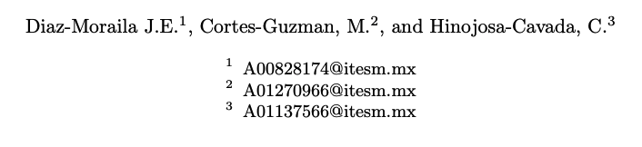

# Introduction

In this challenge, a genetic algorithm is used to adjust the weights of a simple neural network. the weights in the neural network will make it possible to approximate a particular function partially described in data.csv.

|  |  |
| --- | --- |
| x | f(x) |
| -5 | 10.14 |
| -4.9 | 10.47 |
| -4.8 | 11.21 |
| -4.5 | 11.77 |
| -4.3 | 11.1 |

Table of data.csv values

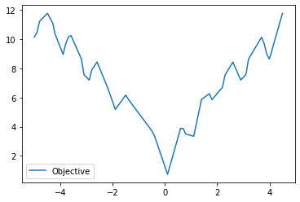

Description of the (partial) objetive function

# Experiments and result

We proceed to perform diferent runs of the genetic algoritms with different number of neurons but the same population size, generations, crossover and mutation rate

## Parameters

Nerurons:

* 6
* 8
* 11
* 110

|  |  |  |  |
| --- | --- | --- | --- |
| Population | Generations | Crossover rate | Mutation rate |
| 100 | 300 | .9 | .1 |

# 6 neurons

We can observe that the run with 6 neurons follows a good trend since the best at each generation keeps decreasing and the average is consistent with that trend

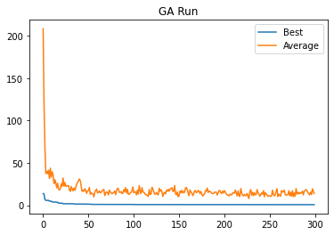

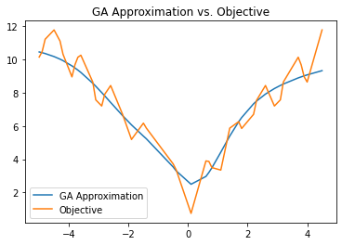

In the comparison of the aproximation with 6 neurons we can observe that is difficult to catch the exact behaviour since it the objetive funcion have several peaks, this approximation give us a SSE of 0.7001

# 8 neurons

The same good-trend behaviour is observed in the 8 neurons approach

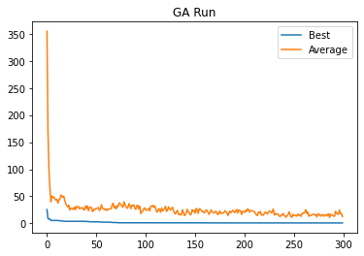

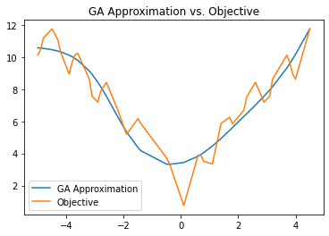

The more visible difference with the previous run is that the 8-neurons run was not able to cath de middle valley and in consecuence it got a worst SSE 0.8399

# 11 Neurons

Although the pattern of the 11-neurons run is consistently good, surprisingly this 11-neurons run score better than the 8-neurons run but worst than the 6-neurons run , giving a SSE of 0.75092.

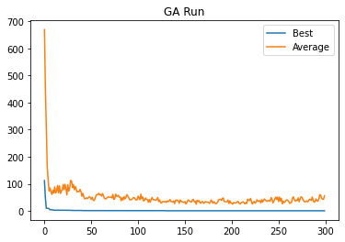

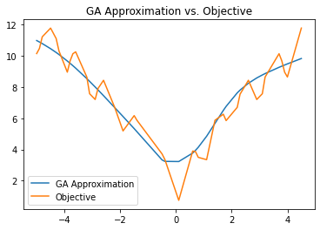

## 110 neurons

We can observe the same pattern in the 11-neuron run, but in the plot comparing the aproximation vs the objetive function we can observe another pattern between runs, and that pattern is that if we increase the number of neurons and we expect worst results, in this case 110-neuron runs give us a SSE of 5.42035

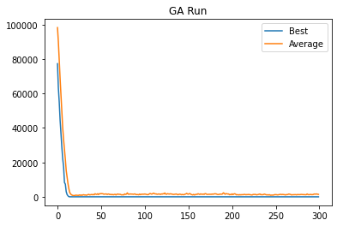

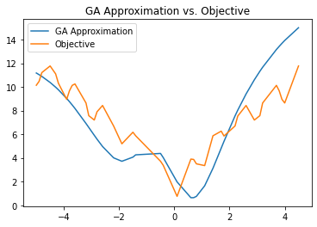

# Conclusion

|  |  |
| --- | --- |
| Neuronas | SSE |
| 6 | 0.7001 |
| 8 | 0.8399 |
| 11 | 0.7509 |
| 110 | 5.4203 |

Prior to the experimentation, one expects that the more number of neurons, the greater the flexibility of the architecture to be able to model the objective function, but apparently the more neurons, the more parameters it has to find and optimize, which becomes counterproductive, perhaps changing the population or the mutation or other parameters of the genetic algorithm will produce better solutions for runs with large number of neurons.