**250 CT Portfolio – Individual Activities**

Academic year 2020/2021

**9195071**

**Individual Activities**

The following activities are to be carried out **individually** by the students **outside lab hours** (though asking for help during labs is possible). **Submit this piece of work separately from the rest of the portfolio**. Notice that since this is not group work submitting the same piece of work as the rest of your group members will be considered plagiarism.

**1. Router Operation Diagram**

Construct a diagram showing the relationship between the different modes of operation/prompts that you used in the course of the labs and the commands that can be used to change between them.

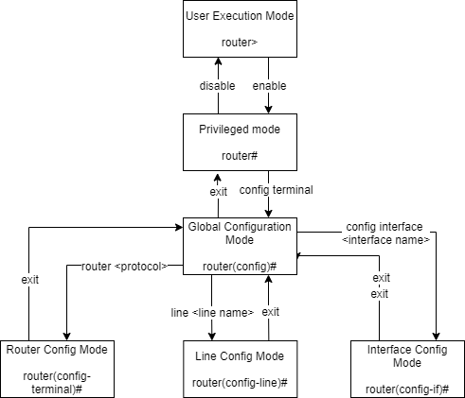

**2. Research Question**

In regards to the portfolio 3 exercise: Access to the outside world for the scavengers’ group is critical for the operation of the company. You have been asked by management to provide some advice on how the network’s fault tolerance can be improved in that regard. Write a short proposal (200-500 words) about the steps that could be taken in order to maximise the chances of that particular group still having access to the internet in the event of equipment failure or other unforeseen problems. State any assumptions you made and what extra equipment and resources could be needed to achieve such a task. Explain the cons and pros of your suggestions and if necessary illustrate the new layout by means of a diagram. References to online material or printed sources (if you use any) do not count towards the word count.

To improve the fault tolerance of the system I would recommend using replication of key components in the network and directing all traffic to the original and duplicate in parallel. In the situation where the original device fails the replicated device will pick up the traffic and allow the team to replace the device with minimal down time. This secondary device could also be set up with different implementations of software in order to handle any errors produced by the primary device. Implementing a circuit breaker design pattern in the network will also reduce the probability of a total failure of the network caused by a single component. Using multiple internet service providers introduces the same redundancy spoken about before, if for any reason an internet service provider goes down, the team can switch it over automatically resulting in a lack of down time. Utilising load balancing throughout the network will dramatically reduce the risk of faults or downtime, as scavengers are the largest group on the network balancing their workload through multiple network nodes will be a large step towards full fault tolerance. If full fault tolerance is required a full fallback system could be implemented, where each component of the network has it’s own fallback. In this model any defect in hardware or software will be covered by a redundant piece of equipment. Any data stored in the network should have a digital and physical backup to ensure recoverability and minimal downtime if corruption or removal should occur. Using fail-stop techniques to further increase the ability of the team to identify where processes have failed and decrease the time it takes for the team to repair or restart hardware and avoid downtime.