The DMC DeLorean
The DMC DeLorean (often referred to simply as the "DeLorean") is a sports car and was the only automobile manufactured by John DeLorean's DeLorean Motor Company (DMC) for the American market from 1981 to 1983. The car was designed by Giorgetto Giugiaro and stood out for its gull-wing doors and brushed stainless-steel outer body panels. It became widely known for its disappointing lack of power and performance, which did not match the expectations created by its looks and price tag. Though its production was short-lived, the car was made memorable through its appearances as the time machine in the Back to the Future media franchise after 1985.
Throughout production, the car kept its basic styling, although minor revisions were made to the hood and wheels. The first production car was completed on January 21, 1981. About 9,000 DeLoreans were made before production halted in late December 1982 shortly after DMC filed for bankruptcy.
Despite the car having a reputation for poor build quality and a less-than-satisfying driving experience, the DeLorean continues to have a cult following driven in part by the popularity of the Back to the Future movies. An estimated 6,500 DeLoreans are still on the road.

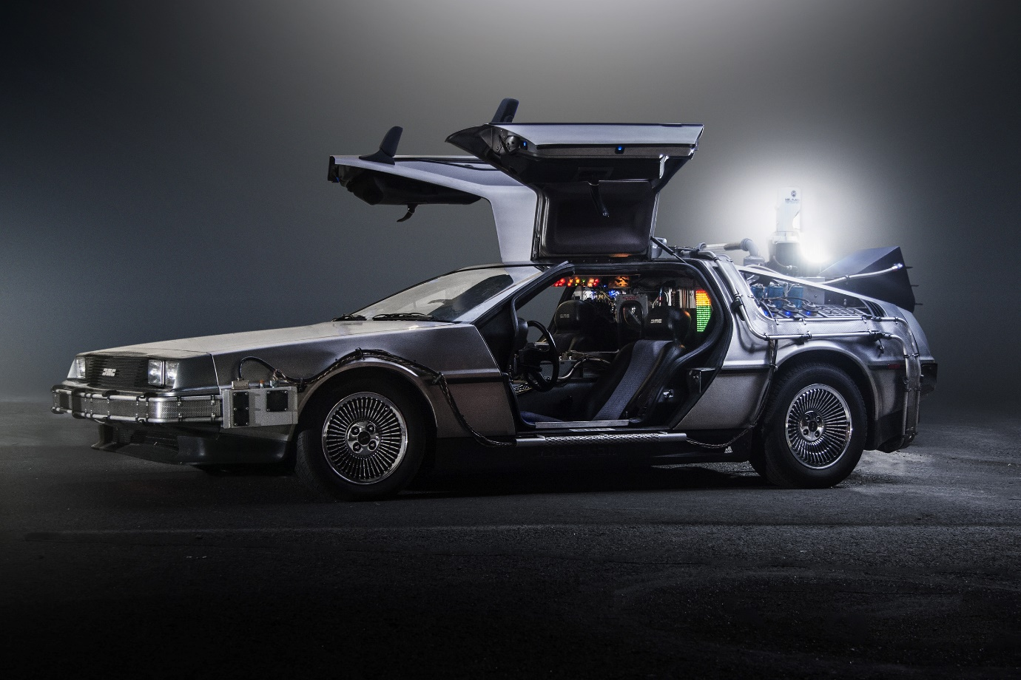

When details surrounding the DeLorean first started to be revealed in the mid-1970s, there were numerous plans and rumors that the DeLorean would have many advanced features, such as elastic reservoir moulding (ERM), a unit construction plastic chassis, a mid-engine layout, airbags, 10 mph bumpers and Pirelli P7 tires; none of them would materialize in the production vehicle.^{[13]}
Originally, the car was intended to have a centrally-mounted Wankel rotary engine. The engine selection was reconsidered when Comotor production ended and the favored engine became the Ford Cologne V6 engine.^{[14]}
The first prototype appeared in October 1976. The prototype was completed by American automotive chief engineer William T. Collins, formerly chief engineer at Pontiac and the prototype was known as the DSV-1, or DeLorean Safety Vehicle.^{[15]} As development continued, the model was referred to as the DSV-12^{[16]} and later the DMC-12 since DMC was targeting a list price of $12,000 upon release.^{[17]}
The Ford V6 engine would soon be abandoned in favor of the complete drivetrain from a Citroën CX 2000 as it was deemed as a more reliable engine choice.^{[18]} However, the 1,985 cc (121 cu in) engine from Citroën was deemed too underpowered for the DeLorean. When Citroën learned of DMC plans to turbocharge the engine, Citroën suggested to DMC to find another engine.^{[19]} Eventually the fuel-injected V6 PRV engine (Peugeot-Renault-Volvo) was selected. As a result, the engine location had to be moved from the mid-engined location in Prototype 1 to a rear-engined location in Prototype 2; a configuration which would be retained in the production vehicle.^{[20]}
The chassis was initially planned to be produced from a new and untested manufacturing technology known as elastic reservoir moulding (ERM), which would lighten the car while presumably lowering its production costs. This new technology, for which DeLorean had purchased patent rights, was eventually found to be unsuitable.^{[21]}
The interior on Prototype 1 was significantly different than the production vehicle. Prototype 1 had a prominent full-width knee bar as it was intended to be a safety car. A medium brown leather covered the seats but were much flatter and didn’t have the comfort and support of the production seats. A black center steering wheel with a fat center was intended to hold an air bag and the driver had a full set of Stewart-Warner gauges. A central warning system would check various fluid levels and even warn of low brake pad thickness though even at this time it was suspected this feature wouldn’t show up on production cars.^{[22]}
These and other changes to the original concept led to considerable schedule pressures. The entire car was deemed to require almost complete re-engineering, which was turned over to engineer Colin Chapman, founder of Lotus Cars. Chapman replaced most of the unproven material and manufacturing techniques with those then employed by Lotus, like the steel backbone chassis.^{[23]}
After several delays and cost overruns, production finally began in late 1980. Around this time DMC officially dropped the name DMC-12 on its now $25,000 car in favor of the model name DeLorean. The DeLorean sports car, as it was described in advertisements,^{[24]} began production in December 1980 with the first production car rolling off the assembly line on January 21, 1981.^{[a][26]}
The DeLorean Motor Company was placed into receivership in February 1982 and filed bankruptcy in October 1982.^{[27]} Consolidated International purchased the unsold DeLoreans and partially completed DeLoreans still on the assembly line and assembled approximately 100 DeLoreans^{[28]} to finish the remaining production on December 24, 1982.^{[1}

