250 CT Portfolio Exercise 3
Academic year 2020/2021

Read me 1st

This activity is part of the coursework portfolio for this module. This particular activity does not need to be signed off – the router configurations and screenshots that demonstrate end to end connectivity need to be submitted instead. You must do portfolio exercises in the order provided. Ensure each activity is completed prior to attempting the next one. Ideally students should work in groups of two or three.

The Problem

As a first grade technician for the mining company Red Dwarf you have been assigned with the task of designing the addressing scheme for their network (see diagram). In order to do so you have to subnet the network 192.168.42.0/24 ensuring that there will be enough addresses to accommodate the needs of each department. Note that the network connects to the outside world through network 172.17.0.0/16 – you can choose an IP address for this connection (ISP’s IP is 172.17.0.1) but it has to be within the same address space.
Lister
Rimmer
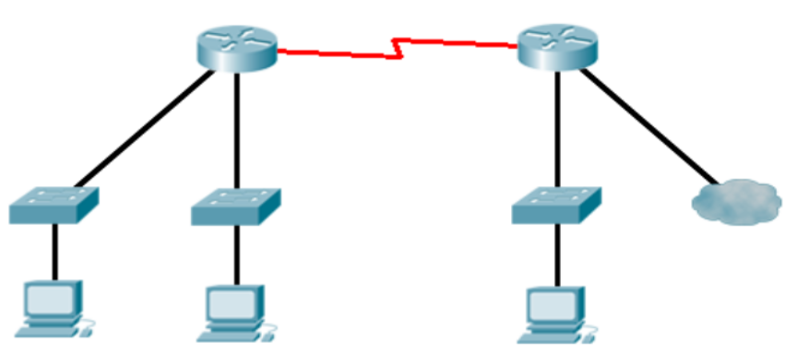
ISP
Officers
(28 Hosts)
Scavengers
(72 hosts)
Canaries
(49 hosts)
172.17.0.1/16

Network Diagram

1. Addressing Scheme

Design the addressing scheme for the network above using VLSM subnet masking. You are allowed to use subnet zero.

 | Subnet | First host | Last host | Broadcast | Mask
Router link | 192.168.42.224 | 192.168.42.225 | 192.168.42.226 | 192.168.42.227 | 255.255.255.252
Officers | 192.168.42.192 | 192.168.42.193 | 192.168.42.222 | 192.168.42.223 | 255.255.255.224
Canaries | 192.168.42.128 | 192.168.42.129 | 192.168.42.190 | 192.168.42.191 | 255.255.255.192
Scavengers | 192.168.42.0 | 192.168.42.1 | 192.168.42.126 | 192.168.42.127 | 255.255.255.128

2. Basic Configuration

For this task you are required to connect the devices using the appropriate cables and configure the interfaces. The commands to do that can be found in the previous portfolio exercise.

3. EIGRP

EIGRP routing protocol configuration is similar to that of RIP (see portfolio 2) but at the same time differs in a number of significant ways. Routers can support multiple instances of this protocol running at the same time, forming different autonomous systems. As such a positive number must be specified when configuring. This number has to be the same for all routers participating to that autonomous system (and thus can exchange information about the networks that form this system).

Router(config)# router EIGRP number

Another difference is that EIGRP expects hosts bits to be specified when adding networks during the routing protocol configuration. Host bit are indicated using a wildcard mask. Inverting the bits of the subnet mask can be used to derive the wildcard mask for each subnet. For instance: network 192.168.177.128 with subnet mask 255.255.255.192 will have 0.0.0.63 as its wildcard (192=11000000₂ while 63=00111111₂). This network could be added to the list of networks the router advertises using the following instruction:

Router(config-router)# network 192.168.177.128 0.0.0.63

Configure the EIGRP protocol for both routers and verify that the configuration using the “show ip route” command and/or pinging addresses in other, not directly connected parts of you network.

4. Static route

It is impossible for a router to have an entry for every network out there. A default gateway can be configured on router Rimmer to forward traffic towards unknown networks. This can be specified as a static route which redirects any network (0.0.0.0) with any subnet mask (0.0.0.0) we do not know about out of a particular interface (for instance fa0/1). The command to do that would look a bit like:

Router(config)# ip route 0.0.0.0 0.0.0.0 fa0/1

Following the configuration of that static route you might want to ensure that other routers in you autonomous system know about this route. This can be achieved by adding the “redistribute static” command to your router EIGRP configuration.

Router(config-router)# redistribute static

After configuring the gateway try to device a test to verify that this is working as expected.

Ping from Canneries to Scavengers, Officers and ISP | 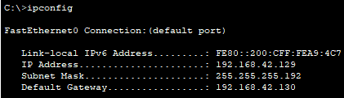  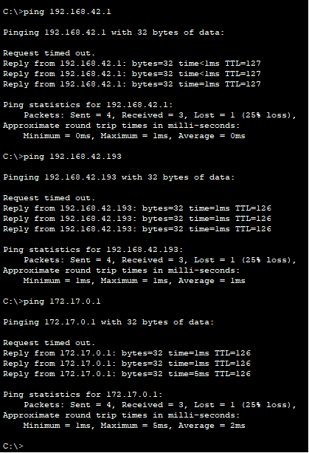
Ping from Scavengers to Canneries, Officers and ISP | 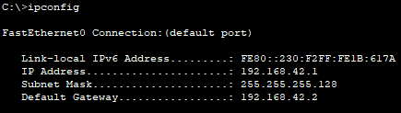  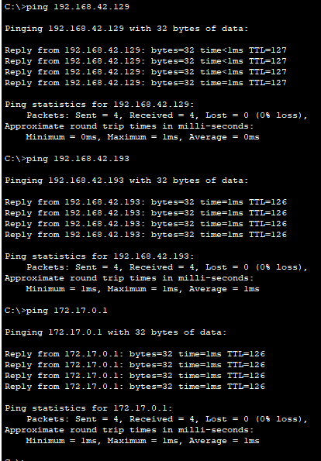
Ping from Officers to Scavengers, Canneries and ISP | 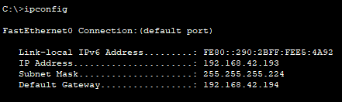  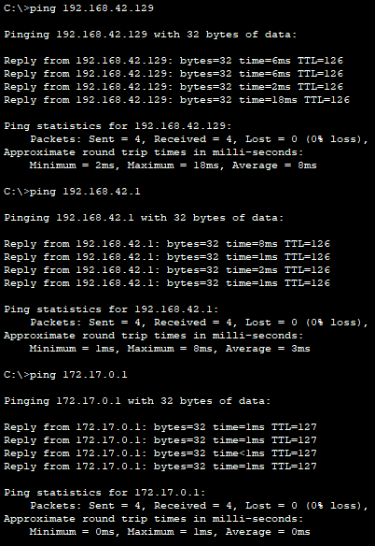
Rimmer running config | Rimmer#show run  Building configuration...  Current configuration : 968 bytes  !  version 15.1  no service timestamps log datetime msec  no service timestamps debug datetime msec  no service password-encryption  !  hostname Rimmer  !  !  !  !  !  !  !  !  no ip cef  no ipv6 cef  !  !  !  !  license udi pid CISCO1941/K9 sn FTX15246IH6-  !  !  !  !  !  !  !  !  !  !  !  spanning-tree mode pvst  !  !  !  !  !  !  interface GigabitEthernet0/0  ip address 192.168.42.194 255.255.255.224  duplex auto  speed auto  !  interface GigabitEthernet0/1  ip address 172.17.0.2 255.255.0.0  duplex auto  speed auto  !  interface Serial0/1/0  ip address 192.168.42.226 255.255.255.252  clock rate 2000000  !  interface Serial0/1/1  no ip address  clock rate 2000000  shutdown  !  interface Vlan1  no ip address  shutdown  !  router eigrp 8  redistribute static  network 192.168.42.192 0.0.0.31  network 192.168.42.224 0.0.0.3  network 172.17.0.0  !  ip classless  ip route 0.0.0.0 0.0.0.0 GigabitEthernet0/1  !  ip flow-export version 9  !  !  !  !  !  !  !  !  line con 0  !  line aux 0  !  line vty 0 4  login  !  !  !  end
Lister Running config | Lister#show run  Building configuration...  Current configuration : 899 bytes  !  version 15.1  no service timestamps log datetime msec  no service timestamps debug datetime msec  no service password-encryption  !  hostname Lister  !  !  !  !  !  !  !  !  no ip cef  no ipv6 cef  !  !  !  !  license udi pid CISCO1941/K9 sn FTX15241X7V-  !  !  !  !  !  !  !  !  !  !  !  spanning-tree mode pvst  !  !  !  !  !  !  interface GigabitEthernet0/0  ip address 192.168.42.130 255.255.255.192  duplex auto  speed auto  !  interface GigabitEthernet0/1  ip address 192.168.42.2 255.255.255.128  duplex auto  speed auto  !  interface Serial0/1/0  ip address 192.168.42.225 255.255.255.252  !  interface Serial0/1/1  no ip address  clock rate 2000000  shutdown  !  interface Vlan1  no ip address  shutdown  !  router eigrp 8  network 192.168.42.128 0.0.0.63  network 192.168.42.0 0.0.0.127  network 192.168.42.224 0.0.0.3  !  ip classless  !  ip flow-export version 9  !  !  !  !  !  !  !  !  line con 0  !  line aux 0  !  line vty 0 4  login  !  !  !  end

Important: You need to submit screenshots that demonstrate connectivity. You can either do so by cut and pasting the output of the show run command to notepad or by using the capture facility offered by the HyperTerminal application. Clearly label the configurations and do not forget to include you addressing scheme as part of your submission.

Group Members

Ideally this task should be completed in groups of two. Groups of three are allowed but not recommended.

Name: James Thomas Student ID: 9195071

Name: Alexander Collins Student ID: 9442540

Name: Liam Smith Student ID: 8452270

Instructor signatures

No instructor signatures are needed for this portfolio exercise. Submissions should include:

- Group member composition
- Addressing scheme
- Router configurations (clearly labelled)
- Evidence that end to end connectivity was achieved (i.e. ping and trace route screenshots)

The first subnet can be the one where all network bits are set to zero. This in effect makes the formula giving the number of subnets 2^{n}-1.
Enhanced Internal Gateway Routing Protocol (EIGRP) is a CISCO proprietary vector routing protocol. It supports variable length subnet masking, uses multiple metrics to rate routes and only sends updates when changes are detected. This makes it a better choice than RIP, especially for bigger and more complex networks - EIGRP offers many advanced features, consumes less bandwidth and offers faster convergence (time taken before all routers get updated with the latest information). The main drawbacks of EIGRP are that it is a proprietary protocol not supported by all vendors and that it is more complex than RIP (requiring more effort to implement and more processing power to run).

