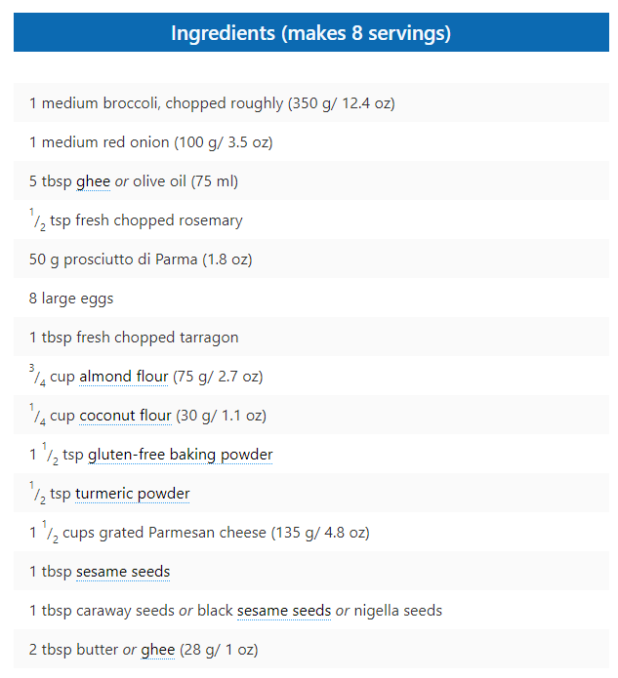

1. Preheat oven to 200 °C/ 390 °F. Cut the broccoli into florets.
2. Place the broccoli florets into boiling water and cook until soft. You don’t want them to be mushy, you just want them to break under gentle pressure from a spoon.
3. Meanwhile, add the ghee or olive oil to a frying pan and heat.
4. Cut four slices from the onion, approx. 1/2 cm (1/4 inch) thick. Chop the remaining red onion, rosemary and prosciutto finely and add to pan. Sauté until softened and fragrant.
5. Break eggs into a large mixing bowl, beat well and then add tarragon, almond and coconut flour, baking powder, turmeric, parmesan cheese and salt and pepper to taste. Add the cooked onion, rosemary and prosciutto.
6. Mix together until well combined and then add broccoli and combine, careful not to break it up too much.
7. Line a 20 cm/ 8 inch springform pan with silicone paper. Melt the butter and brush the base and sides with a good coating of melted butter.
8. While still wet, sprinkle the sesame seeds around the base and side, tilting and turning the pan to help spread the seeds.
9. Spoon the cake mixture into the tin, smooth the top and press the onion rings into the batter.
10. Cook for 45 minutes or until browned on top and a skewer comes out clean.

Serve at room temperature.  
Store in the refrigerator, covered, for up to 3 days.