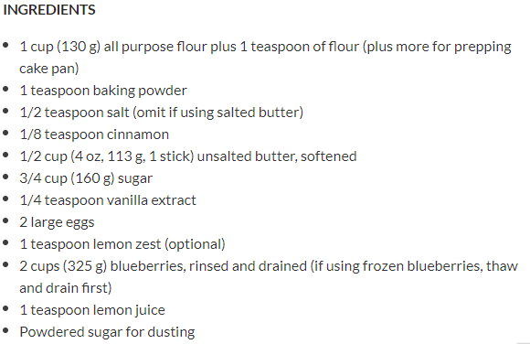

**1 Preheat oven and prepare springform pan:** Preheat oven to 350°F. Lightly butter an 8 or 9-inch springform pan and dust with flour. Or use an 8 or 9-inch round cake pan, butter and dust with flour and line the bottom with parchment paper.

**2 Mix flour with baking powder and salt:** Vigorously whisk together 1 cup of flour with baking powder, salt, and cinnamon and set aside.

**3 Make batter:**Using a mixer, beat the butter on medium high speed for 2 minutes. Add the sugar and beat until light and fluffy, a couple minutes more. Stir in the vanilla extract.

Add the eggs one at a time and beat until well blended. Stir in the lemon zest if using.

Reduce the speed of the mixer to low and slowly add the flour mixture, beating until smooth.

**4 Pour the batter into the prepared springform pan.**

**5 Toss berries with flour and lemon juice, spoon over batter:** Combine the berries with the remaining teaspoon of flour and the lemon juice in a bowl. Spoon the berry mixture over the batter.

**6 Bake:** Bake on middle rack in oven for 50 to 55 minutes at 350°F, or until a tester inserted into the center comes out clean.

Remove from oven and let the cake cool in the pan for 10 minutes.

Carefully slide a thin knife around the edges of the cake to release it from the pan.

**7 Dust with powdered sugar to serve:** Transfer the cake to a platter, berry side up. Dust the cake with powdered sugar to serve.