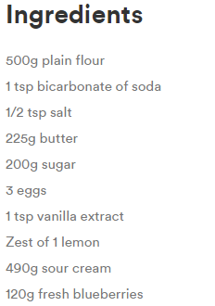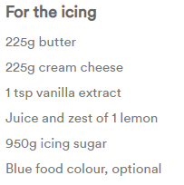Serves: 48 cakes

To make the cupcakes:   
1) Preheat the oven to 180C/Gas 4. Line the cups of a 24-cup cupcake tin with paper baking cases.

2) Mix the flour, bicarbonate of soda and salt together in a bowl. Set aside. Add the butter and sugar to a mixing bowl and cream until light and fluffy. Add the eggs 1 at a time and mix thoroughly. Add the vanilla and lemon zest and mix to combine. Add the dry mixture in 3 parts alternating with the sour cream, ending with dry mixture. Stir in the blueberries.

3) Fill each of the prepared paper cases two-thirds full of the batter. Bake in the oven for 16 to 20 minutes, until a cocktail stick inserted in the cake comes out clean. Cool the cakes on a rack.

For the icing:   
1) Cream the butter and cream cheese until smooth. Add the vanilla, lemon zest and juice and blend until combined. Add the icing sugar gradually until combined. Add the blue colour, if desired.

2) Frost the cooled cupcakes with the cream cheese frosting.