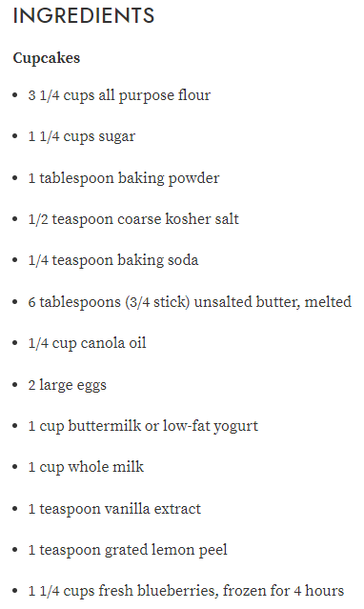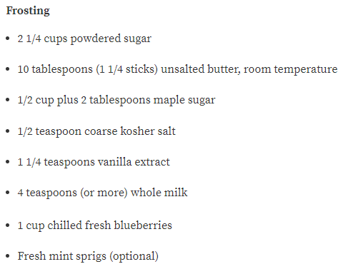

Preheat oven to 350°F. Line two 12-cup muffin pans with paper liners. Sift flour and next 4 ingredients into large bowl. Whisk melted butter and oil in medium bowl. Add eggs; whisk to blend. Whisk in buttermilk, milk, vanilla extract, and peel. Add buttermilk mixture to dry ingredients; whisk just to blend. Stir in frozen blueberries. Divide batter among liners.

Bake cupcakes until tester inserted into center comes out clean, about 23 minutes. Transfer cupcakes to racks; cool.

**For frosting:**

Combine first 5 ingredients in medium bowl. Add 4 teaspoons milk. Using electric mixer, beat until well blended and fluffy, adding more milk by teaspoonfuls if dry (small granules of maple sugar will still remain), about 4 minutes. Spread frosting over top of cupcakes.

Garnish cupcakes with chilled berries, and mint sprigs, if desired. (Can be made 4 hours ahead. Store in airtight container at room temperature.)