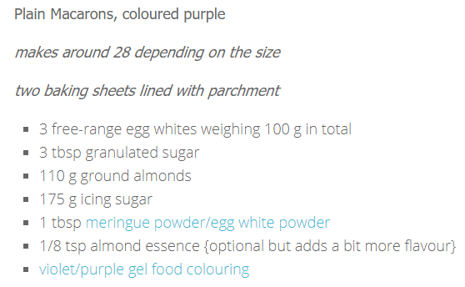

Begin by weighing out the ground almonds, **weigh it out after you have sifted it** to remove any larger grains. Now combine it with the icing sugar and whizz it up in a food processor, or in my case a mini chopper in batches, to get it as finely ground as you can. Set to one side.

**\*Cheat\*** To ‘age’ the egg whites, place them in a bowl and microwave them for 20 seconds on **medium** power. Now put them into a clean, grease-free mixing bowl and add the meringue powder. Use an electric beater to whisk them to frothy peaks. Once the egg whites look good and voluminous add the granulated sugar a spoonful at a time, whisking well between each. The egg whites should now start to look glossy and smooth. Continue whisking to stiff peak stage but no more.

Now ditch the electric mixer and switch to a spatula. Add the almond extract and a colourful blob of the food colouring gel. Be brave, the colour softens during the baking process. Give it a one or two stirs to begin to work the colour in then sift over half the icing sugar/almond mixture. Use the spatula to gently fold the dry ingredients in. As you do this the colour will continue to spread into the batter.

Sift in the rest of the icing sugar/almond mixture and continue carefully folding it in. As soon as no dry ingredients are visible change your technique. Now gently press the batter up the side of the bowl to reduce the volume. The batter will begin to look smoother.

To **test** if the batter is the correct consistency, lift the spatula up and watch to see how the trail of batter running off it falls onto the batter in the bowl. It should leave a soft trail that takes five or six seconds to ‘melt’ back into the batter. If it just sits on top, it’s not ready yet. If you overdo this process, the batter can become too thin. The macarons need to be able to hold their shape when you pipe them out.

Fit a piping bag with a 1cm plain nozzle and fill with the macaron batter. Put a dab of the batter on the corner of each baking sheet to ‘glue’ down the parchment to make piping out easier. Pipe 3 cm wide blobs of the batter on the lined baking sheets, leaving a little space between each. I piped mine free-hand but you could use a template to make them more precise.

Now drop the baking sheets sharply onto the work surface a few times to knock out any air bubbles and to level them, they should settle into fairly smooth discs. **Leave the macarons to form a skin** for anything up to a couple of hours, it depends on the temperature and humidity of the room.

Set the oven to 140 C / gas 1 / 280 F

When the macarons have formed a skin you will be able to gently touch them and they will not be sticky at all. Pop them into the preheated oven. Set the timer for 10 minutes. After the ten minutes the macarons should have risen and have their characteristic ‘feet’ or frill. Switch the baking sheets over, to ensure an even bake, then continue cooking them for a further 8 to 10 minutes.

Keep your eye on them, if any of them start to catch turn the heat down a little. To test if they are ready, they should be firm on their frilly bases, i.e. no movement. If they appear sturdy try lifting one. When they are ready they should lift off the parchment and have a smooth base. Try a few to, depending on the oven, some will cook quicker than others.

When they are cooked remove them from the oven and slide the parchment off the baking sheet and onto the work surface to let them cool. They will cool really quickly.

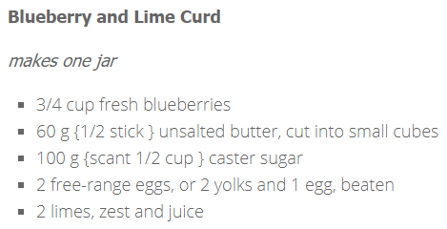

Place the blueberries in a jug or mug with a half teaspoon of water and microwave them for about a minute on high until they are burst and bubbling.

Use a hand mixer to blitz the cooked blueberries to a fine liquid then stir in the lime juice to cool it. Set aside.

Start to melt the butter in a bowl set over a barely simmering pan of shallow water. Do not let the water touch the bottom of the bowl. Once it begins to melt, stir in the caster sugar and continue to cook over a low heat until the sugar melts into the butter and looses its grainy appearance.

Stir in the blueberry/lime juice mixture, this will cool the butter and sugar down. Now add the beaten eggs and the lime zest and beat them in. Continue gently cooking the curd for about 20 to 30 minutes, stirring regularly until the curd thickens.

Pass the curd though a sieve to remove and lumps and zest and pour into a hot, clean jar. Put the lid on and allow to cool completely.

Spend a minute or so pairing up the cooled macarons, finding ones of similar sizes. Spoon a dollop of the cooled curd onto one of the macaron shells then cover it with its pair.

When you have filled all the macarons, leave them in a sealed container for a while, ideally overnight. **This is when the magic happens**. The filling soaks into the macaron creating an incredibly moist, super-tasty **flavour bomb**.