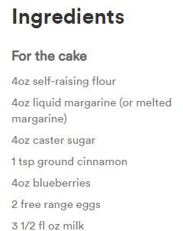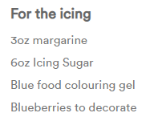

Preheat oven at 180 degrees and prepare a muffin tin with cup cake cases.

Beat together sugar, margarine, eggs and milk with a hand whisk.

Slowly add flour and cinnamon.

Fold in berries.

Divide into cases and bake for 18-20 minutes.

When cool make the topping by beating together the butter/margarine, icing sugar and blue food colouring.

Pipe in swirls and top with blueberries to decorate.