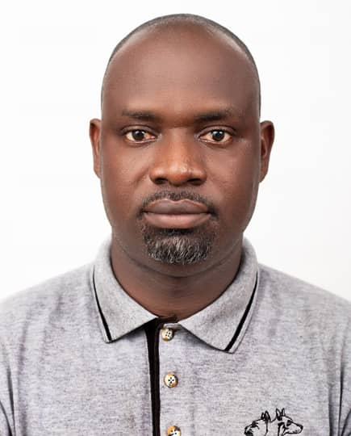

**BISMARK OPARE**

Mobile: +971526641301, +233241797520

Email: opasco208@gmail.com

**PROFILE**

I am a determined individual ready to meet challenges and overcome them. A confident communicator with a good sense of humor, pleasant disposition and enjoys teamwork. Past experiences in the Financial and other sectors have taught me how to understand, analyze and offer best practical solution everywhere I find myself.

**CARRIER OBJECTIVE**

Help attain the objectives of the organization through hard work, selflessness and determination, also to position myself for a greater challenge and responsibilities

**Education**

**Tertiary:              University of Cape Coast, Bachelor’s degree (Management in Education) 2013**

**Senior High:          Okuapeman Senior High (Business Management) 2004**

**Computer cert:   Planner Computer System (2000)**

**Primary and JSS:  Rev. John Teye Mem. Institute (2000)**

**Work experience and Duties**

Dubai Airport (Porter, November 2021 to date)

National Youth Authority: Service Personnel, August 2017- August 2018

JBS Ghana (General Manager / HR, March 2015 to September

Duties

1. Recruitment and selection
2. Training and development of employees
3. Compensation and employee benefits
4. Coordinating employer -employee relationship

*Liberty DMI Microfinance (Branch Marketing and Sales Head, August 2013- Feb, 2015)*

Duties

1. Maintaining client data base
2. Supervising the sales team
3. Bringing new clients on-board through an effective prospecting
4. Performing the duties of the branch manager in his absence
5. Monitoring the sales figures to ensure an increase in sales per every week
6. Ensure the satisfaction of every client.

*Achimota Business College (Management Teacher, 2012)*

*Biotec Enterprise (Salesman , 2005-2014)*

1. Receipt Issuing
2. Bank deposit
3. Stock keeping
4. Inventory taking

**SKILLS**

* Good Communication and Interpersonal Skills
* Proficient in Microsoft Office suite and Windows based application
* Ability to work under pressure
* Able to design website with available software’s.
* Some knowledge in CorelDraw.

**PERSONAL ATTRIBUTES:**

* Excellent interpersonal relationship
* Leadership and tremendous inclination to organizing
* Computer Literate

***REFEREES***

Upon request