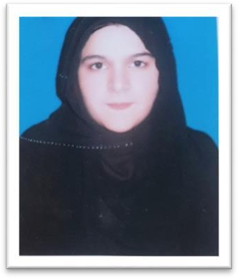**Maryam Arif MCS (IT)**

**Cell**: 0509603318

**Email**: [zohiaarif0301@gmail.com](mailto:zohiaarif0301@gmail.com)

**Address: Mbz,Abudhabi**

## PROFILE

Young creative ambitious professional, highly self-motivated individual with a continuous seeking ambition to succeed at the

highest levels when the opportunities are available. Passionate in performing different skills on Computer.

# Personal info:

* Date of birth:22-09-1994.
* Passport number:HB1982804.
* VisaStatus:Emirates Id

## Qualification

* **Master of Computer Science** (MCS) IT 2019. From National College of Business Administration & Economics Lahore Pakistan.
* **Bachelor of Science** (BSC) IT 2016. From National Science College Gujranwala, Pakistan.
* **(I.CS) Intermediate in Computer Science .***2014 From Excellence College Of Art & Science Gujranwala, Pakistan.*

## Personal Skills

* Have ability to communicate with all levels of management.
* Understand and maintain positive relation with coworkers and seniors.
* Expert in Problem Solving and root cause analysis.
* Ability to work under pressure and tough challenging situations.
* Innovative and energetic.

## Practical Skills/Expertise

* Expert in making attractive websites by using HTML and PHP coding. ●

Photoshop Skills.

* 3D Animations
* Understanding of C++ Language.
* Expert in Microsoft office skills.
* Understanding of different java modules.
* Understanding in database handling in database management.
* Expertise in different hacking modules.
* Expertise in Tracker Software.
* Understanding in different graphics tools.
* Understanding of JavaScript , jQuery, Bootstrap, DHTML, CSS.
* **Experience in .net framework**

## Internship (PAPTECH College)

* Website developer.
* Coder of C++.
* Graphic editor. ● Database Management

## Certificates / Diplomas

* Web designing (3 months diploma) from Soft Solution College Gujranwala Pakistan ●

Web development ( 3 months diploma) from Soft Solution College Gujranwala Pakistan.

* Hacking. ( 3 months diploma) from PAPTECH College Gujranwala.

# Experience

One year experience to work in Paptech institute as website developer or designer.

*6 months working experience in Abicas international Dubia as IT administrator*

*Working in UAE based company Mamati or Maneuver*

## Workshops/Seminars Attended

* Introduction to new hacking skills in 2020.
* Networking management in 2019.
* Android applications and working of it in different android games.
* Photoshop editing on Allama Iqbal Quotations.
* Different Softwares made by C++, Java.

## Language

* English (Reading, Listing, Speaking Fluent.)
* Urdu (Mother Language.)

## Computer Skills

Can operate computer efficiently in all necessary applications of windows as well as over net. I have Complete official experience about**.**

## Hobbies

* Travelling, Reading, Music

## References

Will be provided on request.