**Ramapriya Ramachandran**

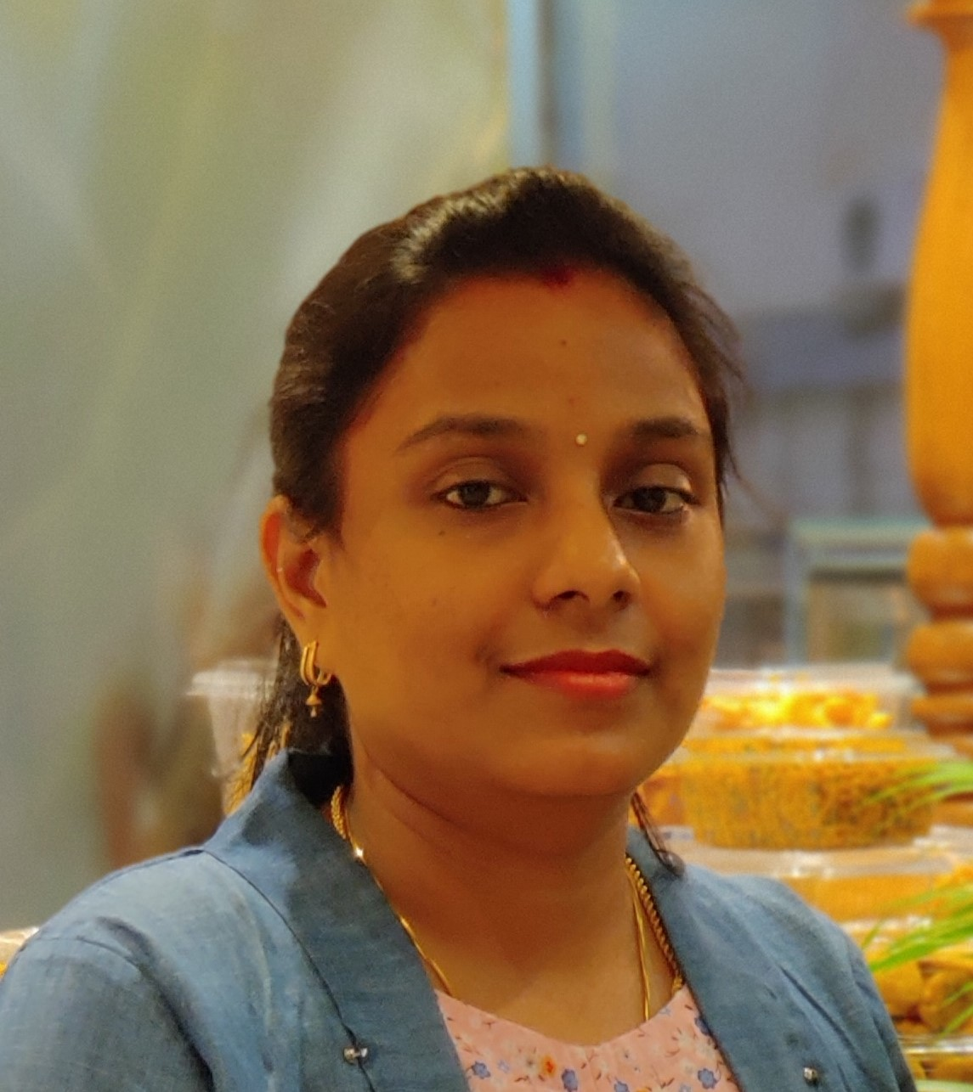

Mobile: +973 66678277

E-mail: ramasep18@gmail.com

CPR Number: 880981016

**Summary**

Responsible teacher with excellent communication and coordination skills demonstrated by 9+ years of classroom experience. Caring and professional with tireless commitment to student learning and overall Wellbeing.

**Highlights**

* Excellent classroom management.
* Teaching/Student Development.
* Student/ Classroom Discipline.
* Organization of Theme and skill projects.
* Strong listener.
* Handling Pressure.
* Play way Method of Teaching.
* Student Evaluation.
* Lesson Plan Development.
* Effectively work with parents.
* Creative Student engagement.
* Relationship Building.

**Experience**

* Worked as a **Primary School Teacher** at **Al Mahd Day Boarding School**, ***Bahrain*** Since **Oct 2021 to Sep2022.**
* Worked as **High School Teacher** at **Kothari Vidhya Mandir**, Puducherry. India Since **Sep 2019 to Sep 2021.**
* Worked as a **High School** **Teacher** at **Achariya World Class Educational Institutions**, Puducherry. India Since **June 2018 to Sep 2019.**
* Worked as a **Teacher** at **Blossoms Primary School**, Puducherry. India Since **July 2015 to May 2018.**
* Worked as **Primary School Teacher** at **Kothari Vidhya Mandir**, Puducherry. India Since **July 2009 to October 2012.**
* Worked as an **Assistant Teacher** at **Stansford International School**, Puducherry. India Since **Sep 2008 to Jan 2009.**

**Roles and Responsibilities**

* Taught wide range of subjects to as many as 30+ students per class.
* Designed and implemented new positive-reinforcement classroom management plan.
* Initiate new assessment plan to evaluate students learning.
* Utilized variety of teaching methods including lectures, media, group discussions and role-playing.
* Utilized after-school tutorial to provide one on one attention, improving student performance.
* Monitor students to maintain discipline and promote an atmosphere to learn.
* Encourage students to participate in class discussion and projects.
* Maintain Student attendance records, grades and other required records.

**Core Competencies**

* Fluent in Math and English.
* Basic Knowledge of Computer.
* Working Knowledge of Microsoft office Programs.

**Education**

* Bachelor of Education, Nehru college of Education, Puducherry University, 2018.
* Bachelor of Science in Mathematics, Alagappa University, 2013.
* D. T. Ed, Vetri Venkateshwara College of Education, Puducherry University, 2008.

**Personal Details**

* Date of Birth : 18th Sep 1988
* Languages known : English, Tamil
* Marital status : Married
* Husband’s Name : Sakthiganapathi Sambassivame
* Present Address : Block 526, Rd: 2620, Flat 23

Barbar, Bahrain

* Nationality : Indian
* Hobbies : Reading Books, Painting, Dancing, DIY Projects

Place: Barbar, Bahrain

Date: Yours Sincerely

(Ramapriya Ramachandran)