**Learning Management System**

**Official Project Name:**

University LMS

**Project Sponsor:**

Ministry of High Education & Scientific Research

Website: <http://portal.mohesr.gov.eg>

**Project Manager:**

Zeyad Ahmed Ali

**Purpose of the project:**

A multi-platform application and system that provides an easier way to manage and enhance the learning process specially in the collegial phase.

**Key Deliverables:**

* **For Students**

A website and a phone application where they can study, learn and be examined.

* **For Professors and TAs**

A dashboard which they put their materials and exams and get results that are enhanced by artificial intelligence to get better overview of the students’ progress

* **For University/College**

A general dashboard which it tracks students portfolios, profiles and grades.

**Project Resources:**

* Servers
* Data Centers

**Summary Budget:**

* Initial Budget
  + For servers components:
    - 2 Millions EGP
  + Hired Developers
    - Salary
* Continuous Budget
  + Maintenance Servers
    - 10 thousands EGP
  + IT Managers
    - Salary

**Assumptions:**

The application will be compatible with most popular phones versions and supports Android/IOS.

**High-Level Risks:**

* Network failure of servers
* Data Loss
* Unwanted Access
  + Modifying of grades
  + Leaking of personal data

**1- Product scope descriptions:**

1-This application helps online education so that students can interact with this application and communicate with professors as well as take exams on it.

**1- Product acceptance:**

1. Stability under heavy pressure
2. Interoperability and synchronization between other services.

**3-The Project Deliverable:**

* **For Students**

A website and a phone application where they can study, learn and be examined.

* **For Professors and TAs**

A dashboard which they put their materials and exams and get results that are enhanced by artificial intelligence to get better overview of the students’ progress

* **For University/College**

A general dashboard which it tracks students portfolios, profiles and grades.

**4-The Project Exclusions:**

Any HR related dashboards for managing the workers and employees in the university.

**5-Project constraints:**

1- The budget of the project

2-Customer and users satisfaction

3-pre-defined launch date

**6 - Assumptions:**The application will be compatible with most  
popular phones versions and supports Android/IOS

**Work Breakdown Structure**

* 1. Starting
     1. Requirements
     2. Doing study about the project
     3. Plan the project
  2. Hardware and Software
     1. Operating System
     2. Testing Devices
  3. Coding
     1. Algorithm Design
     2. Coding the functions in all tasks
     3. Test Functions
     4. Interface the application
  4. Finishing
     1. Test the application
     2. Fixed Errors
     3. Finish the application
     4. Install the Application
     5. Training the administrators

*WBS Dictionary*

* 1. *Starting*

|  |  |
| --- | --- |
| ***Work Package ID*** | *1.1.1* |
| ***Work Package Name*** | *Requirements* |
| ***Description*** | *Collect data about students, professors, and curricula* |
| ***Resources required*** | * *Data of student, professors, and curricula* * *Similar projects* |
| ***Person*** | *Team leader* |
| ***Cost to create*** | *200.000 EGP* |
| ***Start Date*** | *1st May 2022* |
| ***End Date*** | *1st July 2022* |

***1.1 Starting***

|  |  |
| --- | --- |
| ***Work Package ID*** | *1.1.2* |
| ***Work Package Name*** | *Doing study about the project* |
| ***Description*** | 1. *Do a feasibility study on the project in terms of its pros and cons .* |
| ***Resources required*** | * *old research* |
| ***Person*** | *Project manager and Team leader* |
| ***Cost to create*** | *100.000 EGP* |
| ***Start Date*** | *1st May 2022* |
| ***End Date*** | *1st June 2022* |

***1.1 Starting***

|  |  |
| --- | --- |
| ***Work Package ID*** | *1.1.3* |
| ***Work Package Name*** | *Plan the project* |
| ***Description*** | 1. *Make a plan on how to conduct the work and the steps for its implementation.* 2. *Assign tasks to the rest of the project members .* |
| ***Resources required*** | * *old research* * *Similar projects or applications* |
| ***Person*** | *Project manager and Team leader* |
| ***Cost to create*** | *250.000 EGP* |
| ***Start Date*** | *1st July 2022* |
| ***End Date*** | *1st August 2022* |

***1.2 Hardware and Software***

|  |  |
| --- | --- |
| ***Work Package ID*** | *1.2.1* |
| ***Work Package Name*** | *Operating System* |
| ***Description*** | *1) Choosing an operating system compatible with all students, professors and employees .* |
| ***Resources required*** | * *Android operating systems* * *IOS operating systems* |
| ***Person*** | *Developers and designers* |
| ***Cost to create*** | *500.000 EGP* |
| ***Start Date*** | *1st August 2022* |
| ***End Date*** | *20th August 2022* |

***1.2 Hardware and Software***

|  |  |
| --- | --- |
| ***Work Package ID*** | 1.2.2 |
| ***Work Package Name*** | Testing devices |
| ***Description*** | 1) Measuring the quality of performance  2) Try to improve performance if possible  3) Fix errors, if any  4) Determine the operating requirements |
| ***Resources required*** | * The opinions of a group of users |
| ***Person*** | Software Engineer |
| ***Cost to create*** | 500.000 EGP |
| ***Start Date*** | 20th  August 2022 |
| ***End Date*** | 31st August 2022 |

***1.3 Coding***

|  |  |
| --- | --- |
| ***Work Package ID*** | *1.3.1* |
| ***Work Package Name*** | *Algorithm design* |
| ***Description*** | *Writing and designing a set of algorithms that make it easier to write codes in a correct and easy way, which later helps in creating and designing the program.* |
| ***Resources required*** | *_____________* |
| ***Person*** | *Designers* |
| ***Cost to create*** | *500.000 EGP* |
| ***Start Date*** | *1st September 2022* |
| ***End Date*** | *30th September 2022* |

***1.3 Coding***

|  |  |
| --- | --- |
| ***Work Package ID*** | *1.3.2* |
| ***Work Package Name*** | *Coding the function in all tasks* |
| ***Description*** | *Writing the code for the implementation of the program.* |
| ***Resources required*** | *Knowledge of Syntax for the programming language used in creating the program.* |
| ***Person*** | *The programmer* |
| ***Cost to create*** | *300.000 EGP* |
| ***Start Date*** | *1st October 2022* |
| ***End Date*** | *30th December 2022* |

***1.3 Coding***

|  |  |
| --- | --- |
| ***Work Package ID*** | *1.3.3* |
| ***Work Package Name*** | *Test function* |
| ***Description*** | *Verify that the codes and algorithms are free of errors and that they work correctly.* |
| ***Resources required*** | *_____________* |
| ***Person*** | *Software Engineer* |
| ***Cost to create*** | *200.000 EGP* |
| ***Start Date*** | *1st January 2023* |
| ***End Date*** | *1st February 2023* |

***1.3 Coding***

|  |  |
| --- | --- |
| ***Work Package ID*** | *1.3.4* |
| ***Work Package Name*** | *Interface the Application* |
| ***Description*** | *Create an interface for the program so that it is easy to use and has a beautiful and distinctive appearance that allows users to navigate through it to all the sections or parts that they want within the program without any malfunction or defect.* |
| ***Resources required*** | * *facade pictures* * *Hyperlinks to navigate through the program* |
| ***Person*** | *Software Engineer* |
| ***Cost to create*** | *600.000 EGP* |
| ***Start Date*** | *1st February 2023* |
| ***End Date*** | *30th April 2023* |

***1.4 Finishing***

|  |  |
| --- | --- |
| ***Work Package ID*** | *1.4.1* |
| ***Work Package Name*** | *Test the application* |
| ***Description*** | *Check the program with all its features and make sure that it is free of malfunctions.* |
| ***Resources required*** | *_______________* |
| ***Person*** | *Software Engineer* |
| ***Cost to create*** | *150.000 EGP* |
| ***Start Date*** | *1st May 2023* |
| ***End Date*** | *30th May 2023* |

***1.4 Finishing***

|  |  |
| --- | --- |
| ***Work Package ID*** | *1.4.2* |
| ***Work Package Name*** | *Explain and fixed errors* |
| ***Description*** | *Finding faults and trying to correct them, explaining why they occur and how to avoid them.* |
| ***Resources required*** | *_______________* |
| ***Person*** | *Developer and Software Engineer* |
| ***Cost to create*** | *300.000 EGP* |
| ***Start Date*** | *1st June 2023* |
| ***End Date*** | *30th June2023* |

***1.4 Finishing***

|  |  |
| --- | --- |
| ***Work Package ID*** | *1.4.3* |
| ***Work Package Name*** | *Finish the application* |
| ***Description*** | *Finish the project and keep all plans that can be used in the future.* |
| ***Resources required*** | *______________* |
| ***Person*** | *Project manager* |
| ***Cost to create*** | *100.000 EGP* |
| ***Start Date*** | *1stJuly 2023* |
| ***End Date*** | *30th July 2023* |

***1.4 Finishing***

|  |  |
| --- | --- |
| ***Work Package ID*** | *1.4.4* |
| ***Work Package Name*** | *Install the application* |
| ***Description*** | *Publish the program for use on all stores and browsers to download and use it.* |
| ***Resources required*** | *Permission to publish the program in stores and on various sites.* |
| ***Person*** | *Project manager* |
| ***Cost to create*** | *200.000 EGP* |
| ***Start Date*** | *1stAugust2023* |
| ***End Date*** | *20th August2023* |

|  |  |
| --- | --- |
| ***Work Package ID*** | *1.4.5* |
| ***Work Package Name*** | *Training the administrators* |
| ***Description*** | *Training the admins to use the application to manage the students data and professors to use the application.* |
| ***Resources required*** | *Trainers* |
| ***Person*** | *HR* |
| ***Cost to create*** | *200.000 EGP* |
| ***Start Date*** | *1st September 2023* |
| ***End Date*** | *20th September2023* |

**Responsibility Matrix**

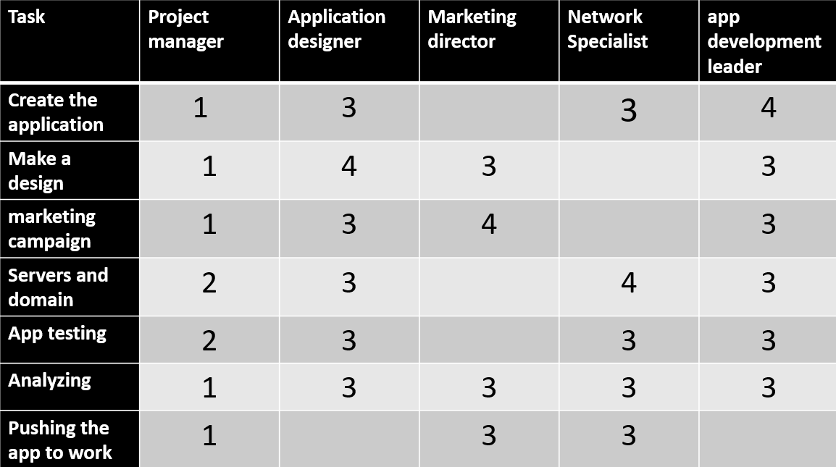

1-Approves 2-Reviews 3-Particpant 4-Creates

**Risks**

1. Failure of the servers

**Solution:** Keeping maintenance and emergency unit.

1. Unauthorized access

**Solution:** Updating databases, increasing awareness about security.

1. Leaking of exams.

**Solution:** optional use of AI to check others answers.

**Network**

|  |  |  |  |
| --- | --- | --- | --- |
| Activity | Description | Preceding Activity | Duration(Months) |
| A | Planning & Setting Environment | None | 3 |
| B | Designing | A | 4 |
| C | Implementation | A | 6 |
| D | Testing | B & C | 3 |
| E | Publishing Phase | D | 2 |

|  |  |  |
| --- | --- | --- |
| 0 | A | 3 |
| 0 | Planning & Setting Environment | |
| 0 | 3 | 3 |

|  |  |  |  |
| --- | --- | --- | --- |
| 3 | B | 7 | |
| 2 | Designing | | |
| 5 | 4 | | 9 |

|  |  |  |  |
| --- | --- | --- | --- |
| 3 | C | 9 | |
| 0 | Implementation | | |
| 3 | 6 | | 9 |

|  |  |  |  |
| --- | --- | --- | --- |
| 9 | D | 12 | |
| 0 | Testing | | |
| 9 | 3 | | 12 |

|  |  |  |  |
| --- | --- | --- | --- |
| 12 | E | 14 | |
| 0 | Publishing Phase | | |
| 12 | 2 | | 14 |

|  |  |  |  |
| --- | --- | --- | --- |
| ES | ID | EF | |
| SL | DESCRIPTION | | |
| LS | DURATION | | LF |

|  |  |  |  |  |  |  |  |  |  |  |  |  |  |  |  |  |  |  |  |  |  |  |
| --- | --- | --- | --- | --- | --- | --- | --- | --- | --- | --- | --- | --- | --- | --- | --- | --- | --- | --- | --- | --- | --- | --- |
| **ID** | **RES** | **DUR** | **ES** | **LF** | **SL** | **1** | **2** | **3** | **4** | **5** | **6** | **7** | **8** | **9** | **10** | **11** | **12** | **13** | **14** | **15** | **16** | **17** |
| A | **2** | 3 | 0 | 5 | 2 | 2 | 2 | 2 | 2 | 2 |  |  |  |  |  |  |  |  |  |  |  |  |
| B | **4** | 4 | 3 | 9 | 2 |  |  |  |  |  | 3 | 3 | 3 | 3 |  |  |  |  |  |  |  |  |
| C | **2** | 6 | 3 | 9 | 0 |  |  |  |  |  | 1 | 1 | 1 | 1 |  |  |  |  |  |  |  |  |
| D | **3** | 3 | 9 | 12 | 0 |  |  |  |  |  |  |  |  |  | 3 | 3 | 3 |  |  |  |  |  |
| E | **2** | 2 | 12 | 14 | 0 |  |  |  |  |  |  |  |  |  |  |  |  | 2 | 2 |  |  |  |
| **Total Resource Load** | | | | | | 2 | 2 | 2 | 2 | 2 | 4 | 4 | 4 | 4 | 3 | 3 | 3 | 2 | 2 |  |  |  |
| **Resource Available** | | | | | | **4** | **4** | **4** | **4** | **4** | **4** | **4** | **4** | **4** | **4** | **4** | **4** | **4** | **4** | **4** | **4** | **4** |

**Fig: Resources**

***Matrix of Activity with cost***

|  |  |  |  |  |  |  |
| --- | --- | --- | --- | --- | --- | --- |
| ID |  |  |  |  |  |  |
| A | 150 | 150 | 100 |  |  |  |
| B | 200 | 200 | 200 | 200 |  |  |
| C | 250 | 250 | 250 | 150 | 100 | 300 |
| D | 400 | 400 | 200 |  |  |  |
| E | 100 | 100 |  |  |  |  |

***Baseline Budget***

|  |  |  |  |  |  |  |  |  |  |  |  |  |  |  |  |
| --- | --- | --- | --- | --- | --- | --- | --- | --- | --- | --- | --- | --- | --- | --- | --- |
| ID | Bu0dget | 1 | 2 | 3 | 4 | 5 | 6 | 7 | 8 | 9 | 10 | 11 | 12 | 13 | 14 |
| A | **450** | 150 | 150 | 150 |  |  |  |  |  |  |  |  |  |  |  |
| B | **800** |  |  |  | 200 | 200 | 200 | 200 |  |  |  |  |  |  |  |
| C | **1300** |  |  |  | 250 | 250 | 250 | 150 | 100 | 300 |  |  |  |  |  |
| D | **1000** |  |  |  |  |  |  |  |  |  | 400 | 400 | 200 |  |  |
| E | **200** |  |  |  |  |  |  |  |  |  |  |  |  | 100 | 100 |
| Total | **3750** | 150 | 150 | 150 | 450 | 450 | 450 | 350 | 100 | 300 | 400 | 400 | 200 | 100 | 100 |
| Commutative | | 150 | 300 | 450 | 900 | 1350 | 1800 | 2150 | 2250 | 2550 | 2950 | 3350 | 3550 | 3650 | 3750 |