Eilat Avidan

CPE301 – SPRING 2018

Design Assignment 01

**DO NOT REMOVE THIS PAGE DURING SUBMISSION:**

The student understands that all required components should be submitted in complete for grading of this assignment.

|  |  |  |  |
| --- | --- | --- | --- |
| **NO** | **SUBMISSION ITEM** | **COMPLETED (Y/N)** | **MARKS**  **(/MAX)** |
| 1 | COMPONENTS LIST AND CONNECTION BLOCK DIAGRAM w/ PINS |  |  |
| 2. | INITIAL CODE OF TASK 1/A |  |  |
| 3. | INCREMENTAL / DIFFERENTIAL CODE OF TASK 2/B |  |  |
| 3. | INCREMENTAL / DIFFERENTIAL CODE OF TASK 3/C |  |  |
| 3. | INCREMENTAL / DIFFERENTIAL CODE OF TASK 4/D |  |  |
| 3. | INCREMENTAL / DIFFERENTIAL CODE OF TASK 5/E |  |  |
| 4. | SCHEMATICS |  |  |
| 5. | SCREENSHOTS OF EACH TASK OUTPUT |  |  |
| 5. | SCREENSHOT OF EACH DEMO |  |  |
| 6. | VIDEO LINKS OF EACH DEMO |  |  |
| 7. | GOOGLECODE LINK OF THE DA |  |  |
|  |  |  |  |
|  |  |  |  |

1. **INITIAL/DEVELOPED CODE OF TASK 1,2,3**
2. **Assembly code**

This is the assembly code to calculate the sum of all the numbers that divisible by 5. We cannot use div instruction, so what I did is to take each value and keep subtracting 5 until getting either 5, which is divisible by 5, or number less than 5- 1,2,3,4 then the number is not divisible by 5. As we know, dealing with 8-bit registers limit us to values up to 255, however, 300 values are needed. I decided to count up to 255, then the counter resets and count again up to 45. Total of 300 numbers.

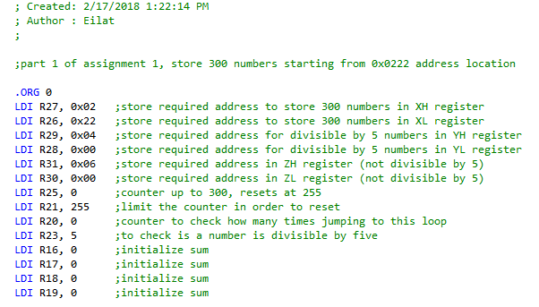

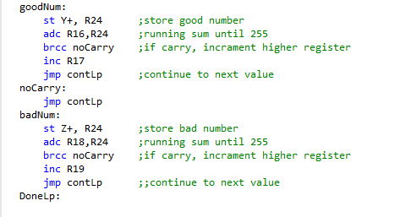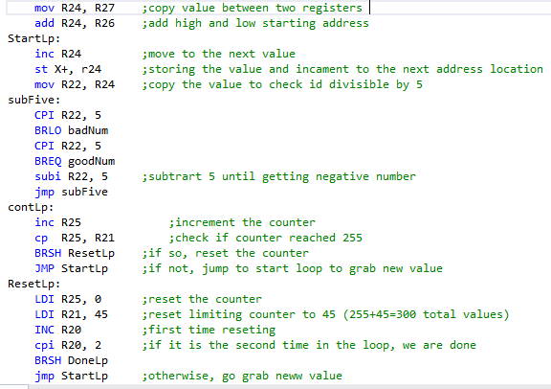

**C code-**

This is a C code to calculate two sums.

The first running sum will add out of 300 numbers the ones that divisible by 5.

The second sum will add all the rest of the numbers.

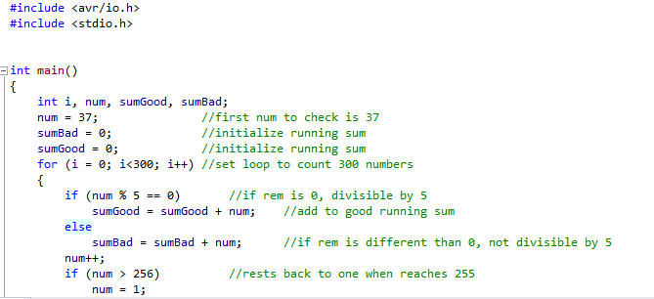I wrote my C code according to my assembly code which starts at value 37 up to 255, then resets to 0, and count again- until reaching 300 values.

1. **TASK 5- get execution time**

To get the ET we need to multiply the period by the number of cycles. However, the software is does it for us.

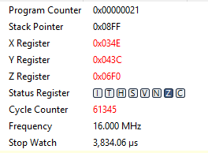

1. **SCREENSHOTS OF EACH TASK OUTPUT (ATMEL STUDIO OUTPUT)**

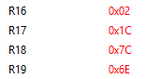

Figure 1 output of assembly code in registers R17:R16 and R19:R18

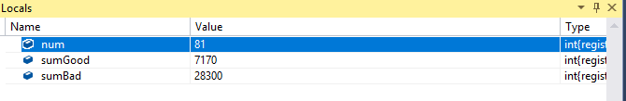

Figure 2 output of C code

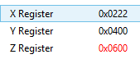

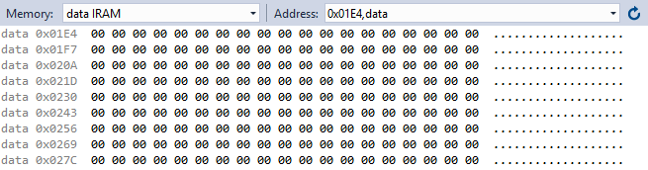Figure 2 storing the beginning addresses

Figure 4 memory before running the code

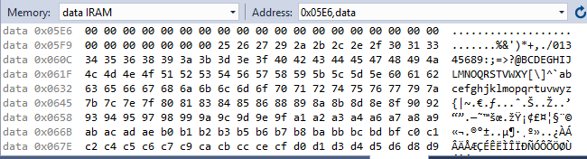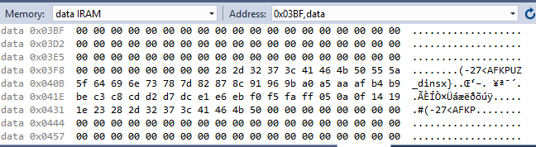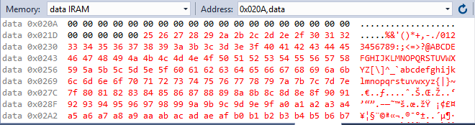

Figure 7 numbers not divisible by five stored in 0x0600

Figure 6 numbers divisible by five stored in 0x0400

Figure 5 memory after running the code storing all the numbers

1. **GITHUB LINK OF THIS DA**

[git@github.com:EilatAvidan2010/Project_submit.git](mailto:git@github.com:EilatAvidan2010/Project_submit.git)

**Student Academic Misconduct Policy**

<http://studentconduct.unlv.edu/misconduct/policy.html>

“This assignment submission is my own, original work”.

Eilat Avidan