Eilat Avidan

CPE301 – SPRING 2018

Design Assignment X

**DO NOT REMOVE THIS PAGE DURING SUBMISSION:**

The student understands that all required components should be submitted in complete for grading of this assignment.

|  |  |  |  |
| --- | --- | --- | --- |
| **NO** | **SUBMISSION ITEM** | **COMPLETED (Y/N)** | **MARKS**  **(/MAX)** |
| 1 | COMPONENTS LIST AND CONNECTION BLOCK DIAGRAM w/ PINS |  |  |
| 2. | INITIAL CODE OF TASK 1/A |  |  |
| 3. | INCREMENTAL / DIFFERENTIAL CODE OF TASK 2/B |  |  |
| 3. | INCREMENTAL / DIFFERENTIAL CODE OF TASK 3/C |  |  |
| 3. | INCREMENTAL / DIFFERENTIAL CODE OF TASK 4/D |  |  |
| 3. | INCREMENTAL / DIFFERENTIAL CODE OF TASK 5/E |  |  |
| 4. | SCHEMATICS |  |  |
| 5. | SCREENSHOTS OF EACH TASK OUTPUT |  |  |
| 5. | SCREENSHOT OF EACH DEMO |  |  |
| 6. | VIDEO LINKS OF EACH DEMO |  |  |
| 7. | GOOGLECODE LINK OF THE DA |  |  |
|  |  |  |  |
|  |  |  |  |

1. **COMPONENTS LIST AND CONNECTION BLOCK DIAGRAM w/ PINS**

The components used for this assignment-

* Atmega328P
* Switch
* Breadboard
* Resistors (mainly 100 ohms)
* LED (red)
* Power supply

1. **INITIAL/DEVELOPED CODE OF TASK 1/A (assembly)**

.org 0

LDI R16, (1<<2)

SBI DDRB , 2 ;set PB2 as an output

LDI R17 , 0 ; using for out

out PORTB, R17

begin:

RCALL delay ;calling timer to wait 0.25 sec

EOR R17, R16 ;xor to toggle the LED

out PORTB, R17

RJMP begin

delay:

LDS R29, TCNT1H ;loading upper bit of counter to R29

LDS R28, TCNT1L ;loading lower bit of counter to R28

LDI R20, 0

STS TCCR1A, R20 ;using control timer register

LDI R20, 2 ;set prescaler of 8

STS TCCR1B, R20 ;start the clock

CPI R28,0x08 ;comparing if lower is 0x08

BRSH body

RJMP delay

body:

CPI R29,0x3D ;comparing if upper bits is 0x3D

BRSH done

RJMP delay

done:

LDI R20,0x00

STS TCNT1H,R20 ;resetting the counter to 0 for next round

LDI R20,0x00

STS TCNT1L,R20 ;resetting the counter to 0 for next round

RET

1. **INITIAL/DEVELOPED CODE OF TASK 1/B (C)**

#include <avr/io.h>

#define *F_CPU* 5000000UL

#include <util/delay.h>

int main()

{

DDRB = 0x04; //set DE2 as an output

PORTB = 0x00; //initialize output to zero

while (1)

{

PORTB |= (1<<2); //turn on LED portb 2

*_delay_ms*(250); //delay of 0.25 seconds

PORTB &= ~(1<<2); //turn off the LED

*_delay_ms*(250); //delay of 0.25 seconds

}

}

**Calculation of TCNT value for task 1:**

**TCNT = (500,000/8)*0.25-1= 15624 (3D08)**

1. **INITIAL/DEVELOPED CODE OF TASK 2/A (assembly)**

.org 0

SBI DDRB, 2 ;PB2 as output

LDI R17,0 ;needed to toogle led

OUT PORTB,R17

CBI DDRD, 2

SBI PORTD, 2 ;port D2 pull up

LDI R20,3 ;to set prescaler

STS TCCR1B,R20 ;Prescaler: 64

start:

SBIC PIND, 2 ; skip when PIND2 is low

RJMP start

SBI PORTB, 2 ; Turn on the LED

SBIC PIND, 2 ; skip when PIND2 is low

RJMP start

CALL DELAY ; Delay for 1 second

CBI PORTB, 2 ; Turn off the LED

RJMP start

delay:

LDS R29, TCNT1H ;loading upper bit of counter to R29

LDS R28, TCNT1L ;loading lower bit of counter to R28

CPI R28,0x84 ;comparing if lower is 0x84

BRSH body

RJMP delay

body:

CPI R29,0x1E

BRSH done

RJMP delay

done:

LDI R20,0x00

STS TCNT1H,R20 ;resetting the counter to 0 for next round

LDI R20,0x00

STS TCNT1L,R20 ;resetting the counter to 0 for next round

RET

1. **INITIAL/DEVELOPED CODE OF TASK 2/B (C)**

#include <avr/io.h>

#include <avr/interrupt.h>

#define *F_CPU* 500000UL //frequency 0.5MHz

#include <util/delay.h>

int main()

{

DDRB |=(1<<2);

DDRD &= ~(1<<2);

while (1)

{

if (PIND & 0x04){ //if switch pressed

PORTB |= (1<<2); //turn on LED at port B2

*_delay_ms* (1000); //wait one sec

}

else {

PORTB &= ~(1<<2); //turn the LED off

}

}

}

**Calculation of TCNT value for task 2:**

**TCNT = (500,000/64)*1-1= 7812 (1E84)**

1. **INITIAL/DEVELOPED CODE OF TASK 3/A (assembly)**

.include "M328DEF.INC"

.org 0

LDI R16, (1<<2)

SBI DDRB , 2 ;set PB2 as an output

LDI R17 , 0 ; using for out

OUT PORTB, R17

begin:

RCALL delay ;calling timer to wait 0.25 sec

EOR R17, R16 ;xor to toggle the LED

out PORTB, R17

RJMP begin

delay:

LDI R28, 0x86 ;load 134 (TCNT value) to the register

OUT TCNT0, R28 ;load the value to TCNT0

LDI R20, 0

OUT TCCR0A, R20

LDI R20, 5 ;5- 1024 prescaler (make the value less than 255- 8 bits)

OUT TCCR0B, R20 ;Timer0, normal mode, int clk, 1024 prescaler

lp:

IN R20, TIFR0 ;check if TOV in TIFR register is set to one

SBRS R20, TOV0 ;if so, skip next instruction

RJMP lp

done:

LDI R20,0x00

OUT TCCR0A, R20 ;stop timer

OUT TCCR0B, R20 ;stop timer

LDI R20, (1<<TOV0)

OUT TIFR0, R20 ;clear flag by writing 1 to TIFR

RET

1. **INITIAL/DEVELOPED CODE OF TASK 3/B (C)**

#include <avr/io.h>

void delay();

int main()

{

DDRB |= 0x04; //set DE2 as an output

PORTB = 0x00; //initialize output to zero

while (1)

{

delay(); // calling delay function

PORTB ^= 0x04; //xor to toggle LED portb 2

}

}

void delay (){

TCNT0 = 0x86; //normal mode, counts up to 134

TCCR0A |= 0;

TCCR0B |= (1 << CS02) | (1 << CS00); //1024 prescaler

while ((TIFR0 & 0x01)== 0)

{

//DO nothing

}

TCCR0A = 0x00; //stop timer

TIFR0 |= (1<<TOV0); //reset flag

}

1. **INITIAL/DEVELOPED CODE OF TASK 4/A (assembly)**

.include "M328DEF.INC"

.org 0

jmp main

.org 0X20

jmp TIMER0_OV_ISR

.org 0x100

main:

LDI R20, HIGH(RAMEND) ;initalize the stack

OUT SPH, R20

LDI R20, LOW(RAMEND)

OUT SPL, R20

LDI R16, (1<<2)

SBI DDRB , 2 ;set PB2 as an output

LDI R17 , 0 ; using for out

OUT PORTB, R17

begin:

LDI R28, 134 ;load 134 (TCNT value) to the register

OUT TCNT0, R28 ;load the value to TCNT0

;timer int init

LDI R20, (1<<TOIE0)

STS TIMSK0, R20

SEI ;enable interrupt

LDI R20, 0

OUT TCCR0A, R20

LDI R20, 5 ;5- 1024 prescaler (make the value less than 255- 8 bits)

OUT TCCR0B, R20 ;Timer0, normal mode, int clk, 1024 prescaler

lp:

RJMP lp ;an infinit loop

TIMER0_OV_ISR:

LDI R20, (1<<TOV0)

OUT TIFR0, R20 ;clear flag by writing 1 to TIFR

EOR R17, R16 ;xor to toggle the LED

OUT PORTB, R17

LDI R28, 134 ;load 134 (TCNT value) to the register

OUT TCNT0, R28 ;load the value to TCNT0

RETI

1. **INITIAL/DEVELOPED CODE OF TASK 4/B (C)**

#include <avr/io.h>

#include <avr/interrupt.h>

volatile int counter = 0;

int main()

{

DDRB = 0x02; //set DE2 as an output

PORTB = 0x00; //initialize output to zero

TCNT0 = 134; //load 134 to the counter

TIMSK0 = (1<<TOIE0); //start timer

TCCR0A = 0;

TCCR0B = 5; //timer0, normal mode, prescaler of 1024

sei(); //interrupt

while (1)

{

// do nothing

}

}

ISR (TIMER1_OVF_vect) {

TIFR0 = (1<<0);

if (counter == 134) {

PORTB ^= (1<<2); //toggle the LED portb 2

counter = 0;

}

else

counter++;

}

1. **INITIAL/DEVELOPED CODE OF TASK 5/A (assembly)**

.include "M328DEF.INC"

.org 0

jmp main

.org 0X02 ;location for ext_int0

jmp EX_int0

main:

LDI R20, HIGH(RAMEND) ;initalize the stack

OUT SPH, R20

LDI R20, LOW(RAMEND)

OUT SPL, R20

SBI DDRB, 2 ;PB2 as output

LDI R17,0 ;needed to toogle led

OUT PORTB,R17

LDI R20,3 ;to set prescaler

STS TCCR1B,R20 ;Prescaler: 64

LDI R20, (1<<INT0)

STS EIMSK, R20 ;set external interrupt

SEI

here:

jmp here

delay:

LDS R29, TCNT1H ;loading upper bit of counter to R29

LDS R28, TCNT1L ;loading lower bit of counter to R28

CPI R28,0x84 ;comparing if lower is 0x84

BRSH body

RJMP delay

body:

CPI R29,0x1E

BRSH done

RJMP delay

EX_int0:

SBI PORTB, 2 ; Turn on the LED

begin:

SBIS PIND2, 2

RJMP begin

call delay

CBI PORTB, 2 ; Turn off the LED

LDI R21, (1<<INTF0)

STS EIFR, R21

RETI

done:

LDI R20,0x00

STS TCNT1H,R20 ;resetting the counter to 0 for next round

LDI R20,0x00

STS TCNT1L,R20 ;resetting the counter to 0 for next round

ret

1. **INITIAL/DEVELOPED CODE OF TASK 5/B (C)**

#include <avr/io.h>

#include <avr/interrupt.h>

#define *F_CPU* 1000000UL //frequency 1MHz

#include <util/delay.h>

int main()

{

DDRB |=(1<<2); //portb sets as an output

DDRD &= ~(1<<2); //protd as an input

EIMSK = (1<<INT0); //int0 is pin B2

EICRA = (1<<ISC01) | (1<<ISC00); //rising edge

sei (); //enable interrupt

while (1)

{

//do nothing

}

}

ISR (INT0_vect) //interrupt, turn on LED

{

EIFR |=(1<<INTF0);

PORTB |= (1<<2); //turn on LED at port B2

*_delay_ms* (1000); //wait one sec

PORTB &= ~(1<<2); //turn the LED off

}

1. **SCHEMATICS**

Task 1:

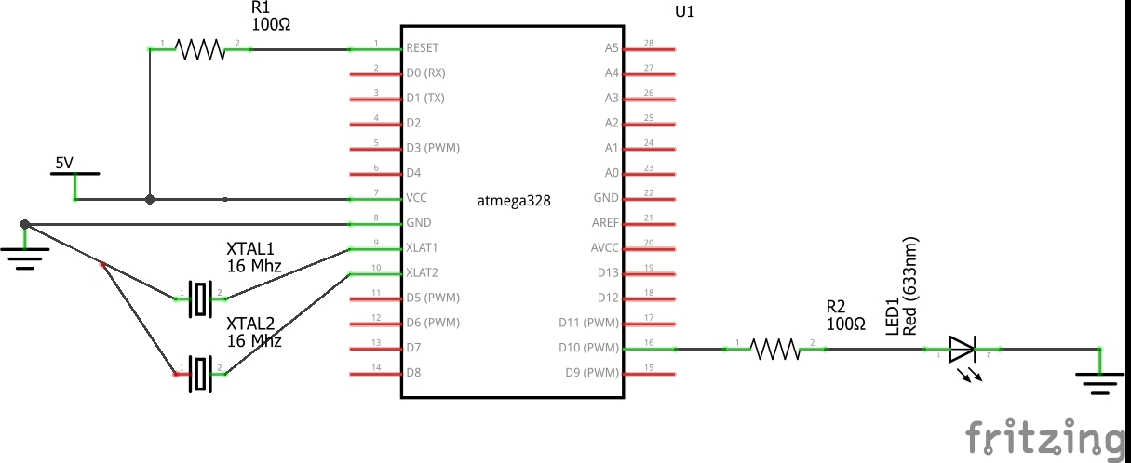

Task 2:

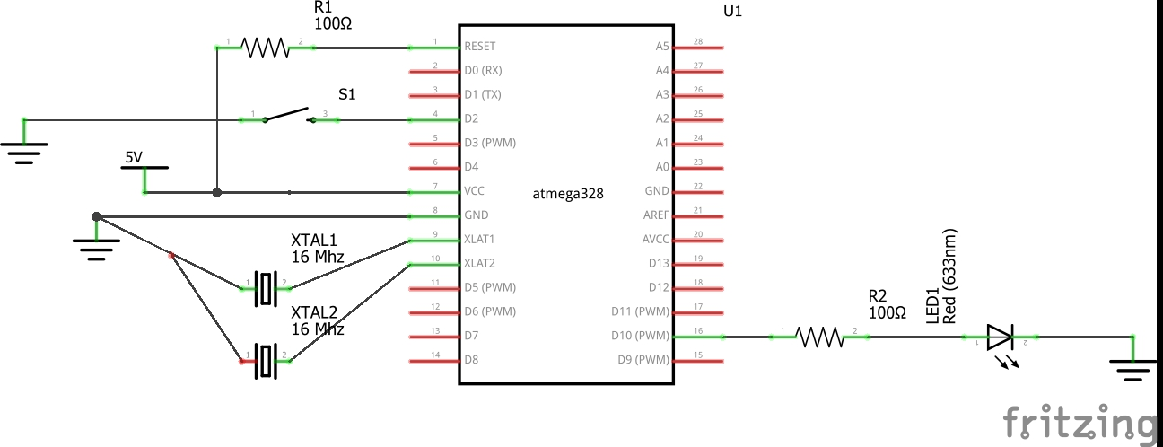

1. **SCREENSHOTS OF EACH TASK OUTPUT (ATMEL STUDIO OUTPUT)**

Task 1:

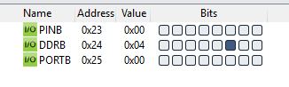

Figure toggle LED

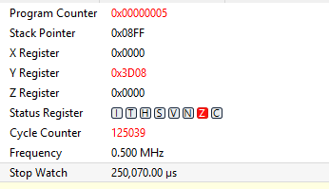

Figure required delay of 0.25 after reset stop watch

Task 1b:

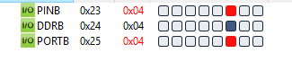

Figure toggle LED

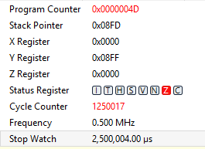

Figure delay of 2.5 second after resetting the stop watch

Task 2:

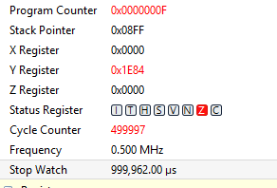

Figure delay of 1 second after resetting the watch

Task 3:

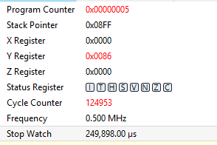

Figure delay of 0.25 sec after resetting the stop watch

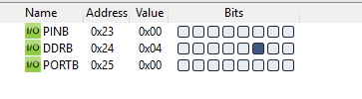

Figure toggle LED

Task 3- C code (measuring the delay after resetting the stop watch)

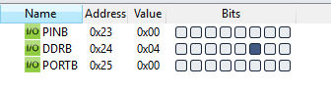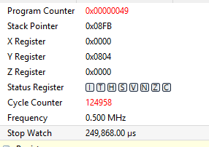

Task 4 (C code) – results of the delay (0.25) seconds and toggle LED

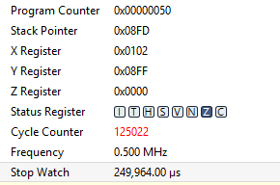

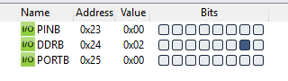

1. **SCREENSHOT OF EACH DEMO (BOARD SETUP)**

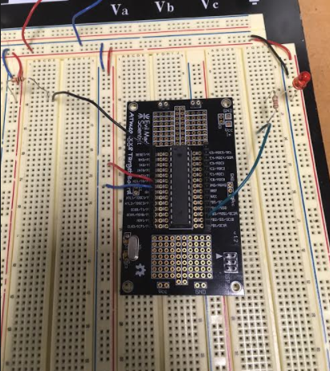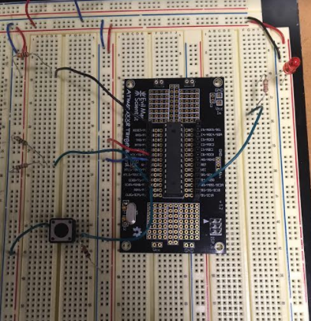

1. **VIDEO LINKS OF EACH DEMO**

Task 1- <https://youtu.be/4F8kpBeYBOw>

Task 2- <https://youtu.be/73utptmEqtw>

1. **GITHUB LINK OF THIS DA**

[git@github.com:EilatAvidan/microcon.git](mailto:git@github.com:EilatAvidan/microcon.git)

**Student Academic Misconduct Policy**

<http://studentconduct.unlv.edu/misconduct/policy.html>

“This assignment submission is my own, original work”.

Eilat Avidan