Eilat Avidan

CPE301 – SPRING 2018

Design Assignment 3

**DO NOT REMOVE THIS PAGE DURING SUBMISSION:**

The student understands that all required components should be submitted in complete for grading of this assignment.

|  |  |  |  |
| --- | --- | --- | --- |
| **NO** | **SUBMISSION ITEM** | **COMPLETED (Y/N)** | **MARKS**  **(/MAX)** |
| 1 | COMPONENTS LIST AND CONNECTION BLOCK DIAGRAM w/ PINS |  |  |
| 2. | INITIAL CODE OF TASK 1/A |  |  |
| 3. | INCREMENTAL / DIFFERENTIAL CODE OF TASK 2/B |  |  |
| 3. | INCREMENTAL / DIFFERENTIAL CODE OF TASK 3/C |  |  |
| 3. | INCREMENTAL / DIFFERENTIAL CODE OF TASK 4/D |  |  |
| 3. | INCREMENTAL / DIFFERENTIAL CODE OF TASK 5/E |  |  |
| 4. | SCHEMATICS |  |  |
| 5. | SCREENSHOTS OF EACH TASK OUTPUT |  |  |
| 5. | SCREENSHOT OF EACH DEMO |  |  |
| 6. | VIDEO LINKS OF EACH DEMO |  |  |
| 7. | GOOGLECODE LINK OF THE DA |  |  |
|  |  |  |  |
|  |  |  |  |

1. **COMPONENTS LIST AND CONNECTION BLOCK DIAGRAM w/ PINS**

* Atmega328P
* FTDI chip
* Mini USB to USB cable
* Switch
* Breadboard
* Resistors (mainly 100 ohms)
* LED (red)
* Power supply

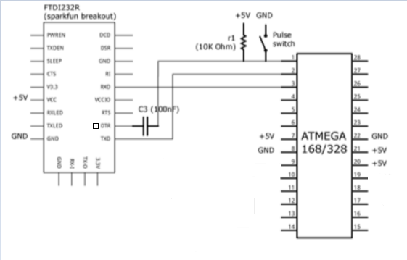

1. **INITIAL/DEVELOPED CODE OF TASK 1/A**

#define *F_CPU* 8000000UL

#define UBRR_9600 51 // for 8Mhz with .2% error

#include <avr/io.h>

#include <util/delay.h>

#include <stdio.h>

#include <avr/interrupt.h>

#include <stdint.h>

// Function Declarations

void read_adc(void);

void adc_init(void);

void USART_init( unsigned int ubrr );

void USART_tx_string( char *data );

volatile unsigned int adc_temp;

char outs[20];

int main(void)

{

adc_init(); // Initialize the ADC (Analog / Digital Converter)

USART_init(UBRR_9600); // Initialize the USART (RS232 interface)

USART_tx_string("Connected!\r\n"); // we're alive!

*_delay_ms*(125); // wait a bit

TIMSK1 = (1<<TOIE1); //timer1 interrupt register

TCNT1 = 34286; //timer counts to this value

TCCR1A = 0;

TCCR1B = (1<<CS12); //256 prescaler

sei();

while(1)

{

// wait for interrupt

}

}

ISR (TIMER1_OVF_vect) //overflow interrupt

{

TCCR1B = 0; //stop the counter

read_adc();

*snprintf*(outs,sizeof(outs),"%3d\r\n", adc_temp); // print ADC value

USART_tx_string(outs);

*_delay_ms*(125); // wait a bit

TCNT1 = 34286;

TCCR1B = (1<<CS12);

}

void adc_init(void)

{

/** Setup and enable ADC **/

ADMUX = (0<<REFS1)| // Reference Selection Bits

(1<<REFS0)| // AVcc - external cap at AREF

(1<<ADLAR)| // ADC left Adjust Result

(0<<MUX2)| // Analog Channel Selection Bits

(0<<MUX1)| // ADC0 Pin

(0<<MUX0);

ADCSRA = (1<<ADEN)| // ADC ENable

(1<<ADSC)| // ADC Start Conversion

(1<<ADATE)| // ADC Auto Trigger Enable

(0<<ADIF)| // ADC Interrupt Flag

(0<<ADIE)| // ADC Interrupt Enable

(1<<ADPS2)| // ADC Prescaler Select Bits

(0<<ADPS1)|

(1<<ADPS0);

}

/* READ ADC PINS*/

void read_adc(void)

{

unsigned char i =4; //set i to 4- make 4 readings

adc_temp = 0; //initialize ADC_TEMP

while (i--)

{

ADCSRA |= (1<<ADSC);

while((ADCSRA & (1<<ADIF)) == 0);

adc_temp += ADCH*2; //sum up 4 readings

*_delay_ms*(50);

}

adc_temp = adc_temp / 4; // Average of four samples

}

/* INIT USART (RS-232) */

void USART_init( unsigned int ubrr )

{

UBRR0H = (unsigned char)(ubrr>>8);

UBRR0L = (unsigned char)ubrr;

UCSR0B = (1 << TXEN0) | (1 <<RXEN0); // Enable receiver, transmitter

UCSR0C = (1 << UCSZ00) | (1 << UCSZ01); //asynchronous 8-bit data 1 stop bit

}

/* SEND A STRING TO THE RS-232*/

void USART_tx_string( char *data )

{

while ((*data != '\0')) //loop until the end of the string

{

while (!(UCSR0A & (1 <<UDRE0))); //wait until flag set

UDR0 = *data;

*_delay_ms*(125); // wait a bit

data++;

}

}

1. **Flow chart**

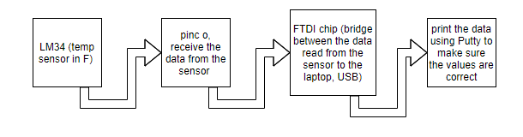

1. **SCREENSHOTS OF EACH TASK OUTPUT (ATMEL STUDIO OUTPUT)**

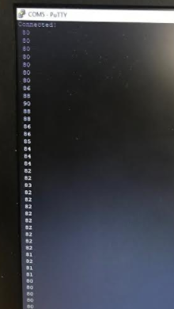

Picture taking from Putty with the displayed values, in one point, we can see that the value increasing, I touched the sensor to make sure that the sensor is reading correctly.

1. **SCREENSHOT OF EACH DEMO (BOARD SETUP)**

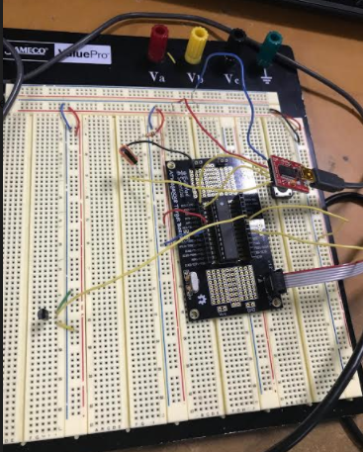

1. **VIDEO LINKS OF EACH DEMO**

<https://youtu.be/b5qD7vp0Rd0>

1. **GITHUB LINK OF THIS DA**

[git@github.com:EilatAvidan/microcon.git](mailto:git@github.com:EilatAvidan/microcon.git)

**Student Academic Misconduct Policy**

<http://studentconduct.unlv.edu/misconduct/policy.html>

“This assignment submission is my own, original work”.

Eilat Avidan