Eilat Avidan

CPE301 – SPRING 2018

Design Assignment 3

**DO NOT REMOVE THIS PAGE DURING SUBMISSION:**

The student understands that all required components should be submitted in complete for grading of this assignment.

|  |  |  |  |
| --- | --- | --- | --- |
| **NO** | **SUBMISSION ITEM** | **COMPLETED (Y/N)** | **MARKS**  **(/MAX)** |
| 1 | COMPONENTS LIST AND CONNECTION BLOCK DIAGRAM w/ PINS |  |  |
| 2. | INITIAL CODE OF TASK 1/A |  |  |
| 3. | INCREMENTAL / DIFFERENTIAL CODE OF TASK 2/B |  |  |
| 3. | INCREMENTAL / DIFFERENTIAL CODE OF TASK 3/C |  |  |
| 3. | INCREMENTAL / DIFFERENTIAL CODE OF TASK 4/D |  |  |
| 3. | INCREMENTAL / DIFFERENTIAL CODE OF TASK 5/E |  |  |
| 4. | SCHEMATICS |  |  |
| 5. | SCREENSHOTS OF EACH TASK OUTPUT |  |  |
| 5. | SCREENSHOT OF EACH DEMO |  |  |
| 6. | VIDEO LINKS OF EACH DEMO |  |  |
| 7. | GOOGLECODE LINK OF THE DA |  |  |
|  |  |  |  |
|  |  |  |  |

1. **COMPONENTS LIST AND CONNECTION BLOCK DIAGRAM w/ PINS**

* Atmega328P
* Switch
* Breadboard
* Resistors
* Power supply
* 3 types of motors: DC, servo, and stepper.
* Potentiometer
* ULN2003 (works with the stepper motor)

1. **INITIAL/DEVELOPED CODE OF TASK 1/A**

**DC Motor code:**

#include <avr/io.h>

#define *F_CPU* 8000000UL

#include <avr/interrupt.h>

#include <util/delay.h>

int main()

{

ADCSRA = 0x87; //ADC enable , prescaler 128

ADMUX = 0x60; //AVcc , left justified

DDRB = 0xFF; //PORTB output

PORTD |= (1<<2); //set up pull up resistor

OCR1A = 0; //0% duty cycle initially

TCCR1B = 0x0D; //prescaler of 1024

TCCR1A = 0x83; //non-inverting mode, fast PWM 10 bit

EIMSK |= (1<<INT0); //enable external interrupt 0

EICRA |= (1<<ISC01); //falling edge trigger

sei();

while (1)

{

ADCSRA |= (1<<ADSC); //start conversion

while ((ADCSRA & (1<<ADIF)) == 0)

{

//wait for conversion to finish

}

}

}

ISR (INT0_vect)

{

EIFR |= (1<<INTF0); //reset flag

if((PORTB & 0b00000001) == 0b00000000)

PORTB |= (1<<0);

else

PORTB &= ~(1<<0);

if(ADCH > 220){

OCR1A = 600; //95% duty cycle

*_delay_ms*(2000);

}

else

OCR1A = 0; //0% duty cycle

}

**Stepper Motor code:**

#include <avr/io.h>

#define *F_CPU* 8000000UL

#include <util/delay.h>

#include <avr/interrupt.h>

void delay_count();

int ADCvalue;

int main(void)

{

DDRC = 0x00; //set port c as an input

DDRD = 0xFF; //set port d as an output

ADMUX = 0x00; //use ADC0 connected to the potentiometer

ADMUX |= (1<<REFS0); //AVcc

ADMUX |= (1<<ADLAR); //right adjust

ADCSRA |= (1<<ADPS2) |(1<<ADPS1) |(1<<ADPS0); //prescaler of 128

ADCSRA |= (1<<ADEN); //ADC enable

ADCSRA |= (1<<ADATE); //auto trigger enable

ADCSRB = 0; //free mode

ADCSRA |= (1<<ADIE); //enable interrupt

ADCSRA |= (1<<ADSC); //start conversion

sei(); //enable interrupt

while (1)

{

{

PORTD = 0x03; //clockwise direction

delay_count();;

PORTD = 0x42;

delay_count();

PORTD = 0xC0;

delay_count();

PORTD = 0x81;

delay_count();

}

}

}

void delay_count ()

{

TCNT0 = 0; //initial count value

OCR0A = ADCvalue/7; //compare value

TCCR0A = (1<<WGM01); // Configure timer0 for CTC mode.

TCCR0B = (1<<CS02) | (1<<CS00) ; // prescaler 1024

while ((TIFR0 & (1<<OCR0A)) == 0);

TCCR0B = 0; //stop timer

TIFR0 = (1<<OCR0A); //reset flag

}

ISR(ADC_vect)

{

ADCvalue = ADCH; // Output ADCH to ADCvalue variable

}

**Servo Motor code:**

#include <avr/io.h>

#define *F_CPU* 8000000UL

#include <util/delay.h>

#include <avr/interrupt.h>

int ADCvalue;

int main(void)

{

TCCR1A |= (1<<COM1A1) | (1<<COM1B1)| (1<<WGM11); //TIMER1

TCCR1B |= (1<<WGM13)| (1<<WGM12)| (1<<CS11)|(1<<CS10); //prescaler 64

ICR1 = 2500; //fPWM = 50Hz, period 20ms

DDRB= 0xFF;

DDRC = 0x00; //set port c as an input

DDRD = 0xFF; //set port d as an output

ADMUX = 0x00; //use ADC0 connected to the potentiometer

ADMUX |= (1<<REFS0); //AVcc

ADMUX |= (1<<ADLAR); //right adjust

ADCSRA |= (1<<ADPS2) |(1<<ADPS1) |(1<<ADPS0); //prescaler of 128

ADCSRA |= (1<<ADEN); //ADC enable

ADCSRA |= (1<<ADATE); //auto trigger enable

ADCSRB = 0; //free mode

ADCSRA |= (1<<ADIE); //enable interrupt

ADCSRA |= (1<<ADSC);

OCR1A = 63; //0 degree, min value

sei();

while (1)

{

OCR1A = ADCvalue; //motor gets ADC value

*_delay_ms*(10);

}

}

ISR(ADC_vect)

{

ADCvalue = ADCH; // Output ADCH to ADC value

}

1. **Flow chart**

**For the DC motor-**

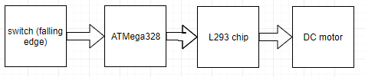

**For the Stepper motor-**

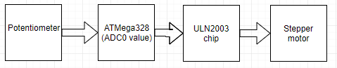

**For the Servo motor-**

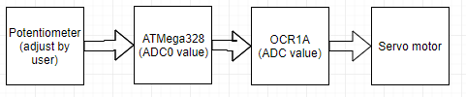

1. **SCREENSHOT OF EACH DEMO (BOARD SETUP)**

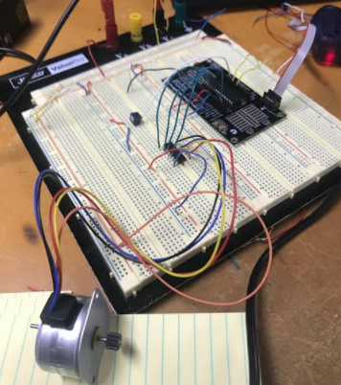

Figure Set up of the stepper motor

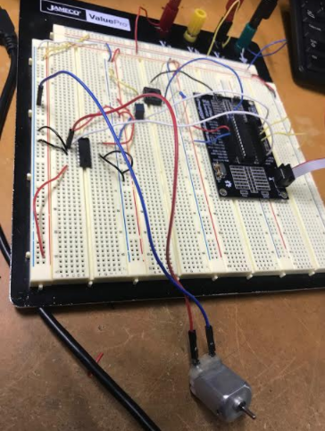

Figure Set up of the DC motor

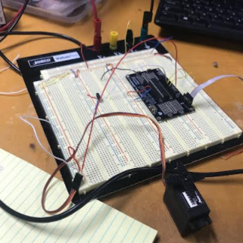

Figure set up of servo motor

1. **VIDEO LINKS OF EACH DEMO**

DC motor- <https://youtu.be/WrnR4ehkQR4>

Stepper motor- <https://youtu.be/2YX0L3S_kJg>

Servo motor- <https://youtu.be/iK1KQTjyQqI>

1. **GITHUB LINK OF THIS DA**

[git@github.com:EilatAvidan/microcon.git](mailto:git@github.com:EilatAvidan/microcon.git)

**Student Academic Misconduct Policy**

<http://studentconduct.unlv.edu/misconduct/policy.html>

“This assignment submission is my own, original work”.

Eilat Avidan