PID Speed Control of DC Motor with Encoder

Eilat Avidan

**Goal:**

* Control the speed of the supplied DC motor with encoder using PID algorithm.
* Display the speed to the terminal using FTDI chip (USART).
* Receive speed value from user and try to adjust the motor accordingly.

**Deliverables:**

This project is divided to three different parts. The first part is to send the motor speed value to the terminal using FTDI chip. Then, the second part is to receive data from the user of the required speed and adjust the motor speed until getting the speed required. The third part is to press a pushbutton that will slow down the motor until complete stop.

# **Components:**

1. AVR ATMEGA328p – an eight-bit microcontroller, easy to use and can be programmed using C or assembly language. Total of 28 pins which 23 pins are programmable I/O Lines. There are three different timers in the chip, 2 timers are 8-bit and one of them is 16-bit timer. There is also one USART module that will be used for the project to send and receive data from and to the motor.
2. DRV8833 Dual Motor Driver- the device has two H-bridge drivers that provides a dual bridge motor solution for many applications.
3. 2,737 RPM- motor with encoder- a DC motor with encoder that can send and receive information regarding the motion of the DC motor. Maximum speed of this motor is 2737 RPM, with a maximum current of 4.9 amp (12-volt maximum voltage).
4. FTDI chip- Future Technology Devices International, used in the project to transfer data from the chip to the computer and vice versa.
5. Switch
6. Power supply (5V)

# [1]

# Schematics

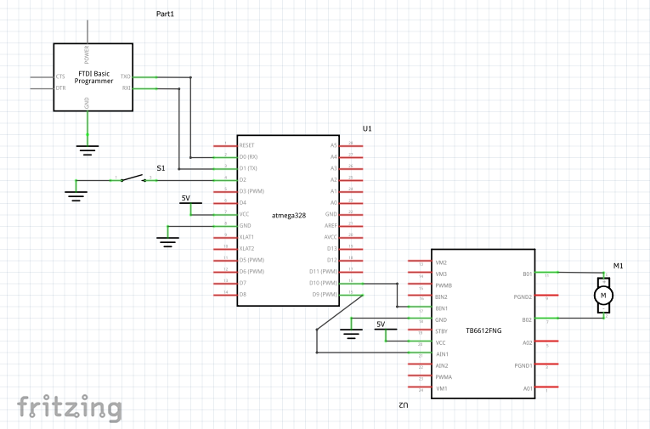

Figure 1: Figure caption centered

* *I could not find a DC motor with encoder in fritzing so I used a regular one.*

Code #1- sending the speed value to the terminal

#define *F_CPU* 8000000UL

#define UBRR_9600 51

#include <avr/io.h>

#include <util/delay.h>

#include <stdio.h>

#include <avr/interrupt.h>

#include <stdint.h>

volatile unsigned int adc_speed; //global variables

char outs[20];

void adc_init(void)

{

ADMUX = (0<<REFS1)| // Reference Selection Bits

(1<<REFS0)| // AVcc - external cap at AREF

(1<<ADLAR)| // ADC left Adjust Result

(0<<MUX2)| // Analog Channel Selection Bits

(0<<MUX1)| // ADC0 Pin

(0<<MUX0);

ADCSRA = (1<<ADEN)| // ADC ENable

(1<<ADSC)| // ADC Start Conversion

(1<<ADATE)| // ADC Auto Trigger Enable

(0<<ADIF)| // ADC Interrupt Flag

(0<<ADIE)| // ADC Interrupt Enable

(1<<ADPS2)| // ADC Prescaler Select Bits

(0<<ADPS1)|

(1<<ADPS0);

}

void read_adc(void)

{

unsigned char i =4; //set i to 4- make 4 readings

adc_speed = 0; //initialize ADC_TEMP

while (i--)

{

ADCSRA |= (1<<ADSC);

while((ADCSRA & (1<<ADIF)) == 0);

adc_speed += ADCH; //sum up 4 readings

*_delay_ms*(50);

}

adc_speed = adc_speed / 4; // Average of four samples

}

void USART_init( unsigned int ubrr )

{

UBRR0H = (unsigned char)(ubrr>>8); //set baud rate

UBRR0L = (unsigned char)ubrr;

UCSR0B = (1 << TXEN0) | (1 <<RXEN0); // Enable receiver, transmitter

UCSR0C = (1 << UCSZ00) | (1 << UCSZ01); //asynchronous 8-bit data 1 stop bit

}

void USART_tx_string( char *data )

{

while ((*data != '\0'))

{

while (!(UCSR0A & (1 <<UDRE0))); //wait for the transmit buffer to empty

UDR0 = *data; //put the data into the empty buffer, which sends the data

*_delay_ms*(125); // wait a bit

data++;

}

}

unsigned char USART_Receive( void )

{

while ( !(UCSR0A & (1<<RXC)) )

{

// Wait for data

}

return UDR0;

}

int main()

{

adc_init(); // Initialize the ADC (Analog / Digital Converter)

USART_init(UBRR_9600); // Initialize the USART (RS232 interface)

USART_tx_string("DC motor with encoder:\r\n");

*_delay_ms*(125); // wait a bit

TCCR0A |= (1 << WGM00); //fast pwm mode

TCCR0A |= (1 << WGM01); //fast pwm mode

TCCR0A |= (1 << COM0A0); //compare output mode

TCCR0A |= (1 << COM0A1); //compare output mode

TCCR0B |= (1 << CS00); //set timer counter

TCCR0B &= ~(1 << CS01);

TCCR0B &= ~(1 << CS02);

OCR0A = 128; //50 % duty cycle

sei();

while(1)

{

// wait for interrupt

}

}

ISR (TIMER0_OVF_vect) //overflow interrupt

{

TCCR0B = 0; //stop the counter

read_adc();

*snprintf*(outs,sizeof(outs),"%3d\r\n", adc_speed); // print ADC value

USART_tx_string(outs);

*_delay_ms*(125); // wait a bit

TCNT0 = 128;

}

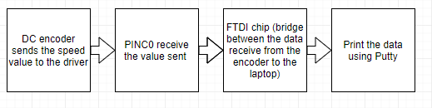

# part#2

#define *F_CPU* 8000000UL

#define UBRR_9600 51 // for 8Mhz with .2% error

#include <avr/io.h>

#include <util/delay.h>

#include <stdio.h>

#include <avr/interrupt.h>

#include <stdint.h>

void read_adc(void);

void adc_init(void);

void USART_init( unsigned int ubrr );

void USART_tx_string( char *data );

volatile unsigned int adc_temp;

char outs[20];

typedef struct encoder_data

{

*int16_t* direction;

*int32_t* count;

} encoder;

typedef struct motor_data

{

*int16_t* velocity_setpoint;

*int16_t* velocity;

*int16_t* integral_error;

*int16_t* previous_error;

*int16_t* kp;

*int16_t* ki;

*int16_t* kd;

} motor;

int encoder_velocity (encoder *e)

{

int velocity = *abs* (e->count);

e-> count = 0; //reset encoder's count

return velocity;

}

int do_pid (motor *m)

{

float p_error; //difference between the velocity we want to the current one

float i_error; //sum of errors

float d_error;

float p_output; //proportional component of the output

float i_output;

float d_output;

float output;

//calculate the errors

p_error = m->velocity_setpoint - m->velocity;

i_error = m->integral_error;

d_error = p_error - m->previous_error;

//calculate the component of the PID output

p_output = m->kp*p_error;

i_output = m->ki*i_error;

d_output = m->kd*d_error;

output = p_output + i_output + d_output;

//update errors

m->integral_error += p_error;

m->previous_error = p_error;

return (int) output;

}

void encoder_update (encoder *e, int A, int B)

{

if (A == 1)

{

if (B == 1)

{

e-> direction = 1;

e-> count++;

}

else

{

e-> direction = 0;

e-> count--;

}

}

else

{

if (B == 1)

{

e-> direction = 0;

e-> count--;

}

else

{

e-> direction = 1;

e-> count++;

}

}

}

int main ()

{

TCCR0A |= (1 << WGM00); //fast pwm mode

TCCR0A |= (1 << WGM01); //fast pwm mode

TCCR0A |= (1 << COM0A0); //compare output mode

TCCR0A |= (1 << COM0A1); //compare output mode

TCCR0B |= (1 << CS00); //set timer counter

TCCR0B &= ~(1 << CS01);

TCCR0B &= ~(1 << CS02);

OCR0A = 128; //50% duty cycle

OCR0A = motor_output (parameters, OCR0A, do_pid(pRMotor));

//encoder initializations

encoder pREncoder = &REncoder; //pointer to right encoder structure

DDRC |= ~(1<<PC0); //encoder A input, channel A

DDRD |= ~(1<<PD3); //encoder B input, channel B

PORTC |= (1<<PC0); //resistor enable

PORTD |= (1<<PD3); //resistor enable

EICRA |= (1 << ISC10); //external interrupt, any logical change on INT1 generate an interrupt request

EIMSK |= (1 << INT1); //enable external interrupt

adc_init(); // Initialize the ADC (Analog / Digital Converter)

USART_init(UBRR_9600); // Initialize the USART (RS232 interface)

USART_tx_string("Connected!\r\n"); // we're alive!

*_delay_ms*(125); // wait a bit

TIMSK1 = (1<<TOIE1); //timer1 interrupt register

TCNT1 = 34286; //timer counts to this value

TCCR1A = 0;

TCCR1B = (1<<CS12); //256 prescaler

sei();

while(1)

{

// wait for interrupt

}

}

ISR(INT1_vect)

{

encoder_update(&REncoder, (PIND & 8) >> 3, (PINC & 1));

}

ISR (TIMER0_OVF_vect) //overflow interrupt

{

TCCR0B = 0; //stop the counter

read_adc();

*snprintf*(outs,sizeof(outs),"%3d\r\n", adc_temp); // print ADC value

USART_tx_string(outs);

*_delay_ms*(125); // wait a bit

TCNT1 = 125;

//TCCR1B = (1<<CS12);

}

void adc_init(void)

{

/** Setup and enable ADC **/

ADMUX = (0<<REFS1)| // Reference Selection Bits

(1<<REFS0)| // AVcc - external cap at AREF

(1<<ADLAR)| // ADC left Adjust Result

(0<<MUX2)| // Analog Channel Selection Bits

(0<<MUX1)| // ADC0 Pin

(0<<MUX0);

ADCSRA = (1<<ADEN)| // ADC ENable

(1<<ADSC)| // ADC Start Conversion

(1<<ADATE)| // ADC Auto Trigger Enable

(0<<ADIF)| // ADC Interrupt Flag

(0<<ADIE)| // ADC Interrupt Enable

(1<<ADPS2)| // ADC Prescaler Select Bits

(0<<ADPS1)|

(1<<ADPS0);

}

/* READ ADC PINS*/

void read_adc(void)

{

unsigned char i =4; //set i to 4- make 4 readings

adc_temp = 0; //initialize ADC_TEMP

while (i--)

{

ADCSRA |= (1<<ADSC);

while((ADCSRA & (1<<ADIF)) == 0);

adc_temp += ADCH*2; //sum up 4 readings

*_delay_ms*(50);

}

adc_temp = adc_temp / 4; // Average of four samples

}

/* INIT USART (RS-232) */

void USART_init( unsigned int ubrr )

{

UBRR0H = (unsigned char)(ubrr>>8);

UBRR0L = (unsigned char)ubrr;

UCSR0B = (1 << TXEN0) | (1 <<RXEN0); // Enable receiver, transmitter

UCSR0C = (1 << UCSZ00) | (1 << UCSZ01); //asynchronous 8-bit data 1 stop bit

}

/* SEND A STRING TO THE RS-232*/

void USART_tx_string( char *data )

{

while ((*data != '\0')) //loop until the end of the string

{

while (!(UCSR0A & (1 <<UDRE0))); //wait until flag set

UDR0 = *data;

*_delay_ms*(125); // wait a bit

data++;

}

}

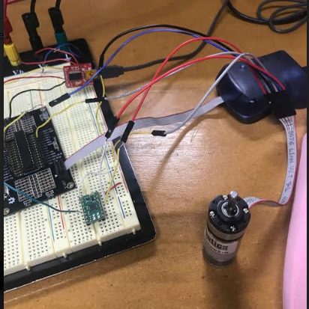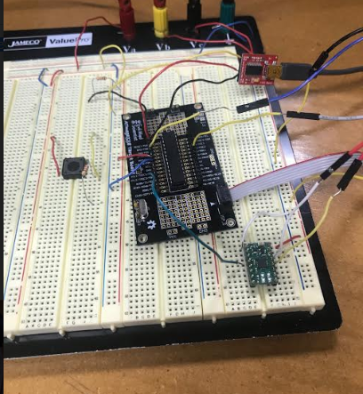

# Conclusion

The project combines many elements that need to work together to perform the required output. Divide it to two parts help a lot to design the project. Even though the code works, I had problem with the encoder that did not work as expected.

1.